Name
Class
Date

1-6
Multiplying and Dividing Real Numbers
Enrichment

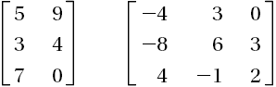
A matrix is a rectangular array of numbers. Some examples of matrices are given at the right.

You can perform operations using matrices. One operation is called scalar multiplication. In scalar multiplication, each number in the matrix is multiplied by the number outside the matrix. The products are listed in another matrix in the same order.
Complete each scalar multiplication.

1. | 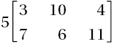 | 2. | 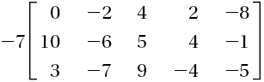
3. | 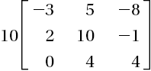 | 4. | 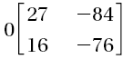

The matrix at the right compares the prices of 3 different digital cameras at 3 different stores.

 |  | Camera A | Camera B | Camera C
Camera Store |  | $153.00 | $207.00 | $255.00
Discount Store |  | $142.50 | $212.00 | $251.00
Electronic Store |  | $192.00 | $209.50 | $249.50

- If the sales tax is 6%, each number in the matrix must be multiplied by 1.06 to determine the total cost of each camera. Write a scalar multiplication problem that could be used to determine the total cost of the cameras.
- Complete the scalar multiplication you wrote in Exercise 5.
- Use the matrix you found in Exercise 6 to determine the difference in the total cost if you bought Camera C from the Discount Store rather than the Camera Store.
- What is the difference between the greatest total cost and the least total cost for Camera A?
Prentice Hall Algebra 1 • Teaching Resources
Copyright © by Pearson Education, Inc., or its affiliates. All Rights Reserved.
58

