Name
Class
Date

1-6
Multiplying and Dividing Real Numbers
Additional Vocabulary Support

Use the list below to complete the graphic organizer.
- Dividing by a fraction is equivalent to multiplying by the of the fraction.
- describes the relationship between a number and its multiplicative inverse
- The reciprocal of a number is its .
- For every nonzero real number a, there is a multiplicative inverse such that
•
•
•
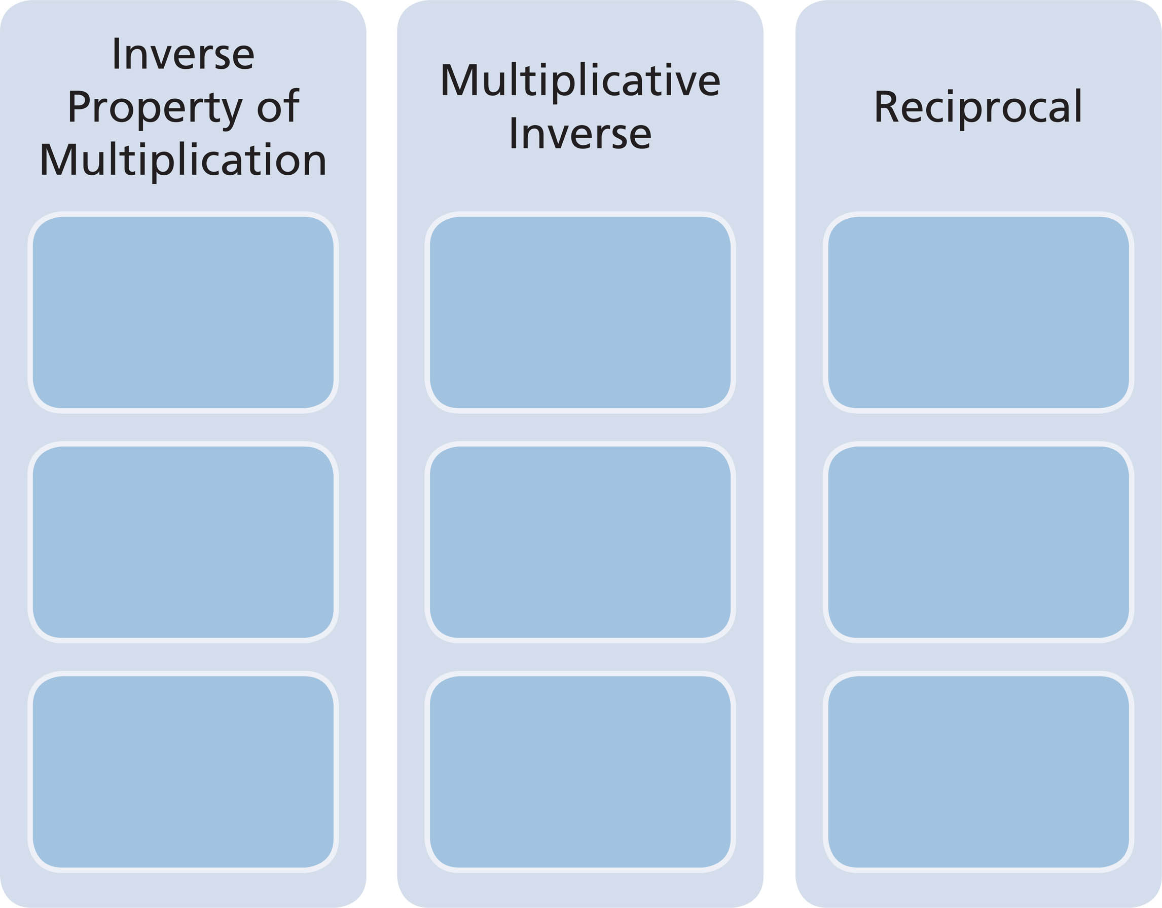
Prentice Hall Algebra 1 • Teaching Resources
Copyright © by Pearson Education, Inc., or its affiliates. All Rights Reserved.
51

