Name
Class
Date
1-7

The Distributive Property
Game: Algebra Baseball

You and a partner will each need four pennies and two number cubes for this
game. You and a classmate will represent two baseball teams. Each team will alternate turns for 7 innings. Each turn starts with an at bat. Use pennies to represent your players.
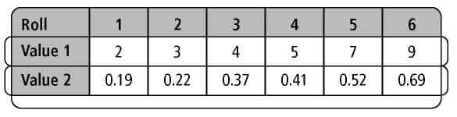

For each at bat, place a penny at home plate and roll a number cube twice. Use the table at the right to determine the values of your two rolls. For example, if your first roll is 2, then your first value is 3. If your second roll is 5, then your second value is 0.52.

Use mental math to multiply the two values. For example, a roll of a 2and a 5 means you multiply 3 and 0.52. By the Distributive Property,
3(0.50 + 0.02) = 1.50 + 0.06 = 1.56.
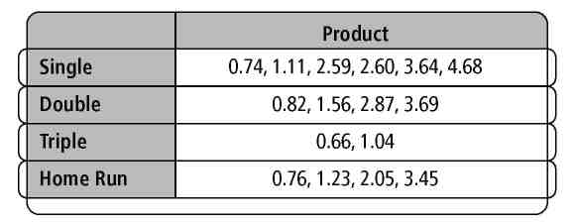
Use the table at the right to determine the result. For example, 1.56. results in a double. This means you move your penny two bases to second base.

Rules
- When a penny reaches home plate, you score a run.
- A single means you move all pennies one base.
- A double means you move all pennies two bases.
- A triple means you move all pennies three bases.
- A home run means all pennies on base, as well as the one at home plate,
score.
- A player who cannot find the product in the table makes an out.
- A player who commits a math error also makes an out.
- After three outs, the other team gets a chance to bat.

Use the scoreboard below to keep score and the field on the next page to move your players. Play ball!
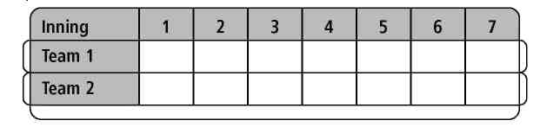
Prentice Hall Algebra 1 • Activities, Games, and Puzzles
Copyright © by Pearson Education, Inc., or its affiliates. All Rights Reserved.
8
8

Date

Class
Name
1-7

The Distributive Property
Game: Algebra Baseball

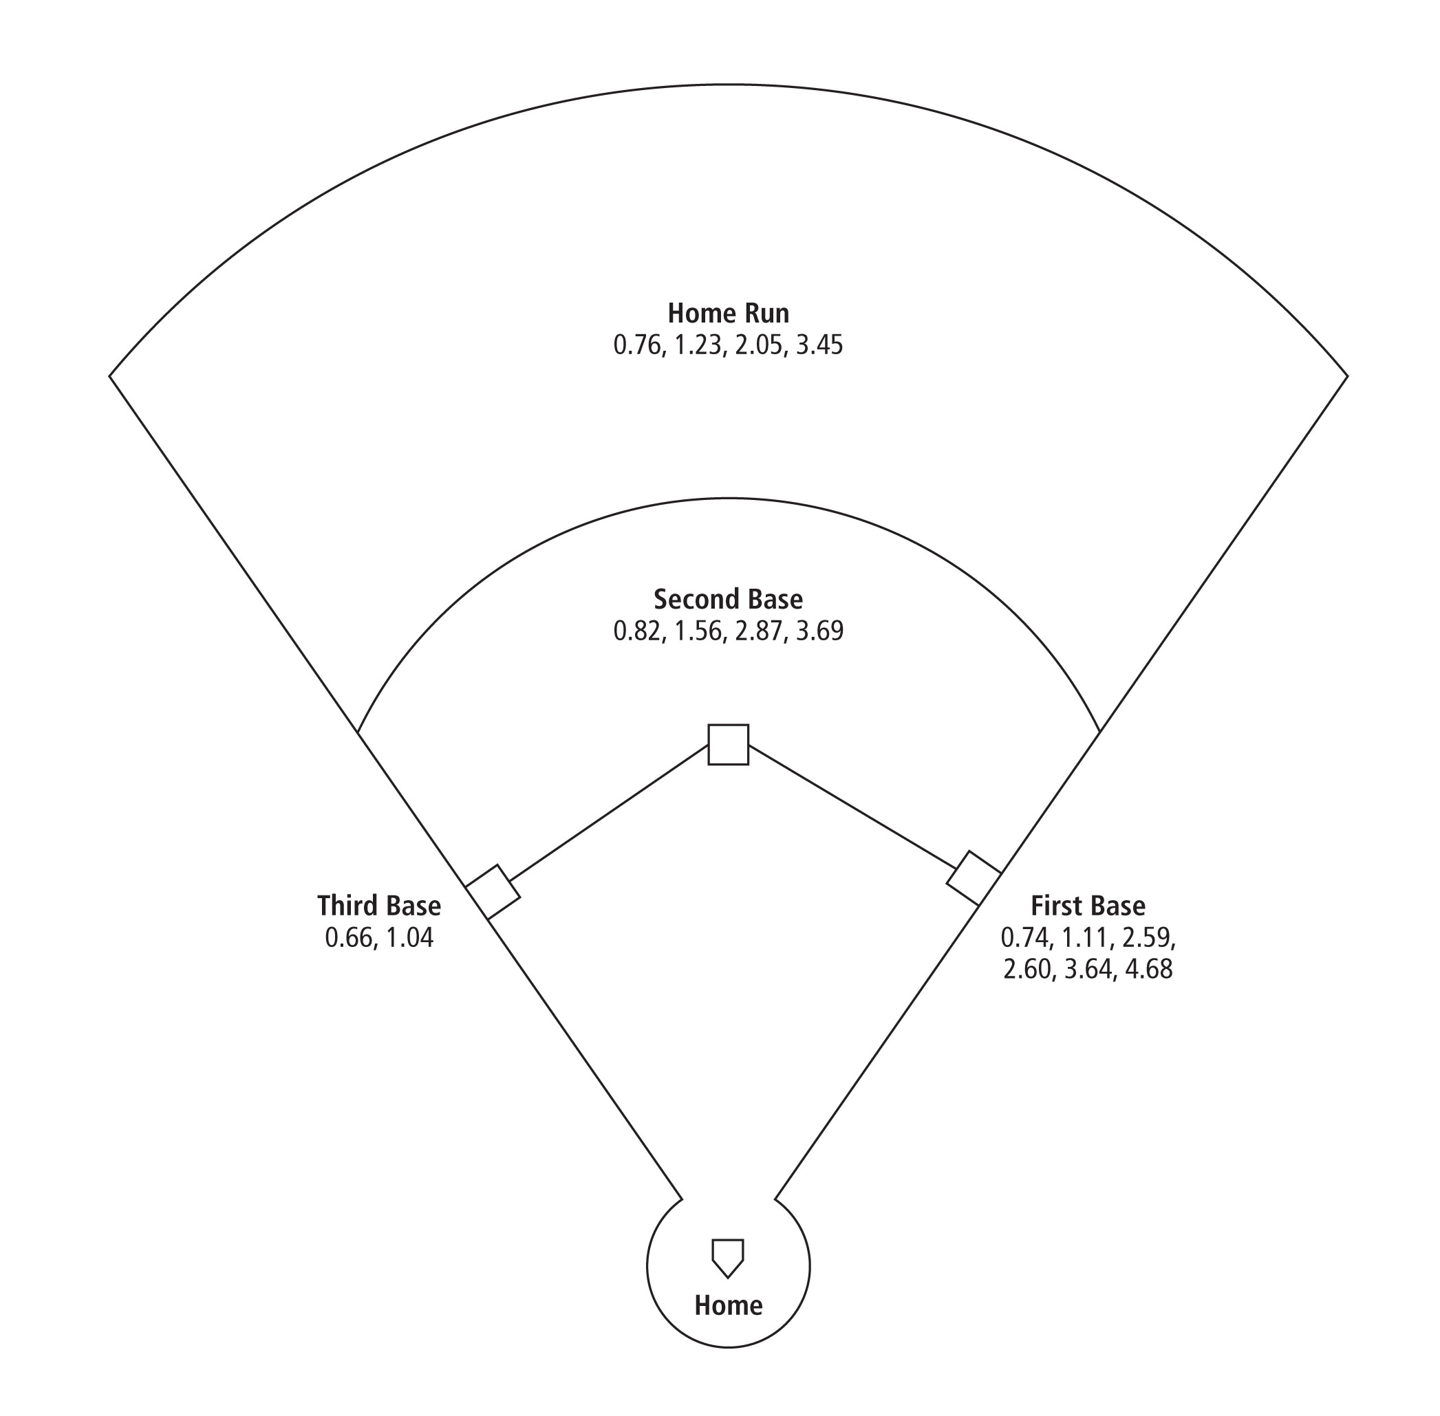
Prentice Hall Algebra 1 • Activities, Games, and Puzzles
Copyright © by Pearson Education, Inc., or its affiliates. All Rights Reserved.
9

