Name
Class
Date

1-8

Puzzle: Algebra Connections
An Introduction to Equations

Determine whether the given number is a solution to the equation. Show your work below each problem or on a separate piece of paper.
If the given number is a solution, then circle the problem number in the maze below. For example, you would circle “1” in the maze if 11 is a solution to –3u + 5 = 28. Follow the circled numbers as a guide to find the correct path through the maze!
1. –3u + 5 = 28; 11 2. 4.5 – 0.9y = 2.7; 2 3. 9m – (–7) = 61; 6
4. 5. 10b – (–5) = 75; 7 6. 7x – 5 = 33; 4
7. 5k + 1 = 16; 3 8. 7r – (–35) = 42; –1 9.
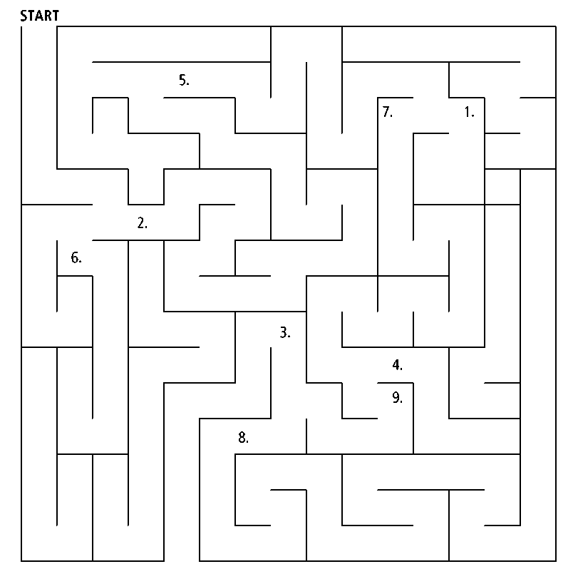
Prentice Hall Algebra 1 • Activities, Games, and Puzzles
Copyright © by Pearson Education, Inc., or its affiliates. All Rights Reserved.
10

