Name
Class
Date

1-8
An Introduction to Equations
Enrichment

The relationships you have examined in this lesson are all called linear — that is, the graph of the relation forms a straight line. Linear relationships are convenient because, once you know the equation or rule, the pattern is predictable.
The relationships shown in the tables are linear. Fill in the missing cells in each table.
1. | 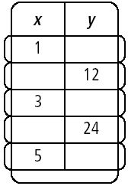 | 2. | 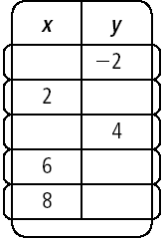 | 3. | 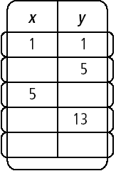
- What is the rule or equation for the relationship represented in the table in Exercise 1?
- What is the rule or equation for the relationship represented in the table in Exercise 2?
- What is the rule or equation for the relationship represented in the table in Exercise 3?

7. Make a table of coordinate pairs from the graph shown at the right.
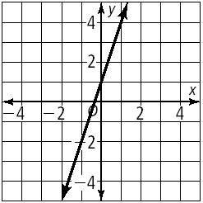

- What is the rule or equation for the relationship represented in the graph?
- What do you notice about the equation and where the line crosses the y-axis on the graph?
Prentice Hall Algebra 1 • Teaching Resources
Copyright © by Pearson Education, Inc., or its affiliates. All Rights Reserved.
78

