Name
Date

Class
1-9
Patterns, Equations, and Graphs
Activity: Sequencing Patterns

This is an activity for you and a classmate. You may wish to discuss your results as a class when everyone has finished. An equation can be used to generate a list of numbers. Depending on the type of equation, you may also be able to see a pattern.
1. Consider y = 3x + 1. What do you get for y when x = 1? x = 2? Complete the table below by finding y for each given value of x.
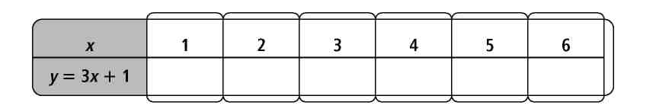
2. Now look at the differences between the entries in your table. What pattern do you see?
3. Based on the pattern, can you determine the y value when x = 7? x = 8? (Do not use the equation to evaluate.)
4. Consider y = –4x + 5. What do you get for a y value when x = 1? x = 2? Complete the table below by finding y for each given value of x.
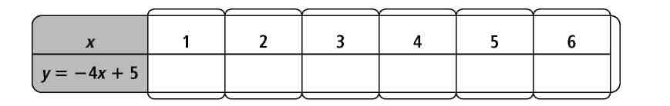
5. Look at the differences between the entries in your table. What pattern do you see?
6. Consider a more general equation of the form y = ax + b where a and b are constants. What is y when x = 1?
7. Based on what you have seen, what can you do with y when x = 1 to find y
when x = 2, x = 3, and so on?
Prentice Hall Algebra 1 • Activities, Games, and Puzzles
Copyright © by Pearson Education, Inc., or its affiliates. All Rights Reserved.
11

