Name
Class
Date

1-9
Patterns, Equations, and Graphs
Enrichment

Marissa decided to sell woodworking crafts that she makes. First she invests $585 in tools. Each item costs $35 in wood and other supplies.
1. Write an equation that relates total costs y to the number of crafts created x.

- Fill in the table to show Marissa’s cost for making 5, 10, 20, 50, and 100 crafts.
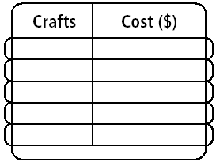
Crafts
Cost ($)
- Graph the relation on the graph at the bottom of this page. Label the line Cost.

4. Marissa sells her crafts for $75 each on the internet. Write an equation that relates her income y to the number of crafts sold x.

- Fill in the table to show Marissa’s income for making 5, 10, 20, 50, and 100 crafts.
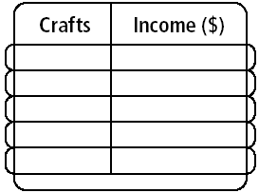
Crafts
Income ($)
- Graph the relation on the graph at the bottom of this page. Label the line Income.

7. How can you identify the break-even point, where expenses are paid and profits begin? Explain. What is the break-even point for Marissa?
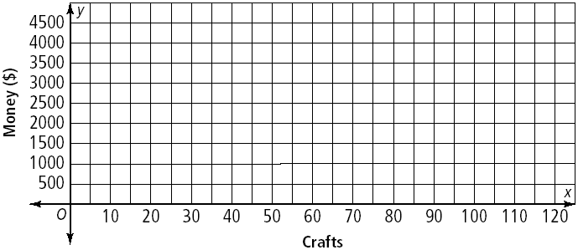

Prentice Hall Algebra 1 • Teaching Resources
Copyright © by Pearson Education, Inc., or its affiliates. All Rights Reserved.
88

