Name
Class
Date

1-9
Patterns, Equations, and Graphs
Practice
Form G

Tell whether the given equation has the ordered pair as a solution.

1. y = x − 4; (5, 1) | 2. y = x + 8; (8, 0) | 3. y = −x − 2; (2, −4)
4. y = −3x; (2, −6) | 5. y = x + 1; (1, 0) | 6. y = −x; (−7, 7)
7. | 8. | 9.
Use a table, an equation, and a graph to represent each relationship.

10. Petra earns $22 per hour. | 11. The calling plan costs $0.10 per minute.
Use the table to draw a graph and answer the question.

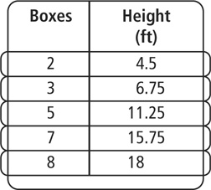  12. The table shows the height in feet of  a stack of medium sized moving boxes. What is the height of a stack of 14 boxes? | 13. The table shows the number of pages Dustin read in terms of hours. How many pages will Dustin read in 12 hours?
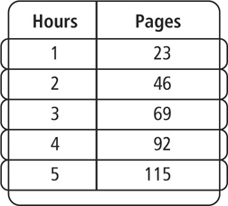
Prentice Hall Gold Algebra 1 • Teaching Resources
Copyright © by Pearson Education, Inc., or its affiliates. All Rights Reserved.
83

Name
Class
Date

1-9
Patterns, Equations, and Graphs
Practice (continued)
Form G

Use the table to write an equation and answer the question.

14. The table shows the amount earned for washing cars. How much is earned for washing 25 cars? | 15. The table shows the distance in terms of hours Jerry and Michelle have traveled on the way to visit their family. They take turns driving for 12 hours. What distance will they travel in that time?

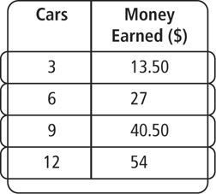
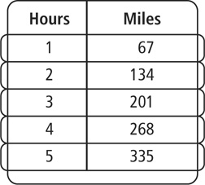
- A worker finds that it takes 9 tiles to cover one square foot of floor. Make a table and draw a graph to show the relationship between the number of tiles and the number of square feet of floor covered. How many square feet of floor will be covered by 261 tiles?

Tell whether the given equation has the ordered pair as a solution.

17. y = 3x − 2; (−1, −5) | 18. y = −5x + 7; (1, −2) | 19. y = −4x − 3; (1, 1)
20. y = 13 + 6x; (−1, 7) | 21. | 22.
- Writing Explain what inductive reasoning is. Include in your explanation what inductive reasoning can be used for.
Prentice Hall Gold Algebra 1 • Teaching Resources
Copyright © by Pearson Education, Inc., or its affiliates. All Rights Reserved.
84

