Name
Class
Date

1-9
Patterns, Equations, and Graphs
Practice
Form K

Tell whether the given ordered pair is a solution of the equation.

1. y = x + 8; (–3, 5) | 2. y = x – 6; (4, –2)
5 = –3 + 8
3. y = x – 12; (3, 15) | 4. y = –7x; (–3, –21)
5. y = x + 8; (–1, 7) | 6. y = –x + 4; (–5, –1)
Use a table, an equation, and a graph to represent each relationship.

7. Zachary sells pencils for $0.15 each. | 8. Jerry earns $40 per hour.
9. Stanton can mow 3 more lawns  per day than Farah. | 10. Beth has been with the company  6 years longer than Paco.

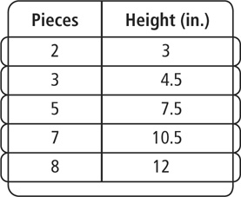
- The table shows the height in inches of a stack of lumber. Draw a graph of the situation. What is the height of a stack of 25 pieces of lumber?

Prentice Hall Foundations Algebra 1 • Teaching Resources
Copyright © by Pearson Education, Inc., or its affiliates. All Rights Reserved.
85

Name
Class
Date

1-9
Patterns, Equations, and Graphs
Practice (continued)
Form K

Use the table to write an equation and answer the question.
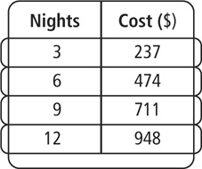
- The table shows the cost of staying at a certain hotel. How much does 30 nights cost?
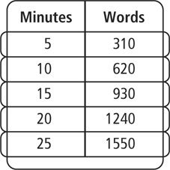
- The table shows the number of words a secretary types in terms of minutes. How many words can he type in 60 minutes?

Tell whether the given ordered pair is a solution of the equation.

14. y = –6x + 1; (–1, –5) | 15.
16. y = –0.1x + 5; (10, 4) | 17. y = 0.25 + 5.5x; (–1, –5.75)
18. | 19.
- Writing Explain how you can use an equation to make predictions about a particular relationship.
Prentice Hall Foundations Algebra 1 • Teaching Resources
Copyright © by Pearson Education, Inc., or its affiliates. All Rights Reserved.
86

