Name
Class
Date

1-9
Patterns, Equations, and Graphs
Reteaching

Tables, equations, and graphs are some of the ways that a relationship between two quantities can be represented. You can use the information provided by one representation to produce one of the other representations; for example, you can use data from a table to produce a graph. You can also use any of the representations to draw conclusions about the relationship.

Are (2, 11) and (5, 3) solutions of the equation y = 3x + 5?
For each ordered pair, you can substitute the x- and y- coordinates into the equation for x and y and then simplify to see if the values satisfy the equation.

For (2, 11): |  | For (5, 3):
11 = 3(2) + 5 | Substitute for x and y. | 3 = 3(5) + 5
11 = 11 | Multiply and then add. | 3 ≠ 20
Since both sides of the equation have the same value, the ordered pair (2, 11) is a solution of the equation y = 3x + 5. Since the two sides of the equation have different values, the ordered pair (5, 3) is not a solution of the equation y = 3x + 5.


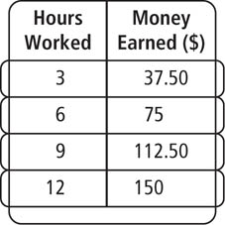
The table shows the relationship between the number of hours Kaya works at her job and the amount of pay she receives. Extend the pattern. How much money would Kaya earn if she worked 40 hours?

Method 1: Write an equation.
y = 12.50x |  | Kaya earns $12.50 per hour.
= 12.50(40) |  | Substitute 40 for x.
= 500 |  | Simplify.
 | She would earn $500 in 40 hours.

Method 2: Draw a graph.
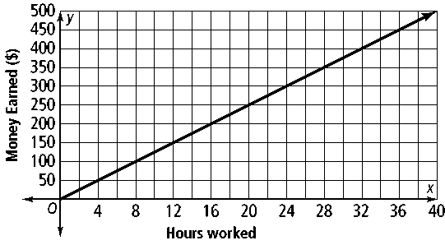
She would earn $500 in 40 hours.

Prentice Hall Algebra 1 • Teaching Resources
Copyright © by Pearson Education, Inc., or its affiliates. All Rights Reserved.
89

Name
Class
Date

1-9
Patterns, Equations, and Graphs
Reteaching (continued)

Exercises
Tell whether the equation has the given ordered pair as a solution.

1. y = x – 7; (2, –5) | 2. y = x + 6; (–5, 11) | 3. y = –x + 1; (–1, 0)
4. y = –5x; (–3, –15) | 5. y = x – 8; (7, –1) | 6.
Use a table, an equation, and a graph to represent each relationship.

7. Tickets to the fair cost $17. | 8. Brian is 5 years older than Sam.

Use the table to draw a graph and answer the question.
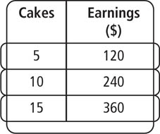
9. The table shows Jake’s earnings for the number of cakes he baked. What are his earnings for baking 75 cakes?
Use the table to write an equation and answer the question.

10. The table shows the number of miles that Kate runs on a weekly basis while training for a race. How many total miles will she have run after 15 weeks?
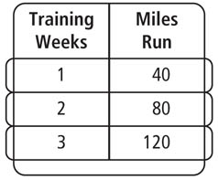

11. The table shows the amount of money Kevin receives for items that he sells. How much will he earn if he sells 30 items?
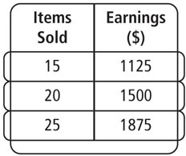

Prentice Hall Algebra 1 • Teaching Resources
Copyright © by Pearson Education, Inc., or its affiliates. All Rights Reserved.
90

