Name
Class
Date

1-9
Patterns, Equations, and Graphs
Additional Vocabulary Support

For Exercises 1–4, draw a line from each word or phrase in Column A to its definition in Column B. The first one is done for you.

 |  | Column A |  | Column B
1. | inductive reasoning |  | to increase
2. | solution of a two variable equation |  | reasoning from cause to effect
3. | extend |  | process of reaching a conclusion based on an observed pattern
4. | deductive reasoning |  | any ordered pair (x, y) that makes the equation true
For Exercises 5-8, draw a line from each word or phrase in Column A to its match in column B based on the situation described. The first one is done for you.
Sophia made one necklace. Each additional hour she can make two more.

 | Column A | Column B
5. | table | y = 2x + 1
6. | equation | When x equals 4, y will equal 9.
7. | ordered pair | (1, 3)
8. | prediction | 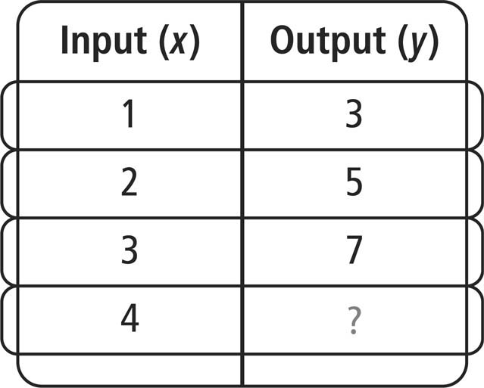
Prentice Hall Algebra 1 • Teaching Resources
Copyright © by Pearson Education, Inc., or its affiliates. All Rights Reserved.
81

