Lima Waziri

Montgomery College

Assignment 5 Implementation

Course: CMSC204

Instructor : David Kujit

April 9, 2023

**Assignment 5 Implementation**

**Learning Experience:**

During Assignment 5, I learned how to use recursion with linked trees and implement it. It was interesting to see how these two concepts can work together.

One thing I struggled with when working on this assignment was the recursive methods. I thought that I knew how to properly implement them, but I still struggled with it. And because I had a hard time with the recursive methods in MorseCodeTree class I couldn’t move to the next step so it kind of delayed me in finishing this assignment.

One thing I will do differently for the next assignment will be that I will practice the concepts beforehand so that I am ready and won’t struggle with it.

**Final UML and GitHub:**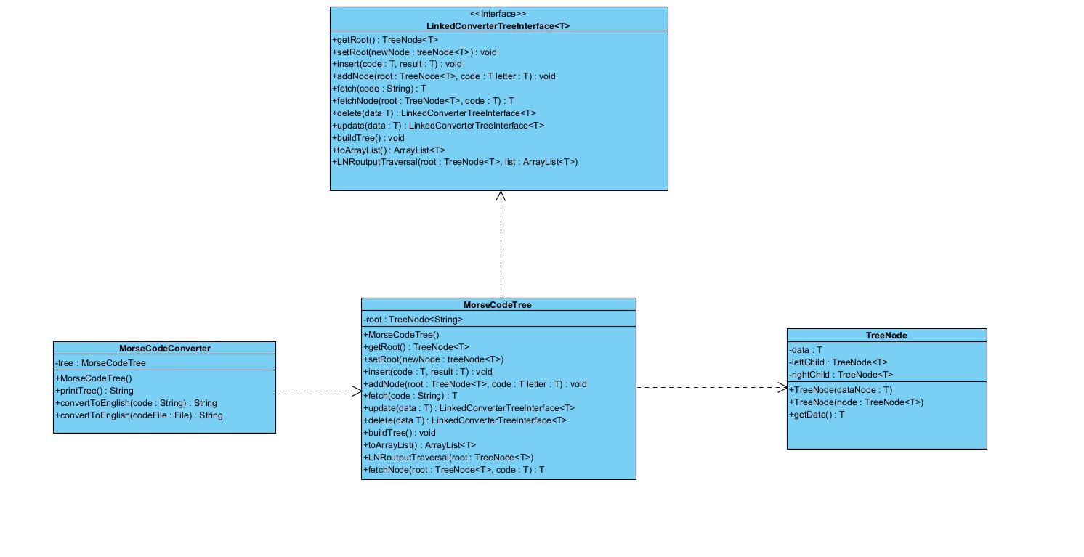

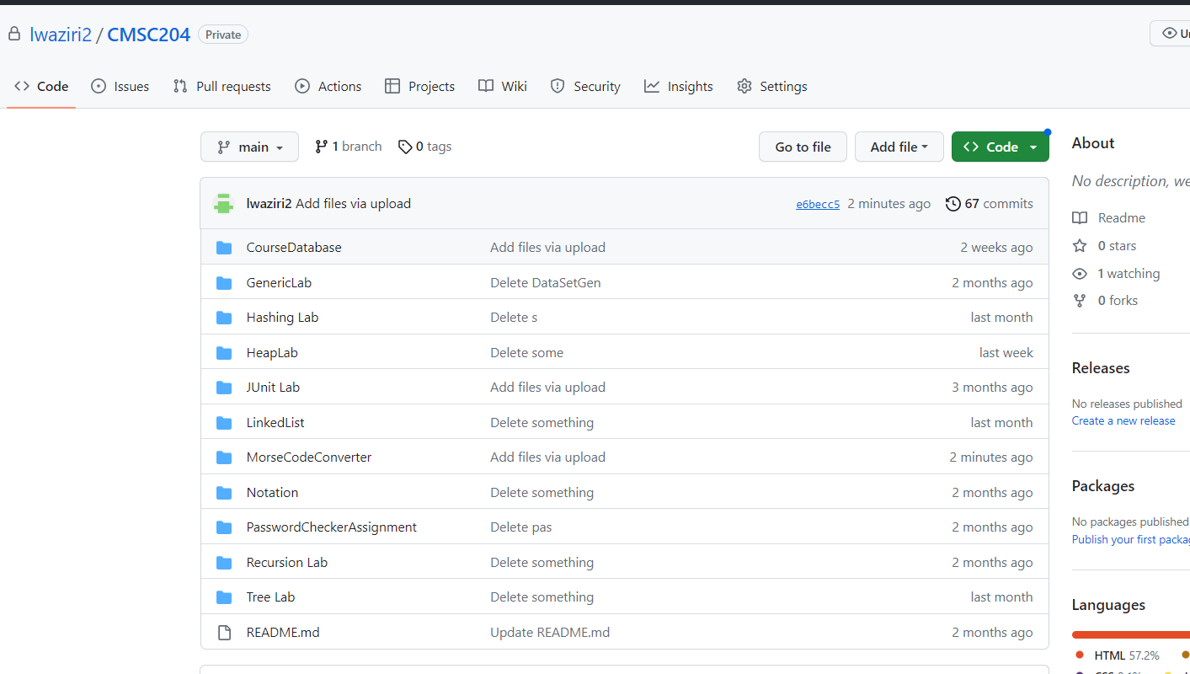

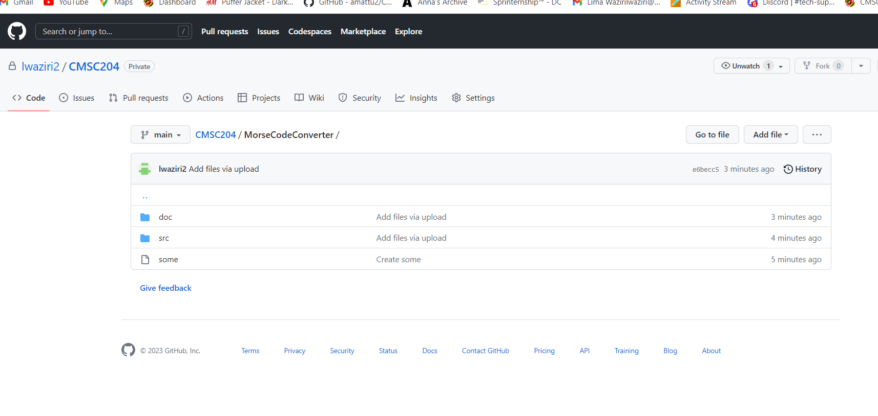

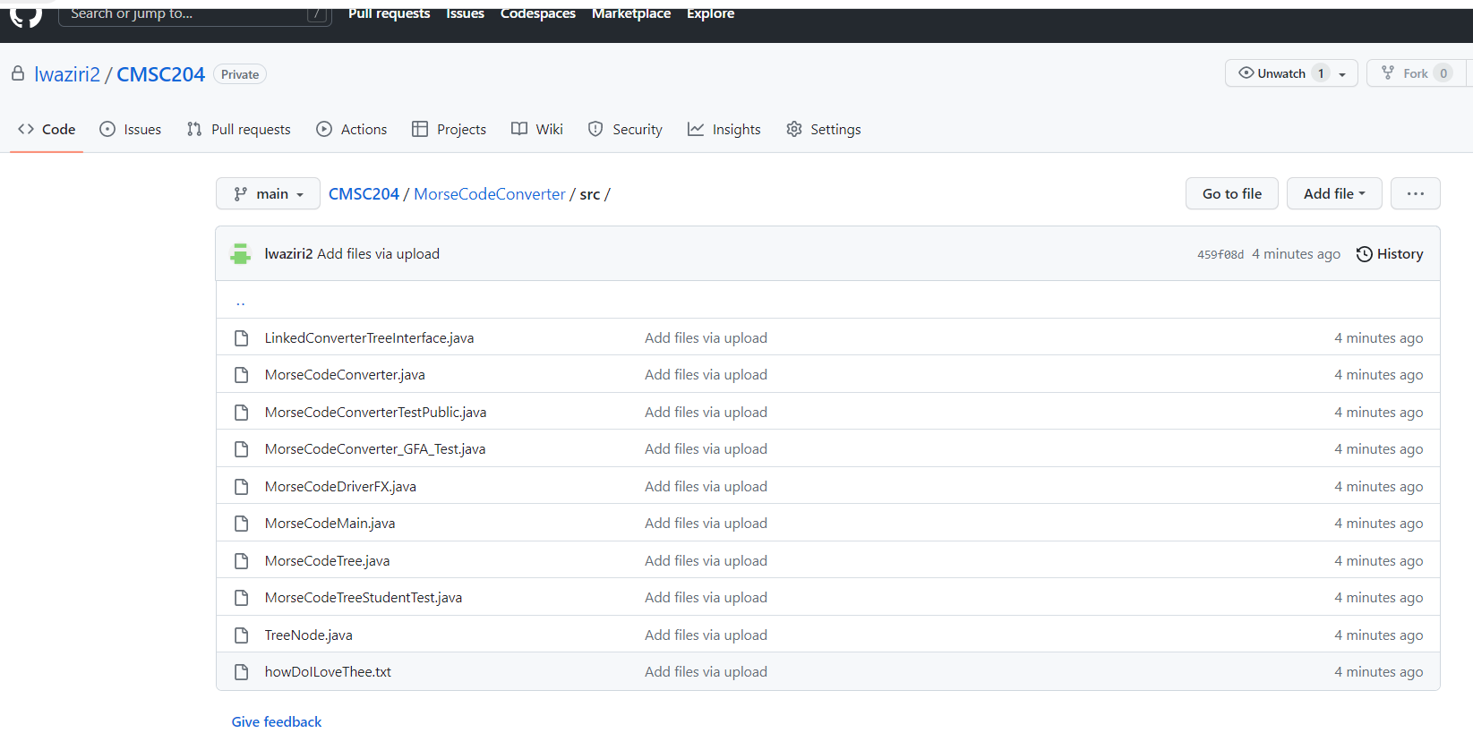

**JUnit Tests:**

