Traffic Lights System Report

Wenbin Lin

This is a mini project for the embedded system. The project is about a smart traffic light system using arduino uno board. The following technology is used:

1. Input/output: to light the LED and read the data from the photoresistor and the status of the button

2. Timer: to time the traffic light changes

3. Interrupt: to trigger the emergency vehicles

4. PWM: to control the brightness of the traffic lights and the LCD

5. ADC: to change the analog data from the photoresistor to digital data

6. Serial communication: to use the USART protocol to receive the data from arduino uno, and display the status and real-time energy consumed of the traffic system

7. LCD Display: to display the traffic status and show the countdown of the timer

8. django: to show the traffic light status and the real-time energy consumed on the html page

9. redis: to store the countdown data and traffic light status

The project is a smart traffic lights system. It use the Arduino board to control the traffic lights. In normal case, it will start with green light for 60 seconds to let the vehicle pass, then yellow light for 3 seconds to alert the vehicle it will turn to red. Then the traffic lights will turn red to let the passenger pass. Then the emergency vehicle can pass quickly. Meanwhile there is a LCD can display the vehicle status and also show the countdown of the lights. It is easy to let the people to understand the traffic light status. Moreover, the system can change the brightness according to the brightness of the environment. There is a light sensor can detect the brightness of the environment. And the brightness of the LED and LCD will change the brightness by the data reading from the sensor. There is a webpage in Django framework display the traffic lights status and the countdown of them. Also it will display the real-time energy consumption of the traffic light system.

For the energy consumption, I don’t use the resistors to fix the voltage for leds. The PWM technology is used to control the voltage. The brightness of the LCD backlight is also adjusted using PWM. Meanwhile, the LED and LCD’s brightness is automatically controlled by the brightness of the environment. The brighter of the environment, and the brighter of the LED and LCD. When it is the evening or night, it can save the energy.

For the energy consumption, the button circuit and the light sensor circuit only consume very little energy, and it can be ignored. Most of the energy is consumed by the LED and the LCD. For the LED, the typical current is 15mA, and the ,minimum voltage is 1.8V, the minimum power consumption is 0.027W. And the maximum voltage is 3.0V, the maximum power consumption is 0.045W. The voltage is determined by the brightness of the environment. For the LCD, typical power consumption contains three parts. First part is display section power consumption, typically is 5V×2mA=0.01W. Second part is backlight power consumption, full power consumption is 5V×15mA=0.075W. But this part can be change by the PWM technology to change the brightness. The third part is control circuit power consumption, typically is 5V×0.5mA=0.0025W. So we use the variant brightness for the value reading from the light sensor, the real-time energy consumption is 0.027+0.01+0.0025+(0.045-0.027+0.075)\*brightness/1024.

Also if there are any emergency vehicles, press the button to trigger the emergency status to let the emergency vehicles pass.

For the display part, I use the Django framework. It can receive the data from the Arduino uno board. And the data contains the status of the traffic lights and the brightness of the environment. When the program receives the data, it will calculate the status of the traffic lights, how long it left and also the real-time energy consumption according to the brightness. And the data after calculating will be stored in redis. The html page will request the data show in the page. So the status of the traffic lights will be sync to the html, and the staff can check the traffic lights without be at the traffic lights.

LCD displays the status of the vehicles and the countdown. The following picture shows the main feature of the project.

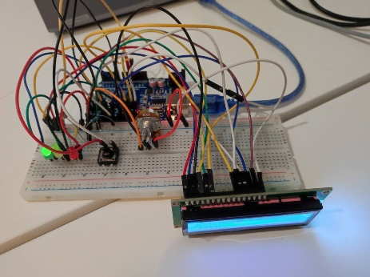

Figure1:Arduino board figure2:LCD

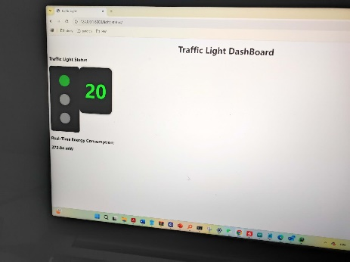

Figure3:web page figure4: bright environment real-time energy

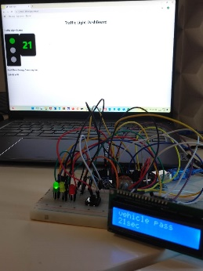

Figure5:dark environment real-time energy figure6：green light

电脑游戏画面

Figure7:red light Figure8:yellow light

Figure9:emergency

Also there are some several sides can be improved. Such as we can not controlled the traffic lights by sending a request from the html page. It just because the serial port can only support one progress to use, I have one progress always listening to the com port. If we use the wifi or Bluetooth to communicate with computer, it can be solved. Also, we can add some functionality to increase or decrease after using wifi or Bluetooth for communication. The html page can display much more information such as camera video if we add camera to it. I will try to improve in further future if I have the opportunity.