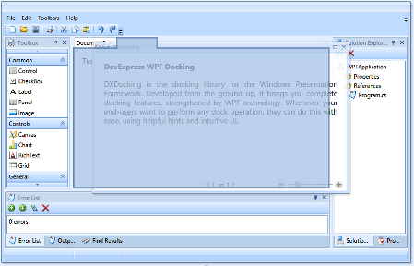

DockLayoutManager is a unique component that simultaneously provides docking and layout functionalities. So, you can easily build a sustainable UI with dock panels and documents, and at the same time have the capability to consistently arrange controls within dock panels. This is all implemented in one DockLayoutManager component.

