CS631: Fall 2017: Deliverable 3

Group 2: Zhenbo Qiao, Mike Lan, Leon Cheung

**Library Catalog: PRINTOUT OF PROGRAM**

**LOGIN**

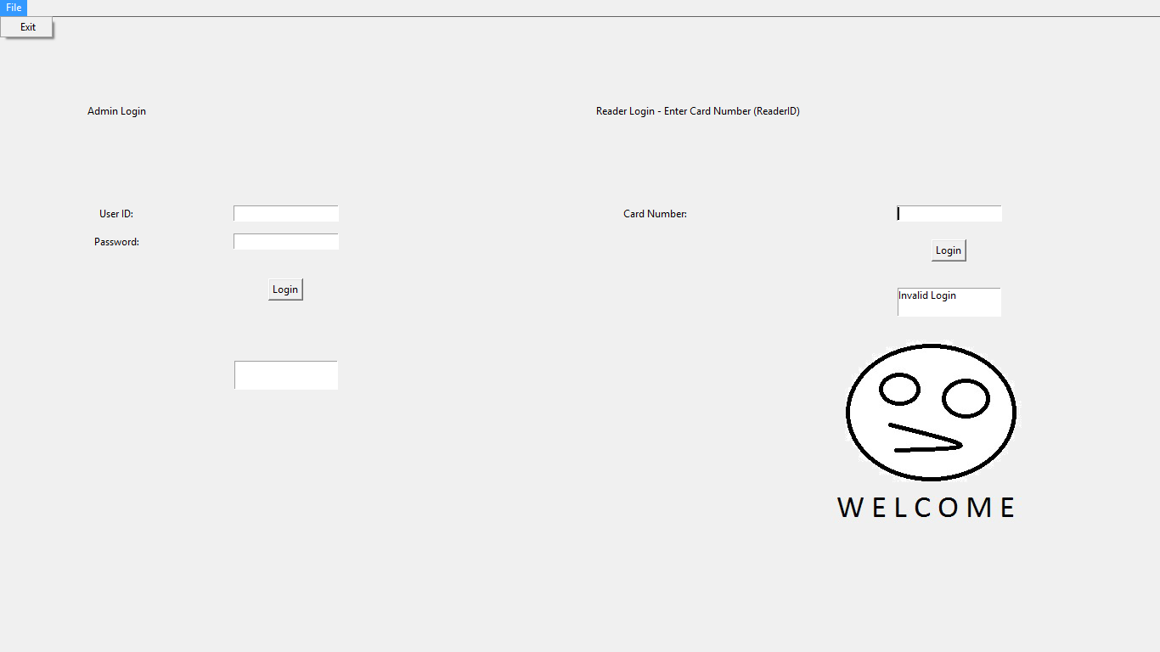

**(READER/ADMIN) SEARCH: VIEW ALL**

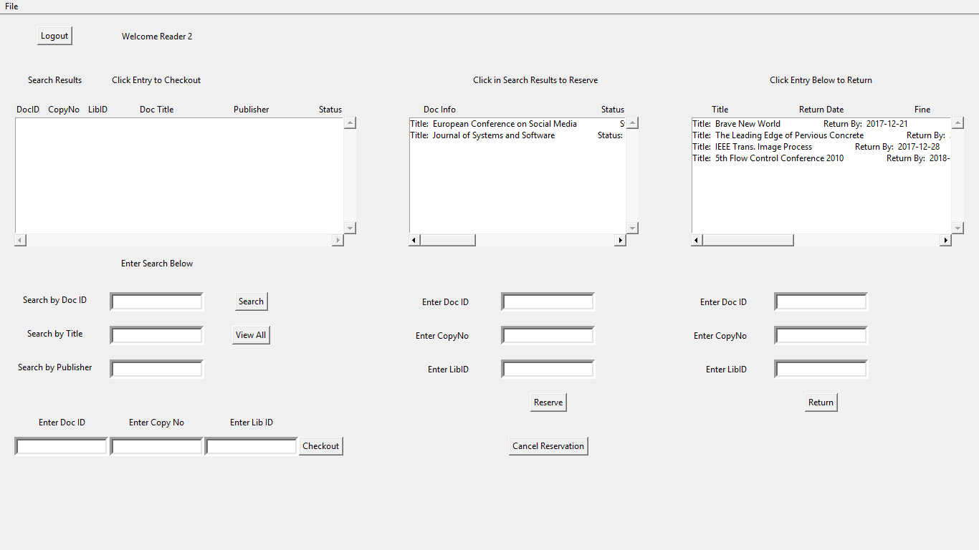 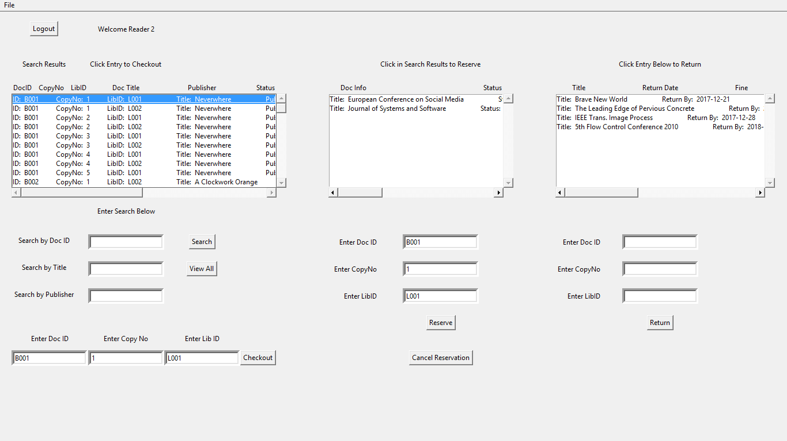

**READER: CHECKOUT FROM RESERVE**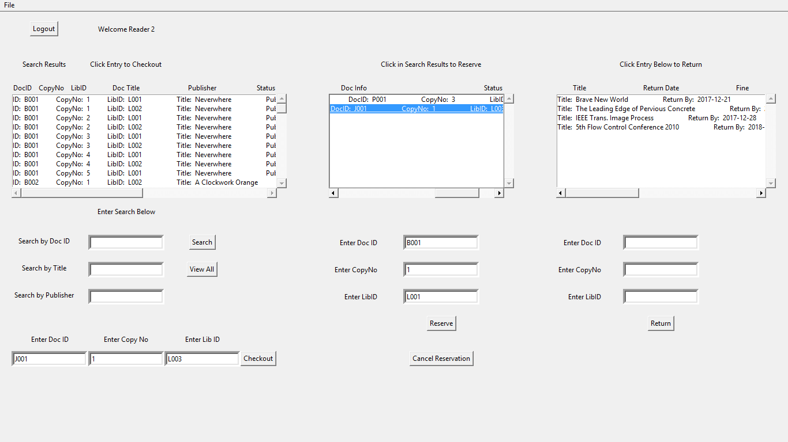 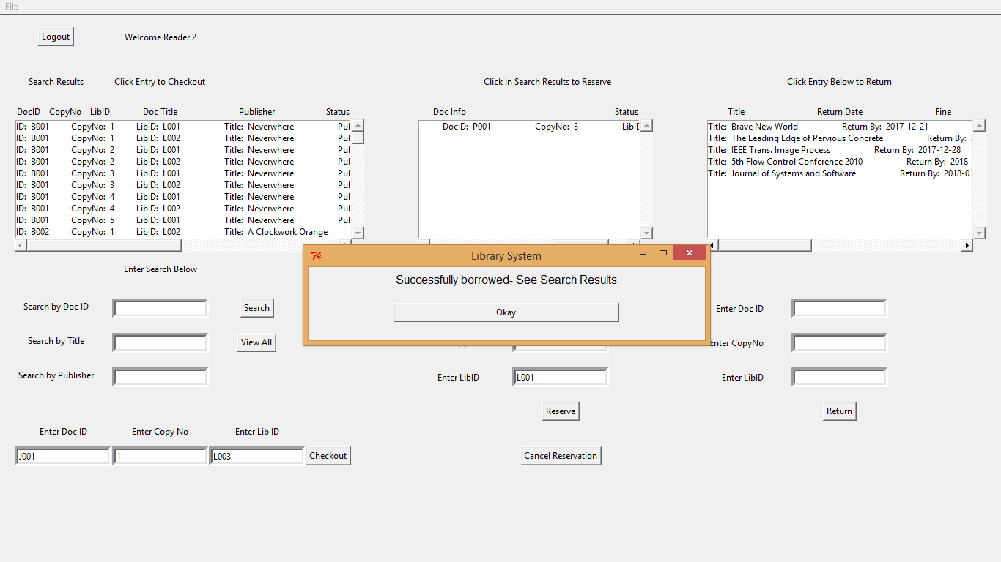

**CANCEL RESERVATION AUTO DUE TO TIME LIMITS / MANUALLY**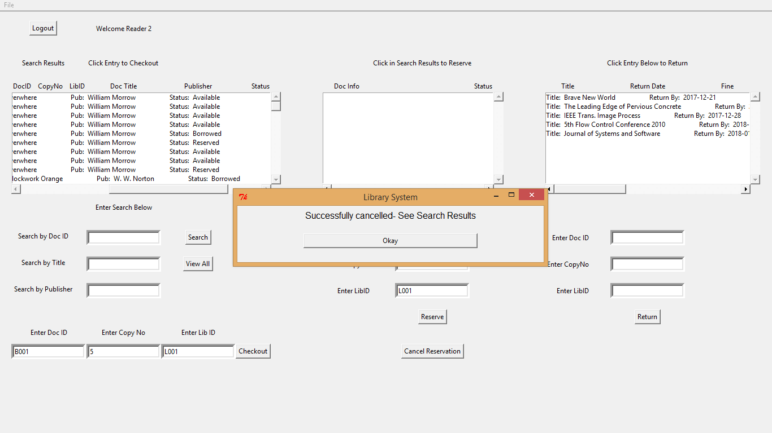

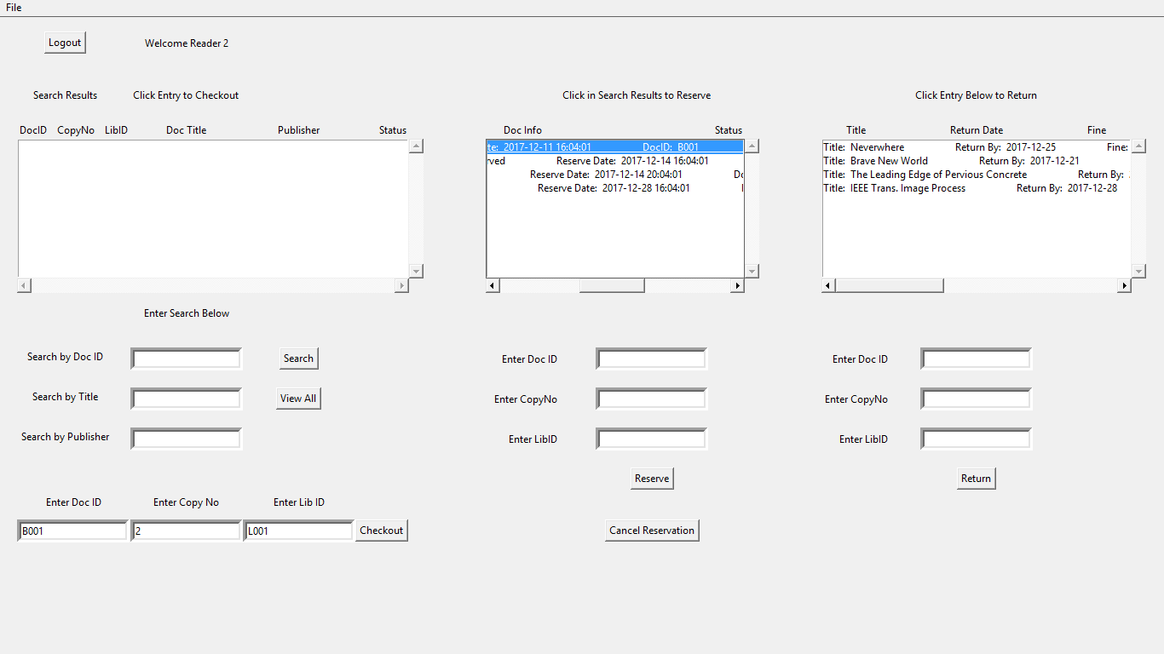 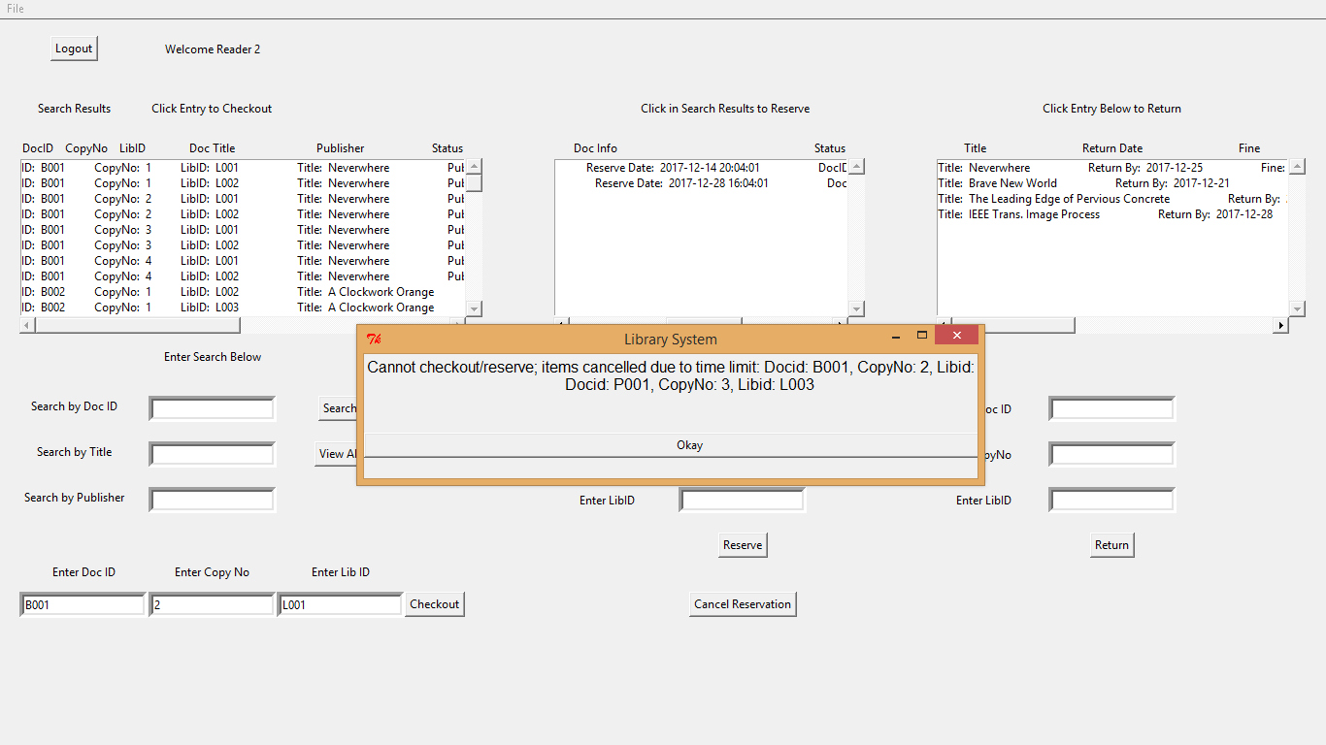

**READER: RETURN ITEM**

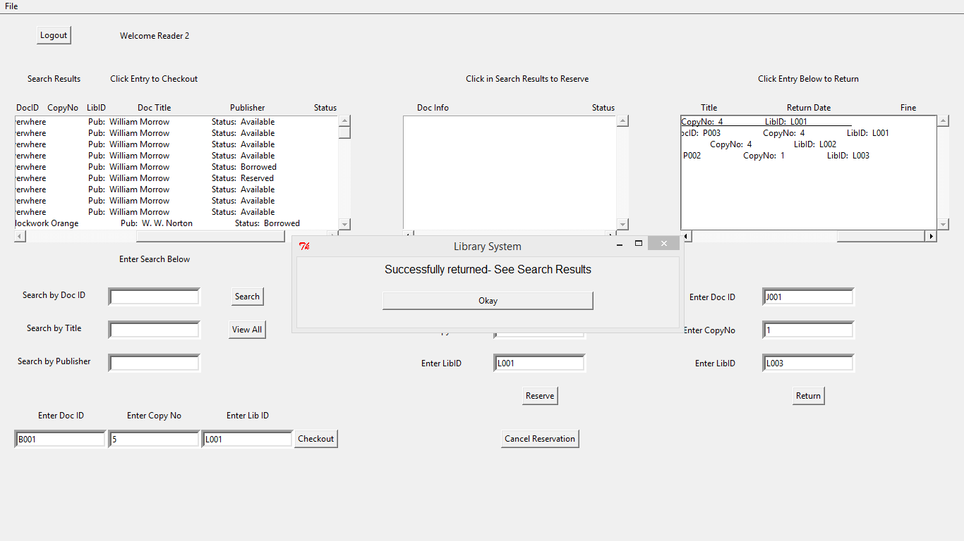

**ERROR MESSAGES**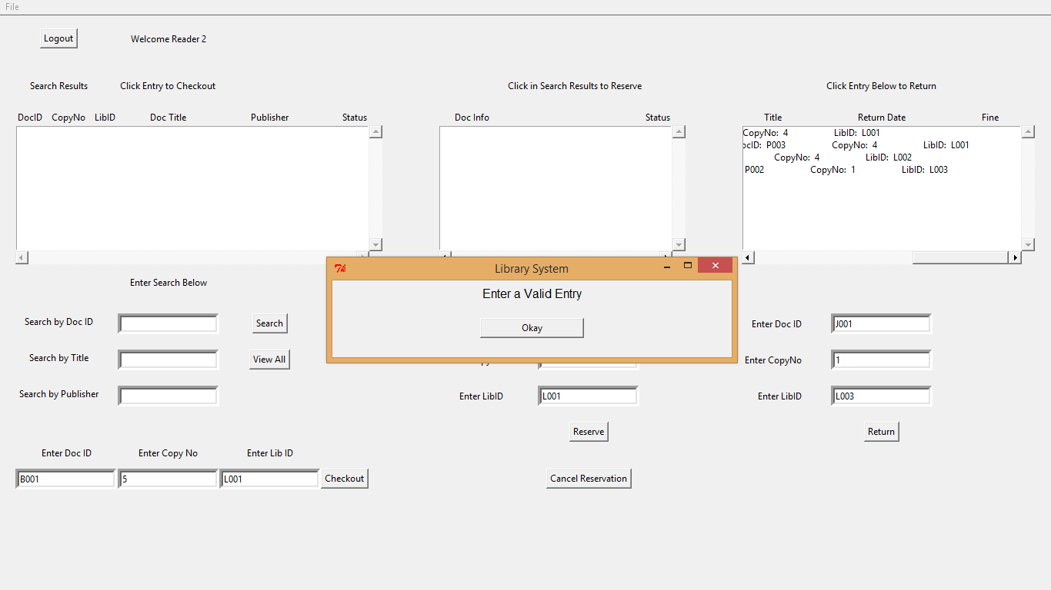 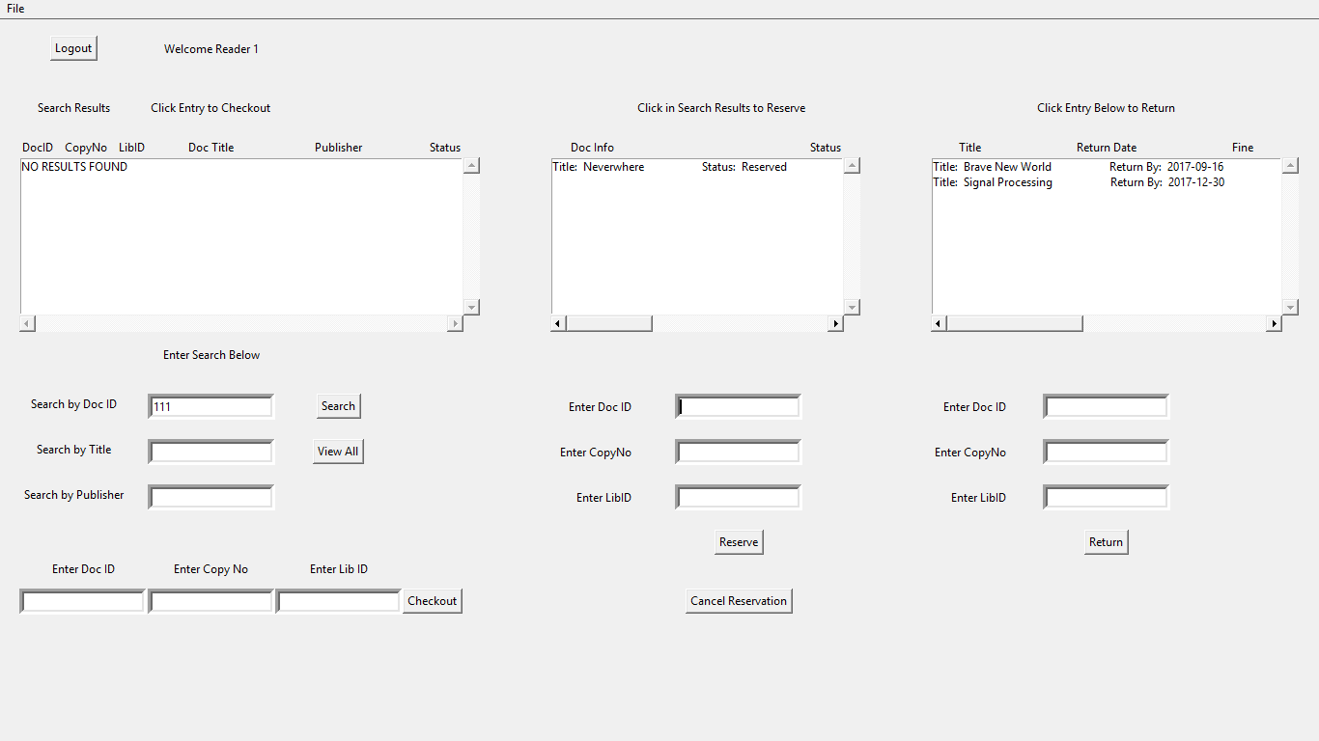

**ADMIN: ADD DOC**

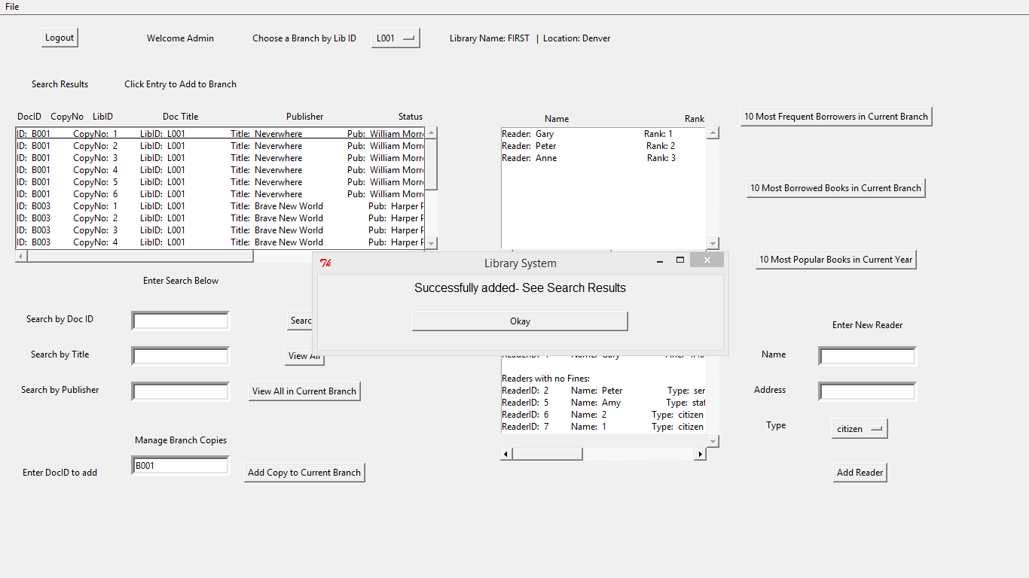

**ADMIN: CHANGE BRANCH**

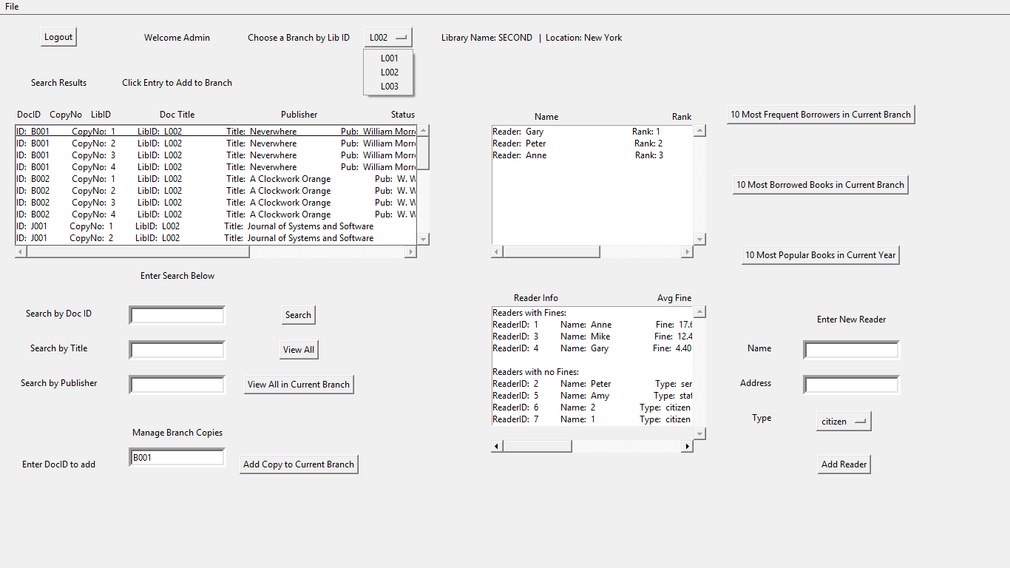

**ADMIN: ADD READER**

