output: word_document: reference_docx: word_styles.docx editor_options: chunk_output_type: inline

Crime in schools Crime in Mexico schools SNA and Crime - previous methods and descriptions My methods Results conclusion

## Error in get(genname, envir = envir) : object 'testthat_print' not found

## create network, nodes and edges

Creating a network for analysis actualizes connections between nodes and edges. These entities are used to create network objects that represent adjacency matrices, or sociomatricies, which are square matricies with nodes as the network’s rows and columns and the binary connections (0, 1) as their edges. At its simplist connection, for example, a link between two nodes is represented by a 1, 0 otherwise. Sometimes networks can be directed where a node sends information to a recieving node, but the information is not reciprocated. In our case, our data is undirected and represents two groups, crimes and schools. ADD DESCRIPTION OF SOCIOMATRIX?? Density of the network = 0.03590093

## [1] 126

## categoria_ delito escuela_nivel calle_hech   
## Min. : 1.000 Min. : 1.00 Min. : 1.0 Min. : 1   
## 1st Qu.: 1.000 1st Qu.: 38.00 1st Qu.:15.0 1st Qu.: 414   
## Median : 1.000 Median : 89.00 Median :20.0 Median : 805   
## Mean : 3.463 Mean : 75.14 Mean :19.6 Mean : 805   
## 3rd Qu.: 2.000 3rd Qu.:107.00 3rd Qu.:20.0 3rd Qu.:1195   
## Max. :14.000 Max. :126.00 Max. :37.0 Max. :1589   
##   
## colonia_he alcaldia_h escuela domicilio   
## Min. : 1.0 Min. : 1.00 Min. : 1 Min. : 1.0   
## 1st Qu.:171.0 1st Qu.: 4.00 1st Qu.: 537 1st Qu.: 524.2   
## Median :362.0 Median : 7.00 Median :1060 Median :1053.5   
## Mean :353.1 Mean : 7.69 Mean :1054 Mean :1052.8   
## 3rd Qu.:537.0 3rd Qu.: 9.00 3rd Qu.:1576 3rd Qu.:1580.8   
## Max. :709.0 Max. :16.00 Max. :2087 Max. :2106.0   
## NA's :35

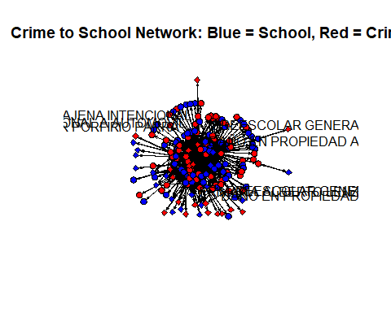

## Centrality Measures

Looking at the centrality measures of a network helps to identify various ways in which a node is connected to other nodes. There are 3 basic types of centrality measures including degree centrality, closeness centrality, and betweenness centrality. Degree centrality measures the number of connections a node is to other nodes within the network (Wasserman, Faust, 1994). Closeness centrality meausures how close a node is to all the other nodes in the network based on their distance apart, or how long it takes to get from one node to another. Betweenness centrality measures how many nodes a particular node sits between, for example, how central is this node for facilitating information flow within a network, are they an essential stop or can they be skipped?

The degree centrality for the top three school nodes is, PRIMARIA GENERAL (d = 198) translates to “public elementary school”, PREESCOLAR GENERAL(d = 160) translantes to “public preschool”, and SECUNDARIA GENERAL (d = 116) translates to “public middle school”. The degree centrality for the top crime nodes is VIOLENCIA FAMILIAR (d = 30) translates to “domestic violence”, ROBO A TRANSEUNTE EN VIA PUBLICA CON VIOLENCIA (d = 28) translates to “mugging”, ROBO A NEGOCIO SIN VIOLENCIA (d = 24) translates to “non-violent business robbery”, and AMENAZAS (d = 24) translates to “threats.” With this information we can assume that public schools have a higher number of crimes in their neighborhood, and the top crimes in a school’s a 150m radius are domestic “violence”, “mugging”, “non-violent business robbery”, and “threats.” Overall, the top ten nodes with the highest degree measures were schools, which is inline with the type of data we are using as schools in the center of their own 150m radius.

The closeness centrality measures for the top three school nodes are “public elementary school”, (c = 0.64), “public preschool” (c = 0.55), and “public middle school”(c = 0.47). The top crime centrality measure are “domestic violence” (c = 0.50), “mugging” (c = 0.49), “business robbery” (c = .048), and “threats” (c = 0.48). The top school and crime centralities are the same, but their order of greater closeness starts with “public elementary school”, “public preschool”, “domestic violence”, and then “mugging”. We can assume that these top nodes happen in close proximity to each other.

The top betweenness centrality measures for school nodes are also “public elementary school” (b = 11055.1143),“public preschool” (b = 6530.8892), and “public middle school” (b = 3473.3928). The top betweenness scores for crime slightly changed and their measures are, “domestic violence” (b = 1406.7534), “mugging” (b = 977.0407), and ROBO DE VEHICULO DE SERVICIO PARTICULAR SIN VIOLENCIA (b = 889.8290) translates to “non-violent theft of a private vehicle”. The top 5 betweeness nodes overall are schools, meaning that schools are a central componenet for crimes in the neighborhood. This is expected because of the nature of the data and how the radius around the schools was set-up to collect the crime data.

## [1] "Degree Centrality: Crimes"

## ROBO DE ACCESORIOS DE AUTO   
## 22   
## ROBO DE VEHICULO DE SERVICIO PARTICULAR SIN VIOLENCIA   
## 22   
## AMENAZAS   
## 24   
## ROBO A NEGOCIO SIN VIOLENCIA   
## 24   
## ROBO A TRANSEUNTE EN VIA PUBLICA CON VIOLENCIA   
## 28   
## VIOLENCIA FAMILIAR   
## 30   
## SECUNDARIA PARA TRABAJADORES   
## 36   
## LACTANTE, MATERNAL Y PREESCOLAR   
## 40   
## TELESECUNDARIA   
## 48   
## INTERVENCION TEMPRANA, PREESCOLAR, PRIMARIA Y CAPACITACION LABORAL ESPECIAL   
## 52   
## ESCUELA SECUNDARIA TECNICA   
## 82   
## PREESCOLAR GENERAL CON SERVICIO ASISTENCIAL   
## 100   
## SECUNDARIA GENERAL   
## 116   
## PREESCOLAR GENERAL   
## 160   
## PRIMARIA GENERAL   
## 198

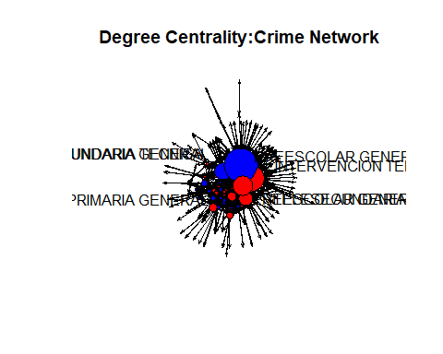

## numeric(0)

## [1] "Closeness Centrality: Crimes"

## ROBO DE ACCESORIOS DE AUTO   
## 0.4723032   
## ROBO DE VEHICULO DE SERVICIO PARTICULAR SIN VIOLENCIA   
## 0.4723032   
## SECUNDARIA GENERAL   
## 0.4736842   
## ROBO DE OBJETOS   
## 0.4750733   
## ROBO A TRANSEUNTE DE CELULAR CON VIOLENCIA   
## 0.4778761   
## AMENAZAS   
## 0.4807122   
## ROBO A NEGOCIO SIN VIOLENCIA   
## 0.4807122   
## ROBO A TRANSEUNTE EN VIA PUBLICA CON VIOLENCIA   
## 0.4864865   
## VIOLENCIA FAMILIAR   
## 0.4894260   
## PREESCOLAR GENERAL   
## 0.5510204   
## PRIMARIA GENERAL   
## 0.6428571

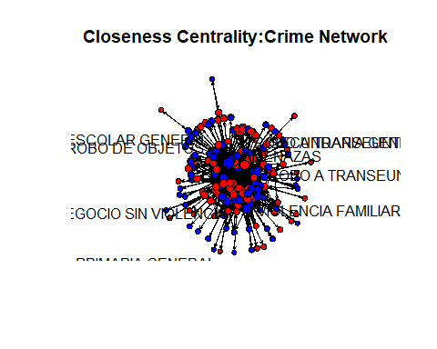

## numeric(0)

## [1] "Betweeness Centrality: Crimes"

## ABUSO DE CONFIANZA   
## 723.3710   
## ROBO A REPARTIDOR CON VIOLENCIA   
## 749.4151   
## ROBO DE VEHICULO DE SERVICIO PARTICULAR SIN VIOLENCIA   
## 889.8290   
## TELESECUNDARIA   
## 947.5054   
## ROBO A TRANSEUNTE EN VIA PUBLICA CON VIOLENCIA   
## 977.0407   
## VIOLENCIA FAMILIAR   
## 1406.7534   
## ESCUELA SECUNDARIA TECNICA   
## 1882.7507   
## PREESCOLAR GENERAL CON SERVICIO ASISTENCIAL   
## 2564.4826   
## SECUNDARIA GENERAL   
## 3473.3928   
## PREESCOLAR GENERAL   
## 6530.8892   
## PRIMARIA GENERAL   
## 11055.1143

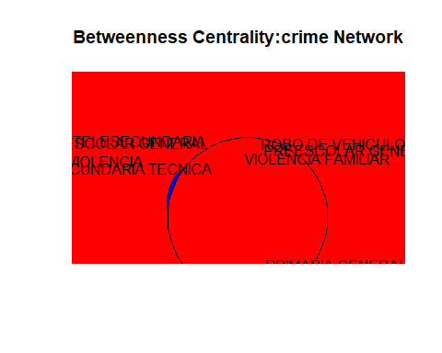

## numeric(0)

## Duality and Bipartite Line Graphs

The network is composed of two sets, crime and schools, where crime can belong to a group of crimes but also to the buffer raduis around a school, and visa vera. Understanding the value of connections within and between particular sets can help understand how a particular school might be connected to a particular crime. Breiger’s duality measures consider the value of ties between a set of individuals and a set of groups (Breiger, 1974). In this case crime can be understood as individuals and schools as groups (side note, an interesting turn of events would be to look at overall crime categories to individual schools and see the difference between these networks). Similar to the set-up of the dataset, Breiger’s axioms help describe the ties between crime and schools, specifically the second axiom of symmetry where two connecting nodes in a membership groups are both connected to each other, instead of one directed connection. Similarly, if two membership groups share a person they are mutually related (Breiger, 1974). In his first axiom Breiger also states, “an axiom that the intersection of any two sets belonging to either class [crime, schools] is contained in the power set of the other class” (Breiger, 1974). Essentially, these two statesments describe how crime nodes and school nodes can be related by similar connecting ties, and the destinction of reflexivity where belonging to a group is relatable and groups relate to their individual members. But what does this mean for crime and schools?

As crimes connected within a school radius we can look further into the notion of duality by using a bipartite netowrk to consider the intersection of these two sets. In thier work on temporal dynamics of bipartite networks, Broccatelli et al use bipartite networks with a temporal aspect to modes covert networks to intersect actors and events across time (Broccatelli, et al., 2016). They implement three steps, an affiliation matrix of the two sets, they generate a line graph projection where edges between individuals are transformed to nodes while excluding redundant ties, and last they further reduce the ties to contain only the edges that connect the individual nodes to the group nodes (Broccatelli, et al., 2016).

## rows cols  
## [1,] 1 7  
## [2,] 1 15  
## [3,] 1 20  
## [4,] 2 15  
## [5,] 2 20  
## [6,] 2 31  
## [7,] 3 1  
## [8,] 3 15  
## [9,] 3 16  
## [10,] 3 20  
## [11,] 3 22  
## [12,] 3 31  
## [13,] 3 32  
## [14,] 3 35  
## [15,] 3 36  
## [16,] 4 7  
## [17,] 4 9  
## [18,] 4 15  
## [19,] 4 16  
## [20,] 4 20  
## [21,] 4 31  
## [22,] 5 16  
## [23,] 5 20  
## [24,] 5 31  
## [25,] 5 32  
## [26,] 6 7  
## [27,] 6 15  
## [28,] 6 16  
## [29,] 6 20  
## [30,] 7 7  
## [31,] 7 9  
## [32,] 7 11  
## [33,] 7 15  
## [34,] 7 16  
## [35,] 7 20  
## [36,] 7 22  
## [37,] 7 27  
## [38,] 7 30  
## [39,] 7 31  
## [40,] 7 32  
## [41,] 7 37  
## [42,] 8 15  
## [43,] 8 20  
## [44,] 8 31  
## [45,] 9 37  
## [46,] 10 20  
## [47,] 11 20  
## [48,] 12 7  
## [49,] 12 15  
## [50,] 12 20  
## [51,] 12 31  
## [52,] 12 37  
## [53,] 13 7  
## [54,] 13 9  
## [55,] 13 15  
## [56,] 13 16  
## [57,] 13 20  
## [58,] 13 31  
## [59,] 14 15  
## [60,] 14 16  
## [61,] 14 20  
## [62,] 15 15  
## [63,] 15 20  
## [64,] 15 31  
## [65,] 15 34  
## [66,] 15 37  
## [67,] 16 9  
## [68,] 16 15  
## [69,] 16 16  
## [70,] 16 20  
## [71,] 16 31  
## [72,] 17 15  
## [73,] 17 16  
## [74,] 18 15  
## [75,] 18 16  
## [76,] 18 20  
## [77,] 19 20  
## [78,] 19 31  
## [79,] 20 31  
## [80,] 21 16  
## [81,] 22 7  
## [82,] 23 7  
## [83,] 23 9  
## [84,] 23 15  
## [85,] 23 20  
## [86,] 24 37  
## [87,] 25 7  
## [88,] 25 9  
## [89,] 25 11  
## [90,] 25 15  
## [91,] 25 16  
## [92,] 25 20  
## [93,] 25 31  
## [94,] 25 37  
## [95,] 26 20  
## [96,] 26 31  
## [97,] 27 15  
## [98,] 27 20  
## [99,] 28 20  
## [100,] 29 15  
## [101,] 30 15  
## [102,] 30 20  
## [103,] 30 31  
## [104,] 31 16  
## [105,] 31 20  
## [106,] 31 31  
## [107,] 32 7  
## [108,] 32 15  
## [109,] 32 16  
## [110,] 32 20  
## [111,] 32 31  
## [112,] 33 7  
## [113,] 33 9  
## [114,] 33 11  
## [115,] 33 15  
## [116,] 33 16  
## [117,] 33 20  
## [118,] 33 31  
## [119,] 33 32  
## [120,] 33 34  
## [121,] 34 11  
## [122,] 35 20  
## [123,] 36 15  
## [124,] 37 7  
## [125,] 37 15  
## [126,] 37 16  
## [127,] 37 20  
## [128,] 38 7  
## [129,] 38 16  
## [130,] 38 20  
## [131,] 39 7  
## [132,] 39 15  
## [133,] 39 16  
## [134,] 39 20  
## [135,] 39 31  
## [136,] 40 20  
## [137,] 41 20  
## [138,] 42 7  
## [139,] 42 20  
## [140,] 43 20  
## [141,] 44 15  
## [142,] 44 20  
## [143,] 44 31  
## [144,] 44 32  
## [145,] 45 7  
## [146,] 45 9  
## [147,] 45 15  
## [148,] 45 20  
## [149,] 45 23  
## [150,] 45 32  
## [151,] 46 20  
## [152,] 46 31  
## [153,] 47 16  
## [154,] 47 20  
## [155,] 47 37  
## [156,] 48 15  
## [157,] 48 20  
## [158,] 48 31  
## [159,] 48 32  
## [160,] 49 7  
## [161,] 49 15  
## [162,] 49 16  
## [163,] 49 20  
## [164,] 49 21  
## [165,] 49 31  
## [166,] 49 32  
## [167,] 49 37  
## [168,] 50 13  
## [169,] 50 20  
## [170,] 51 16  
## [171,] 51 20  
## [172,] 52 7  
## [173,] 52 11  
## [174,] 52 15  
## [175,] 52 16  
## [176,] 52 20  
## [177,] 52 26  
## [178,] 52 30  
## [179,] 52 31  
## [180,] 52 33  
## [181,] 52 37  
## [182,] 53 11  
## [183,] 53 20  
## [184,] 53 31  
## [185,] 53 37  
## [186,] 54 20  
## [187,] 55 16  
## [188,] 55 20  
## [189,] 56 7  
## [190,] 57 7  
## [191,] 58 7  
## [192,] 58 15  
## [193,] 58 16  
## [194,] 58 20  
## [195,] 58 31  
## [196,] 59 4  
## [197,] 59 20  
## [198,] 60 16  
## [199,] 61 15  
## [200,] 61 20  
## [201,] 62 15  
## [202,] 62 31  
## [203,] 63 15  
## [204,] 63 31  
## [205,] 64 15  
## [206,] 64 20  
## [207,] 65 9  
## [208,] 65 31  
## [209,] 66 15  
## [210,] 66 20  
## [211,] 67 7  
## [212,] 67 15  
## [213,] 67 20  
## [214,] 67 29  
## [215,] 68 32  
## [216,] 69 31  
## [217,] 70 11  
## [218,] 70 15  
## [219,] 70 20  
## [220,] 71 7  
## [221,] 71 9  
## [222,] 71 11  
## [223,] 71 15  
## [224,] 71 16  
## [225,] 71 20  
## [226,] 71 30  
## [227,] 71 31  
## [228,] 71 37  
## [229,] 72 20  
## [230,] 73 7  
## [231,] 73 9  
## [232,] 73 11  
## [233,] 73 15  
## [234,] 73 16  
## [235,] 73 20  
## [236,] 73 24  
## [237,] 73 31  
## [238,] 73 37  
## [239,] 74 7  
## [240,] 74 8  
## [241,] 74 9  
## [242,] 74 11  
## [243,] 74 14  
## [244,] 74 15  
## [245,] 74 16  
## [246,] 74 20  
## [247,] 74 31  
## [248,] 74 32  
## [249,] 74 34  
## [250,] 74 37  
## [251,] 75 15  
## [252,] 76 15  
## [253,] 77 7  
## [254,] 77 15  
## [255,] 77 20  
## [256,] 77 31  
## [257,] 78 7  
## [258,] 78 9  
## [259,] 78 15  
## [260,] 78 16  
## [261,] 78 20  
## [262,] 78 22  
## [263,] 78 30  
## [264,] 78 31  
## [265,] 79 9  
## [266,] 79 11  
## [267,] 79 14  
## [268,] 79 15  
## [269,] 79 20  
## [270,] 79 37  
## [271,] 80 20  
## [272,] 80 31  
## [273,] 81 7  
## [274,] 81 15  
## [275,] 81 20  
## [276,] 81 31  
## [277,] 81 37  
## [278,] 82 20  
## [279,] 83 15  
## [280,] 83 20  
## [281,] 84 20  
## [282,] 85 7  
## [283,] 85 9  
## [284,] 85 15  
## [285,] 85 16  
## [286,] 85 20  
## [287,] 85 31  
## [288,] 85 33  
## [289,] 85 37  
## [290,] 86 16  
## [291,] 87 15  
## [292,] 87 20  
## [293,] 88 15  
## [294,] 89 6  
## [295,] 89 15  
## [296,] 89 16  
## [297,] 89 20  
## [298,] 89 25  
## [299,] 89 31  
## [300,] 89 34  
## [301,] 89 37  
## [302,] 90 16  
## [303,] 90 20  
## [304,] 91 20  
## [305,] 91 31  
## [306,] 91 32  
## [307,] 92 7  
## [308,] 92 9  
## [309,] 92 11  
## [310,] 92 14  
## [311,] 92 15  
## [312,] 92 16  
## [313,] 92 20  
## [314,] 92 26  
## [315,] 92 31  
## [316,] 92 32  
## [317,] 92 37  
## [318,] 93 15  
## [319,] 93 16  
## [320,] 93 20  
## [321,] 94 15  
## [322,] 95 15  
## [323,] 96 2  
## [324,] 96 7  
## [325,] 96 9  
## [326,] 96 11  
## [327,] 96 15  
## [328,] 96 16  
## [329,] 96 20  
## [330,] 96 22  
## [331,] 96 26  
## [332,] 96 28  
## [333,] 96 31  
## [334,] 96 32  
## [335,] 96 33  
## [336,] 96 37  
## [337,] 97 15  
## [338,] 97 16  
## [339,] 97 20  
## [340,] 97 31  
## [341,] 98 11  
## [342,] 98 15  
## [343,] 98 20  
## [344,] 99 1  
## [345,] 99 2  
## [346,] 99 7  
## [347,] 99 9  
## [348,] 99 11  
## [349,] 99 15  
## [350,] 99 16  
## [351,] 99 20  
## [352,] 99 31  
## [353,] 99 32  
## [354,] 99 34  
## [355,] 100 15  
## [356,] 101 7  
## [357,] 101 15  
## [358,] 102 9  
## [359,] 102 15  
## [360,] 102 16  
## [361,] 102 20  
## [362,] 102 30  
## [363,] 103 11  
## [364,] 103 15  
## [365,] 103 20  
## [366,] 103 31  
## [367,] 104 15  
## [368,] 104 20  
## [369,] 104 31  
## [370,] 104 32  
## [371,] 105 15  
## [372,] 105 20  
## [373,] 106 1  
## [374,] 106 7  
## [375,] 106 9  
## [376,] 106 11  
## [377,] 106 15  
## [378,] 106 16  
## [379,] 106 20  
## [380,] 106 31  
## [381,] 106 32  
## [382,] 106 37  
## [383,] 107 15  
## [384,] 107 16  
## [385,] 107 20  
## [386,] 107 30  
## [387,] 107 31  
## [388,] 107 34  
## [389,] 108 7  
## [390,] 108 8  
## [391,] 108 9  
## [392,] 108 11  
## [393,] 108 15  
## [394,] 108 16  
## [395,] 108 18  
## [396,] 108 20  
## [397,] 108 31  
## [398,] 109 15  
## [399,] 109 20  
## [400,] 110 15  
## [401,] 110 20  
## [402,] 110 31  
## [403,] 110 36  
## [404,] 111 9  
## [405,] 111 15  
## [406,] 111 16  
## [407,] 111 20  
## [408,] 111 31  
## [409,] 112 7  
## [410,] 112 9  
## [411,] 112 15  
## [412,] 112 16  
## [413,] 112 17  
## [414,] 112 19  
## [415,] 112 20  
## [416,] 112 21  
## [417,] 112 30  
## [418,] 112 31  
## [419,] 112 37  
## [420,] 113 7  
## [421,] 113 9  
## [422,] 113 15  
## [423,] 113 16  
## [424,] 113 20  
## [425,] 113 37  
## [426,] 114 15  
## [427,] 114 20  
## [428,] 114 32  
## [429,] 115 20  
## [430,] 115 21  
## [431,] 116 7  
## [432,] 116 15  
## [433,] 116 20  
## [434,] 116 31  
## [435,] 117 7  
## [436,] 117 15  
## [437,] 117 16  
## [438,] 117 20  
## [439,] 118 31  
## [440,] 119 31  
## [441,] 120 16  
## [442,] 120 20  
## [443,] 121 20  
## [444,] 122 7  
## [445,] 122 9  
## [446,] 122 11  
## [447,] 122 12  
## [448,] 122 15  
## [449,] 122 16  
## [450,] 122 20  
## [451,] 122 31  
## [452,] 122 37  
## [453,] 123 15  
## [454,] 123 20  
## [455,] 124 15  
## [456,] 124 20  
## [457,] 124 31  
## [458,] 125 16  
## [459,] 125 20  
## [460,] 126 3  
## [461,] 126 5  
## [462,] 126 7  
## [463,] 126 8  
## [464,] 126 9  
## [465,] 126 10  
## [466,] 126 11  
## [467,] 126 15  
## [468,] 126 16  
## [469,] 126 20  
## [470,] 126 21  
## [471,] 126 31  
## [472,] 126 32  
## [473,] 126 34  
## [474,] 126 37

## [1] "bi-dynamic line graph of school-to-school ties WITHIN crimes"

## S1C7 S1C15 S1C20 S2C15 S2C20 S2C31 S3C1 S3C15 S3C16 S3C20 S3C22 S3C31  
## S1C7 1 0 0 0 0 0 0 0 0 0 0 0  
## S1C15 0 1 0 1 0 0 0 1 0 0 0 0  
## S1C20 0 0 1 0 1 0 0 0 0 1 0 0  
## S2C15 0 1 0 1 0 0 0 1 0 0 0 0  
## S2C20 0 0 1 0 1 0 0 0 0 1 0 0  
## S2C31 0 0 0 0 0 1 0 0 0 0 0 1  
## S3C1 0 0 0 0 0 0 1 0 0 0 0 0  
## S3C15 0 1 0 1 0 0 0 1 0 0 0 0  
## S3C16 0 0 0 0 0 0 0 0 1 0 0 0  
## S3C20 0 0 1 0 1 0 0 0 0 1 0 0  
## S3C22 0 0 0 0 0 0 0 0 0 0 1 0  
## S3C31 0 0 0 0 0 1 0 0 0 0 0 1  
## S3C32 0 0 0 0 0 0 0 0 0 0 0 0  
## S3C35 0 0 0 0 0 0 0 0 0 0 0 0  
## S3C36 0 0 0 0 0 0 0 0 0 0 0 0  
## S3C32 S3C35 S3C36  
## S1C7 0 0 0  
## S1C15 0 0 0  
## S1C20 0 0 0  
## S2C15 0 0 0  
## S2C20 0 0 0  
## S2C31 0 0 0  
## S3C1 0 0 0  
## S3C15 0 0 0  
## S3C16 0 0 0  
## S3C20 0 0 0  
## S3C22 0 0 0  
## S3C31 0 0 0  
## S3C32 1 0 0  
## S3C35 0 1 0  
## S3C36 0 0 1

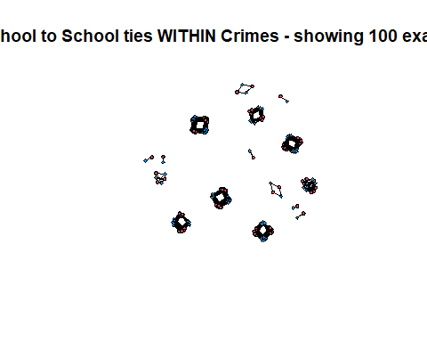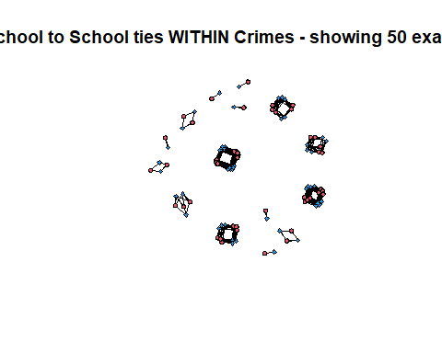

## [1] "Bi-dynamic line graph of time flow of crimes (connecting a crime to the next crime, whatever it is) WITHIN each school"

## S1C7 S1C15 S1C20 S2C15 S2C20 S2C31 S3C1 S3C15 S3C16 S3C20 S3C22 S3C31  
## S1C7 0 1 0 0 0 0 0 0 0 0 0 0  
## S1C15 0 0 1 0 0 0 0 0 0 0 0 0  
## S1C20 0 0 0 0 0 0 0 0 0 0 0 0  
## S2C15 0 0 0 0 1 0 0 0 0 0 0 0  
## S2C20 0 0 0 0 0 1 0 0 0 0 0 0  
## S2C31 0 0 0 0 0 0 0 0 0 0 0 0  
## S3C1 0 0 0 0 0 0 0 1 0 0 0 0  
## S3C15 0 0 0 0 0 0 0 0 1 0 0 0  
## S3C16 0 0 0 0 0 0 0 0 0 1 0 0  
## S3C20 0 0 0 0 0 0 0 0 0 0 1 0  
## S3C22 0 0 0 0 0 0 0 0 0 0 0 1  
## S3C31 0 0 0 0 0 0 0 0 0 0 0 0  
## S3C32 0 0 0 0 0 0 0 0 0 0 0 0  
## S3C35 0 0 0 0 0 0 0 0 0 0 0 0  
## S3C36 0 0 0 0 0 0 0 0 0 0 0 0  
## S3C32 S3C35 S3C36  
## S1C7 0 0 0  
## S1C15 0 0 0  
## S1C20 0 0 0  
## S2C15 0 0 0  
## S2C20 0 0 0  
## S2C31 0 0 0  
## S3C1 0 0 0  
## S3C15 0 0 0  
## S3C16 0 0 0  
## S3C20 0 0 0  
## S3C22 0 0 0  
## S3C31 1 0 0  
## S3C32 0 1 0  
## S3C35 0 0 1  
## S3C36 0 0 0

