<https://www.gamasutra.com/view/feature/134542/a_practical_guide_to_game_writing.php?print=1>

**High Level Narrative Summary**

Post stone-age stone age era. Young man is cast out by his tribe, as they do not understand his mental disorder, Schizophrenia. He must find an herb that rids him of this illness found in the place far from his home. His illness slowly worsens as the story progresses.

**Major Locations**

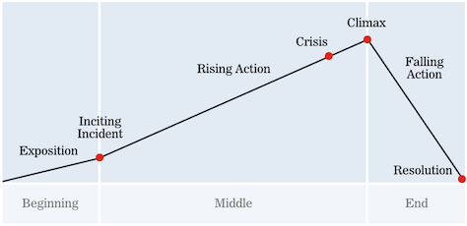

* Tribe village – Exposition
  + Shows the norm of the tribe village.
    - Fish being cooked on spit roasts.
    - Men making tools.
    - Women looking after children and cooking.
    - Player can talk to some NPC’s.
      * As player walks around;
        + They hear voices.
        + Hallucinate, visuals worsen.
    - Player objective to enter hut and sleep.
      * As he enters his mother asks, “Is everything okay?”
      * Player responds, gets to choose dialogue:
        + “I don’t feel so good. I’m going to rest.” – Continue.
        + “I’m okay.” – Stay in village scene.
* Inside hut – Inciting Incident
  + Player wakes up in the middle of the night screaming.
    - Hallucinating visuals.
      * Hut is on fire.
      * The floor is puddled in blood.
  + The visuals return to normal, as he is comforted by his mother.
* Around a camp fire.
  + Shaman points him in the direction of the woods.
    - “You must go. Find the root of the Tutato herb, in the heavens above the clouds. Atop mount Kwar. There you will be rid of your cursed body. Go now.”
  + Shaman sprinkles powder onto the fire as it flames up into a fireball.
  + Player picks up speer and bow and proceeds to walk towards the woods, glancing back.
  + Fades to black.
* Woods – Rising Action.
  + Puzzles.
  + Enemies.
* Cave – Rising Action.
  + Puzzles.
  + Enemies.
* Mountain – Rising Action.
  + Puzzles.
  + Enemies.
* Near the top of the mountain – Crisis.
  + Hallucinations get to their worst.
  + Boss fight.
* Mountain – Climax.
  + Realises that he still needs the herb.
  + Climbs up the mountain face, ‘parkours up’.
  + Finds the herb and eats it.
* Tribe village – Resolution.
  + Arrives back at village and hugs mother.
    - Mother, “It’s been too long.” *A tear falls from her cheek, smiles*
    - Player, *Hugs*
  + Fades to black.

**Detailed Story Outline**

**Story Presentation Plan**

Story will be told through cut-scenes and dialogue from the character, memories, hallucinations.

**Estimated Cut-scene Breakdown**

* Inside hut – Inciting Incident
* Around a camp fire.
* Mountain – Climax.
  + Eating herb. (Animation)
* Tribe village – Resolution.

**Characters**

Nzar (Player).

Shaman.

Nzar’s mother.

Villagers (Small interactions dialogue):

* Man making a speer tip.
* Woman cooking food.

Boss.

Other hallucination enemies.

**Text Database**