**SOFT252 Report (max 2000)**

**1 Functionality (500 words with screenshots)**

**1.1 What does the application do?**

Overview: To assist in creating a developer presence on the internet, in which the admin (developer) can upload/edit/remove portfolio and blog pieces via the dashboard. Communication between the client and the developer with an instant messaging service. Registration and login services, managed by the admin in the dashboard, that includes removing and banning accounts.

**1.2 How do users interact with it?**

**1.2.1 User Accounts**

**Registration**

<Insert Images with steps>

**Login**

<Insert images with steps>

**1.2.2 Manage Blogs**

**Create Blog**

<Insert images with steps>

**Edit Blog**

<Insert images with steps>

**Remove Blog**

<Insert images with steps>

**1.2.3 Manage Portfolio**

**Create Item**

<Insert images with steps>

**Edit Item**

<Insert images with steps>

**Remove Item**

<Insert images with steps>

**1.2.4 Manage Users**

**Remove Users**

<Insert images with steps>

**Ban Users**

<Insert images with steps>

**1.2.5 Instant Messaging**

**Admin/Developer**

<Insert images with steps>

**Client**

<Insert images with steps>

**1.3 What technologies were included?**

* NodeJS
  + Bcryptjs
    - Hashes and salt the user password.
  + Body-parser
    - Used with express to get data from the body of the Document Object Model.
  + Cookie-parser
  + Cucumber
    - Tests Use Cases against the system.
  + Debug
  + Express
    - Handles server side, get and post requests.
  + Express-handlebars
    - The view. Ability to input data from the server into the view without refresh.
  + Express-socket.io-session
    - Used to parse express-session data to socket.io.
  + Express-validator
    - Validates information such as Password length, E-mail verification and adds errors to an array.
  + http-errors
  + Mongodb
    - Database to store user data, messages, blogs and portfolio items.
  + Mongoose
    - MongoDB helper.
  + Morgan
  + Multer
    - Used to store files, accessible in the public folder. The path will be stored in the database for access from the view.
  + Serve-favicon
  + Socket.io
    - Used for user to user communication. Between the admin and users. A many to one relationship.
  + Express-generator
    - Generated express folder structure.
* Data Storage
  + MongoDB
  + Mongoose
  + MongoDB Atlas
    - Used to store collections and documents online.
* Other JavaScript plugins
  + Dotdotdot.js
    - Applied an ellipsis to content after assigned amount of lines. This was implemented into the thumbnails for blogs/portfolios.
* HTML
  + HTML5 Boilerplate
    - Was originally used as the folder structure for the website before switching to express. Some parts of the folder files are still included.
  + FontAwesome
    - A selected of icons with varying sizes.
  + GoogleFonts
    - These fonts are applicable for a good user experience.
  + ARIA
    - The content of this website will be readily available for those with disabilities, making it accessible for all.
* CSS
  + Bootstrap 4
    - Responsive helper classes so that the website can be designed for both mobile and desktop.
* JS
  + jQuery
    - A more efficient form of Javascript.

**2 Requirements (200 words with additional documents in appendices)**

**2.1 Who was the app aimed at?**

The app is aimed specifically for a developer who requires an online presence, a website to share content and update potential clients on work. It is also used as a viewing and messaging service for others considered as potential freelance clientele for the developer. See personas for a more detailed analysis of users.

<Include documentation for Personas>

**2.2 What features were included and why?**

The app needed to include a dashboard so that the admin could create/edit/remove blogs and portfolio items to consistently update the potential clients and interested viewers. The app also needed a Registration and Login service so that 3rd party services could not access the instant messaging service. Rather the users that have a verified E-mail will be granted access. Also, in future adaptions the comment section will be for the users. These users needed to be managed in the dashboard with the Manage Users feature. See Use Cases for a more detailed analysis of features.

Folder destination:

SOFT352 > Node > Cucumber > features > {Feature_Name}.feature (file extension)

**2.3 Functional, e.g., unit, testing**

// Tests here…

**3 Design (200 words with UML diagrams)**

// UML here

**3.1 What processes run where (clients/servers/peers)?**

**3.2 How do the processes interact?**

**3.3 How are the data and code structured?**

**3.4 Why are these structures appropriate?**

**4 Performance (500 words, quantitative and qualitative data, result statistics, diagrams)**

**4.1 How effective were the user interaction mechanisms (User Testing)**

**4.2 How responsive is the application?**

**4.3 How quickly does it load?**

**4.4 How heavy/light is the network load generated?**

**4.5 How robust is your application to failure and unreliable users?**

**4.6 How are users interacting with it?**

**5 Development Process (400 words)**

**5.1 Description of the development process.**

A ScrumBan approach was used for development using various DevOps techniques. ScrumBan is a mix between Scrum and Kanban methodologies, usually utilized in teams, however this iterative approach suited the project well, with consistent functionality testing and changes to the backlog. This was more suitable than the waterfall methodology. This was utilized on Trello, moving items from the backlog, to planning, splitting items into releases, and sprints to be complete within a 2-week period at a time. This gave clear, concise milestones to push for.

After committing and pushing changes to a repository on GitHub, the commit would be detected by Jenkins. Throughout the development process I failed to develop my solution in accordance to the Unit Tests. This was due to the inexperience with the MEAN stack and uncertainty with the items I could test until the very end. However, after the completion of the system, I assigned the tests to Jenkins so that it would build the project depending on the success of Use Case test (Cucumber) and Unit Tests. If these tests failed, I could have revisited my solution.

**5.2 Description of the tools and technologies supporting the development process.**

**5.2.1 Project Management**

* Trello
  + Link: //
  + This tool manages the backlog of items and follow a ScrumBan approach with moveable cards.
* Elegantt for Trello
  + Image: //
  + A plugin used with Trello to create a Product Roadmap. A roadmap provides an overview for release/sprint deadlines.
* Scrum for Trello
  + A plugin used with Trello to support a ScrumBan flow, assigning values to cards for predicted hours, and hours complete.
* Burndown Chart for Trello
  + Image: //
  + A plugin that goes together with Scrum for Trello, creating a burndown chart depending on the values from the hours complete. This predicts the date of completion with a graph demonstrating where the project stands compared to where it should be.
* GitHub
  + Link: //
  + GitHub provides a repository service and version control. Commits and pushes allow the data to be pulled from other systems. Rollback operations can be used to undo previous commits therefore data cannot be lost.
* GitHub for Desktop
  + A Desktop client for GitHub repositories with a user-friendly interface for push and pull requests.
* DiffMerge
  + Used in conjunction with the merge of branches. If there are any conflicts that cannot be resolved by GitHub then changes can be edited with DiffMerge.
* Atom
  + Used to write the source code for HTML, CSS and JavaScript/JQuery.

**5.2.2 Documentation**

* Sketchpad 5.1
  + A creation tool for drawing the user persona images.
* Balsamiq Mockups 3
  + A tool to create sketches/prototypes of the webpage design. Also used to represent a tree hierarchy of pages.
* Microsoft Word & PDF
  + Used for documenting reports/test results/personas/user stories.

**5.2.3 DevOps**

* Jenkins
  + Used as a service to test build against Use Tests (Cucumber) and Unit Tests (JUnit) and build depending on success.
* Ngrok
  + Used to make local IP accessible to public so that Jenkins (Hosted on 127.0.0.1:8080) could read Git Commits using Webhooks.

**6 Personal Reflection (200 words)**

**7 References**

// Reference all tools.

**8 Appendices**

**8.1 Personas**

Persona 1 – Liam

|  |  |
| --- | --- |
| https://i.gyazo.com/bd8f953e089f126b09a7ae64e1382e68.png | **Behaviours**   * Uploads games that he has created to the web. * Blogs about his development process. * Communicates with clientele. * Advertises himself to find more clientele. |
| **Facts**   * Age: 21 * Studies Computing with Games Development. * Lives in England. * Is motivated and organised. | **Goals & Needs**   * Be a known games developer in the industry. * Become a better developer. * Be organized. * Have a professional developer profile. |

Persona 2 – Darren

|  |  |
| --- | --- |
| https://i.gyazo.com/6bf73af82a2faf748b65116565935e8b.png | **Behaviours**   * Browses the web when bored. * Looks for connections via LinkedIn to develop his game idea. * Games a little but not too much. |
| **Facts**   * Age: 25 * Works a full-time job for accountancy. * Has a dog. * Plays Xbox. * Has a LinkedIn account. * Likes money. | **Goals & Needs**   * Communicate with games developers that will make his game. * Review developer blogs and portfolios. * Discover social medias for communication. |

**Identification of Primary Features based on Personas**

**[Persona 1 – Liam]**

**Feature:**

Create Portfolio.

**Why do they need the feature?**

So that the developer can present his work to potential clients.

**Other apps that use this feature:**

<http://www.iamdeantate.com/bioshock/>

Details: Each page on this website has an extensive amount of detail for every title created. This is the main attribute of the website.

<http://www.pierre-stempin.com/>

Details: Linear style portfolio with navigation that scrolls down the page instead of opening a new page. Has all the information and pictures embed into one page.

<http://www.yanknoop.com/>

Details: Simplistic grid design of pictures representing portfolio pieces. Clicking on these leads the user to separate pages showing details of the project, and media.

**Feature:**

Create Blogs.

**Why do they need the feature?**

So that they can organize and advertise their work over the development cycle.

**Other apps that use this feature:**

<https://en.blog.wordpress.com/>

Details: WordPress is known for its modular, customizable approach to blog pages. This has all the features that I require for my own blog page, recent dates, comments, blog posts, search queries etcetera.

<https://brainybeard.co.uk/blog/>

Simple blog layout with linear page layout, with buttons that lead to other pages related to the blog posts.

**Feature:**

Chat communication.

**Why do they need the feature?**

Useful for the client and the admin to communicate with eachother through instant messaging services.

**Other apps that use this feature:**

<https://support.microsoft.com/en-gb/contactus/>

Details: Microsoft Contact Us app connects you to staff after initializing the conversation. The connection closes after closing the window.

<https://www.facebook.com/>

Details: Use instant messaging via a friends list. Keeps track of conversations and notifies when there is a new message.

**8.2 User Stories**

**[ADMIN]**

**As a…**

Admin

**I need…**

Add blog posts

**So that…**

The site can be consistently updated with new blog posts.

**As a…**

Admin

**I need…**

Remove blog posts

**So that…**

Blog posts can be taken down without going into the code.

**As a…**

Admin

**I need…**

Edit blog posts

**So that…**

Existing blog posts can be updated with information, or in case the wrong information was added.

**As a…**

Admin

**I need…**

Remove users

**So that…**

Spam accounts or accounts that have caused offense can be deleted.

**As a…**

Admin

**I need…**

Add portfolio items

**So that…**

The site can be consistently updated with new portfolio items.

**As a…**

Admin

**I need…**

Remove portfolio items

**So that…**

Portfolio items can be taken down without going into the code.

**As a…**

Admin

**I need…**

Edit portfolio items

**So that…**

Existing portfolio items can be updated with information, or in case the wrong information was added.

**As a…**

Admin

**I need…**

Remove blog comments

**So that…**

Offensive comments or spam can be moderated.

**As a…**

Admin

**I need…**

Accept chat requests

**So that…**

Communication with clients can be queued and spoken to after accepting.

**As a…**

Admin

**I need…**

Communicate with client

**So that…**

Message the client over a short period of time. Chat history should be saved.

**As a…**

Admin

**I need…**

Decline chat requests

**So that…**

Due to a known repeat spammer, or other reasons the admin should be able to decline the chat request.

**As a…**

Admin

**I need…**

Reply to comments/Comment

**So that…**

The admin can comment on own posts or reply to discussion on blog posts.

**As a…**

Admin

**I need…**

Sign in

**So that…**

I can get to the admin panel. Account should be pre-created with username and password.

**[USER]**

**As a…**

User

**I need…**

Comment on blog posts

**So that…**

I can discuss topics with other users and the administrator/developer.

**As a…**

User

**I need…**

Edit/Remove own comments

**So that…**

Any mistake made can be reverted.

**As a…**

User

**I need…**

Navigate the website

**So that…**

I can get between pages such as blogs, portfolio, and home page.

**As a…**

User

**I need…**

Chat with admin

**So that…**

I can discuss further means of discussion and projects for commission.

**8.3 Sketches**

**Page Hierarchy**

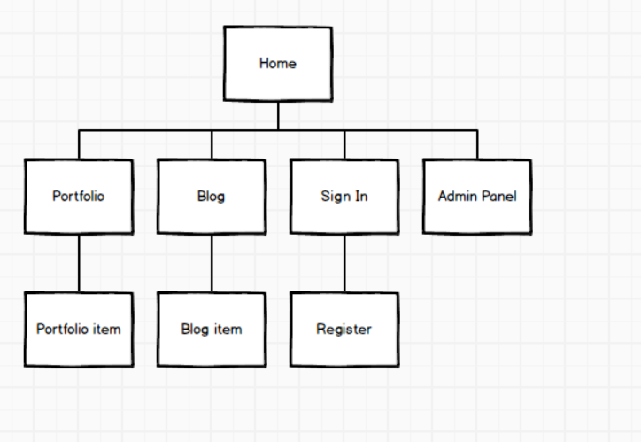

**Instant Messaging**

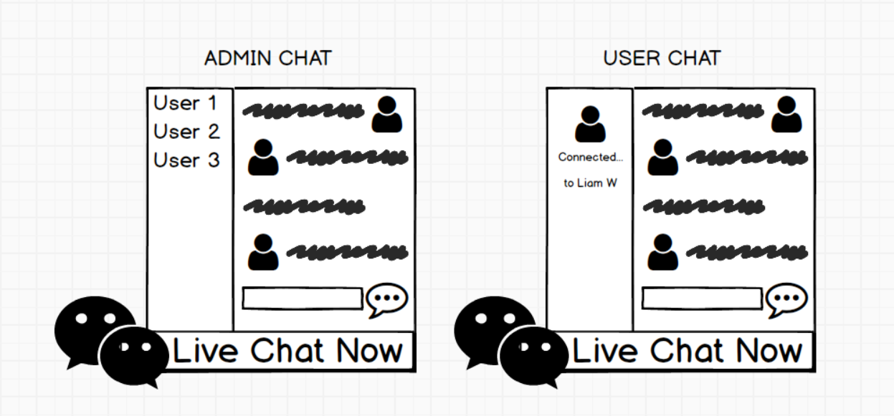

**Homepage**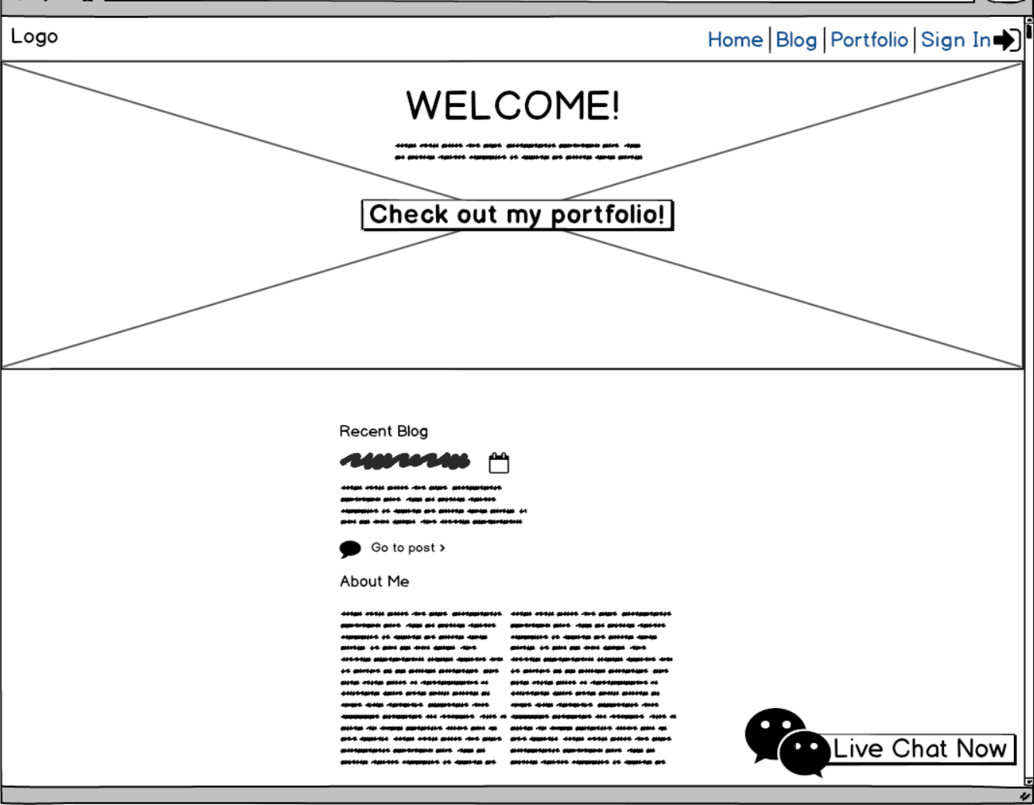

**Portfolio page**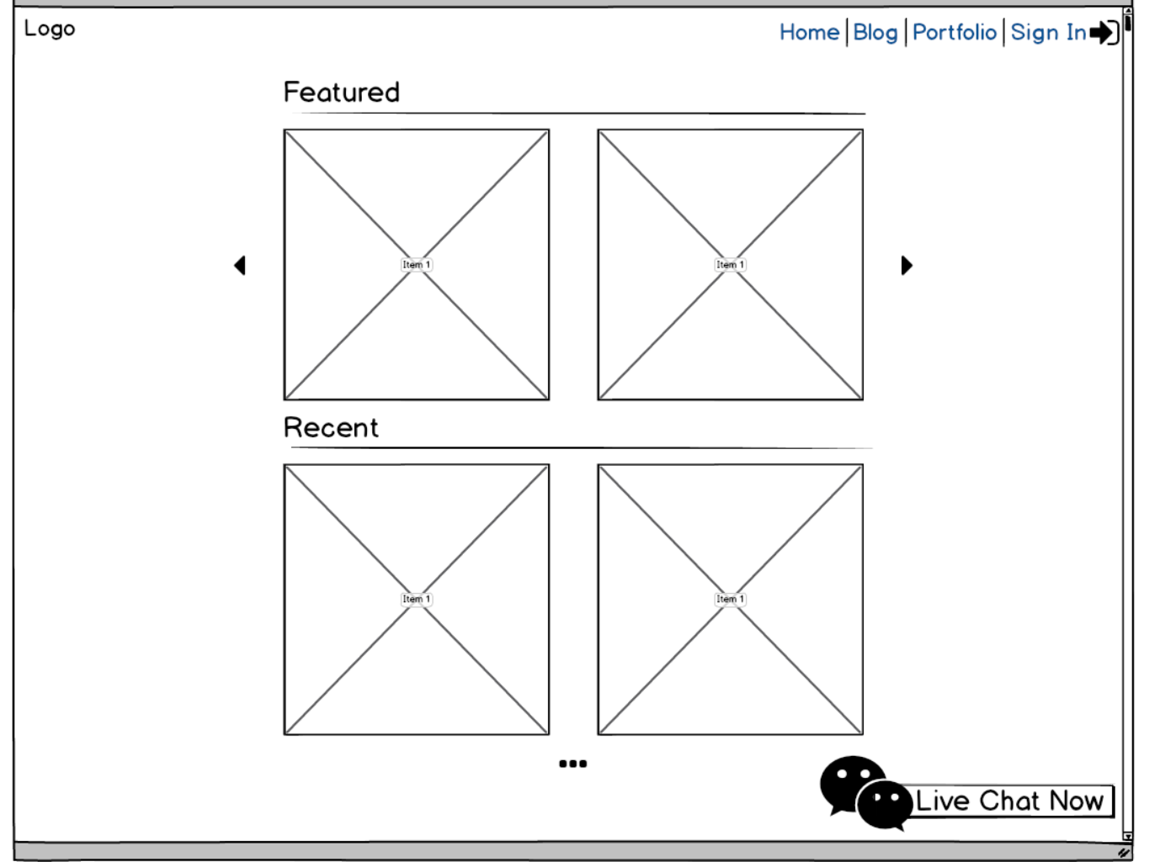

**Blog page**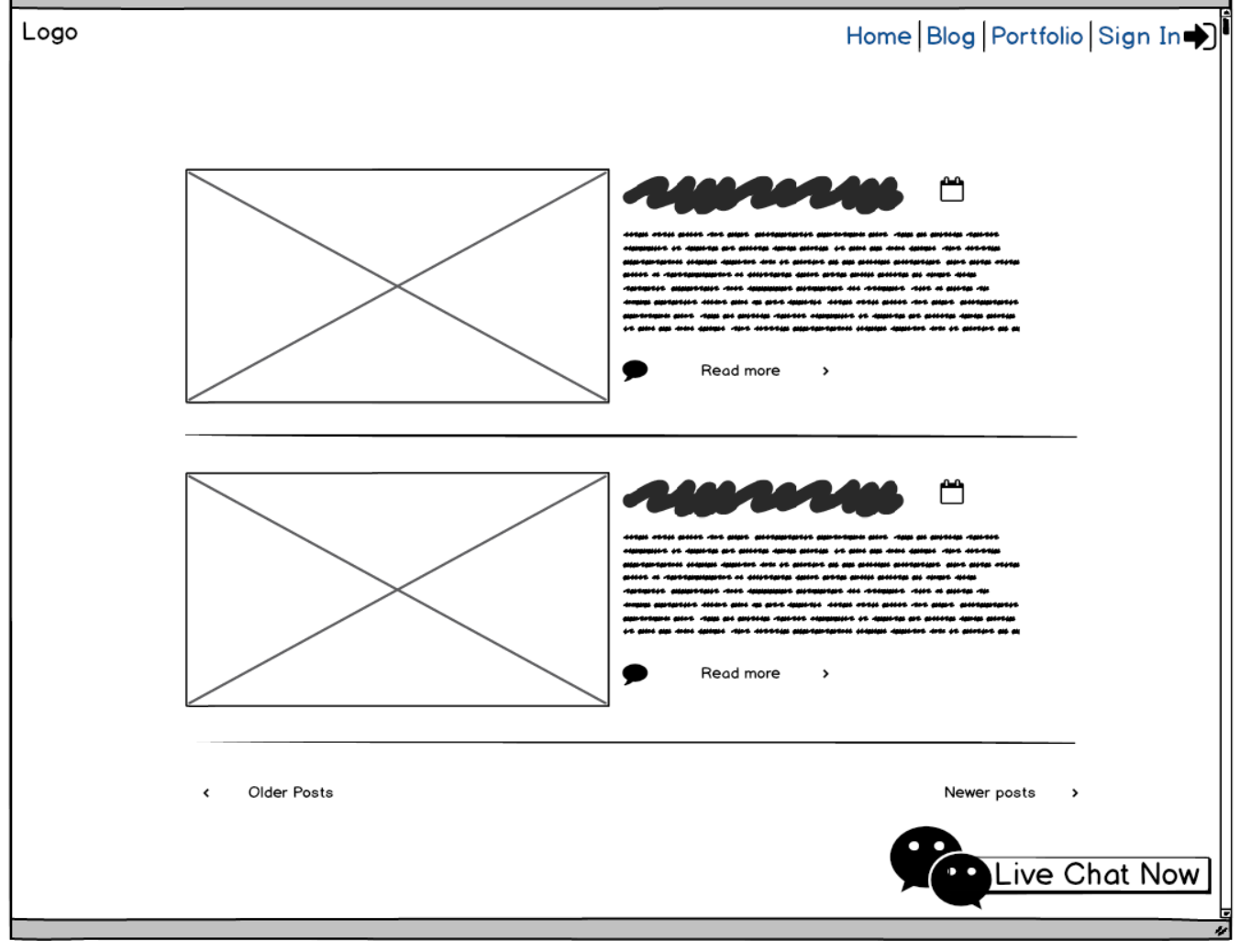

**Admin – Manage Users**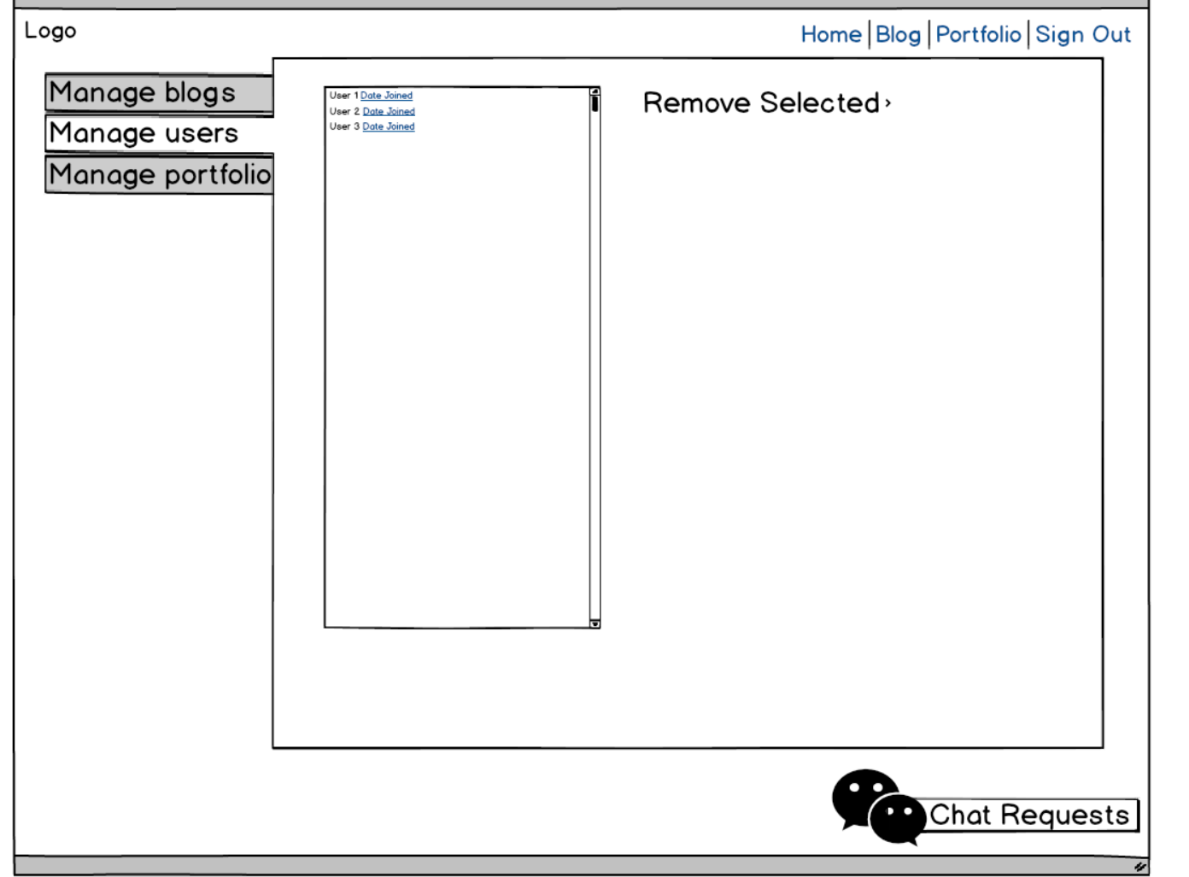

**Admin – Manage Portfolio – Create Portfolio**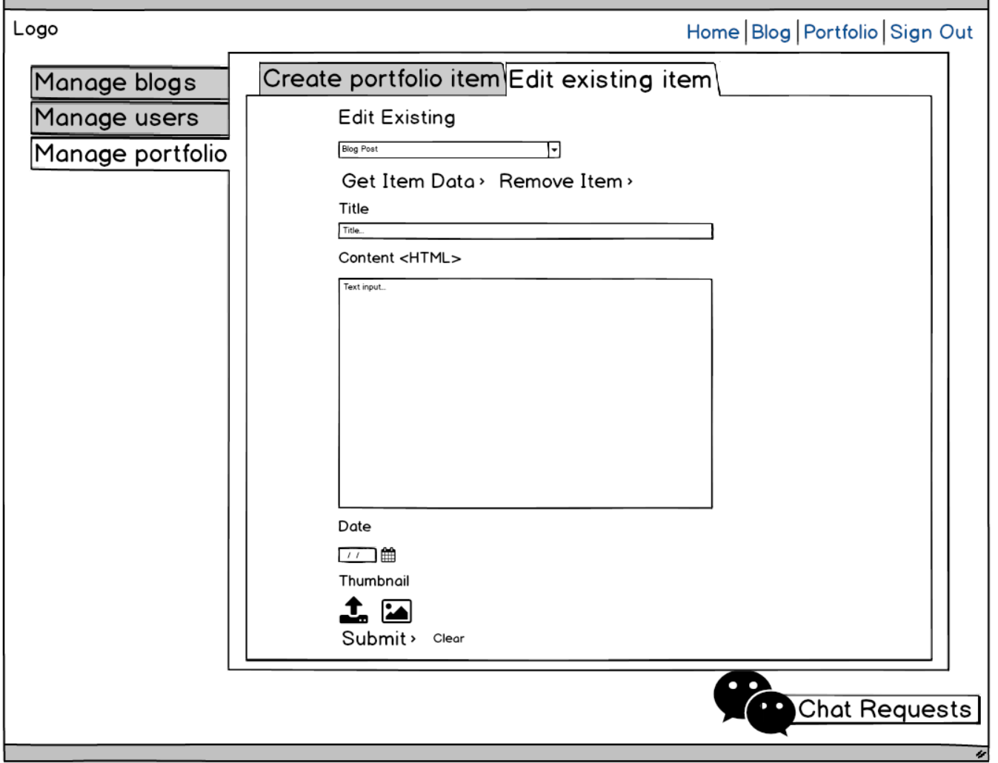

**Admin – Manage Portfolio – Edit Portfolio**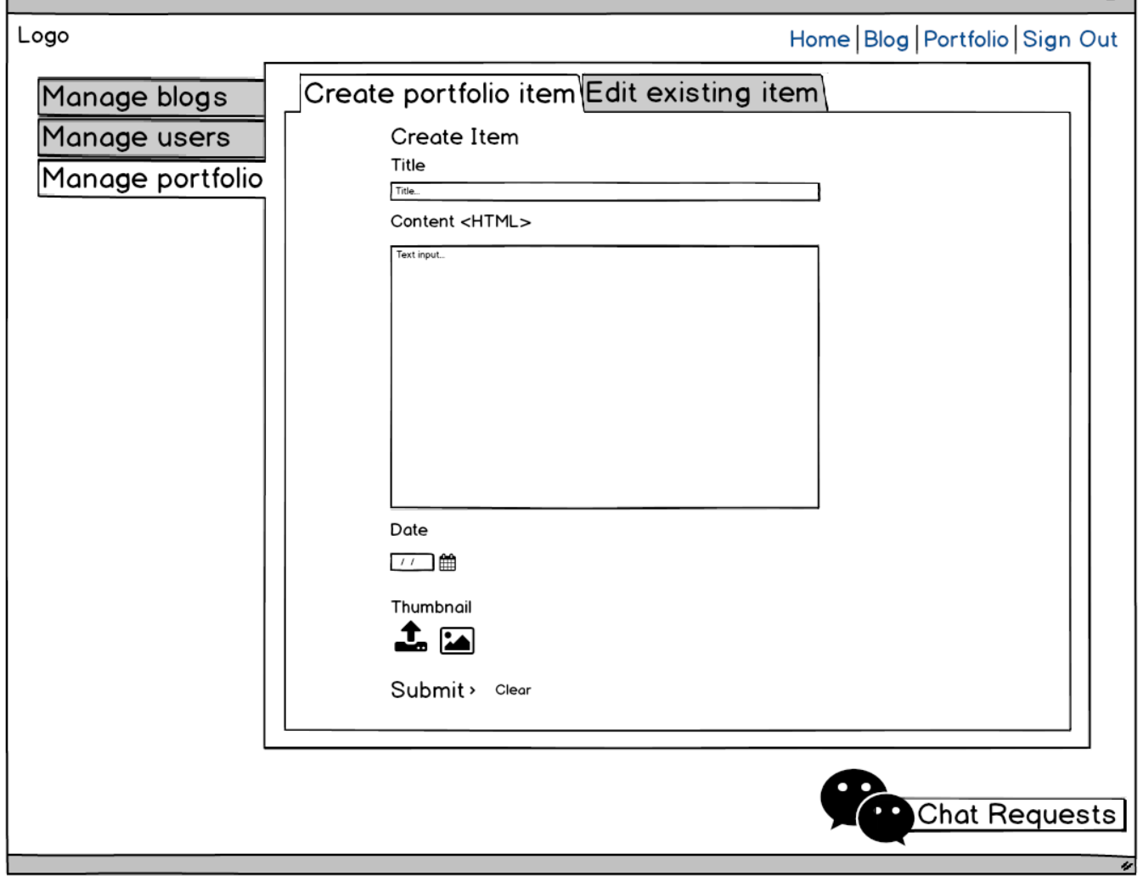

**Admin – Manage Blog – Add Blog**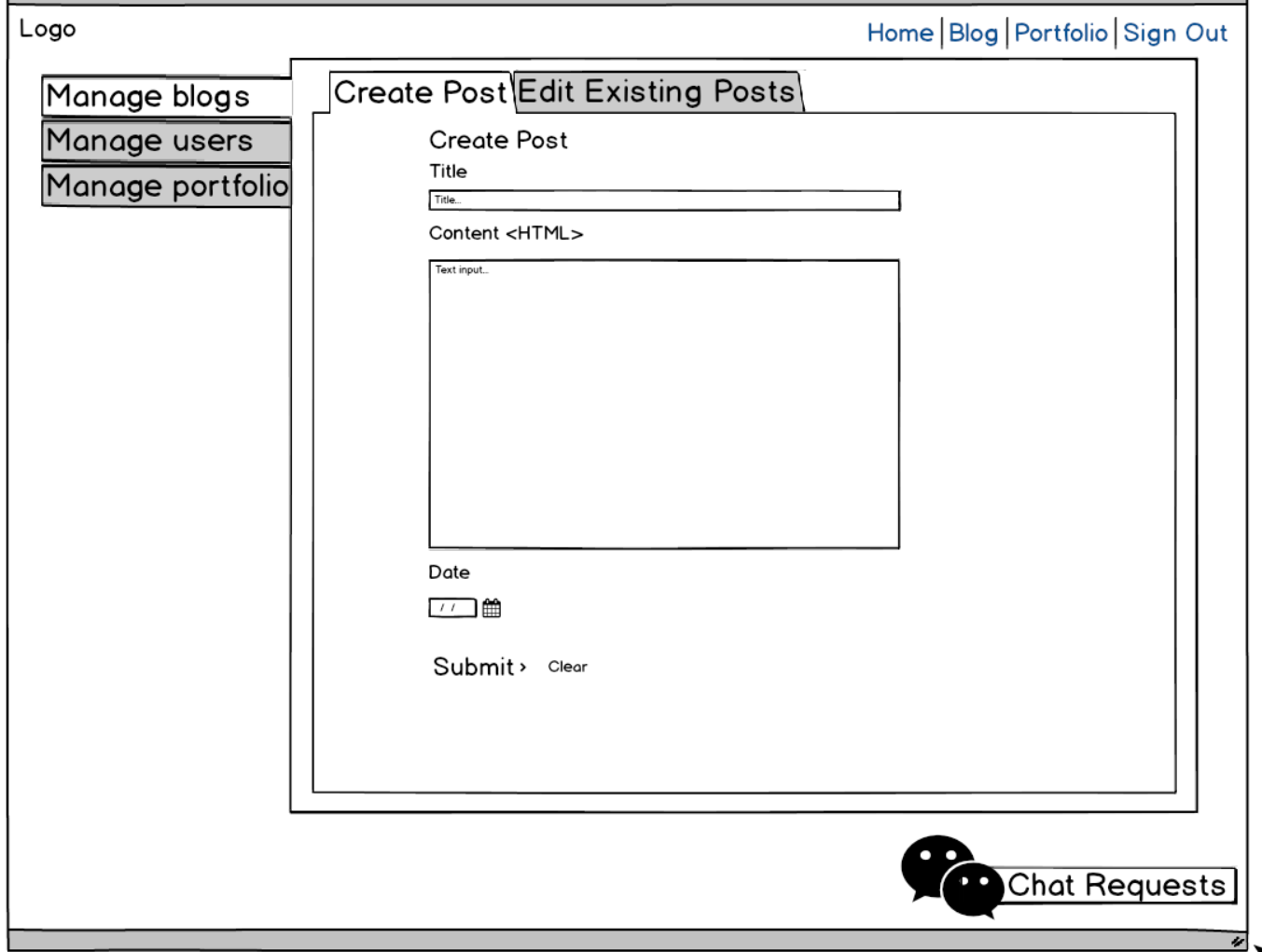

**Admin – Manage Blog – Edit Blog**