|  |
| --- |
| Manually Testing Pets |
| GET |
|  |
| POST |
|  |
| PUT |
|  |
| DELETE |

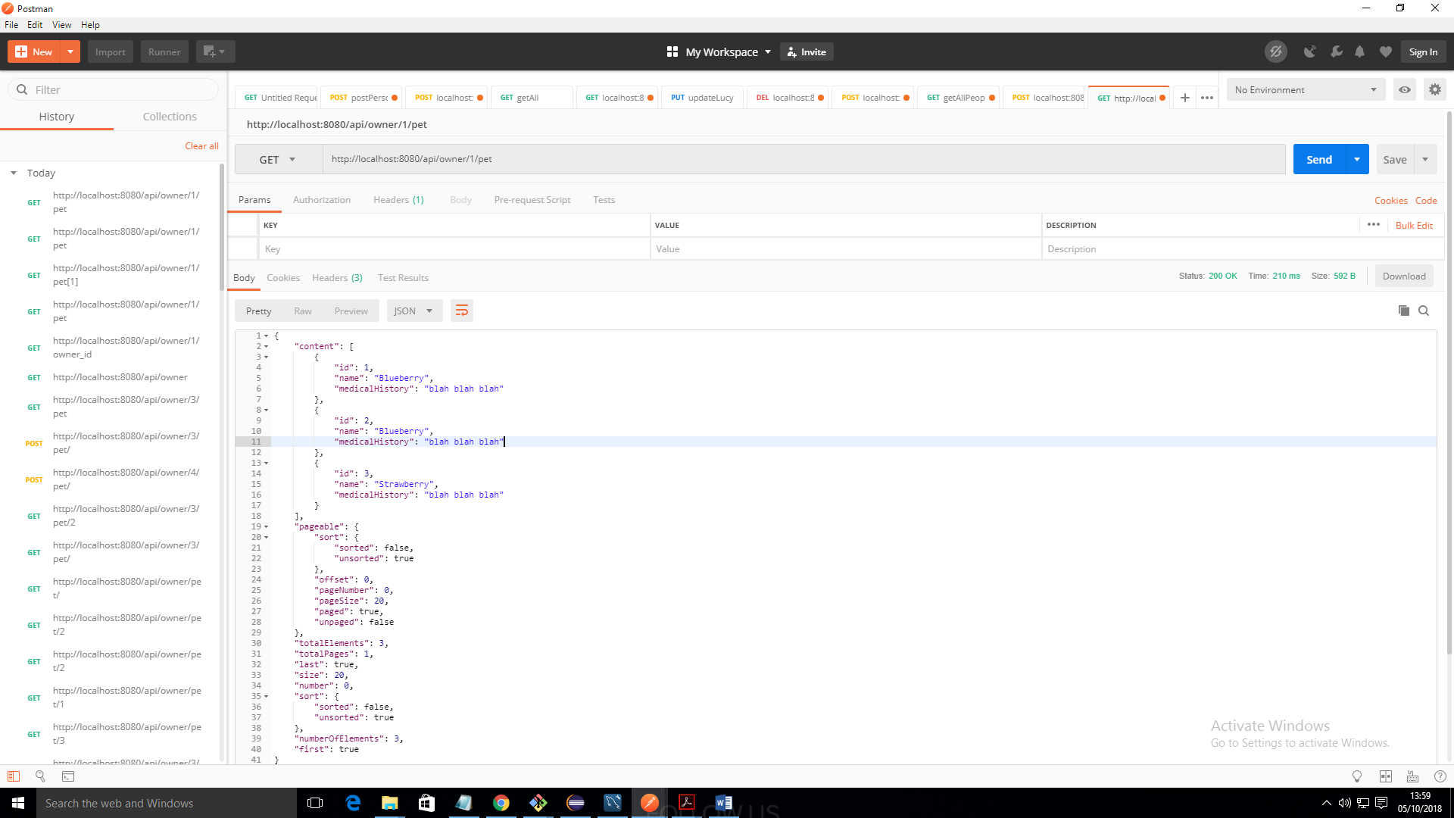

OWNER