Title: Post hoc Power is Not Informative

Authors: Lacey W. Heinsberg, PhD, RN¹; Daniel E. Weeks, PhD^{1,2}

¹Department of Human Genetics, Graduate School of Public Health, University of Pittsburgh, Pittsburgh, Pennsylvania, USA
²Department of Biostatistics, Graduate School of Public Health, University of Pittsburgh, Pittsburgh, Pennsylvania, USA

Authors Email addresses and ORCID iDs
Lacey W. Heinsberg: law145@pitt.edu, 0000-0002-7690-5485
Daniel E. Weeks: weeks@pitt.edu, 0000-0001-9410-7228

Corresponding author: Lacey W. Heinsberg, PhD, RN

Department of Human Genetics

Graduate School of Public Health

University of Pittsburgh

Public Health 3102A

130 De Soto Street

Pittsburgh, PA 15261

E-mail: law145@pitt.edu

Tel: 412-624-3001 | Fax: 412-624-3020

Funding: Research reported in this publication was partially supported by the National Institutes of Health under award numbers TL1TR001858, R01HL1333040, and R01HL093093.

Word count: 1243

NOTE: This is the submitted version of this manuscript (i.e., pre-peer review version) self-archived on L Heinsberg’s personal website/repository to support accessibility until the 12-month paywall embargo is lifted (at which time the manuscript will be available via PubMed central). A peer reviewed and published version can be found in Genetic Epidemiology at https://onlinelibrary.wiley.com/doi/abs/10.1002/gepi.22464

Published citation:
Heinsberg LW, Weeks DE. Post hoc power is not informative. Genet Epidemiol. 2022 Oct;46(7):390-394. doi: 10.1002/gepi.22464. Epub 2022 Jun 1. PMID: 35642557; PMCID: PMC9452450.

ABSTRACT
Post hoc power estimates are often requested by reviewers after a study has been conducted. The purpose of this commentary is to provide a heuristic explanation of why post hoc power should not be used. To illustrate our point, we provide a detailed simulation study of two essentially identical research experiments hypothetically conducted at two separate universities. The simulation demonstrates that post hoc power calculations are misleading and simply not informative for data interpretation.
Key words: Observed power; Retrospective power; Achieved power; Post-experiment power; Exploratory data analysis

INTRODUCTION
Predicted (i.e., pre-study) statistical power is critical in research study design and sample size determination. Akin to screening or diagnostic sensitivity, predicted statistical power can be interpreted as the probability of observing a statistically significant result (i.e., rejecting the null hypothesis) if a true association indeed exists (Nuzzo, 2016). Well-powered studies are essential to (1) support detection of clinically meaningful differences, (2) limit false negative findings that can lead to a perceived lack of clinically meaningful differences, and (3) support responsible stewardship of resources such as money and time of the research team, study participants, and community partners (Zhang et al., 2019).
Unfortunately, post hoc (i.e., post-study) power estimates are often requested by reviewers after a study has been conducted. While post hoc power is regularly calculated using the observed effect size in the mathematical formula for computing predicted statistical power (Bababekov et al., 2018; Zheleznyakova et al., 2016), this approach is conceptually and mathematically incorrect (Zumbo & Hubley, 1998). Likewise, this application is misleading as it assumes that the observed effect size is similar to the true effect size which is only perfectly known when data are simulated. Further, post hoc power is redundant with observed findings as there is a one-to-one relationship between the p-value and power. This is particularly problematic when used to explain a nonsignificant finding (the most frequent reason post hoc power is requested) as, even when a study is carefully designed and well-powered in reality, large p-values will always translate to low observed power (Althouse & Chow, 2019).
While the misconceptions of post hoc power have been documented in more detail elsewhere (Althouse, 2021; Althouse & Chow, 2019; Dziak et al., 2020; Hoenig & Heisey, 2001; Levine & Ensom, 2001; Zumbo & Hubley, 1998), the purpose of this commentary is to provide a heuristic explanation of why post hoc power should not be used. As such, please consider the following scenario.
THOUGHT EXPERIMENT
Suppose two scientific groups, one at University A and one at University B, are serendipitously working on essentially identical research experiments, using genetically identical mice (n=100) being fed the same diet. The purpose of their experiments is to determine the association between a two-allele genetic marker G (minor allele frequency=0.5) and a quantitative trait Y. Both groups use simple linear regression (i.e., Y ~ G) and a significance threshold of 0.05. Based on the power calculations they submitted with their grant applications to secure funding for the studies, a sample size of 100 mice and significance threshold of 0.05 gives them 80% predicted statistical power to detect an effect size of 0.368 or greater (Figure 1).

FIGURE 1 ABOUT HERE

The two groups carry out their experiments and arrive at remarkably similar statistical results (Table 1). Each group writes up their results, and each of their reviewers requests a post hoc power estimate.

TABLE 1 ABOUT HERE

While the results in Table 1 are very similar, each with a p-value that is “teetering on the brink of significance” (“Still Not Significant,” 2013) at approximately 0.052, they came from distinct realities with different true effect sizes (set a priori as part of the simulation of data for this study). Unfortunately, there is nothing in the statistical results that distinguishes the realities from which the two sets of results came. For example, in the case of University A and University B described here, while the observed effect sizes were 0.290 and 0.275, the true effect sizes were quite different at 0.402 and 0.201, respectively (Table 2). We want to believe there is an important effect in these data given the trending p-values observed, so we feel compelled to ask – “Perhaps the sample size just wasn’t large enough to detect an effect?” Sure enough, use of the observed effect sizes suggests that the post hoc power was low for each experiment (<0.60). If these post hoc power calculations were to be presented in the published papers summarizing the results from Universities A and B, readers would arrive at similar conclusions about power for both experiments, but these conclusions would be wrong in different ways. Specifically, readers would conclude that experiment A was underpowered when it was not (post hoc power=0.584; simulation-derived true power=0.841) and that experiment B had greater power (but still low power) than it did in reality (post hoc power=0.534; simulation-derived true power=0.322). Full code with complete details for the simulated experiments and calculation of observed/true power can be found on GitHub at [[NOTE: CODE TO BE PLACED ON GITHUB FOLLOWING PEER REVIEW. SEE SUPPLEMENTARY ATTACHMENT]].

TABLE 2 ABOUT HERE

While we acknowledge that these observations are surprising as a priori we would have assumed that the true underlying effect sizes should be very similar for both experiments, differences in the true effect size caused by environmental or other unmeasured effects are a common and real limitation of all research studies. Regardless of reality, however, after the experiments are done and the results are in hand, post hoc power estimates do not lend any additional information regarding interpretation of the results because they are a direct function of the p-value and parameter estimates. As mentioned above, true effect sizes can only perfectly be known if the data are simulated. In this case, the results of both experiments were the same even though the true effect sizes were different, so looking at the results and associated post hoc power does not aid in interpretation. While conducting post hoc power estimates using a range of clinically or experimentally meaningful effects sizes is more appropriate than using the observed effect sizes, it remains that these hypothetical power values do not change the interpretation of the actual results that were obtained (Figure 2).

FIGURE 2 ABOUT HERE

DISCUSSION AND CONCLUSION
The scenario above demonstrates that post hoc power calculations are misleading and do not assist in data interpretation. Rather than using post hoc power estimates, authors should interpret their findings with careful regard for the design and limitations of the study in question, as well as the observations of other researchers. In doing so, authors should focus on the use of confidence intervals in data reporting as they better inform readers of the possibility of low power or inappropriate sample sizes than post hoc power calculations, and are more easily understood than p-values and power by a range of audiences (Hoenig & Heisey, 2001).
Further, because post hoc power calculations are most often requested for statistically nonsignificant findings, we would like to remind researchers of several reasons (first summarized by Levine & Ensom (2001)) that negative results can arise: (1) there actually is no true association; (2) there is a true association, but the effect is smaller than hypothesized so it could not be detected with the given sample size; (3) there is a true association with an effect as large or larger than hypothesized, but it was not detected by chance; (4) the variance of the sampled data is greater than expected or observed previously, causing excessive noise in the data that prevented detection of a true association; or (5) there were confounding factors that were unaccounted for, making the results appear as if there was no association or a smaller effect than in reality (Levine & Ensom, 2001).
In sum, in advance of the study, researchers should use predicted statistical power for study planning but, after the study is done, researchers should not use post hoc power for explanation or interpretation of observed statistical results. We encourage authors and peer-reviewers to avoid using or requesting post hoc power calculations as they are misleading, they do not add scientific value, and they are simply not informative.

DECLARATIONS:

Acknowledgements: The authors would like to thank the many anonymous reviewers who inspired this paper by requesting post hoc power estimates.

Conflict of Interest: The funders had no role in the design of the study; simulation, analyses, or interpretation of data; writing of the manuscript; or decision to publish the results. As such, the authors declare no conflict of interest.

Availability of Code: [[NOTE: CODE TO BE PLACED ON GITHUB FOLLOWING PEER REVIEW. SEE SUPPLEMENTARY ATTACHMENT]]

Authors’ Roles: DEW conceptualized the premise of the paper and wrote the initial code to simulate the experiments and assess power at Universities A and B. LWH adapted and added to the code throughout development of the manuscript. LWH drafted the initial manuscript and DEW reviewed, critically revised, and approved the final manuscript. All authors agree to be accountable for all aspects of the work.

REFERENCES
Althouse, A. D. (2021). Post Hoc Power: Not Empowering, Just Misleading. The Journal of Surgical Research. United States. https://doi.org/10.1016/j.jss.2019.10.049
Althouse, A. D., & Chow, Z. R. (2019). Comment on “Post-hoc Power: If You Must, At Least Try to Understand”. Annals of Surgery. United States. https://doi.org/10.1097/SLA.0000000000003296
Bababekov, Y. J., Stapleton, S. M., Mueller, J. L., Fong, Z. V., & Chang, D. C. (2018). A Proposal to Mitigate the Consequences of Type 2 Error in Surgical Science. Annals of Surgery, 267(4), 621–622. https://doi.org/10.1097/SLA.0000000000002547
Dziak, J. J., Dierker, L. C., & Abar, B. (2020). The Interpretation of Statistical Power after the Data have been Gathered. Current Psychology (New Brunswick, N.J.), 39(3), 870–877. https://doi.org/10.1007/s12144-018-0018-1
Hoenig, J. M., & Heisey, D. M. (2001). The Abuse of Power. The American Statistician, 55(1), 19–24. https://doi.org/10.1198/000313001300339897
Levine, M., & Ensom, M. H. (2001). Post hoc power analysis: an idea whose time has passed? Pharmacotherapy, 21(4), 405–409. https://doi.org/10.1592/phco.21.5.405.34503
Nuzzo, R. L. (2016). Statistical Power. PM&R, 8(9), 907–912. https://doi.org/https://doi.org/10.1016/j.pmrj.2016.08.004
Still Not Significant. (2013). Retrieved October 27, 2021, from https://mchankins.wordpress.com/2013/04/21/still-not-significant-2/
Zhang, Y., Hedo, R., Rivera, A., Rull, R., Richardson, S., & Tu, X. M. (2019). Post hoc power analysis: is it an informative and meaningful analysis? General Psychiatry, 32(4), e100069. https://doi.org/10.1136/gpsych-2019-100069
Zheleznyakova, G. Y., Cao, H., & Schiöth, H. B. (2016). BDNF DNA methylation changes as a biomarker of psychiatric disorders: literature review and open access database analysis. Behavioral and Brain Functions : BBF, 12(1), 17. https://doi.org/10.1186/s12993-016-0101-4
Zumbo, B. D., & Hubley, A. M. (1998). A Note on Misconceptions Concerning Prospective and Retrospective Power. Journal of the Royal Statistical Society: Series D (The Statistician), 47(2), 385–388. https://doi.org/https://doi.org/10.1111/1467-9884.00139

TABLES
Table 1. Results of simple linear regression examining the association between a two-allele genetic marker, G, and a quantitative trait, Y, for experiments at Universities A and B.
University | Est (95% CI) | Statistic | P-value
A | 0.290 (-0.002 to 0.582) | 1.970 | 0.0517
B | 0.275 (-0.002 to 0.553) | 1.968 | 0.0519

Table 2. Observed effect size/power and true effect size/power for experiments at Universities A and B.
University | Observed Effect Size | Post hoc power | True Effect Size | True Power
A | 0.290 | 0.584 | 0.402 | 0.841
B | 0.275 | 0.537 | 0.201 | 0.322
NOTE: Observed effect sizes are consistent with those in Table 1. Post hoc power was computed at the observed effect size. True effect sizes were set a priori as part of the simulation of data for this study. True power was computed using simulation. See full simulation of experiment at GitHub: [[NOTE: CODE TO BE PLACED ON GITHUB FOLLOWING PEER REVIEW. SEE SUPPLEMENTARY ATTACHMENT]]

FIGURES
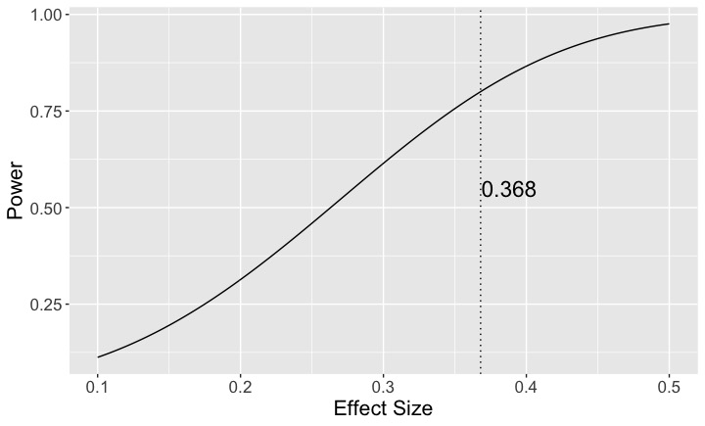
Figure 1. Predicted statistical power curve for experiments at Universities A and B. The black solid line represents analytically-derived estimates of predicted pre-study power as a function of assumed effect size while the black dotted line indicates the minimum effect size (0.368) the study has 80% predicted power to detect.

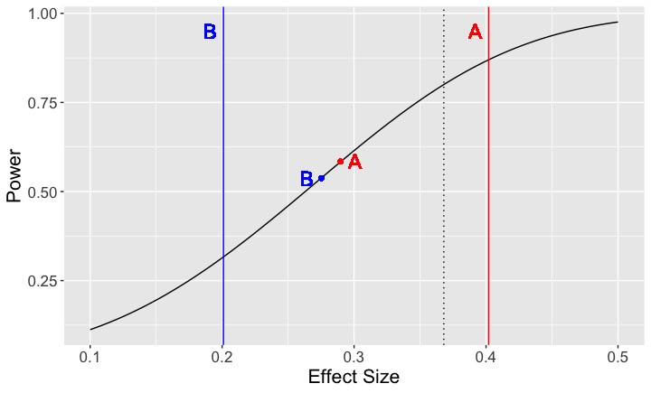
Figure 2. Predicted statistical power curve relative to observed and true effect sizes of experiments at Universities A and B. The curved black line indicates analytically-derived estimates of predicted pre-study power as a function of assumed effect size. The vertical black dotted line indicates the predicted statistical power of 80% to detect a minimum effect size of 0.368 or greater. The red and blue dots indicate the observed effect sizes for experiments A and B of 0.290 and 0.275, respectively. The vertical red and blue lines indicate the true effect sizes set a priori as part of the simulation of data for experiments A and B of 0.402 and 0.201, respectively.

