Word count: 343 / 350 words

**SPECIFIC CLUSTERS OF FATTY ACIDS (FA) ACROSS MULTIPLE SERUM LIPID FRACTIONS UNDERLIE PATHOPHYSIOLOGICAL FEATURES OF TYPE 2 DIABETES IN THE CANADIAN PROSPECTIVE METABOLISM AND ISLET CELL EVALUATION (PROMISE) COHORT**

**Luke W. Johnston1, Zhen Liu1, Ravi Retnakaran2,3, Stewart B. Harris5, Richard P. Bazinet1, Anthony J. Hanley1,3,5**

1 Department of Nutritional Sciences, University of Toronto, Toronto, Canada  
2 Lunenfeld Tanenbaum Research Institute, Mount Sinai Hospital, Toronto, Canada  
3 Division of Endocrinology, University of Toronto, Toronto, Canada.  
4 Centre for Studies in Family Medicine, University of Western Ontario, London, Canada.  
5 Dalla Lana School of Public Health, University of Toronto, Toronto, Canada

**Background**: Since FA within individual lipid fractions fulfill distinct physiological functions, specific clusters of FA across these fractions could be indicative of a greater risk for diabetes. Our aim, therefore, was to identify specific patterns in the composition of FA across multiple lipid fractions and determine their association with insulin sensitivity (IS) and beta-cell function.

**Methods**: Adults at risk for diabetes (n=477) had blood drawn at fasting and during an OGTT. FA from triacylglycerol (TGFA), phospholipid, cholesteryl ester, and non-esterified (NEFA) fractions were quantified from fasting samples and the mole percent (mol%) of total lipids was calculated. Outcome measures included the Matsuda index (ISI) for IS and the Insulin Secretion-Sensitivity Index-2 (ISSI-2) for beta-cell function. Partial least squares (PLS) was used to identify underlying clusters in the FA composition, with FA from all lipid fractions included as the predictor variables and ISI or ISSI-2 as the response variables, in separate PLS models.

**Results**: The first two PLS components (C1 and C2) were extracted. These components explained 22.4-39.2% of the variance in the outcomes and explained 21.8-22.5% of the variance in the FA. TGFA and NEFA had strong negative loadings on C1 and C2, respectively (Figure A), although only a subset of specific TGFA contributed substantially to the variability in the outcomes with C1 and C2 (i.e. TG14:0, TG16:0, TG16:1n-7, TG18:0, TG18:1n-9, TG18:1n-7; Figure B). A lower PLS score, indicating a higher mol% of these specific TGFA, associated with 5.8-7% lower ISI and 3.7-3.8% lower ISSI-2.

**Conclusions**: We identified a cluster of TGFA that had strong negative associations with IS and beta-cell function. These TGFA (e.g. 16:1n-7) are reported to be markers of de novo lipogenesis from simple carbohydrates and to exhibit lipotoxic effects. Our results suggest that only a subset of FA from a broad spectrum of serum FA may underlie the association between lipids and glucose dysregulation, and that these lipids are possible mediators between the reported associations of carbohydrate intake and diabetes risk.

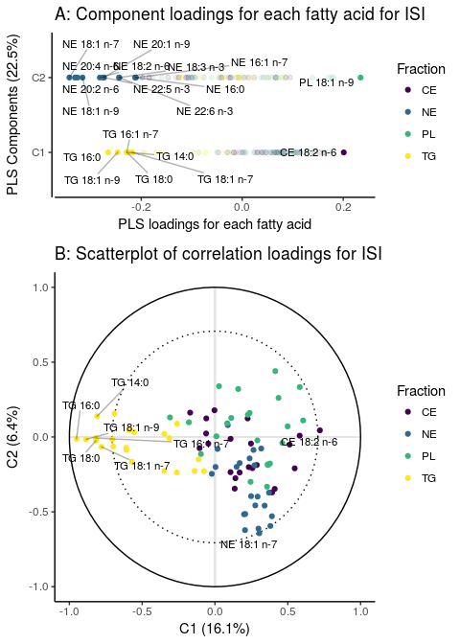

**Author information**

* Presenting author contact:
  + Name: Luke W. Johnston
  + Telephone: +16474606580
  + Email: [luke.johnston@mail.utoronto.ca](mailto:luke.johnston@mail.utoronto.ca)
* Presentation preferred: Either oral or poster
* I am a younger researcher: Post Doctorate researcher