Word count:

**Specific multi-fraction serum fatty acid compositions underlie metabolic characteristics in an Canadian population at risk for type 2 diabetes**

Luke W. Johnston, Zhen Liu, Richard P. Bazinet, Anthony J. Hanley

**Background**:

Fatty acids can positively or negatively influence metabolic function, which can impact

**Methods**:

Adults at risk for diabetes had 3 visits over 6 yrs (n=477). TGFA (mol%) was measured at baseline. Outcomes were MetS components waist, HDL, clinical TG, fasting glucose (FG), and mean arterial pressure (MAP). We used partial least squares (PLS) to extract TGFA clusters. We evaluated longitudinal associations using generalized estimating equations (GEE) adjusted for time, sex, age, and ethnicity.

**Results**:

fa <- grep("^pct_.*", names(project_data), value = TRUE)  
fit <- project_data %>%   
 design("pls") %>%   
 add_settings(ncomp = 6, validation = "CV") %>%   
 add_variables("xvar", fa) %>%   
 add_variables("yvar", "ISI") %>%   
 construct() %>%   
 scrub()  
  
summary(fit)  
## Data: X dimension: 230 88   
## Y dimension: 230 1  
## Fit method: kernelpls  
## Number of components considered: 6  
## TRAINING: % variance explained  
## 1 comps 2 comps 3 comps 4 comps 5 comps 6 comps  
## X 18.06 24.72 31.85 36.14 40.71 44.42  
## Y 31.77 44.56 51.77 57.48 60.18 62.07  
pls::loadings(fit)  
##   
## Loadings:  
## Comp 1 Comp 2 Comp 3 Comp 4 Comp 5 Comp 6  
## pct_ce140 0.129 -0.247 0.136   
## pct_ce141n7 0.105 -0.203 0.209   
## pct_ce160 0.142 -0.257 0.193   
## pct_ce161n7 -0.208 0.350 -0.205   
## pct_ce180 -0.177   
## pct_ce181n9 0.167 -0.183 0.231   
## pct_ce181n7 0.168 -0.112 0.229   
## pct_ce182n6 0.201 -0.157 -0.128 0.154 0.144  
## pct_ce183n6 -0.189 0.175   
## pct_ce183n3 0.141 -0.186 0.141  
## pct_ce200 0.113 -0.192 0.112  
## pct_ce201n9 0.112 -0.125 0.139  
## pct_ce202n6 -0.125 0.210   
## pct_ce203n6 -0.296 -0.201   
## pct_ce204n6 0.119 -0.253 0.134 -0.202  
## pct_ce220 0.116 -0.185 0.141  
## pct_ce205n3 -0.113 0.206 -0.221  
## pct_ce221n9 -0.165   
## pct_ce224n6 0.117 -0.169   
## pct_ce241n9 -0.112   
## pct_ce225n3 0.107   
## pct_ce226n3 0.117 -0.196 0.206 -0.179  
## pct_ne140 -0.177 0.224  
## pct_ne141n7 -0.149 0.173  
## pct_ne160 -0.188 0.111 -0.229 0.264  
## pct_ne161n7 -0.194 0.111 -0.243 0.239  
## pct_ne180 0.111 -0.189 0.187 -0.150   
## pct_ne181n9 0.118 -0.302 0.183 -0.115 0.213  
## pct_ne181n7 -0.317 0.141 0.131 -0.196 0.204  
## pct_ne182n6 0.115 -0.273 0.203 0.285  
## pct_ne183n6 -0.179   
## pct_ne183n3 0.106 -0.211 0.188 -0.121 0.254  
## pct_ne200 0.144 -0.112   
## pct_ne201n9 -0.178 0.186 -0.121 0.156  
## pct_ne202n6 -0.294 0.210 0.158  
## pct_ne203n6 -0.175 0.133   
## pct_ne204n6 -0.316 0.125   
## pct_ne220   
## pct_ne205n3 0.127 -0.101 0.108   
## pct_ne221n9   
## pct_ne224n6 -0.213 0.104 -0.231   
## pct_ne241n9 -0.155 0.122   
## pct_ne225n3 -0.228 0.127   
## pct_ne226n3 -0.244 0.173 -0.180  
## pct_pl140 0.221 -0.111 -0.185 0.124  
## pct_pl141n7 -0.105 -0.136  
## pct_pl160 0.113 0.148 0.191 -0.216   
## pct_pl161n7 0.346 -0.268   
## pct_pl180 0.128 -0.220 -0.134 -0.274  
## pct_pl181n9 0.107 0.247 0.180 -0.112 -0.140  
## pct_pl181n7 0.175 0.129 0.192   
## pct_pl182n6 0.157 0.242 -0.226 0.132  
## pct_pl183n6 0.105 -0.118 0.170 -0.222   
## pct_pl183n3 0.252 -0.209   
## pct_pl200 0.119 0.105 -0.121 -0.119  
## pct_pl201n9 0.131 0.217 -0.111   
## pct_pl202n6 0.147 -0.189 -0.163  
## pct_pl203n6 -0.113 -0.141 0.116  
## pct_pl204n6 -0.148 0.134 -0.383  
## pct_pl220 0.166   
## pct_pl205n3 -0.175 0.121 -0.308  
## pct_pl221n9 0.118 -0.169 -0.139  
## pct_pl224n6 0.217 -0.271   
## pct_pl241n9 0.135 -0.146   
## pct_pl225n3 -0.146  
## pct_pl226n3 -0.134 0.153 0.194 -0.274  
## pct_tg140 -0.214   
## pct_tg141n7 -0.182 0.101 -0.142   
## pct_tg160 -0.248   
## pct_tg161n7 -0.214 0.196 -0.129   
## pct_tg180 -0.214   
## pct_tg181n9 -0.231 0.103   
## pct_tg181n7 -0.207 0.133   
## pct_tg182n6 -0.186 0.159 -0.184 0.152   
## pct_tg183n6 -0.155 -0.103  
## pct_tg183n3 -0.147 0.144 -0.264 0.140   
## pct_tg200 0.105 0.107 -0.142   
## pct_tg201n9 0.203   
## pct_tg202n6 -0.162 -0.115 0.227 -0.111  
## pct_tg203n6 -0.167 -0.122 0.169 0.102   
## pct_tg204n6 -0.152 -0.136 0.176 -0.255  
## pct_tg220 -0.111 0.140 -0.145 0.134  
## pct_tg205n3 0.198 -0.177 0.128 -0.302  
## pct_tg221n9   
## pct_tg224n6 -0.197 -0.110 0.161 -0.127   
## pct_tg241n9 0.107 -0.113 0.114  
## pct_tg225n3 -0.126 0.145 -0.147 0.259 -0.220  
## pct_tg226n3 -0.141 0.174 -0.152 0.167 -0.312  
##   
## Comp 1 Comp 2 Comp 3 Comp 4 Comp 5 Comp 6  
## SS loadings 1.095 1.709 1.455 1.526 1.463 1.787  
## Proportion Var 0.012 0.019 0.017 0.017 0.017 0.020  
## Cumulative Var 0.012 0.032 0.048 0.066 0.082 0.103  
pls::corrplot(fit)

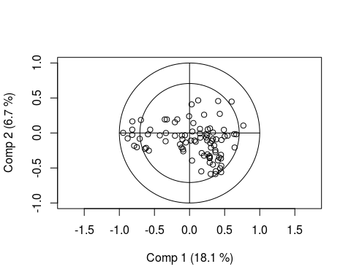

pls::coefplot(fit)

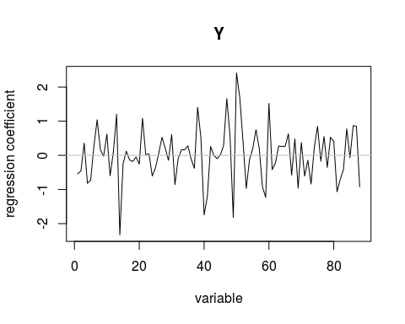

pls::loadingplot(fit)

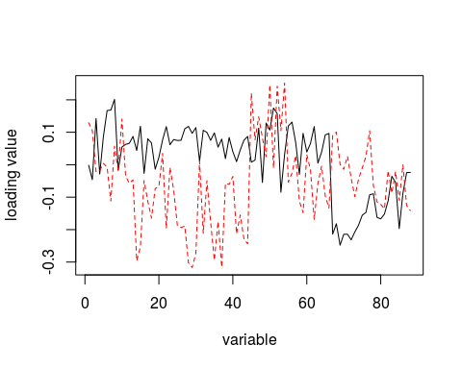

pls::scoreplot(fit)

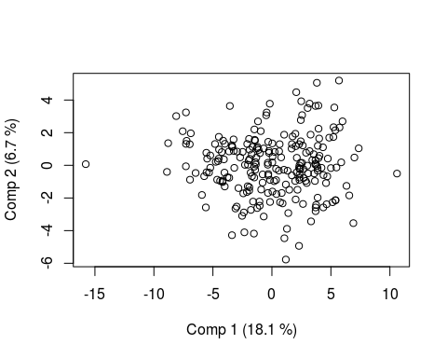

pls::predplot(fit)  
  
#plotly::ggplotly(seer::view_pls_xloadings(fit))  
seer::view_pls_xloadings(fit)

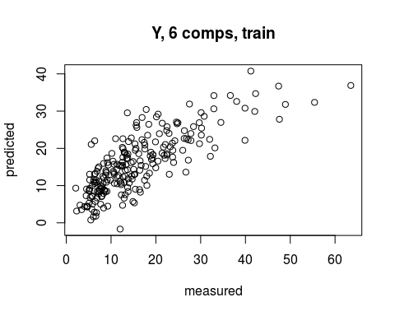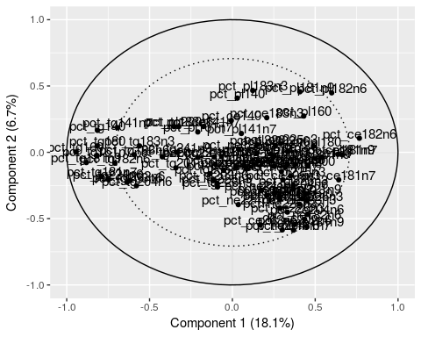

fit <- project_data %>%   
 design("pls") %>%   
 add_settings(ncomp = 6, validation = "CV") %>%   
 add_variables("xvar", fa) %>%   
 add_variables("yvar", c("Glucose0", "lTAG", "MAP", "invHDL", "Waist")) %>%   
 construct() %>%   
 scrub()  
summary(fit)  
## Data: X dimension: 225 88   
## Y dimension: 225 5  
## Fit method: kernelpls  
## Number of components considered: 6  
## TRAINING: % variance explained  
## 1 comps 2 comps 3 comps 4 comps 5 comps 6 comps  
## X 17.509 24.688 30.000 38.194 42.29 47.01  
## Glucose0 1.389 4.302 4.739 6.241 10.19 10.59  
## lTAG 87.007 87.526 87.568 87.569 87.72 87.76  
## MAP 2.753 6.224 11.408 16.754 18.96 23.82  
## invHDL 51.071 52.032 54.659 59.958 61.64 61.65  
## Waist 25.804 38.283 43.151 45.189 50.72 51.33  
seer::view_pls_xloadings(fit)

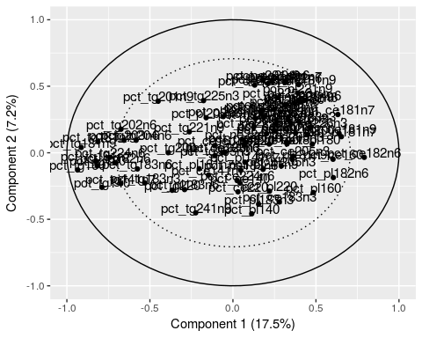

fit <- project_data %>%   
 design("pls") %>%   
 add_settings(ncomp = 6, validation = "CV") %>%   
 add_variables("xvar", fa) %>%   
 add_variables("yvar", c("Glucose0", "lTAG", "MAP", "invHDL", "Waist",   
 "lALT", "lCRP", "HOMA2_S")) %>%   
 construct() %>%   
 scrub()  
summary(fit)  
## Data: X dimension: 220 88   
## Y dimension: 220 8  
## Fit method: kernelpls  
## Number of components considered: 6  
## TRAINING: % variance explained  
## 1 comps 2 comps 3 comps 4 comps 5 comps 6 comps  
## X 18.4359 23.594 31.322 36.489 40.897 44.405  
## Glucose0 0.7129 4.264 5.537 7.408 7.620 8.445  
## lTAG 86.6997 87.412 88.072 88.256 88.281 89.176  
## MAP 1.5408 2.676 2.695 3.080 4.303 4.989  
## invHDL 45.0095 50.451 54.161 57.143 57.595 59.395  
## Waist 18.4893 35.276 35.696 36.680 37.695 39.283  
## lALT 7.7740 8.099 11.390 11.670 12.284 12.469  
## lCRP 5.3542 16.495 22.168 23.175 26.834 27.587  
## HOMA2_S 32.5909 47.438 54.489 60.676 63.846 66.023  
seer::view_pls_xloadings(fit)

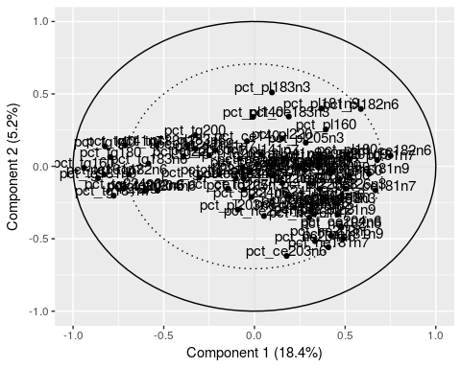

# Neither added sugar nor discretionary fat is useful in the context of PLS and   
# Fatty Acid composition  
#   
# fit <- project_data %>%   
# design("pls") %>%   
# add_settings(ncomp = 6, validation = "CV") %>%   
# add_variables("xvar", fa) %>%   
# add_variables("yvar", c("diet_discret_fat")) %>%   
# construct() %>%   
# scrub()  
# summary(fit)  
# seer::view_pls_xloadings(fit)

**Discussion**: