ESM Material

ESM Methods
Generalized estimating equations (GEE) is analogous to mixed effects models, except it emphasizes population-level trends over individual-level trends that mixed models use. Because it can handle autocorrelations in the outcome (as would be seen in variables measured over time), GEE modeling is well suited to longitudinal data. Latent class mixed models (LCMM) is a form of mixed effects modeling that tries to categorize individuals into groups that have similar clusters; in the case of the present analysis are the trajectories in beta-cell function over time. Because mixed models use the participant as the random effect, LCMM can identify individuals who similarly change over time.
Partial least squares (PLS) regression is a technique similar to principal component analysis (PCA) that is designed to extract meaningful information from multivariate, high dimensionality data (e.g. as in metabolomic and other -omic type analyses). These types of methods try to extract as much of the variance in the data into a smaller number of components or factors. The difference between PCA and PLS is that PLS is a supervised method, while PCA is not. This means that PLS uses a response variable(s), i.e. an outcome or Y, to describe the variation in the predictors (X) while PCA only describes the variation inherent in X. Because of this, PLS can be better at predicting the contributions of predictor variables against an outcome variable. Partial least squares discriminant analysis (PLS-DA) is a form of PLS, except the Y is a discrete (i.e. categorical) variable and not a continuous one. Therefore, PLS-DA is able to predict who will belong to which group based on the values of the predictors.
The two plots generated from the PLS-DA analysis show the results from both the response (i.e. LCMM beta-cell function groups and dyslgycemia status) and the predictors (all 22 NEFA). The response result plots as seen in ESM Fig. 5 and ESM Fig. 7 show the poor discriminatory ability of the PLS-DA model, with ESM Fig. 9 showing a hypothetical example of good discriminatory ability. When the predictors represent an underlying pattern that may exist between groups, the plots will show greater separation between the groups in addition to a low misclassification rate. The predictor result plots as seen in ESM Fig. 6 and ESM Fig. 8 show which of the predictor variables contribute the most to the explained variance. Variables between the solid and dashed lines explain between 50-100% of the explained variance. Whether the variables have positive or negative values on either of the components axes determines how they contribute to each group. For instance, if those individuals with dysglycemia have a positive value for component 1 and the fatty acid 16:0 also has a positive value for component 1, this indicates that 16:0 is predictive of having dysglycemia.

ESM Tables and Figures
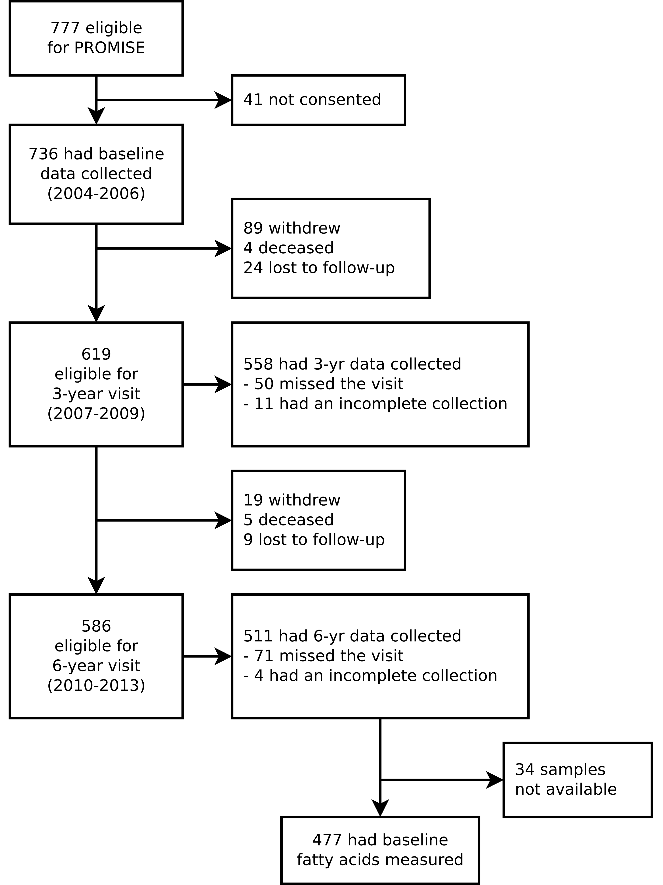
ESM Fig. 1: CONSORT diagram of sample size at each examination visit.
ESM Table 1: Comparing generalized estimating equation models adjusting for different covariates using Quasi-Likelihood Information Criterion.
Model | QIC | Delta
log(ISI)
M4 | -1583 | 0
M5 | -1583 | 0.2
M6 | -1582 | 0.8
M3 | -1576 | 6.9
M8 | -1574 | 9.5
M2 | -1574 | 9.7
M9 | -1573 | 10
M7 | -1572 | 11.2
M1 | -1539 | 44.1
M0 | -1051 | 532.1
log(ISSI-2)
M9 | -2478 | 0
M8 | -2477 | 1.1
M7 | -2477 | 1.1
M5 | -2474 | 4.2
M6 | -2473 | 5.1
M2 | -2472 | 6.5
M3 | -2470 | 8.5
M4 | -2468 | 9.8
M1 | -2458 | 20.5
M0 | -2139 | 339.2
Given the number of possible combinations of outcome and predictor variables, only ISI and ISSI-2 with total non-esterified fatty acids (nmol/mL) were used to compare various GEE models and to select a final model. Baseline age was used as including both the original age and the time variable would result in collinearity. Column names are: QIC is the quasi-likelihood information criteria (smaller values, eg. larger negative values, indicate a better fit compared to other models), Delta is the QIC minus the lowest QIC (models with delta <10 are considered equivalent). Models were:
- M0: log(ISSI-2) or log(ISI) = total non-esterified fatty acids (nmol/mL) + time
- M1: M0 + waist + sex + ethnicity + baseline age
- M2: M1 + ALT
- M3: M2 + physical activity
- M4: M3 + alcohol intake
- M5: M4 + family history of diabetes
- M6: M5 + smoking status
- M7: M2 + ALT + family history of diabetes + smoking status
- M8: M2 + ALT + family history of diabetes
- M9: M8 + time by NEFA interaction

ESM Table 2: Raw concentration values (nmol/mL) of each non-esterified fatty acid in the PROMISE cohort at the baseline visit (2004-2006). Values are presented as mean (SD).
NEFA | Concentrations (nmol/mL)
22:6n-3 | 1.7 (1.2)
22:5n-3 | 0.7 (0.4)
20:5n-3 | 0.7 (0.6)
18:3n-3 | 4.7 (2.1)
22:4n-6 | 0.4 (0.3)
20:4n-6 | 3.1 (1.4)
20:3n-6 | 1.5 (1.4)
20:2n-6 | 0.9 (0.4)
18:3n-6 | 0.7 (0.6)
18:2n-6 | 54.1 (19.4)
18:1n-7 | 10.1 (4.0)
16:1n-7 | 10.3 (6.9)
14:1n-7 | 0.3 (0.3)
24:1n-9 | 0.6 (0.8)
22:1n-9 | 0.3 (0.3)
20:1n-9 | 1.7 (1.5)
18:1n-9 | 142.5 (52.5)
22:0 | 0.2 (0.2)
20:0 | 0.7 (0.3)
18:0 | 55.2 (14.1)
16:0 | 90.0 (33.8)
14:0 | 3.2 (2.9)
Total | 383.4 (116.4)
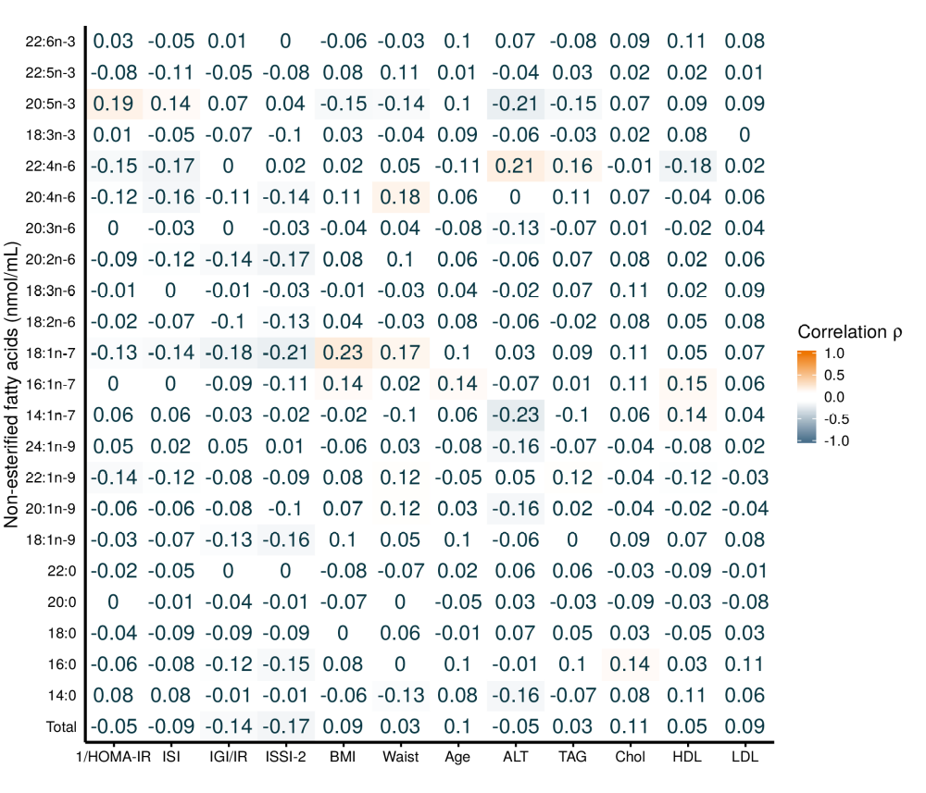
ESM Fig. 2: Pearson correlation heatmap of non-esterified fatty acids (nmol/mL) and basic PROMISE participant characteristics for the baseline visit (2004-2006). Darkness of the colour indicates the magnitude of the correlation, with orange indicating positive and blue indicating negative correlations.
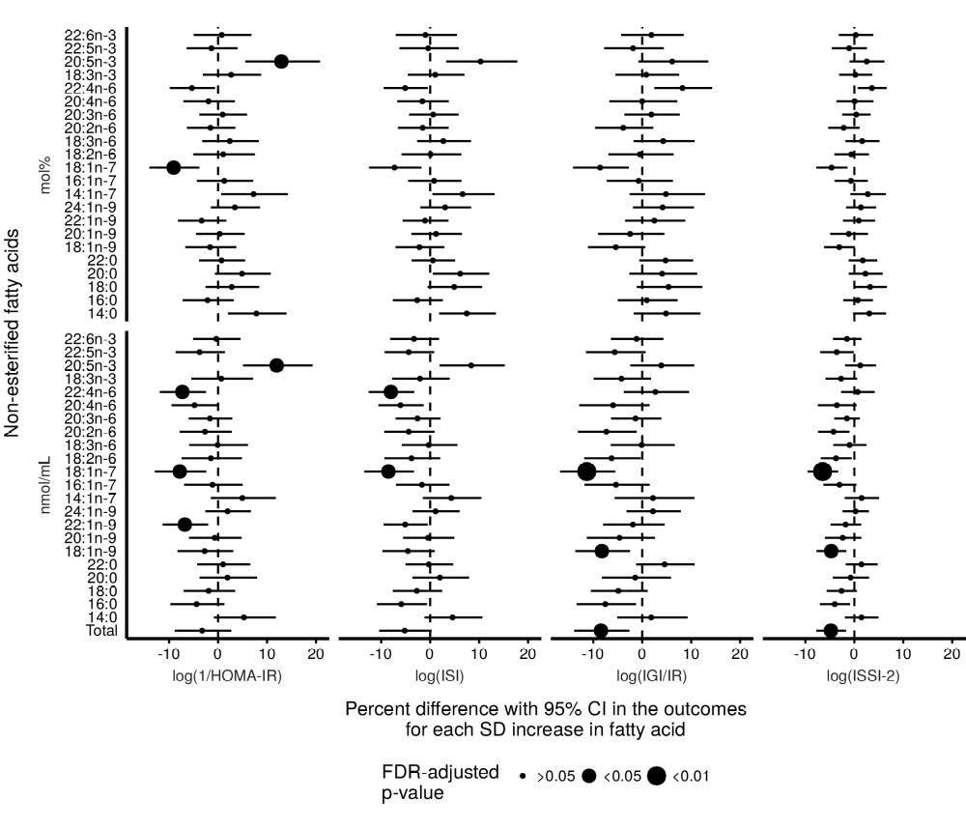
ESM Fig. 3: Unadjusted generalized estimating equation modeling of the longitudinal association of individual non-esterified fatty acids (mol% and nmol/mL) with insulin sensitivity and beta-cell function over 6 years in the PROMISE cohort. GEE models are only adjusted for time. Outcome variables were log-transformed, predictor variables were scaled, and x-axis values were exponentiated to represent percent difference per SD increase in the fatty acid. P-values were adjusted for the BH false discovery rate, with the largest dot representing a significant (p<0.05) association (*).
ESM Table 3: Longitudinal associations of individual non-esterified fatty acids (mol% and nmol/mL) with insulin sensitivity and beta-cell function over the 6 years in the PROMISE cohort. GEE models were adjusted for time, sex, ethnicity, baseline age, WC, ALT, and family history of diabetes. Outcome variables were log-transformed, predictor variables were scaled, and x-axis values were exponentiated to represent percent difference per SD increase in the fatty acid. P-values were adjusted for the BH false discovery rate, with significant (p<0.05) associations indicated by asterisk (*).
Fatty acid | log(1/HOMA-IR) | log(ISI) | log(IGI/IR) | log(ISSI-2)
mol%
14:0 | 3.1 (-1.2, 7.6) | 4.7 (0.2, 9.5) | -1.8 (-7.3, 4.1) | -0.5 (-3.3, 2.4)
16:0 | -0.9 (-4.5, 2.8) | -0.7 (-4.7, 3.4) | -1.6 (-6.9, 4.0) | -0.6 (-3.2, 2.1)
18:0 | 0.3 (-3.8, 4.6) | 1.7 (-2.6, 6.3) | 5.1 (-0.9, 11.5) | 2.4 (-0.6, 5.5)
20:0 | 1.5 (-3.3, 6.4) | 2.2 (-2.8, 7.5) | 2.6 (-3.2, 8.9) | 1.0 (-2.0, 4.1)
22:0 | -1.3 (-5.3, 2.8) | -1.3 (-5.3, 2.8) | 1.8 (-2.8, 6.6) | -0.2 (-2.6, 2.3)
18:1n-9 | 0.2 (-3.7, 4.2) | -1.2 (-5.3, 3.1) | -1.2 (-6.3, 4.1) | -0.6 (-3.2, 2.1)
20:1n-9 | 2.5 (-1.8, 6.9) | 2.8 (-1.6, 7.5) | 0.6 (-6.3, 8.0) | 0.6 (-3.2, 4.6)
22:1n-9 | -2.3 (-5.7, 1.3) | -1.0 (-4.5, 2.7) | 4.6 (-0.6, 10.2) | 2.1 (-1.0, 5.2)
24:1n-9 | 3.6 (-0.3, 7.6) | 3.3 (-1.0, 7.7) | 4.3 (-1.8, 10.8) | 1.4 (-1.7, 4.6)
14:1n-7 | 3.3 (-1.7, 8.5) | 4.3 (-0.6, 9.4) | -0.8 (-7.5, 6.3) | 0.0 (-3.0, 3.2)
16:1n-7 | 4.2 (-0.3, 8.9) | 4.1 (-0.4, 8.8) | -2.1 (-7.9, 4.2) | -0.8 (-3.7, 2.2)
18:1n-7 | 1.1 (-3.4, 5.7) | 0.9 (-3.8, 5.9) | 0.1 (-5.7, 6.3) | 0.8 (-2.3, 3.9)
18:2n-6 | -2.4 (-6.9, 2.2) | -2.3 (-6.9, 2.6) | -3.5 (-9.4, 2.7) | -2.1 (-5.1, 1.0)
18:3n-6 | 1.8 (-2.0, 5.7) | 2.0 (-1.9, 6.0) | 3.4 (-1.7, 8.8) | 0.9 (-2.0, 3.9)
20:2n-6 | -0.7 (-4.7, 3.4) | -1.5 (-5.8, 3.1) | -0.4 (-6.7, 6.2) | -0.3 (-3.6, 3.0)
20:3n-6 | 0.5 (-3.2, 4.3) | 0.2 (-3.9, 4.4) | 3.5 (-2.1, 9.3) | 1.2 (-1.7, 4.2)
20:4n-6 | 0.1 (-4.1, 4.4) | -0.7 (-5.0, 3.8) | 4.6 (-2.2, 11.8) | 2.5 (-1.2, 6.3)
22:4n-6 | -2.9 (-7.0, 1.4) | -3.0 (-7.1, 1.2) | 6.4 (-0.1, 13.3) | 2.0 (-1.1, 5.2)
18:3n-3 | 0.3 (-3.4, 4.1) | -0.5 (-4.5, 3.7) | -0.8 (-6.1, 4.8) | -0.5 (-3.2, 2.4)
20:5n-3 | 7.4 (2.2, 12.9) | 5.9 (0.5, 11.6) | 3.4 (-3.3, 10.6) | 0.8 (-2.4, 4.2)
22:5n-3 | -2.0 (-5.5, 1.6) | -1.5 (-5.8, 3.0) | 0.2 (-5.9, 6.7) | 0.0 (-3.5, 3.5)
22:6n-3 | -2.8 (-6.0, 0.5) | -3.9 (-7.9, 0.3) | 1.4 (-4.2, 7.2) | -0.3 (-3.2, 2.7)
nmol/mL
Total | -1.1 (-5.0, 2.9) | -2.9 (-6.8, 1.2) | -8.4 (-13.4, -3.1)* | -4.3 (-6.9, -1.7)*
14:0 | 1.7 (-2.7, 6.3) | 2.8 (-1.8, 7.6) | -3.9 (-10.1, 2.7) | -1.5 (-4.5, 1.5)
16:0 | -1.5 (-5.5, 2.6) | -2.6 (-6.5, 1.5) | -8.9 (-14.1, -3.3)* | -4.3 (-6.9, -1.7)*
18:0 | -0.7 (-4.5, 3.3) | -2.0 (-5.8, 2.0) | -4.3 (-9.7, 1.5) | -2.4 (-5.3, 0.6)
20:0 | 0.7 (-4.0, 5.6) | 0.1 (-4.7, 5.1) | -1.7 (-8.5, 5.5) | -1.2 (-4.8, 2.5)
22:0 | -1.2 (-5.6, 3.4) | -2.2 (-6.5, 2.4) | 0.6 (-4.1, 5.6) | -1.0 (-3.4, 1.5)
18:1n-9 | -0.9 (-4.8, 3.1) | -2.8 (-6.7, 1.4) | -7.0 (-11.9, -1.7) | -3.6 (-6.1, -1.0)*
20:1n-9 | 2.1 (-2.1, 6.4) | 2.0 (-2.2, 6.3) | -1.9 (-9.2, 6.0) | -0.6 (-4.4, 3.3)
22:1n-9 | -3.5 (-6.8, 0.0) | -3.0 (-6.5, 0.7) | 1.6 (-3.6, 7.1) | 0.3 (-2.5, 3.3)
24:1n-9 | 2.4 (-1.0, 5.9) | 1.6 (-2.2, 5.5) | 2.1 (-3.3, 7.9) | 0.3 (-2.4, 3.1)
14:1n-7 | 2.0 (-2.8, 7.1) | 2.9 (-1.8, 7.7) | -2.8 (-10.2, 5.3) | -0.8 (-3.9, 2.4)
16:1n-7 | 1.9 (-2.5, 6.6) | 1.7 (-2.6, 6.3) | -6.4 (-12.3, 0.0) | -2.9 (-5.8, 0.1)
18:1n-7 | -0.5 (-4.6, 3.8) | -2.1 (-6.4, 2.3) | -7.1 (-12.7, -1.1) | -3.4 (-6.3, -0.4)
18:2n-6 | -1.9 (-5.9, 2.2) | -3.5 (-7.5, 0.7) | -7.9 (-12.9, -2.7)* | -4.3 (-6.9, -1.6)*
18:3n-6 | 0.9 (-3.3, 5.2) | 0.6 (-3.8, 5.2) | -0.6 (-5.6, 4.7) | -1.3 (-3.8, 1.4)
20:2n-6 | -0.8 (-4.6, 3.0) | -2.9 (-6.8, 1.2) | -5.1 (-11.2, 1.4) | -2.8 (-5.9, 0.4)
20:3n-6 | -1.2 (-4.5, 2.2) | -2.3 (-6.0, 1.6) | 0.3 (-4.8, 5.7) | -0.4 (-3.0, 2.2)
20:4n-6 | -0.6 (-4.5, 3.4) | -3.0 (-6.9, 1.1) | -1.0 (-8.6, 7.1) | -0.6 (-4.6, 3.7)
22:4n-6 | -3.2 (-7.4, 1.2) | -4.7 (-9.0, -0.1) | -0.3 (-6.5, 6.4) | -1.1 (-4.3, 2.1)
18:3n-3 | -0.5 (-4.4, 3.5) | -2.5 (-6.4, 1.6) | -6.0 (-10.9, -0.9) | -3.4 (-6.1, -0.5)
20:5n-3 | 6.5 (1.6, 11.6) | 4.2 (-1.0, 9.6) | 0.9 (-5.3, 7.4) | -0.5 (-3.3, 2.4)
22:5n-3 | -2.3 (-6.3, 1.9) | -3.3 (-7.5, 1.1) | -2.7 (-8.8, 3.7) | -1.8 (-5.3, 1.8)
22:6n-3 | -2.9 (-6.2, 0.5) | -5.2 (-9.0, -1.1) | -1.8 (-6.5, 3.2) | -1.9 (-4.4, 0.6)

ESM Table 4: Unadjusted generalized estimating equation models of the longitudinal associations of individual non-esterified fatty acids (mol% and nmol/mL) with insulin sensitivity and beta-cell function over the 6 years in the PROMISE cohort. GEE models are only adjusted for time. Outcome variables were log-transformed, predictor variables were scaled, and x-axis values were exponentiated to represent percent difference per SD increase in the fatty acid. P-values were adjusted for the BH false discovery rate, with significant (p<0.05) associations indicated by asterisk.
Fatty acid | log(1/HOMA-IR) | log(ISI) | log(IGI/IR) | log(ISSI-2)
mol%
14:0 | 7.8 (2.0, 14.0) | 7.5 (1.8, 13.4) | 4.9 (-1.7, 11.9) | 3.1 (-0.3, 6.5)
16:0 | -2.2 (-7.2, 3.2) | -2.6 (-7.6, 2.6) | 0.9 (-5.0, 7.2) | 0.7 (-2.3, 3.8)
18:0 | 2.8 (-2.6, 8.4) | 4.9 (-0.5, 10.6) | 5.4 (-1.1, 12.3) | 3.2 (-0.1, 6.6)
20:0 | 4.9 (-0.7, 10.7) | 6.1 (0.5, 12.1) | 4.1 (-2.6, 11.2) | 2.3 (-1.1, 5.8)
22:0 | 0.7 (-3.9, 5.5) | 0.6 (-3.8, 5.1) | 4.8 (-0.6, 10.4) | 1.7 (-1.1, 4.7)
18:1n-9 | -1.6 (-6.7, 3.7) | -2.2 (-7.1, 2.9) | -5.4 (-11.1, 0.6) | -3.1 (-6.2, 0.1)
20:1n-9 | 0.3 (-4.5, 5.4) | 1.2 (-3.8, 6.5) | -2.5 (-9.0, 4.5) | -1.1 (-4.9, 2.8)
22:1n-9 | -3.4 (-8.2, 1.7) | -1.0 (-5.6, 3.7) | 2.5 (-3.5, 8.8) | 0.9 (-2.3, 4.2)
24:1n-9 | 3.4 (-1.5, 8.6) | 3.0 (-2.0, 8.4) | 4.2 (-1.9, 10.6) | 1.3 (-1.7, 4.4)
14:1n-7 | 7.2 (0.6, 14.3) | 6.6 (0.5, 13.2) | 4.8 (-2.6, 12.8) | 2.8 (-0.8, 6.4)
16:1n-7 | 1.3 (-4.3, 7.2) | 0.8 (-4.5, 6.4) | -0.7 (-7.3, 6.3) | -0.7 (-4.0, 2.7)
18:1n-7 | -9.1 (-14.0, -3.8)* | -7.3 (-12.5, -1.8) | -8.6 (-14.1, -2.7) | -4.7 (-7.8, -1.4)
18:2n-6 | 1.0 (-5.1, 7.5) | 0.1 (-5.9, 6.4) | -0.5 (-6.9, 6.4) | -0.6 (-4.1, 3.0)
18:3n-6 | 2.4 (-3.2, 8.3) | 2.7 (-2.7, 8.3) | 4.3 (-1.8, 10.7) | 1.6 (-1.8, 5.1)
20:2n-6 | -1.5 (-6.4, 3.5) | -1.5 (-6.6, 3.8) | -3.9 (-9.6, 2.3) | -2.2 (-5.3, 1.1)
20:3n-6 | 0.9 (-3.8, 5.9) | 0.6 (-4.3, 5.8) | 1.9 (-3.6, 7.7) | 0.4 (-2.5, 3.3)
20:4n-6 | -2.0 (-7.1, 3.4) | -1.6 (-6.7, 3.8) | 0.0 (-6.7, 7.2) | 0.1 (-3.6, 3.9)
22:4n-6 | -5.3 (-9.9, -0.6) | -5.1 (-9.5, -0.5) | 8.2 (2.5, 14.3) | 3.6 (0.7, 6.6)
18:3n-3 | 2.7 (-3.1, 8.8) | 1.0 (-4.6, 7.0) | 0.8 (-5.5, 7.5) | 0.2 (-3.1, 3.7)
20:5n-3 | 12.9 (5.6, 20.8)* | 10.3 (3.3, 17.8) | 6.1 (-0.8, 13.5) | 2.5 (-1.0, 6.1)
22:5n-3 | -1.4 (-6.4, 4.0) | -0.4 (-6.3, 5.8) | -1.9 (-7.8, 4.4) | -1.1 (-4.6, 2.6)
22:6n-3 | 0.7 (-5.0, 6.8) | -1.0 (-7.0, 5.5) | 1.9 (-4.3, 8.5) | 0.3 (-3.2, 3.9)
nmol/mL
Total | -3.3 (-8.9, 2.7) | -5.2 (-10.4, 0.3) | -8.4 (-13.9, -2.6)* | -4.8 (-7.8, -1.7)*
14:0 | 5.3 (-0.9, 11.8) | 4.6 (-1.2, 10.7) | 1.8 (-5.1, 9.2) | 1.5 (-1.9, 4.9)
16:0 | -4.4 (-9.7, 1.3) | -5.9 (-10.9, -0.6) | -7.5 (-13.4, -1.3) | -4.0 (-7.0, -0.9)
18:0 | -1.9 (-7.0, 3.5) | -2.7 (-7.6, 2.4) | -4.9 (-10.5, 1.1) | -2.6 (-5.6, 0.5)
20:0 | 1.9 (-3.8, 8.0) | 2.0 (-3.6, 7.9) | -1.4 (-8.3, 5.9) | -0.8 (-4.4, 3.0)
22:0 | 1.0 (-4.3, 6.6) | -0.3 (-5.0, 4.7) | 4.6 (-1.2, 10.7) | 1.4 (-1.8, 4.8)
18:1n-9 | -2.8 (-8.3, 3.1) | -4.6 (-9.8, 0.9) | -8.2 (-13.7, -2.5)* | -4.7 (-7.7, -1.6)*
20:1n-9 | -0.7 (-5.9, 4.8) | -0.5 (-5.6, 4.9) | -4.6 (-11.3, 2.6) | -2.4 (-6.0, 1.4)
22:1n-9 | -6.8 (-11.3, -2.0)* | -5.1 (-9.5, -0.5) | -1.9 (-8.0, 4.6) | -1.8 (-4.8, 1.4)
24:1n-9 | 1.9 (-2.6, 6.7) | 1.1 (-3.6, 6.0) | 2.2 (-3.2, 7.9) | 0.2 (-2.4, 3.0)
14:1n-7 | 4.9 (-1.5, 11.8) | 4.3 (-1.5, 10.5) | 2.2 (-5.6, 10.7) | 1.5 (-2.0, 5.0)
16:1n-7 | -1.1 (-6.9, 5.0) | -1.7 (-7.0, 3.9) | -5.4 (-11.8, 1.5) | -3.0 (-6.3, 0.4)
18:1n-7 | -7.8 (-12.9, -2.4)* | -8.5 (-13.5, -3.3)* | -11.3 (-16.8, -5.5)* | -6.5 (-9.5, -3.3)*
18:2n-6 | -1.5 (-7.4, 4.9) | -3.8 (-9.3, 2.0) | -6.3 (-11.9, -0.3) | -3.7 (-6.9, -0.5)
18:3n-6 | -0.1 (-5.9, 6.1) | -0.3 (-5.8, 5.6) | -0.1 (-6.4, 6.6) | -1.0 (-4.3, 2.5)
20:2n-6 | -2.7 (-7.8, 2.8) | -4.4 (-9.4, 0.9) | -7.3 (-13.1, -1.1) | -4.3 (-7.4, -1.0)
20:3n-6 | -1.7 (-6.0, 2.9) | -2.6 (-7.1, 2.1) | -1.4 (-6.4, 3.9) | -1.5 (-4.1, 1.1)
20:4n-6 | -4.8 (-9.5, 0.1) | -6.1 (-10.6, -1.3) | -6.0 (-12.9, 1.5) | -3.6 (-7.4, 0.5)
22:4n-6 | -7.3 (-11.9, -2.5)* | -8.0 (-12.6, -3.3)* | 2.7 (-3.8, 9.6) | 0.7 (-2.7, 4.2)
18:3n-3 | 0.7 (-5.4, 7.1) | -2.1 (-7.8, 4.0) | -4.2 (-9.9, 1.8) | -2.7 (-5.9, 0.6)
20:5n-3 | 12.0 (5.1, 19.3)* | 8.4 (1.9, 15.2) | 3.9 (-2.5, 10.6) | 1.2 (-1.9, 4.4)
22:5n-3 | -3.8 (-8.7, 1.4) | -4.4 (-9.3, 0.8) | -5.6 (-11.5, 0.7) | -3.6 (-7.0, -0.1)
22:6n-3 | -0.4 (-5.1, 4.6) | -3.3 (-8.2, 1.8) | -1.2 (-6.4, 4.3) | -1.5 (-4.4, 1.4)
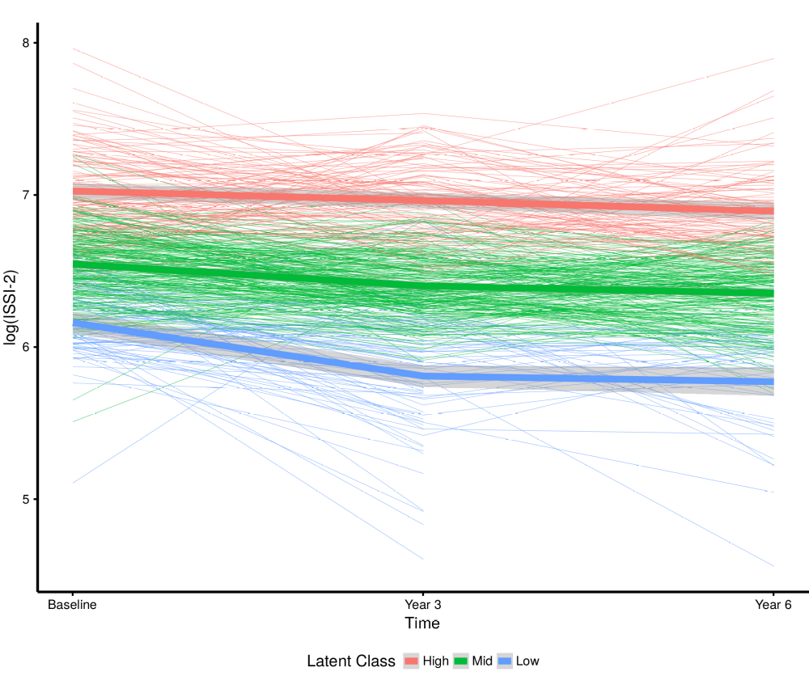
ESM Fig. 4: Latent class mixed model (LCMM) analysis to identify individual classes of trajectories for log(ISSI-2) over the 6 years in the PROMISE cohort. LCMM is a technique that identifies groups of participants that share a similar underlying trajectory in beta-cell function over the 6 years (e.g. no change compared to declines in ISSI-2). Red lines indicate individuals with a high beta-cell function who stayed high, green represents those in the middle, and blue represents those who had the lowest beta-cell function.
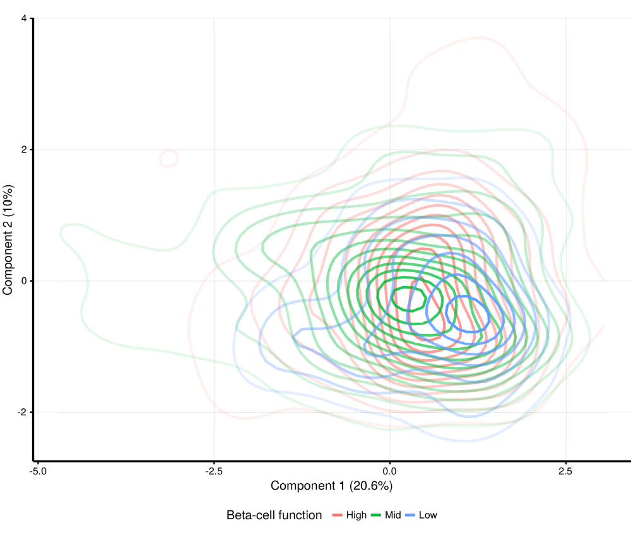
ESM Fig. 5: Clustering of extracted components from the partial least squares discriminant analysis (PLS-DA) on the classes extracted from the latent class mixed model (LCMM) in 463 participants from the baseline PROMISE visit (2004-2006). See the ESM Methods for a description of PLS-DA and interpreting this plot. The percent explained variance of each component is shown in brackets on each axis. Red, green, and blue lines indicate participants classified as high, middle, and low for beta-cell function, respectively, from the LCMM analysis. See ESM Fig. 9 for a hypothetical example plot showing good discriminatory ability between groups.
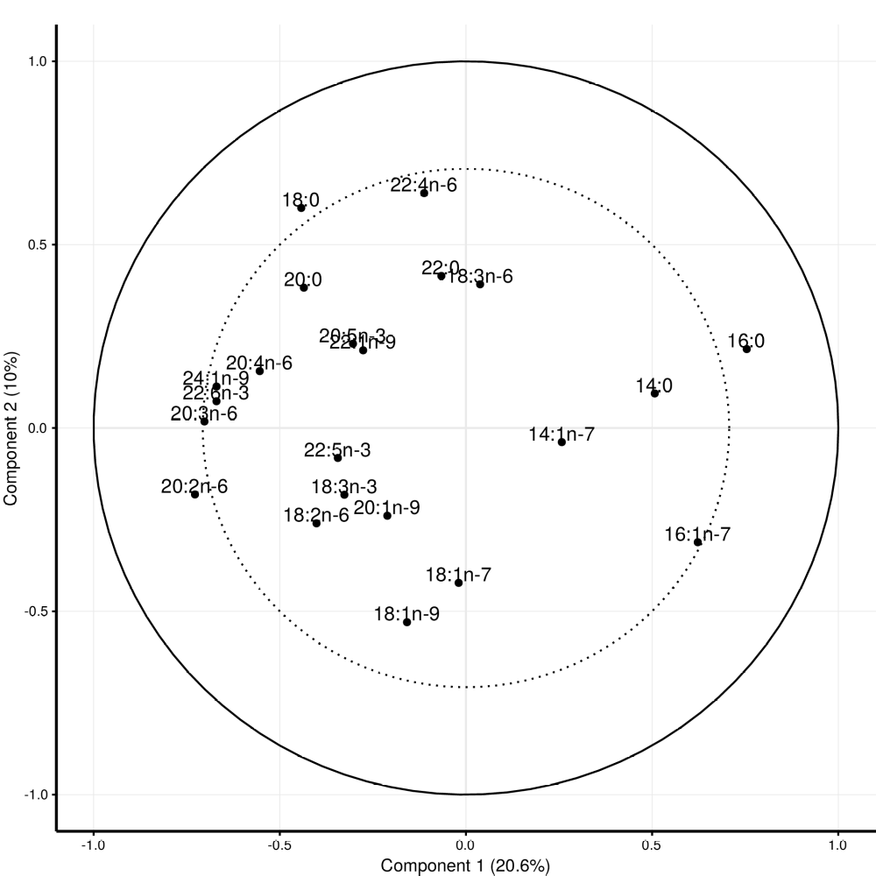
ESM Fig. 6: Pattern loadings from partial least squares discriminant analysis (PLS-DA) to identify potential clusters of NEFA composition within the classes extracted from the latent class mixed model in 463 participants from the baseline PROMISE visit (2004-2006). The percent explained variance of each component is shown in brackets on each axis. The solid line represents an explained variance of 100% while the dashed line represents an explained variance of 50%. See the ESM Methods for a description of PLS-DA and an explanation of interpreting this plot.
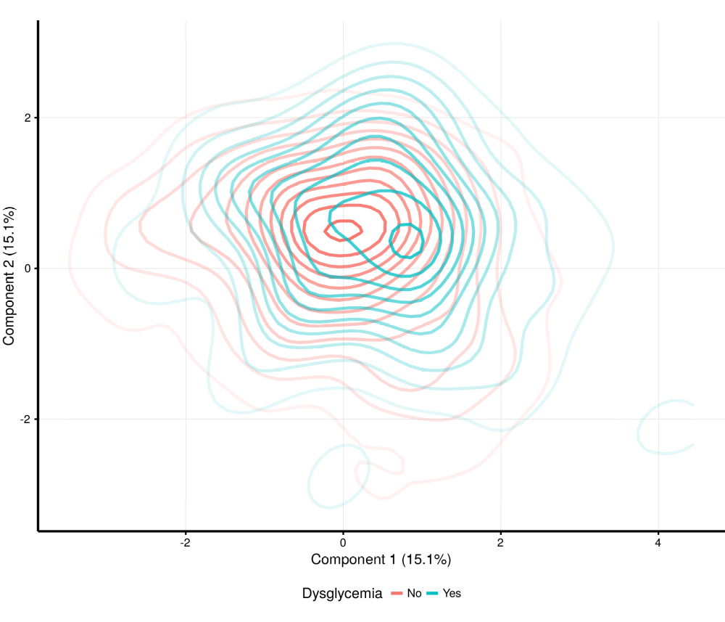
ESM Fig. 7: Clustering of extracted components from the partial least squares discriminant analysis for dysglycemia (IFG, IGT, DM) conversion status over the 6-years in the participants from the baseline PROMISE visit (2004-2006). See the ESM Methods for a description of PLS-DA and interpreting this plot. The percent explained variance of each component is shown in brackets on each axis. Blue lines indicate dysglycemia conversion or maintanence and red lines indicate no dysglycemia status. See ESM Fig. 9 for a hypothetical example plot showing good discriminatory ability between groups.
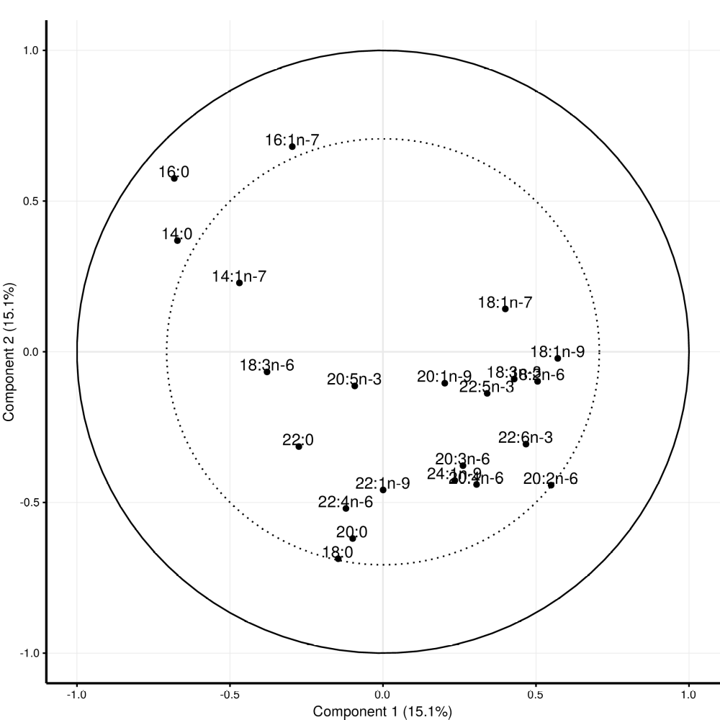
ESM Fig. 8: Pattern loadings from partial least squares discriminant analysis (PLS-DA) to identify potential clusters of NEFA composition for dysglycemia (IFG, IGT, DM) conversion status over the 6-years in the participants from the baseline PROMISE visit (2004-2006). See the ESM Methods for a description of PLS-DA and an explanation of interpreting this plot. The percent explained variance of each component is shown in brackets on each axis. The solid line represents an explained variance of 100% while the dashed line represents an explained variance of 50%.
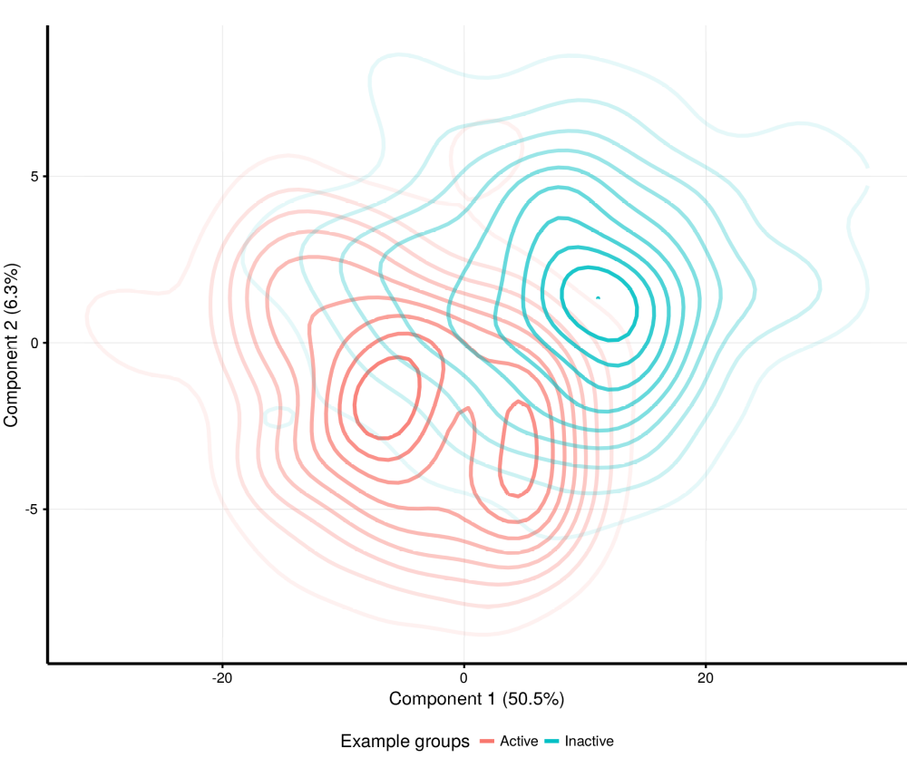
ESM Fig. 9: Example results of a high discriminatory ability to classify groups accurately when using partial least squares discriminatory analysis (PLS-DA). Discriminatory ability is evident from the amount of separation between the two groups. In this case, PLS-DA was 82% accurate at correctly classifying groups. See the ESM Methods for a description of PLS-DA and for interpreting this plot.

