# Title page

Title: Total non-esterified fatty acids, but not composition, predict progression in beta-cell dysfunction: The Prospective Metabolism and Islet Cell Evaluation (PROMISE) cohort

Running title: NEFA and the pathogenesis of diabetes

Author: Luke W. Johnston, Stewart Harris, Ravi Retnakaran, Bernard Zinman, Zhen Liu, Richard P. Bazinet, Anthony J. Hanley

Affiliation:

Corresponding author:

* Name: Anthony J. Hanley
* Current address:
* Phone number:
* Fax number:
* Email: [anthony.hanley@utoronto.ca](mailto:anthony.hanley@utoronto.ca)

Word count: 3527 / 4000

Table and figure count: 3 / 4

# Abstract

Objective:

Research Design and Methods:

Results:

Conclusions:

# Background

Total non-esterified fatty acids (NEFA) have been well documented to influence the pathogenesis of type 2 diabetes mellitus. Experimental work has shown that exposure to high concentrations of NEFA can induce insulin resistance in insulin-sensitive tissues such as muscle and liver, and in addition can impair pancreatic beta-cell production of insulin (1,2). Epidemiological and clinical studies have reported concordant findings, showing in particular that elevated total plasma NEFA associates with increased risk for incident type 2 diabetes (3,4).

Much of the previous experimental work on the role of NEFA in type 2 diabetes utilized individual fatty acid species such as palmitic acid (16:0) or oleic acid (18:1n-9), or alternatively, used specific oils such as soybean oil as the exposure to characterize the impact of total NEFA. However, fatty acids comprise multiple classes of molecules with diverse physiological functions, and few studies have compared the effects of a broader spectrum of fatty acids. Notably, one study suggests that eicosapentaenoic acid (20:5n-3) can protect against the lipotoxic effect of palmitic acid in the beta-cells (5).

Despite a sizable literature studying the role of total NEFA concentrations in diabetes, there are important gaps in the research. In particular, there have been few long term studies in humans that have examined a range of NEFA species. The majority of previous studies have utilized animal models or cell lines, have been short term human infusion trials, or have been epidemiological studies that only looked at total NEFA (and not individual species). To date, there have been no longitudinal studies examining the role of the composition of the NEFA blood lipid fraction on the pathogenesis of diabetes, which is critical to understanding associations at a more granular level given the protracted natural history of diabetes and the growing appreciation of the divergent effects of individual fatty acid species. Therefore, our research objective was to examine the association of serum NEFA composition on changes over time in insulin sensitivity and beta-cell function in a longitudinal cohort. We hypothesized that higher palmitic acid and lower polyunsaturated fatty acids such as eicosapentaenoic acid would associate with worsening (or declining) insulin sensitivity and beta-cell function over 6 years.

# Subjects and Methods

Participants from London and Toronto, Canada, were recruited into the Prospective Metabolism and Islet cell Evaluation (PROMISE) cohort. Eligibility for recruitment into PROMISE required having one or more risk factors for type 2 diabetes mellitus, including obesity, hypertension, family history of diabetes, and/or a history of gestational diabetes or birth of a macrosomic infant. Participants aged 30 years and older (n=736) attended the baseline visit between 2004-2006. Follow-up examinations in this cohort occur every three years, with three examination visits completed to date (2004-2006, 2007-2009, and 2010-2013). The current study used data on participants who did not have diabetes at baseline, who returned for one or more follow-up examinations, and who had samples available for fatty acid measurements (n=477). A diagram of the sample size at each visit is shown in Supplemental Figure S1. At each examination, participants undergo metabolic characterization, anthropometric measurements, and questionnaires on lifestyle and sociodemographics. Research ethics approval was obtained from Mount Sinai Hospital and the University of Western Ontario, and all participants provided written informed consent. Data collection methods were standardized across the 2 centres and research nurses were centrally trained.

## Blood measure assessments

At each examination, an 8-12 hour fasting blood sample was draw from each participant, followed by a 75g oral glucose tolerance test (OGTT) with a 30 minute and 2 hour blood draw. All blood samples were processed and frozen at -70°C. Alanine aminotransferase (ALT) was measured using standard laboratory procedures. Cholesterol, HDL, and triglycerides (TG) were measured using Roche Modular's enzymatic coloimetric tests (Mississauga, ON). Both specific insulin and glucose were derived from the OGTT at fasting, 30 minute, and 2 hour time points. Specific insulin was measured using the Elecsys 1010 (Roche Diagnostics, Basel, Switzerland) immunoassay analyzer and electrochemiluminescence immunoassay. This assay shows 0.05% cross-reactivity to intact human pro-insulin and the Des 31,32 circulating split form (Linco Res. Inc), and has a CV of 9.3%. Glucose was determined using an enzymatic hexokinase (Roche Modular, Roche Diagnostics) with a detection range of 0.11 (2 mg/dL) to 41.6 mmol/L. The inter-assay %CV is <1.1% and intra-assay %CV is < 1.9%. All assays were performed at the Banting and Best Diabetes Centre Core Lab at Mt Sinai Hospital, Toronto. Impaired fasting glucose (IFG), impaired glucose tolerance (IGT), and diabetes were categorized using the 2006 WHO criteria (6).

NEFA composition was quantified using stored fasting serum samples from the baseline visit, which had been frozen at -70°C for 4-6 years and had not been exposed to any freeze-thaw cycles. Serum fatty acids have been documented to be stable at these temperatures for up to 10 years (7). A known amount of heptadecanoic acid (17:0) {{confirm}} was added to the serum as an internal standard prior to extracting total lipids according to the method of Folch (8). Each serum lipid fraction (NEFA, cholesteryl ester, phospholipid, and triacylglycerol) was isolated using thin layer chromatography; each fractionwas visualized under UV light after lightly spraying with 8-anilino-1-naphthalene sulfonic acid (0.1% wt/vol) and then converted to fatty acid methyl esters with 14% boron trifluoride in methanol at 100°C for 1 h. Fatty acid methyl esters were separated and quantified using a Varian-430 gas chromatograph (Varian, Lake Forest, CA, USA) equipped with a Varian Factor Four capillary column and a flame ionization detector, which were injected in splitless mode. Fatty acid concentrations (nmol/ml) were calculated by proportional comparison of gas chromatography peak areas to that of the internal standards (9,10). There were 22 fatty acids measured in the NEFA fraction. Given the diverse biology, as well as the complexity of the analyses, findings for other lipid fractions in this cohort are reported separately (see {{pl and ce paper}} for the analysis of the phospholipid and cholesteryl ester fractions).

## Outcome variables

Insulin sensitivity and beta-cell function indices were computed using the OGTT glucose and insulin data. Insulin sensitivity was assessed using 1/HOMA-IR (1 divided by HOMA-IR) (11) and the Insulin Sensitivity Index (ISI) (12). HOMA-IR largely reflects hepatic insulin resistance, while ISI reflects whole-body insulin sensitivity (13). Beta-cell function was assessed using the Insulinogenic Index (14) over HOMA-IR (IGI/IR) and the Insulin Secretion-Sensitivity Index-2 (ISSI-2) (15). IGI/IR is a measure of the first phase insulin secretion while ISSI-2 is analogous to the disposition index (but using OGTT variables). Each index has been validated against gold standard measures (11,12,15).

## Anthropometrics and sociodemographics

Height, weight, and waist circumference (WC) were measured at all clinic examinations using standard procedures. WC was measured at the natural waist, defined as the narrowest part of the torso between the umbilicus and the xiphoid process. BMI was calculated by dividing weight (kg) by height (m) squared. Sociodemographic information including age, sex, and ethnicity, were determined using questionnaires administered at each examination. In the lifestyle questionnaire, physical activity was determined using a version of the Modifiable Activity Questionnaire (MAQ) (16). The MAQ collects information on leisure and occupational activity, including intensity, frequency, and duration, over the past year. Each reported activity from the MAQ was weighted by its metabolic intensity allowing for the estimation of MET-hours per week.

## Statistical analysis

The primary outcome variables for this analysis were 1/HOMA-IR, ISI, IGI/IR, and ISSI-2; outcome variables were log-transformed for the statistical modeling. The primary predictor variables for this study were 22 individual NEFA species, analysed as mole percent (mol%) of the total fraction and as concentration (nmol/mL). Pearson correlation coefficients were computed to assess relationships of individual NEFA with other continuous variables.

For the primary analysis, generalized estimating equation (GEE) models (17) were used to determine the longitudinal associations between the outcome variables and the predictor variables. Given the longitudinal design an auto-regressive (AR1) correlation matrix was chosen for the GEE models, though other matrices (eg. exchangeable) had similar fit (data not shown). GEE is well suited to longitudinal cohort studies given it's capacity to handle missed visits. The predictor variables and continuous covariates were scaled (mean centered and standardized). The NEFA variables were classified as *time-independent* (held constant) as they were measured only at the baseline visit, while the outcome variables and covariates were set as *time-dependent*. No imputation was conducted on missing values.

Covariate selection was based on previous literature, directed acyclic graph (18) recommendations, and quasi-likelihood information criterion (QIC). Supplemental Table S1 shows the covariates compared using QIC and Supplemental Figure S9 shows the specified directed acyclic graph. The final GEE model we selected differed between insulin sensitivity and beta-cell function models. For insulin sensitivity, we adjusted for time, sex, ethnicity, baseline age, WC, ALT, MET, alcohol intake, and family history of diabetes (M6). For beta-cell function, the last few models were comparable in performance, so we report results from the simplest model (M8), adjusting for time, sex, ethnicity, baseline age, WC, ALT, and family history of diabetes. After scaling, log-transforming, and exponentiating the GEE estimates, the GEE results are interpreted as an expected percent difference in the outcome variable for every SD increase in the predictor variable given the covariates are held constant. While models with a time interaction did not perform better than those without in terms of QIC (M6.1 and M8.1) in Supplemental Table S1, we ran models with a time by predictor term for each of the NEFA to test if there was an interaction by time. Given that TG is a risk factor for diabetes and that NEFA contribute to TG production, TG may act as a mediator between NEFA and the outcomes. However, only a subset of the participants at the 6-yr visit had clinically measured TG. To determine the role of TG in the association between NEFA and the outcomes, TG was included in the GEE model as a sensitivity analysis. Lastly for the GEE models, we tested for an interaction with sex or ethnicity by the predictor term for each outcome variable.

While GEE accounts for the longitudinal design of the data, this approach is limited in that it cannot analyze the inherent multivariate nature of the composition of the NEFA fraction. As such, after running the GEE models for the longitudinal analysis, partial least squares discriminant analysis (PLS-DA) was used to identify the patterns of NEFA composition against beta-cell function (using ISSI-2, which had most of the associations in the GEE models) and for those who converted to or maintained dysglycemia status (either IFG, IGT, or DM) over the 6 years. Since PLS-DA can't handle longitudinal data, the longitudinal data was included by extracting latent trajectories of beta-cell function (ISSI-2) over the 6 years using latent class mixed models (LCMM). A limitation of these methods, excluding LCMM, is that they can not be adjusted for covariates.

All analyses were performed using R 3.2.4 (19), along with the R packages geepack 1.2.0.1 for GEE (20), caret 6.0.64 for PLS-DA, and lcmm 1.7.5 for LCMM. The R code for this manuscript is available at {{link}}. Results were statistically significance at p<0.05, after adjusting for multiple testing using the Benjamini-Hochberg False Discovery Rate (21).

# Results

## Basic characteristics of the PROMISE cohort

Within this subset of the PROMISE cohort at the baseline visit, 349 (73%) were females and 337 (70.5%) had European-ancestry. The average age of the participants was 50.2 years (9.8 SD) and the average BMI was 31.1 (6.4 SD). Most of the subset of the cohort, 308 (64.8%), had a family history of diabetes. The primary outcome variables had a significant median decline between 14.4% to 26.4% (p<0.001) over the 6 years in this subset of the PROMISE cohort. Consistent with this decline, there were 42 (9%) participants who developed diabetes while 96 (20%) participants either converted to or maintained IFG or IGT status over the 6 years.

Figure 1 shows the distribution of the NEFA composition. Four individual NEFA made up the vast majority (89.3%) of the total NEFA fraction. The largest contributors were 18:1n-9 (36.6%), 16:0 (23.5%), 18:0 (15.2%), and 18:2n-6 (14%). All individual NEFA as well as the total fraction had correlations which ranged from weak to null (r<0.3) with the basic characteristics (see Supplemental Figure S2).

## GEE modeling

Several associations were seen in the unadjusted GEE models (see Supplemental Figure S3), particularly for the concentration data. Full model adjustment (Figure 2) attenuated most of these associations, where total NEFA, 16:0, and 18:2n-6 (all as nmol/mL) had negative associations between IGI/IR and ISSI-2. The magnitude of association for each of these variables was fairly consistent for each beta-cell function measure. For every one SD decrease in any of these three NEFA variables, there was an average predicted 8.4% lower IGI/IR and 4.1% lower ISSI-2 at each clinic visit. None of the NEFA variables as a mol% had any association with the outcomes. Adjusting for TG attenuated all associations with IGI/IR and ISSI-2 (data not shown), though sample size at the 6 year visit is restricted to n=128 in those who had TG measured. There were no significant interaction effects between time, sex, or ethnicity and the individual NEFA on any of the outcome measures (data not shown). Raw values from the GEE models are shown in Supplemental Table S3 for unadjusted models and Supplemental Table S2 for fully adjusted models.

## Latent trajectory and NEFA pattern recognition

Three latent classes were extracted from LCMM, with 270 participants in the high, 119 in the middle, and 84 in the low beta-cell function groups. The trajectories of the three groups are shown in Supplemental Figure S4. These groups were used as the beta-cell function response variables in the PLS-DA analysis. The PLS-DA results show a very poor discriminatory ability of the NEFA composition in classifying participants into the correct beta-cell function latent class. Only 272 (57.5%) participants were correctly classified, primarily into the middle group. The specific NEFA composition was not able to accurately classify participants who had low or high beta-cell function. Supplemental Figure S5 shows the loadings of individual NEFA by the extracted component and Supplemental Figure S6 shows the clustering of the components by ISSI-2 latent class. The PLS-DA analysis using dysglycemia status conversion or maintenances as the response variable showed similar poor discriminatory ability, though better than the beta-cell function trajectory results. While 347 (72.6%) participants were classified correctly based on dysglycemia status, examining the clustering of the NEFA composition showed poor discrimination between groups (see Supplemental Figure S7 and Supplemental Figure S8).

# Discussion

In a Canadian population of adults who are at-risk for diabetes, we found that higher total NEFA concentrations independently predicted a lower beta-cell function over 6 years. While we found negative associations with palmitic acid (16:0), oleic acid (18:1n-9), and linoleic acid (18:2n-6) modelled as a concentration (nmol/mL), no associations were seen for the proportion of these fatty acids and further clustering analysis found no predictive ability of these NEFA on beta-cell function or dysglycemia. These observations suggest that the absolute size of the total NEFA fraction, rather than the specific composition of any individual NEFA, likely influences the pathogenesis of diabetes.

The role of total NEFA in the etiology of diabetes is a well-studied area of research. Epidemiological studies have shown that higher NEFA associate with lower insulin secretion and a higher risk for developing diabetes (4,22). In a cross-sectional analysis of the RISCK cohort, total NEFA had a negative association with insulin sensitivity and a particularly strong negative association with beta-cell function (23). Experimentally, several potential mechanisms have been elucidated for the role of NEFA on beta-cell function, particularly for palmitic acid. Prolonged exposure to elevated NEFA can induce apoptosis in the beta-cells, possibly through endoplasmic reticulum stress, formation of ceramides, and generation of nitric oxide, as well as impairment of proinsulin production and mitochondrial function (2,24–27). The present analysis is the first study to our knowledge to examine the longitudinal association of a broad spectrum of individual NEFA species (?)on beta-cell function in a large cohort. We found that there was a strong signal of higher total NEFA, palmitic acid, oleic acid, and linoleic acid as concentrations with lower beta-cell function. However, in modelling these fatty acids as mol%, and using novel clustering analysis approaches, no individual or specific fatty acid species in the NEFA fraction predicted lower beta-cell function, insulin sensitivity, or dysglycemia status. Taken together, these results suggest that it is the absolute size of the circulating NEFA fraction, irrespective of any specific composition of fatty acid species, that is responsible for the hypothesized lipotoxic effects of NEFA on the beta-cells.

Biologically, within a free-living population chronic elevation of NEFA may be mediating it's association through TG. In normal metabolism, NEFA enters the liver and assists in the production of TG that is to be processed into very-low density lipoproteins (VLDL) (28). As such higher NEFA may contribute to hypertriglyceridemia, which is a known risk factor for diabetes. In the sensitivity analysis adjusting for TG, all associations with beta-cell function were attenuated, suggesting that NEFA may in fact be mediating it's association through TG. However, a major limitation to the TG-adjusted GEE models is the reduced sample size in the 6 year visit, as only a subset (n=128) of participants had TG measured.

There is substantial experimental evidence highlighting the role of increased NEFA and the subsequent increase in insulin resistance via impairment of insulin signaling cascades (reviewed in previously published articles (29–32)). However, in this longitudinal analysis, we saw no association of any individual or total NEFA with hepatic (1/HOMA-IR) or whole-body insulin sensitivity (ISI). There are some possible explanations for these findings. Previous studies done *in vivo* were mostly short term infusion protocols (5,27,33,34) or pharmocologic (3,35) trials and the observational research was generally cross-sectional or correlational (23,36–38). The short time periods of these studies and the experimentally-induced elevations in NEFA concentrationsmake it difficult to assess the causal role in non-experimental environments over long time frames. Moreover, some studies have found null or weak associations of NEFA and IR (23,34,39,40), suggesting that either NEFA has only a minor role in IR or that NEFA is the effect, but not cause, of the underlying IR. Adipose tissue, which release NEFA during fasting, can become insulin resistant and thus lipolysis of intracellular TG by hormone-sensitive lipase may not respond to the inhibitory action of insulin. As such, IR may develop before elevations in blood NEFA. There is also evidence to suggest that insulin may be involved in NEFA uptake (41), further supporting the hypothesis that elevated NEFA is a consequence of higher IR. However, we could not examine this potential hypothesis as NEFA was only collected at the baseline visit.

There are two other possible explanations for our null findings for the insulin sensitivity measures. First, there may be differences in physiology between fasting and postprandial NEFA kinetics. For instance, some experimental studies using clamp protocols found that fasting NEFA was a weak predictor of insulin sensitivity compared to postprandial concentrations of NEFA (34,40). Inefficiencies in NEFA uptake into the adipose tissue following postprandial TG lipolysis via lipoprotein lipase may result in NEFA spillover into the blood and a subsequent increase in circulating NEFA (42), which may be more metabolically active given postprandial activity. Second, the null findings may be due to the high risk population examined in PROMISE. It may be that in this population, IR has become well established and NEFA may not contribute to IR at this somewhat more advanced stage in the pathogenesis of diabetes.

Few studies have examined the composition of NEFA on metabolic functioning. One recent, well-analyzed study used a variety of advanced fatty acid measurement and statistical techniques to explore the multivariate relationship between the NEFA composition and components of the metabolic syndrome (MetS) (43). Specifically, the authors identified NEFA 16:1n-9, 20:1n-9, and 22:4n-6 to correlate with components of the MetS. Another similar study examining diabetes found that 16:0, 18:0, 18:1, 18:2, 18:3 may be useful biomarkers for identifying healthy compared to diabetic individuals (44). However, in both studies, major limitations were the smaller sample sizes (approximately 100 subjects) and the cross-sectional design.

There are a few important limitations to our study. NEFA were only quantified at the baseline visit and as such we cannot investigate whether there were concomitant changes in NEFA and the metabolic measures. However, we believe this is a strength for our specific objective, as the chance of reverse causality is reduced given that fatty acid and glucose metabolism pathways are tightly integrated. This is also an observational cohort, and there may be some residual confounding we haven't considered or that couldn't be measured. Nonetheless, we were as thorough as possible in understanding and minimizing potential confounding. Finally, our cohort consists of individuals at-risk for diabetes, who are primarily female of European-ancestry and as such our results may not be generalizable to other populations. However, given these limitations, our study also has several strengths, including the longitudinal design and the rigorous statistical techniques and methods applied, which are specifically suited to investigating temporal relationships and to handling the multivariate nature of the data. Lastly, our cohort contains highly detailed and comprehensive variable measurements at each collection visit, and has both concentration and mol% data for the fatty acids.

In conclusion, we found that total NEFA was a strong predictor for lower beta-cell function over 6 years, irrespective of the specific composition of the NEFA fraction. While future studies are needed to confirm these findings, given the cost and labour involved in quantifying the NEFA composition, our results suggest that further research on the NEFA composition may not be as fruitful and cost-effective then if the simpler, easy to measure total NEFA concentration was used.

## Acknowledgements

The authors thank Jan Neuman, Paula Van Nostrand, Stella Kink, and Annette Barnie of the Leadership Sinai Centre for Diabetes, Mount Sinai Hospital, Toronto, Canada and Sheila Porter and Mauricio Marin of the Centre for Studies in Family Medicine, University of Western Ontario, London, Canada for their expert technical assistance and dedication in their work for PROMISE. The authors had the following responsibility: LWJ conducted research, analyzed data, and wrote the paper; RR, ZL, BZ, and SBH designed research, conducted research, and provided essential materials (infrastructure and clinical resources); RR, BZ, SBH, RPB, and AG provided intellectual feedback on the paper; RPB conducted research, provided essential reagents and materials; AJH designed research, assisted with interpretation, and provided intellectual feedback on all versions of the paper; LWJ and AJH had primary responsibility for final content. All authors read and approved the final manuscript. The authors report no potential conflicts of interest relevant to this study.

# Tables

Table 1: Basic characteristics of the PROMISE participants at each of the 3 clinic visits.

|  |  |  |  |
| --- | --- | --- | --- |
| Measure | Baseline | 3-yr | 6-yr |
| HOMA-IR | 13.1 (8.5-22.1) | 16.3 (10-27.1) | 16.6 (10.8-26.1) |
| IGI/IR | 7.1 (4.2-10.6) | 5.6 (3.6-9.8) | 5.6 (3.5-9) |
| ISI | 13.6 (8.7-21.8) | 11.6 (6.9-19.1) | 11.6 (7.5-17.5) |
| ISSI-2 | 727.5 (570-922.5) | 613.4 (493.9-836.7) | 622.6 (474-811.8) |
| Age (yrs) | 50.2 (9.8) | 53.2 (9.7) | 56.3 (9.5) |
| NEFA (nmol/mL) | 383.4 (116.4) | - | - |
| BMI (kg/m2) | 31.1 (6.4) | 31.4 (6.5) | 31.1 (6.6) |
| Chol (mmol/L) | 5.2 (0.9) | 5.1 (1.0) | 5.1 (0.9) |
| HDL (mmol/L) | 1.4 (0.4) | 1.3 (0.4) | 1.4 (0.4) |
| TAG (mmol/L) | 1.5 (0.8) | 1.4 (0.8) | 1.4 (0.7) |
| WC (cm) | 98.5 (15.5) | 99.3 (15.7) | 100.4 (15.7) |
| Ethnicity |  |  |  |
| - European | 337 (71%) | 336 (71%) | 299 (71%) |
| - Latino/a | 58 (12%) | 57 (12%) | 48 (11%) |
| - Other | 51 (11%) | 51 (11%) | 45 (11%) |
| - South Asian | 32 (7%) | 32 (7%) | 30 (7%) |
| Sex |  |  |  |
| - Female | 349 (73%) | 349 (73%) | 307 (73%) |
| - Male | 129 (27%) | 127 (27%) | 115 (27%) |

Note: Values are in median (IQR), mean (SD), and n (%).

# Figures

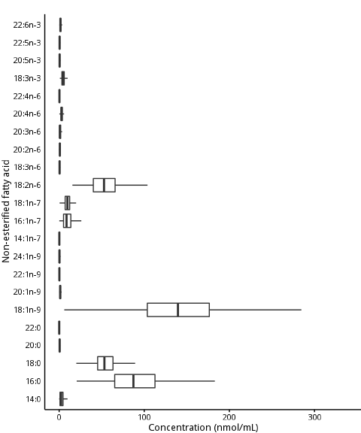

Figure 1: Concentrations (nmol/mL) of each non-esterified fatty acid in PROMISE participants at the baseline visit (2004-2006).

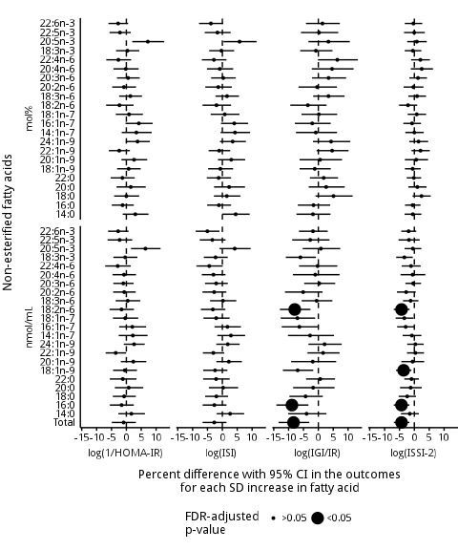

Figure 2: Longitudinal associations of individual non-esterified fatty acids (mol% and nmol/mL) with insulin sensitivity and beta-cell function using generalized estimating equations over the 6 years in the PROMISE cohort. Adjusted for time, sex, ethnicity, baseline age, WC, ALT, and family history of diabetes (plus physical activity and alcohol intake for beta-cell function models). Outcome variables were log-transformed, predictor variables were scaled, and x-axis values were exponentiated to represent percent difference per SD increase in the fatty acid. P-values were adjusted for the BH false discovery rate, presented as the dot size.

# Supplemental Material

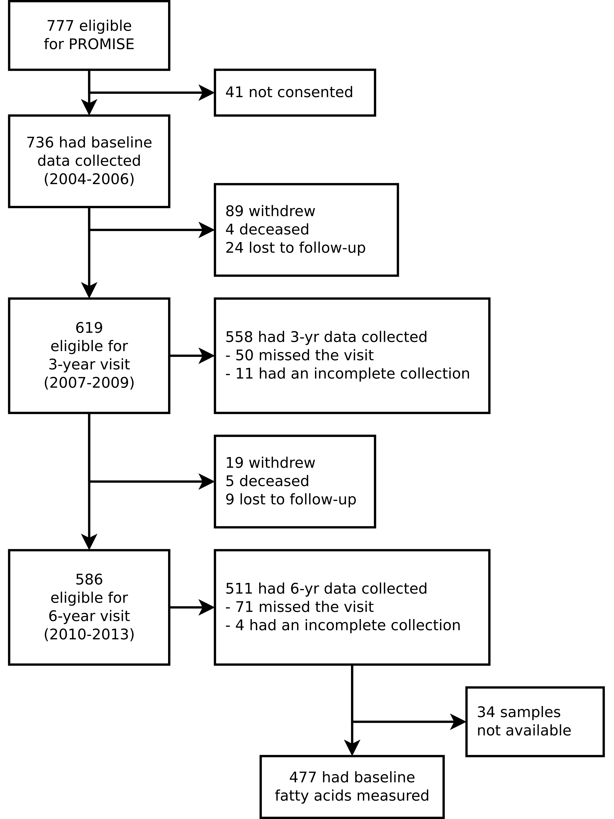

Supplemental Figure S1: CONSORT diagram of sample size at each examination visit.

Supplemental Table S1: Comparing generalized estimating equation models adjusting for different covariates using Quasi-Likelihood Information Criterion.

|  |  |  |
| --- | --- | --- |
| Model | QIC | Delta |
| **log(ISI)** |  |  |
| M4 | -1581.0 | 0.0 |
| M5 | -1580.8 | 0.2 |
| M6 | -1580.2 | 0.7 |
| M6.1 | -1579.8 | 1.2 |
| M3 | -1574.0 | 7.0 |
| M2 | -1571.2 | 9.7 |
| M1 | -1536.9 | 44.1 |
| M0 | -1049.8 | 531.2 |
| **log(ISSI-2)** |  |  |
| M8.1 | -2475.3 | 0.0 |
| M8 | -2474.2 | 1.1 |
| M7 | -2474.1 | 1.2 |
| M5 | -2471.1 | 4.2 |
| M6 | -2470.2 | 5.1 |
| M2 | -2468.8 | 6.5 |
| M3 | -2466.8 | 8.4 |
| M4 | -2465.5 | 9.8 |
| M1 | -2454.9 | 20.4 |
| M0 | -2137.3 | 338.0 |

Given the number of possible combinations of outcome and predictor variables, only ISI and ISSI-2 with total non-esterified fatty acids (nmol/mL) were used to compare various GEE models and to select a final model. Baseline age was used as including both the original age and the time variable would result in collinearity. Column names: QIC is the quasi-likelihood information criteria (smaller values, eg. larger negative values, indicate a better fit compared to other models), Delta is the QIC minus the lowest QIC (models with delta <10 are considered equivalent). Models were:

* M0: log(ISSI-2) or log(ISI) = total non-esterified fatty acids (nmol/mL) + time
* M1: M0 + waist + sex + ethnicity + baseline age
* M2: M1 + ALT
* M3: M2 + physical activity
* M4: M3 + alcohol intake
* M5: M4 + family history of diabetes
* M6: M5 + smoking status
* M6.1: M6 + time by NEFA interaction
* M7: M2 + family history of diabetes + smoking status
* M8: M2 + family history of diabetes
* M8.1: M8 + time by NEFA interaction

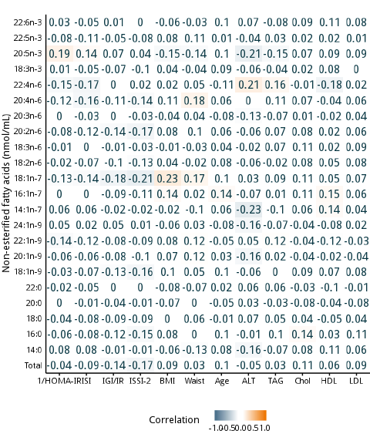

Supplemental Figure S2: Pearson correlation heatmap of non-esterified fatty acids (nmol/mL) and basic PROMISE participant characteristics for the baseline visit (2004-2006). Darkness of the colour indicates the magnitude of the correlation, with blue indicating positive and orange indicating negative correlations.

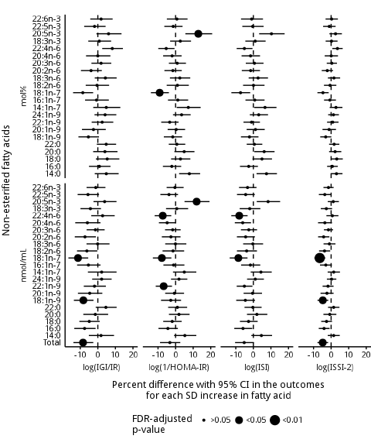

Supplemental Figure S3: Unadjusted generalized estimating equation modeling of the longitudinal association of individual non-esterified fatty acids (mol% and nmol/mL) with insulin sensitivity and beta-cell function over 6 years in the PROMISE cohort. Models are only adjusted for time. Outcome variables were log-transformed, predictor variables were scaled, and x-axis values were exponentiated to represent percent difference per SD increase in the fatty acid. P-values were adjusted for the BH false discovery rate, presented as the dot size.

Supplemental Table S2: Longitudinal associations of individual non-esterified fatty acids (mol% and nmol/mL) with insulin sensitivity and beta-cell function using generalized estimating equations over the 6 years in the PROMISE cohort. Adjusted for time, sex, ethnicity, baseline age, WC, ALT, and family history of diabetes (plus physical activity and alcohol intake for beta-cell function models). Outcome variables were log-transformed, predictor variables were scaled, and x-axis values were exponentiated to represent percent difference per SD increase in the fatty acid. P-values were adjusted for the BH false discovery rate, indicated by asterisk.

|  |  |  |  |  |
| --- | --- | --- | --- | --- |
| Fatty acid | log(1/HOMA-IR) | log(ISI) | log(IGI/IR) | log(ISSI-2) |
| **nmol/mL** |  |  |  |  |
| 14:0 | 3.0 (-1.2, 7.4) | 4.5 (0.0, 9.2) | -1.8 (-7.3, 4.1) | -0.5 (-3.3, 2.4) |
| 16:0 | -1.3 (-4.9, 2.5) | -1.2 (-5.1, 2.9) | -1.6 (-6.9, 4.0) | -0.6 (-3.2, 2.1) |
| 18:0 | 0.0 (-4.1, 4.3) | 1.5 (-2.8, 6.0) | 5.1 (-1.0, 11.5) | 2.4 (-0.6, 5.5) |
| 20:0 | 1.5 (-3.3, 6.5) | 2.3 (-2.8, 7.6) | 2.6 (-3.2, 8.9) | 1.0 (-2.0, 4.1) |
| 22:0 | -1.3 (-5.3, 2.8) | -1.2 (-5.2, 2.9) | 1.8 (-2.8, 6.6) | -0.2 (-2.6, 2.3) |
| 18:1n-9 | 0.8 (-3.1, 4.8) | -0.7 (-4.8, 3.6) | -1.2 (-6.3, 4.2) | -0.6 (-3.2, 2.1) |
| 20:1n-9 | 2.6 (-1.7, 7.0) | 3.0 (-1.5, 7.7) | 0.6 (-6.3, 8.0) | 0.6 (-3.2, 4.6) |
| 22:1n-9 | -2.4 (-5.9, 1.2) | -1.1 (-4.6, 2.6) | 4.6 (-0.6, 10.1) | 2.1 (-1.0, 5.2) |
| 24:1n-9 | 3.8 (-0.2, 7.9) | 3.5 (-0.8, 7.9) | 4.3 (-1.8, 10.7) | 1.4 (-1.7, 4.6) |
| 14:1n-7 | 3.4 (-1.6, 8.5) | 4.3 (-0.6, 9.3) | -0.9 (-7.5, 6.3) | 0.0 (-3.0, 3.2) |
| 16:1n-7 | 4.2 (-0.3, 8.9) | 4.0 (-0.5, 8.7) | -2.1 (-7.9, 4.2) | -0.8 (-3.7, 2.2) |
| 18:1n-7 | 0.9 (-3.6, 5.6) | 0.8 (-3.9, 5.7) | 0.2 (-5.7, 6.3) | 0.8 (-2.3, 4.0) |
| 18:2n-6 | -2.3 (-6.8, 2.4) | -2.0 (-6.7, 2.9) | -3.5 (-9.4, 2.8) | -2.1 (-5.1, 1.0) |
| 18:3n-6 | 1.3 (-2.4, 5.2) | 1.6 (-2.3, 5.6) | 3.4 (-1.7, 8.8) | 0.9 (-2.0, 3.9) |
| 20:2n-6 | -0.8 (-4.7, 3.3) | -1.4 (-5.7, 3.2) | -0.4 (-6.7, 6.3) | -0.3 (-3.6, 3.0) |
| 20:3n-6 | 0.6 (-3.2, 4.5) | 0.3 (-3.8, 4.5) | 3.5 (-2.1, 9.3) | 1.2 (-1.7, 4.2) |
| 20:4n-6 | -0.2 (-4.3, 4.1) | -0.9 (-5.2, 3.6) | 4.6 (-2.2, 11.8) | 2.5 (-1.2, 6.3) |
| 22:4n-6 | -2.7 (-6.8, 1.6) | -2.8 (-6.9, 1.4) | 6.4 (-0.1, 13.3) | 2.0 (-1.1, 5.2) |
| 18:3n-3 | 0.4 (-3.5, 4.3) | -0.3 (-4.4, 4.0) | -0.8 (-6.1, 4.8) | -0.5 (-3.2, 2.4) |
| 20:5n-3 | 7.2 (2.0, 12.7) | 5.8 (0.4, 11.5) | 3.4 (-3.3, 10.6) | 0.8 (-2.4, 4.2) |
| 22:5n-3 | -2.1 (-5.7, 1.5) | -1.7 (-5.9, 2.8) | 0.2 (-5.9, 6.7) | 0.0 (-3.5, 3.5) |
| 22:6n-3 | -2.8 (-6.0, 0.6) | -3.9 (-7.8, 0.3) | 1.4 (-4.2, 7.2) | -0.3 (-3.2, 2.7) |
| **mol%** |  |  |  |  |
| Total | -0.9 (-4.9, 3.2) | -2.7 (-6.6, 1.4) | -8.3 (-13.4, -3.0)* | -4.3 (-6.9, -1.7)* |
| 14:0 | 1.7 (-2.7, 6.2) | 2.6 (-1.9, 7.3) | -4.0 (-10.2, 2.7) | -1.5 (-4.5, 1.5) |
| 16:0 | -1.6 (-5.5, 2.5) | -2.7 (-6.6, 1.4) | -8.9 (-14.1, -3.3)* | -4.3 (-6.9, -1.7)* |
| 18:0 | -0.8 (-4.6, 3.2) | -2.0 (-5.8, 1.9) | -4.3 (-9.7, 1.5) | -2.4 (-5.3, 0.6) |
| 20:0 | 0.8 (-3.9, 5.7) | 0.3 (-4.5, 5.3) | -1.8 (-8.5, 5.5) | -1.2 (-4.8, 2.5) |
| 22:0 | -1.2 (-5.6, 3.4) | -2.1 (-6.5, 2.5) | 0.6 (-4.1, 5.6) | -1.0 (-3.4, 1.5) |
| 18:1n-9 | -0.5 (-4.5, 3.6) | -2.5 (-6.4, 1.7) | -7.0 (-11.9, -1.7) | -3.6 (-6.1, -1.0)* |
| 20:1n-9 | 2.3 (-1.8, 6.7) | 2.2 (-2.0, 6.6) | -1.9 (-9.2, 6.0) | -0.6 (-4.4, 3.3) |
| 22:1n-9 | -3.6 (-7.0, -0.1) | -3.0 (-6.6, 0.6) | 1.6 (-3.7, 7.1) | 0.3 (-2.5, 3.3) |
| 24:1n-9 | 2.6 (-0.9, 6.2) | 1.8 (-2.0, 5.8) | 2.1 (-3.3, 7.9) | 0.3 (-2.4, 3.1) |
| 14:1n-7 | 2.2 (-2.6, 7.1) | 2.9 (-1.7, 7.7) | -2.8 (-10.2, 5.3) | -0.8 (-3.9, 2.4) |
| 16:1n-7 | 2.0 (-2.4, 6.6) | 1.7 (-2.6, 6.2) | -6.4 (-12.3, 0.0) | -2.9 (-5.8, 0.1) |
| 18:1n-7 | -0.4 (-4.5, 4.0) | -2.1 (-6.4, 2.4) | -7.0 (-12.7, -1.1) | -3.4 (-6.3, -0.4) |
| 18:2n-6 | -1.6 (-5.6, 2.6) | -3.2 (-7.2, 1.0) | -7.9 (-12.9, -2.7)* | -4.3 (-6.9, -1.6)* |
| 18:3n-6 | 0.4 (-3.6, 4.7) | 0.2 (-4.1, 4.7) | -0.6 (-5.6, 4.7) | -1.3 (-3.8, 1.4) |
| 20:2n-6 | -0.7 (-4.4, 3.1) | -2.7 (-6.7, 1.4) | -5.1 (-11.2, 1.4) | -2.8 (-5.9, 0.5) |
| 20:3n-6 | -1.0 (-4.4, 2.5) | -2.1 (-5.8, 1.8) | 0.3 (-4.8, 5.7) | -0.4 (-3.0, 2.2) |
| 20:4n-6 | -0.8 (-4.6, 3.2) | -3.0 (-6.9, 1.1) | -1.0 (-8.6, 7.1) | -0.6 (-4.6, 3.7) |
| 22:4n-6 | -2.9 (-7.1, 1.5) | -4.4 (-8.7, 0.1) | -0.3 (-6.5, 6.4) | -1.1 (-4.3, 2.1) |
| 18:3n-3 | -0.4 (-4.4, 3.7) | -2.3 (-6.2, 1.8) | -6.0 (-10.9, -0.9) | -3.4 (-6.1, -0.5) |
| 20:5n-3 | 6.4 (1.6, 11.5) | 4.2 (-0.9, 9.5) | 0.8 (-5.3, 7.4) | -0.5 (-3.3, 2.4) |
| 22:5n-3 | -2.3 (-6.3, 2.0) | -3.4 (-7.6, 1.1) | -2.7 (-8.8, 3.7) | -1.8 (-5.3, 1.8) |
| 22:6n-3 | -2.8 (-6.2, 0.7) | -5.0 (-9.0, -1.0) | -1.8 (-6.5, 3.2) | -1.9 (-4.4, 0.6) |

Supplemental Table S3: Unadjusted generalized estimating equations models of the longitudinal associations of individual non-esterified fatty acids (mol% and nmol/mL) with insulin sensitivity and beta-cell function over the 6 years in the PROMISE cohort. Models are only adjusted for time. Outcome variables were log-transformed, predictor variables were scaled, and x-axis values were exponentiated to represent percent difference per SD increase in the fatty acid. P-values were adjusted for the BH false discovery rate, indicated by asterisk.

|  |  |  |  |  |
| --- | --- | --- | --- | --- |
| Fatty acid | log(IGI/IR) | log(1/HOMA-IR) | log(ISI) | log(ISSI-2) |
| **nmol/mL** |  |  |  |  |
| 14:0 | 4.8 (-1.8, 11.9) | 7.8 (2.0, 14.0) | 7.5 (1.8, 13.4) | 3.1 (-0.3, 6.5) |
| 16:0 | 0.9 (-5.0, 7.2) | -2.2 (-7.2, 3.2) | -2.6 (-7.6, 2.6) | 0.7 (-2.3, 3.8) |
| 18:0 | 5.3 (-1.1, 12.2) | 2.8 (-2.6, 8.4) | 4.9 (-0.5, 10.6) | 3.2 (-0.1, 6.6) |
| 20:0 | 4.0 (-2.7, 11.2) | 4.9 (-0.7, 10.7) | 6.2 (0.5, 12.1) | 2.3 (-1.1, 5.8) |
| 22:0 | 4.8 (-0.6, 10.4) | 0.7 (-3.9, 5.5) | 0.6 (-3.8, 5.1) | 1.7 (-1.1, 4.7) |
| 18:1n-9 | -5.4 (-11.0, 0.7) | -1.6 (-6.7, 3.7) | -2.2 (-7.1, 2.9) | -3.1 (-6.2, 0.1) |
| 20:1n-9 | -2.5 (-9.0, 4.5) | 0.3 (-4.5, 5.4) | 1.2 (-3.8, 6.5) | -1.1 (-4.9, 2.8) |
| 22:1n-9 | 2.5 (-3.5, 8.8) | -3.4 (-8.2, 1.7) | -1.0 (-5.6, 3.7) | 0.9 (-2.3, 4.2) |
| 24:1n-9 | 4.1 (-1.9, 10.5) | 3.4 (-1.5, 8.6) | 3.0 (-2.0, 8.4) | 1.3 (-1.7, 4.4) |
| 14:1n-7 | 4.8 (-2.6, 12.8) | 7.2 (0.6, 14.3) | 6.6 (0.5, 13.2) | 2.8 (-0.8, 6.4) |
| 16:1n-7 | -0.7 (-7.3, 6.3) | 1.3 (-4.3, 7.2) | 0.8 (-4.5, 6.4) | -0.7 (-4.0, 2.7) |
| 18:1n-7 | -8.6 (-14.1, -2.7) | -9.1 (-14.1, -3.8)* | -7.3 (-12.5, -1.8) | -4.6 (-7.8, -1.4) |
| 18:2n-6 | -0.5 (-6.9, 6.4) | 1.0 (-5.1, 7.5) | 0.1 (-5.9, 6.4) | -0.6 (-4.1, 3.0) |
| 18:3n-6 | 4.3 (-1.8, 10.7) | 2.4 (-3.2, 8.3) | 2.7 (-2.7, 8.3) | 1.6 (-1.8, 5.1) |
| 20:2n-6 | -3.9 (-9.6, 2.3) | -1.5 (-6.4, 3.5) | -1.5 (-6.6, 3.8) | -2.2 (-5.3, 1.1) |
| 20:3n-6 | 1.8 (-3.6, 7.7) | 0.9 (-3.8, 5.9) | 0.6 (-4.3, 5.8) | 0.4 (-2.5, 3.3) |
| 20:4n-6 | 0.0 (-6.7, 7.2) | -2.0 (-7.1, 3.4) | -1.6 (-6.7, 3.8) | 0.1 (-3.6, 3.9) |
| 22:4n-6 | 8.2 (2.5, 14.3) | -5.3 (-9.9, -0.6) | -5.1 (-9.5, -0.5) | 3.6 (0.7, 6.6) |
| 18:3n-3 | 0.8 (-5.5, 7.6) | 2.7 (-3.1, 8.8) | 1.0 (-4.6, 7.0) | 0.2 (-3.1, 3.7) |
| 20:5n-3 | 6.1 (-0.8, 13.5) | 12.9 (5.6, 20.8)* | 10.3 (3.3, 17.8) | 2.5 (-1.0, 6.1) |
| 22:5n-3 | -1.9 (-7.8, 4.4) | -1.4 (-6.4, 4.0) | -0.4 (-6.3, 5.8) | -1.1 (-4.6, 2.6) |
| 22:6n-3 | 1.9 (-4.3, 8.4) | 0.7 (-5.0, 6.8) | -1.0 (-7.0, 5.5) | 0.3 (-3.2, 3.9) |
| **mol%** |  |  |  |  |
| Total | -8.4 (-13.9, -2.6)* | -3.3 (-8.9, 2.7) | -5.2 (-10.4, 0.3) | -4.8 (-7.8, -1.7)* |
| 14:0 | 1.8 (-5.1, 9.2) | 5.3 (-0.9, 11.8) | 4.6 (-1.2, 10.7) | 1.4 (-1.9, 4.9) |
| 16:0 | -7.5 (-13.4, -1.3) | -4.4 (-9.7, 1.3) | -5.9 (-10.9, -0.6) | -4.0 (-7.0, -0.9) |
| 18:0 | -4.9 (-10.5, 1.1) | -1.9 (-7.0, 3.5) | -2.7 (-7.6, 2.4) | -2.6 (-5.6, 0.5) |
| 20:0 | -1.5 (-8.3, 5.9) | 1.9 (-3.8, 8.0) | 2.0 (-3.6, 8.0) | -0.8 (-4.4, 3.0) |
| 22:0 | 4.6 (-1.2, 10.7) | 1.0 (-4.2, 6.6) | -0.3 (-5.0, 4.7) | 1.4 (-1.7, 4.8) |
| 18:1n-9 | -8.2 (-13.6, -2.5)* | -2.8 (-8.3, 3.1) | -4.6 (-9.8, 0.9) | -4.7 (-7.7, -1.6)* |
| 20:1n-9 | -4.6 (-11.3, 2.6) | -0.7 (-5.9, 4.8) | -0.5 (-5.5, 4.9) | -2.4 (-6.0, 1.4) |
| 22:1n-9 | -1.9 (-8.0, 4.6) | -6.8 (-11.3, -2.0)* | -5.1 (-9.5, -0.5) | -1.8 (-4.8, 1.4) |
| 24:1n-9 | 2.2 (-3.2, 7.9) | 1.9 (-2.6, 6.7) | 1.1 (-3.6, 6.0) | 0.2 (-2.4, 3.0) |
| 14:1n-7 | 2.2 (-5.7, 10.7) | 4.9 (-1.5, 11.8) | 4.3 (-1.5, 10.5) | 1.5 (-2.0, 5.0) |
| 16:1n-7 | -5.4 (-11.8, 1.5) | -1.1 (-6.9, 5.0) | -1.7 (-7.0, 3.9) | -3.0 (-6.3, 0.4) |
| 18:1n-7 | -11.3 (-16.8, -5.5)* | -7.8 (-12.9, -2.4)* | -8.5 (-13.5, -3.3)* | -6.5 (-9.5, -3.3)* |
| 18:2n-6 | -6.3 (-11.9, -0.3) | -1.5 (-7.4, 4.9) | -3.8 (-9.3, 2.0) | -3.7 (-6.9, -0.5) |
| 18:3n-6 | -0.1 (-6.4, 6.7) | -0.1 (-5.9, 6.1) | -0.3 (-5.8, 5.6) | -1.0 (-4.3, 2.5) |
| 20:2n-6 | -7.3 (-13.1, -1.1) | -2.7 (-7.8, 2.8) | -4.4 (-9.4, 0.9) | -4.2 (-7.4, -1.0) |
| 20:3n-6 | -1.4 (-6.4, 3.9) | -1.7 (-6.0, 2.9) | -2.6 (-7.1, 2.1) | -1.5 (-4.1, 1.1) |
| 20:4n-6 | -6.0 (-12.9, 1.5) | -4.8 (-9.5, 0.1) | -6.1 (-10.6, -1.3) | -3.6 (-7.4, 0.5) |
| 22:4n-6 | 2.7 (-3.7, 9.6) | -7.3 (-11.9, -2.5)* | -8.0 (-12.6, -3.3)* | 0.7 (-2.7, 4.2) |
| 18:3n-3 | -4.2 (-9.9, 1.8) | 0.7 (-5.4, 7.2) | -2.1 (-7.8, 4.0) | -2.7 (-5.9, 0.6) |
| 20:5n-3 | 3.9 (-2.5, 10.6) | 12.0 (5.1, 19.3)* | 8.4 (1.9, 15.2) | 1.2 (-1.9, 4.4) |
| 22:5n-3 | -5.6 (-11.5, 0.7) | -3.8 (-8.7, 1.4) | -4.4 (-9.3, 0.8) | -3.6 (-7.0, -0.1) |
| 22:6n-3 | -1.2 (-6.4, 4.3) | -0.4 (-5.1, 4.6) | -3.3 (-8.2, 1.8) | -1.5 (-4.4, 1.4) |

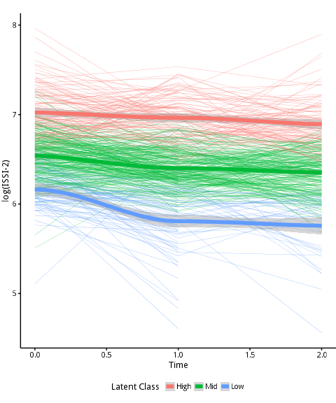

Supplemental Figure S4: Latent class mixed model analysis to identify individual classes of trajectories for log(ISSI-2) over the 6 years in the PROMISE cohort.

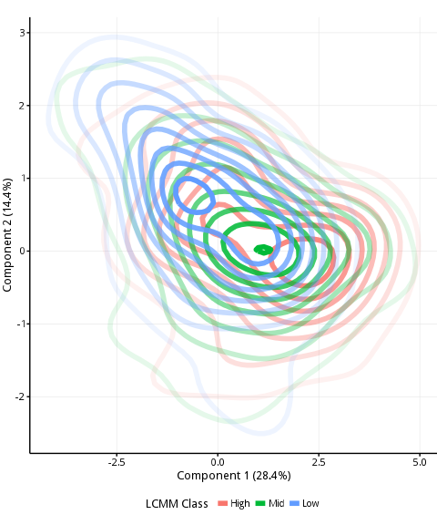

Supplemental Figure S5: Clustering of extracted components from the partial least squares discriminant analysis on the classes extracted from the latent class mixed model (LCMM) in 463 participants from the baseline PROMISE visit (2004-2006). The percent explained variance of each component is shown in brackets on each axis. {{colour}}, {{colour}}, {{colour}} lines indicate participants classified as high, middle, and low for beta-cell function, respectively, from the LCMM analysis.

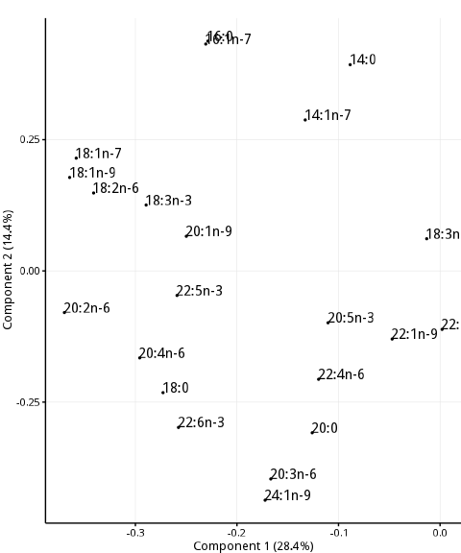

Supplemental Figure S6: Pattern loadings from partial least squares discriminant analysis to identify potential clusters of NEFA composition within the classes extracted from the latent class mixed model in 463 participants from the baseline PROMISE visit (2004-2006). The percent explained variance of each component is shown in brackets on each axis.

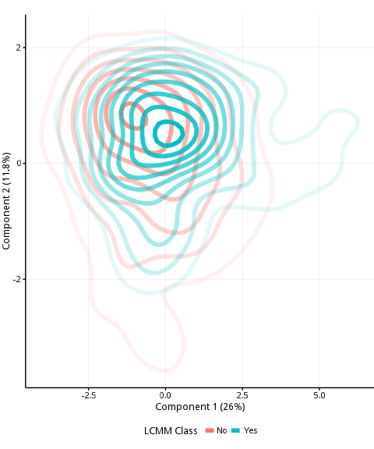

Supplemental Figure S7: Clustering of extracted components from the partial least squares discriminant analysis for dysglycemia (IFG, IGT, DM) conversion status over the 6-years in the participants from the baseline PROMISE visit (2004-2006). The percent explained variance of each component is shown in brackets on each axis. {{colour}} lines indicate dysglycemia conversion or maintanence and {{colour}} lines indicate no dysglycemia status.

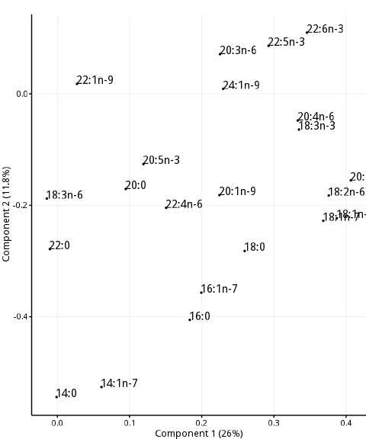

Supplemental Figure S8: Pattern loadings from partial least squares discriminant analysis to identify potential clusters of NEFA composition for dysglycemia (IFG, IGT, DM) conversion status over the 6-years in the participants from the baseline PROMISE visit (2004-2006). The percent explained variance of each component is shown in brackets on each axis.

# References

1. Rachek LI. Free Fatty acids and skeletal muscle insulin resistance. Prog Mol Biol Transl Sci. 2014;121:267–92.

2. Cnop M. Fatty acids and glucolipotoxicity in the pathogenesis of Type 2 diabetes. Biochem Soc Trans. 2008 Jun;36(Pt 3):348–52.

3. Daniele G, Eldor R, Merovci A, Clarke GD, Xiong J, Tripathy D, et al. Chronic reduction of plasma free fatty acid improves mitochondrial function and whole-body insulin sensitivity in obese and type 2 diabetic individuals. Diabetes. 2014;63(8):2812–20.

4. Salgin B, Ong KK, Thankamony A, Emmett P, Wareham NJ, Dunger DB. Higher fasting plasma free fatty acid levels are associated with lower insulin secretion in children and adults and a higher incidence of type 2 diabetes. J Clin Endocrinol Metab. 2012;97(9):3302–9.

5. Xiao C, Giacca A, Carpentier A, Lewis GF. Differential effects of monounsaturated, polyunsaturated and saturated fat ingestion on glucose-stimulated insulin secretion, sensitivity and clearance in overweight and obese, non-diabetic humans. Diabetologia. 2006;49(6):1371–9.

6. WHO, IDF. Definition and diagnosis of diabetes mellitus and intermediate hyperglycaemia: Report of a WHO/IDF consultation. 2006.

7. Matthan NR, Ip B, Resteghini N, Ausman LM, Lichtenstein AH. Long-term fatty acid stability in human serum cholesteryl ester, triglyceride, and phospholipid fractions. J Lipid Res. 2010 Sep;51(9):2826–32.

8. Folch J, Lees M, Sloane Stanley GH. A simple method for the isolation and purification of total lipides from animal tissues. J Biol Chem. 1957;226(1):497–509.

9. Nishi S, Kendall CWC, Gascoyne A-M, Bazinet RP, Bashyam B, Lapsley KG, et al. Effect of almond consumption on the serum fatty acid profile: A dose-response study. Br J Nutr. 2014 Oct;112(7):1137–46.

10. Chen CT, Liu Z, Bazinet RP. Rapid de-esterification and loss of eicosapentaenoic acid from rat brain phospholipids: An intracerebroventricular study. J Neurochem. 2011;116(3):363–73.

11. Matthews D, Hosker J, Rudenski A. Homeostasis model assessment: Insulin resistance and beta-cell function from fasting plasma glucose and insulin concentrations in man. Diabetologia. 1985;28(7):412–9.

12. Matsuda M, DeFronzo R. Insulin sensitivity indices obtained from oral glucose tolerance testing: Comparison with the euglycemic insulin clamp. Diabetes Care. 1999;22(9):1462–70.

13. Abdul-Ghani M, Matsuda M, Balas B, DeFronzo R. Muscle and liver insulin resistance indexes derived from the oral glucose tolerance test. Diabetes Care. 2007;30(1):89–94.

14. Wareham N, Phillips D, Byrne C, Hales C. The 30 minute insulin incremental response in an oral glucose tolerance test as a measure of insulin secretion. Diabet Med. 1995;12(10):931.

15. Retnakaran R, Qi Y, Goran M, Hamilton J. Evaluation of proposed oral disposition index measures in relation to the actual disposition index. Diabet Med. 2009;26(12):1198–203.

16. Kriska A, Knowler W, LaPorte R, Drash A, Wing R, Blair S, et al. Development of questionnaire to examine relationship of physical activity and diabetes in Pima Indians. Diabetes Care. 1990;13(4):401–11.

17. Zeger SL, Liang KY. Longitudinal data analysis for discrete and continuous outcomes. Biometrics. 1986 Mar;42(1):121–30.

18. Greenland S, Pearl J, Robins JM. Causal diagrams for epidemiologic research. Epidemiology. 1999;10(1):37–48.

19. R Core Team. R: A Language and Environment for Statistical Computing [Internet]. Vienna, Austria: R Foundation for Statistical Computing; 2015. Available from: <http://www.R-project.org/>

20. Højsgaard S, Halekoh U, Yan J. The R Package geepack for Generalized Estimating Equations. Journal of Statistical Software. 2006;15/2:1–11.

21. Benjamini Y, Hochberg Y. Controlling the False Discovery Rate: A Practical and Powerful Approach to Multiple Testing. Journal of the Royal Statistical Society Series B (Methodological) [Internet]. 1995;57(1):289–300. Available from: <http://www.jstor.org/stable/2346101>

22. Pankow JS, Duncan BB, Schmidt MI, Ballantyne CM, Couper DJ, Hoogeveen RC, et al. Fasting plasma free fatty acids and risk of type 2 diabetes: The atherosclerosis risk in communities study. Diabetes Care. 2004;27(1):77–82.

23. Johns I, Goff L, Bluck LJ, Griffin BA, Jebb SA, Lovegrove JA, et al. Plasma free fatty acids do not provide the link between obesity and insulin resistance or $β$-cell dysfunction: Results of the Reading, Imperial, Surrey, Cambridge, Kings (RISCK) study. Diabet Med. 2014 Nov;31(11):1310–5.

24. Maris M, Robert S, Waelkens E, Derua R, Hernangomez MH, D’Hertog W, et al. Role of the saturated nonesterified fatty acid palmitate in beta cell dysfunction. J Proteome Res. 2013;12(1):347–62.

25. Carpentier A, Zinman B, Leung N, Giacca A, Hanley AJG, Harris SB, et al. Free fatty acid-mediated impairment of glucose-stimulated insulin secretion in nondiabetic Oji-Cree individuals from the Sandy Lake community of Ontario, Canada: A population at very high risk for developing type 2 diabetes. Diabetes. 2003;52(6):1485–95.

26. Giacca A, Xiao C, Oprescu AI, Carpentier AC, Lewis GF. Lipid-induced pancreatic beta-cell dysfunction: Focus on in vivo studies. Am J Physiol Endocrinol Metab. 2011;300(2):E255–62.

27. Xiao C, Giacca A, Lewis GF. The effect of high-dose sodium salicylate on chronically elevated plasma nonesterified fatty acid-induced insulin resistance and beta-cell dysfunction in overweight and obese nondiabetic men. Am J Physiol Endocrinol Metab. 2009;297(5):E1205–1211.

28. Nielsen S, Karpe F. Determinants of VLDL-triglycerides production. Curr Opin Lipidol. 2012 Aug;23(4):321–6.

29. Martins AR, Nachbar RT, Gorjao R, Vinolo MA, Festuccia WT, Lambertucci RH, et al. Mechanisms underlying skeletal muscle insulin resistance induced by fatty acids: Importance of the mitochondrial function. Lipids Health Dis. 2012;11:30.

30. Ebbert JO, Jensen MD. Fat depots, free fatty acids, and dyslipidemia. Nutrients. 2013;5(2):498–508.

31. Capurso C, Capurso A. From excess adiposity to insulin resistance: The role of free fatty acids. Vascul Pharmacol. 2012;57(2-4):91–7.

32. Surampudi P, John-Kalarickal J, Fonseca V. Emerging concepts in the pathophysiology of type 2 diabetes mellitus. Mt Sinai J Med. 2009;76(3):216–26.

33. Szendroedi J, Frossard M, Klein N, Bieglmayer C, Wagner O, Pacini G, et al. Lipid-induced insulin resistance is not mediated by impaired transcapillary transport of insulin and glucose in humans. Diabetes. 2012;61(12):3176–80.

34. Kehlenbrink S, Koppaka S, Martin M, Relwani R, Cui M-H, Hwang J-H, et al. Elevated NEFA levels impair glucose effectiveness by increasing net hepatic glycogenolysis. Diabetologia. 2012;55(11):3021–8.

35. Liang H, Tantiwong P, Sriwijitkamol A, Shanmugasundaram K, Mohan S, Espinoza S, et al. Effect of a sustained reduction in plasma free fatty acid concentration on insulin signalling and inflammation in skeletal muscle from human subjects. J Physiol. 2013 Jun;591(Pt 11):2897–909.

36. Miller MR, Pereira RI, Langefeld CD, Lorenzo C, Rotter JI, Chen Y-DI, et al. Levels of free fatty acids (FFA) are associated with insulin resistance but do not explain the relationship between adiposity and insulin resistance in Hispanic Americans: The IRAS Family Study. J Clin Endocrinol Metab. 2012;97(9):3285–91.

37. Bush NC, Basu R, Rizza RA, Nair KS, Khosla S, Jensen MD. Insulin-mediated FFA suppression is associated with triglyceridemia and insulin sensitivity independent of adiposity. J Clin Endocrinol Metab. 2012 Nov;97(11):4130–8.

38. Il’yasova D, Wang F, D’Agostino J R B, Hanley A, Wagenknecht LE. Prospective association between fasting NEFA and type 2 diabetes: Impact of post-load glucose. Diabetologia. 2010;53(5):866–74.

39. Gray B, Muhlhausler BS, Davies PSW, Vitetta L. Liver enzymes but not free fatty acid levels predict markers of insulin sensitivity in overweight and obese, nondiabetic adults. Nutr Res. 2013 Oct;33(10):781–8.

40. Magkos F, Fabbrini E, Conte C, Patterson BW, Klein S. Relationship between adipose tissue lipolytic activity and skeletal muscle insulin resistance in nondiabetic women. J Clin Endocrinol Metab. 2012;97(7):E1219–23.

41. Ramos-Roman MA, Lapidot SA, Phair RD, Parks EJ. Insulin activation of plasma nonesterified fatty acid uptake in metabolic syndrome. Arterioscler Thromb Vasc Biol. 2012 Aug;32(8):1799–808.

42. Almandoz JP, Singh E, Howell LA, Grothe K, Vlazny DT, Smailovic A, et al. Spillover of Fatty acids during dietary fat storage in type 2 diabetes: Relationship to body fat depots and effects of weight loss. Diabetes. 2013 Jun;62(6):1897–903.

43. Dai L, Gonçalves CMV, Lin Z, Huang J, Lu H, Yi L, et al. Exploring metabolic syndrome serum free fatty acid profiles based on GC-SIM-MS combined with random forests and canonical correlation analysis. Talanta. 2015 Apr;135:108–14.

44. Liu L, Li Y, Guan C, Li K, Wang C, Feng R, et al. Free fatty acid metabolic profile and biomarkers of isolated post-challenge diabetes and type 2 diabetes mellitus based on GC-MS and multivariate statistical analysis. J Chromatogr B Analyt Technol Biomed Life Sci. 2010;878(28):2817–25.