**Short Assignment: NFS484**

*De novo* lipogenesis (DNL) is the process of converting carbohydrates into fatty acids. Fatty acids are essentially produced from carbohydrates in this order: 14:0, 14:1n-7, 16:0, 16:1n-7, 18:0, 18:1n-9 (or 18:1n-7), 20:0, and 20:1n-9. This process of creating fatty acids is important since fatty acids are necessary for the normal functioning of the body, such as for hormones or cellular structures (e.g. cell membrane). However, recent studies suggest that excess DNL may be harmful to health. A study was conducted on a cohort of participants who are at risk for various chronic diseases. Fatty acids were measured along with the Metabolic Syndrome (MetS) components, which is a cluster of measures that are risk factors for cardiovascular disease and include blood pressure (systolic: SBP, and diastolic: DBP), fasting blood glucose (FPG), HDL (1/HDL is the inverse of HDL), triglycerides (TG), and waist size.

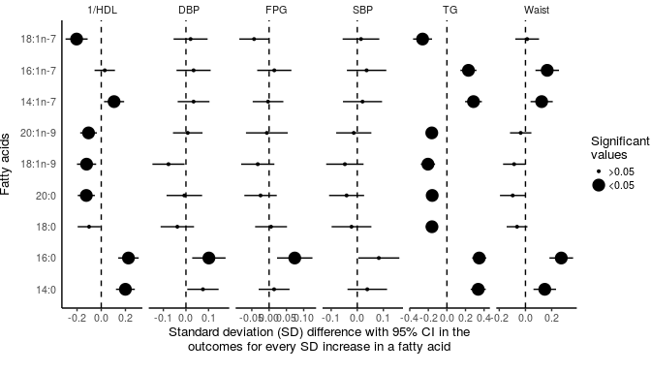

Figure: Each dot is represents an association between the MetS component and a fatty acid. The large dot means it is a significant association. The value of the dot on the x-axis is interpreted as a standard deviation (SD) increase in the MetS component for every one SD increase in the fatty acid (for example, for 16:0 with DBP that has a value of 0.1 means that when 16:0 increases by one SD DBP increases by 0.1 SD). A positive value means harmful and a negative value means beneficial.

**Questions:**

1. Refined carbohydrates and simple sugars contribute to excess and sudden increases in blood glucose. Given that the liver increases DNL to help reduce blood glucose, would you expect to see higher amounts of the smaller fatty acids (14:0, 16:0, 14:1n-7, 16:1n-7)? (1 mark)
   * Yes
   * No
2. Choose the correct response for each statement: (4 marks)
   * (TRUE / FALSE) Higher 16:0 is associated positively (harmfully) with nearly all aspects of the MetS
   * (TRUE / FALSE) All saturated fatty acids are positively (harmfully) associated with MetS
   * (TRUE / FALSE) Omega-9 fatty acids (18:1n-9 and 20:1n-9) are negatively (beneficially) associated with HDL and TG
   * (TRUE / FALSE) More than four fatty acids have positive (harmful) associations with MetS
3. Based on the results of the figure and question 1, are higher amounts of the DNL fatty acids harmful or beneficial for metabolic health? (1 mark)
   * Harmful
   * Beneficial
4. Based on these results, which would be the most likely conclusion if refined carbohydrates were reduced in a person's diet: (1 mark)
   * The person would have no change in the risk of MetS and cardiovascular disease
   * Less of the DNL fatty acids would be produced and risk of disease would be lower
   * There would be more DNL fatty acids and metabolic health would be lower
5. Based on this assignment and from the tutorial material, would individuals who had low-to-moderate respiratory quotient (RQ) compared to high RQ be at a higher risk of accumulating harmful fatty acids? (1 mark)
   * Yes
   * No
6. With aging, there is an increased prevalence of MeS components and the tendency for higher fasting RQ. Given this would you expect that the prevalence of harmful fatty acids be higher in an older compared to a younger population? (1 mark)
   * Yes
   * No