**University of Toronto**

**Faculty of Arts and Science**

**Midterm Exam**

**Advanced Nutrition**

**NFS 484H1 F/ 1484H1 F**

**Duration – 2 hours**

**Submitted By:**

Jessica Bihari 999785745

Danxi Cheng 1000534157

Denise Kim 997333210

Muna Osman 997466344

Carly Visentin 997665780

**Study 1: (28/50)**

**Background:** Insulin resistance is a component of the metabolic syndrome, a cluster of symptoms which predispose individuals to type 2 diabetes (T2DM) and cardiovascular disease (CVD), leading causes of death in developed countries. Epidemiological studies have demonstrated that offspring of undernourished mothers are more likely to develop components of the metabolic syndrome in adulthood. The “thrifty phenotype” hypothesis postulates that maternal undernutrition during pregnancy causes adaptations in fetal development. An undernourished fetus will ensure its survival by directing nutrients towards survival organs, such as the brain and heart, while compromising nutrient delivery to other organs, such as the pancreas and kidney. The reallocation of nutrients may lead to the failure of compromised organs, increasing an individual’s risk of developing components of the metabolic syndrome. Therefore, individuals who possess the “thrifty phenotype” may be more susceptible to the effects of environmental risk factors for T2DM in adulthood such as the consumption of high-energy foods and a sedentary lifestyle which are common in developed countries.

**Study:** An *in vivo* study was conducted to evaluate the effects of maternal nutrient restriction in early gestation on the glucose-insulin dynamics and liver function of the offspring in adulthood. Pregnant ewes were subjected to a nutrient-restricted (NR: 50% National Research Council (NRC) recommendations) or a control (C: 100% NRC recommendations) diet during gestational days 28-78. Both the NR and C groups were then fed a 100% NRC recommended diet from gestational day 79 through to lactation. Female lambs from each litter were reared on a 100% NRC recommended diet for 6 years. At 6 years of age, ewes from both maternal treatment groups were adapted from the standard diet (hay and grain) to the highly palatable experimental diet (pellets) over a 2 week acclimation period. The ewes were then fed the experimental diet *ad libitum* for 11 weeks. Fasted baseline plasma glucose and insulin concentrations were measured before and after the 11 week feeding trial. There was no significant difference in fasting plasma glucose and insulin levels between the two groups. A frequently sampled intravenous glucose tolerance (FSIGT) test was also performed prior to and following the 11 week feeding trial. Insulin sensitivity (SI), glucose effectiveness (Sg: ability of glucose to increase glucose uptake and suppress endogenous glucose output independent of insulin), acute insulin response to glucose (AIRg: insulin response in first 10 minutes after glucose injection) and disposition index (DI: measure of the ability of the pancreatic β-cells to compensate for insulin resistance (chronic compensation can lead to pancreatic exhaustion and subsequent glucose intolerance)) were measured. Blood samples were collected every two weeks during the feeding period and plasma insulin and insulin to glucose ratio were measured. To determine the impact of nutrient restriction on gluconeogenic enzyme expression, hepatic tissue samples were collected from each ewe. The mRNA expression of phosphoenolpyruvate carboxykinase (PEPCK: initiates hepatic gluconeogenesis) and glucose-6-phosphatase (G6P: dephosphorylates glucose) in hepatic tissue was measured.

**Questions:**

**1.       Describe Table 1 and Figure 1. (4/50)**

Figure 1:

Plasma Insulin: NR> C

Plasma Insulin to glucose ratio: NR > C

Table 1:

Insulin sensitivity (SI): NR<C

Glucose effectiveness (Sg); Acute Insulin Response to glucose (AIRg); Disposition Index (DI): NR>C

**2. Describe the relative mRNA expression of hepatic PEPCK and G6P (Figure 2). (2/50)**

The relative mRNA expression of PEPCK is significantly greater in the NR group compared to the C group (P<0.05). The relative mRNA expression of G6P is not significantly different between the two groups.

**3. Discuss the implications of the differences in hepatic PEPCK and G6P mRNA expression on glucose effectiveness. (6/50)**

PEPCK is involved in the initiation of hepatic gluconeogenesis (Background). Its increased expression in NR offspring (Figure 2) suggests that NR offspring have greater hepatic production of glucose compared to the control offspring. G6P is an enzyme involved in dephosphorylating glucose-6-phosphate to glucose (Background). There is no significant difference in its relative mRNA expression between the NR and control groups (Figure 2). Glucose-6-phosphate must be dephosphorylated to glucose prior to being released from the liver (Lecture Notes). The increase in PEPCK expression, but not in G6P expression, suggests that the excess glucose-6-phosphate formed by hepatic gluconeogenesis cannot be released from the liver. Instead, it will accumulate and be directed towards the formation of glycogen for storage.

As a result, NR in early gestation causes offspring to have:

1. An increase in hepatic gluconeogenic activity

2. More efficient glycogen storage instead of glucose release

These results are consistent with the observed increase in glucose effectiveness in NR offspring (Table 1). Glucose effectiveness refers to the ability of glucose to increase glucose uptake and suppress endogenous glucose output independent of insulin (Background). NR offspring suppress endogenous glucose output from the liver by directing newly synthesized glucose-6-phosphate to glycogen synthesis rather than converting it to glucose and releasing it into the blood.

**4.   Explain the significance of the elevated insulin to glucose ratio in NR ewes and how it relates to the β-cells function of NR ewes.  (6/50)**

The insulin to glucose ratio of the NR ewes was significantly higher than that of the control group (Figure 1). An increased ratio of insulin to glucose indicates that more insulin is required per glucose unit to maintain blood glucose and is an indicator of insulin resistance. The NR offspring have impaired insulin sensitivity (Table 1) in adulthood, therefore, greater amounts of insulin are required to promote the uptake of glucose into peripheral tissues, yielding the observed increase in insulin to glucose ratio.

The impaired insulin sensitivity observed in NR ewes is likely the result of maternal undernourishment during early gestation. The offspring of undernourished mothers prioritize delivery of nutrients to survival organs, such as the brain and heart, and deprive nutrient delivery to other organs, such as the pancreas and kidney (Background). As a result, the offspring of undernourished mothers are more likely to develop symptoms of metabolic syndrome such as insulin resistance (Background).

The elevated insulin to glucose ratio observed in the NR offspring is consistent with the NR offspring’s higher DI (Table 1). DI is a measure of the ability of the pancreatic β-cells to compensate for insulin resistance (Background). Therefore, the β-cells of NR offspring compensate for peripheral tissue insulin resistance by increasing insulin secretion in response to a glucose challenge in order to maintain blood glucose levels. Acute pancreatic compensation can be beneficial; however, chronic compensation can lead to pancreatic exhaustion and subsequent β-cell dysfunction (Background).

**5.   Based on the background information, study results, and lecture material, discuss how maternal undernutrition during pregnancy can increase the offspring’s risk of developing type 2 diabetes in adulthood. (10/50)**

Insulin resistance is a component of the metabolic syndrome and a risk factor for T2DM (Background).  Maternal undernutrition during pregnancy leads to the development of insulin resistance in the offspring. In this study ewes whose mothers were undernourished in early pregnancy  had lower insulin sensitivity compared to control offspring (Table 1) marked by increased levels of plasma insulin (hyperinsulemia) and a greater insulin to glucose ratio (Figure 1). These NR offspring possess mechanisms to compensate for the insulin resistance in peripheral tissues. First, NR ewes have increased glucose effectiveness compared to control ewes (Table 1). Glucose effectiveness refers to the ability of glucose to increase glucose uptake and suppress endogenous glucose output independent of insulin (Background). Endogenous glucose output is suppressed in NR offspring due to alterations in enzymatic activity. NR ewes have increased expression of PEPCK (the enzyme that initiates hepatic gluconeogenesis), yet no change in G6P (the enzyme that dephosphorylates glucose allowing it to be released from the cell) expression, relative to control ewes (Figure 2). Increased expression of PEPCK indicates that the liver is producing greater amounts of glucose. However, the increased production of glucose is not matched by increased expression of G6P. Therefore the extra glucose that is synthesized in the liver is not secreted but rather converted to liver glycogen and stored. As a result, endogenous glucose output is reduced in order to maintain blood glucose levels.  In another attempt to compensate for the insulin resistance, the pancreatic β-cellsof NR ewes secrete more insulin in response to a glucose challenge. This is demonstrated by the increased acute insulin response to glucose (Table 1) indicating that more insulin is being secreted per glucose unit. As a result, NR ewes have a greater disposition index than control ewes (Table 1). While this compensation will yield short term benefits in terms of maintaining blood glucose levels, chronic compensation can lead to pancreatic exhaustion and glucose intolerance (Background). If the pancreatic insulin output is exhausted, the insulin mediated glucose clearance will decrease in NR ewes, who have decreased insulin sensitivity, leading to increased levels of blood glucose. Hyperglycemia is a risk factor for T2DM (Lecture Notes), therefore, a chronic increase in blood glucose levels will predispose individuals to developing T2DM.

**Table 1:** Glucose and insulin dynamics of 6-yr-old female offspring born to control (C) and nutrient restricted (NR) mothers in response to the *ad libitum* feeding period

|  |  |  |  |
| --- | --- | --- | --- |
| Measure | C - Control  (n= 4) | NR-  Nutrient Restricted (n= 4) | P-value |
| Insulin sensitivity (SI), X10-4 mIU-1·1·min-1 | 9.3 ± 1.5 | 5.7 ± 0.7 | 0.049 |
| Glucose effectiveness (Sg), X10-2 min-1 | 0.8 ± 0.1 | 1.7 ± 0.2 | 0.001 |
| Acute Insulin response to glucose (AIRg), mIU·l-1·min | 32.9 ± 7.7 | 144 ± 23.0 | 0.001 |
| Disposition Index (DI) | 322 ± 99.1 | 727 ± 77.0 | 0.009 |

Data are expressed as means +/- SE. P-values denote significant differences between NR and C offspring.

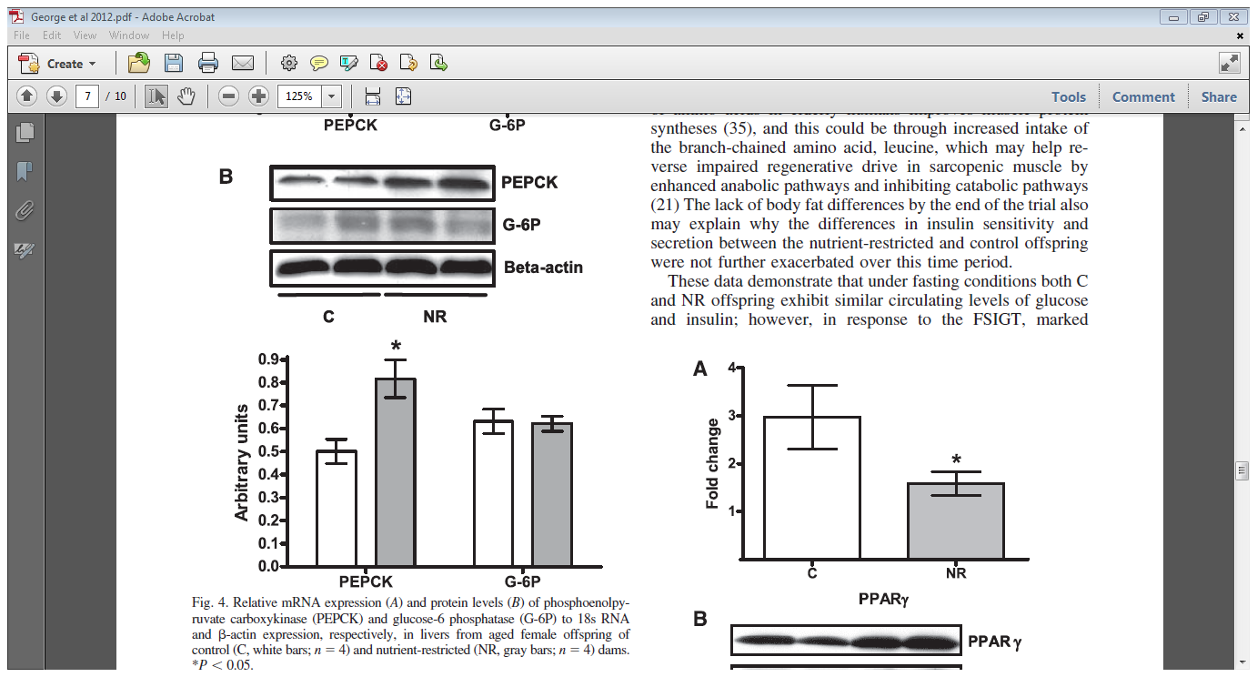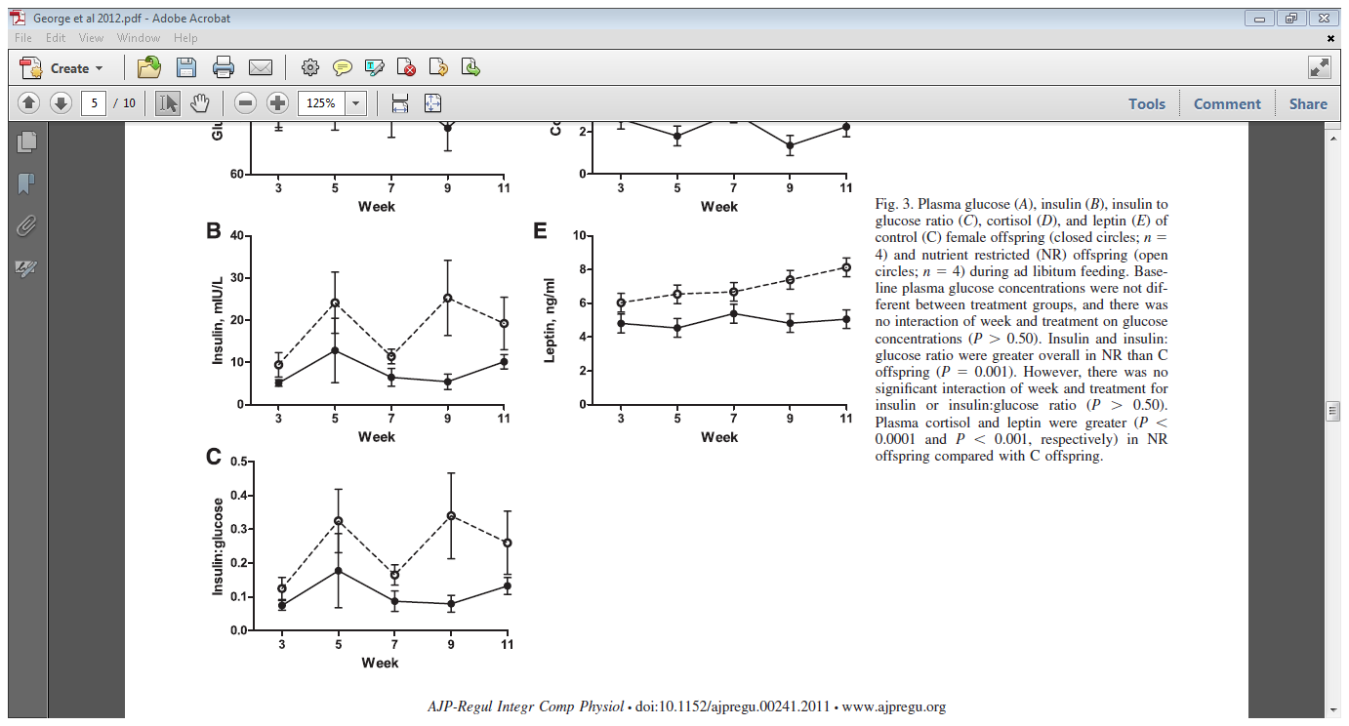

**B**

**A**

|  |  |
| --- | --- |
| **Figure 1**: Plasma (A) insulin and (B) insulin to glucose ratio of control (C) female offspring (closed circles; n=4) and nutrient restricted (NR) offspring (open circles; n=4) during *ad libitum* feeding. Insulin and insulin to glucose ratio were greater overall in NR than C offspring (*P*=0.001). | **Figure 2:** Relative mRNA expression of PEPCK and G6P in livers from aged female offspring of control (C, white bars; n=4) and nutrient restricted (NR, gray bars; n=4) dams. \**P*<0.05 |

**Study 2 (22/50)**

**Background**: Socioeconomic inequalities are major contributors to cardiovascular disease (CVD) and type 2 diabetes (T2DM) (two diseases that may be the result of the metabolic syndrome); however, this mechanism is not clearly understood. A previous study demonstrated an association between the development of CVD in adulthood and an increased BMI in childhood. Another study found that children with a higher BMI were more likely to develop insulin resistance. Children with insulin resistance have a greater likelihood of developing T2DM and an adverse lipid profile. There has been extensive research on the effect of socioeconomic status on childhood obesity, yet there is a gap in the literature as no studies have addressed the effect of socioeconomic inequalities on lipid and glucose metabolism in childhood. The impaired metabolism of these substrates can have negative health effects in adulthood.  One indicator of socioeconomic inequality that is of interest to researchers is maternal education.

**Study**: The purpose of this study was to investigate the association between socioeconomic status and lipid and glucose metabolism in 5-6 year olds. This study was part of a larger prospective, cohort study from fetal life onwards. During a health check, children who had been fasting from the night before, had their finger pricked to draw capillary blood. A total of 1308 blood samples from ethnically homogeneous children were used in this study. It was important that they were ethnically homogeneous (i.e., both their mother and grandmother were Dutch) because lipid and glucose metabolism and education levels differ by ethnicity.

In 1308 children, childhood BMI, cholesterol, HDL-C, LDL-C, triglycerides, fasting blood glucose, and C-peptide (measure of total insulin secretion) were measured. During analysis, 49% of the C-peptide concentrations fell below the detection limit of 0.34 nmol/L so a homeostatic model assessment (HOMA-IR [an indicator of insulin resistance - the higher the number the more insulin resistant the individual]) was used to quantify insulin resistance, using glucose and C-peptide concentrations. Using this assessment the capillary blood samples of a smaller subset of 974 children were measured for C-peptide and a HOMA-IR value was determined.

To determine socioeconomic status, mothers filled out a questionnaire reporting their education levels as: low (no education or primary school only; lower vocational secondary education or technical secondary education); mid (higher vocational secondary education, intermediate vocational education); or high (higher vocational education, university education).

**Question 6. Describe the results in Table 2. (4/50)**

Childhood BMI is significantly higher in children with lower maternal education compared to children with mid or high maternal education. There is no significant difference in HDL-C, LDL-C and triglyceride profile among educational groups. Blood glucose, C-peptide and HOMA-IR are significantly higher in children of less educated mothers.

**Question 7.**  **Based on the background and results presented in this study, how does lower socioeconomic status predispose children to type 2 diabetes? (6/50)**

From Table 2, there is no relationship between maternal education and lipid metabolism as no significant differences were observed in HDL-C, LDL-C, and triglyceride profile among the 3 educational groups (Table 2). However, children of mothers with lowereducation are more likely to have impaired glucose metabolism. This is evident as these children’s  blood glucose, C-peptide, and HOMA-IR levels are significantly higher compared to children of more educated mothers (Table 2), indicating that they have greater insulin secretion and are also more insulin resistant (Background). This suggests that maternal education is a significant socioeconomic factor that contributes to the development of impaired glucose metabolism in children, leading to early onset of insulin resistance and metabolic syndrome, and increasing the risk of T2DM and CVD (Background). This relationship may be mediated through factors including childhood body weight. Children of less educated mothers have a higher BMI (Table 2). Children with a higher BMI are more likely to develop insulin resistance (Background), increasing their susceptibility to the effects of environmental factors for T2DM in adulthood.

**Question 8. You have been working in a community health centre situated in a low-income area for over 20 years as a registered dietitian. You have noticed a trend in which the children of your clients have developed T2DM in early adulthood. This seems to be a health concern in this community. After checking medical records, you found that many of the mothers of these children were undernourished during pregnancy and that the children had high BMI’s indicating they were overweight.**

**Based on the background information and the data presented in the two studies, how would you speculate that children born to mothers who were undernourished during pregnancy are predisposed to an increased risk of T2DM?**

**Your colleagues proposed to implement an exercise program for overweight children. This program would screen for mothers that fit the profile of being undernourished during pregnancy and/or have low maternal education so that their children could be enlisted in the program. Based on class notes on exercise’s effect on insulin resistance and information presented in this mid-term, do you think that the exercise program will be effective for this demographic of children? Explain your reasoning. (12/50)**

Insulin resistance is a component of the metabolic syndrome and a risk factor for T2DM (Background). Previous studies have demonstrated that children with a higher BMI were more likely to develop insulin resistance (Background). Children of mothers with a lower socioeconomic status (defined by maternal education) had a higher BMI and also exhibited characteristics of insulin resistance (Table 2). Children of less educated mothers had higher blood glucose, C-peptide (measure of total insulin secretion), and HOMA-IR (an indicator of insulin resistance) compared to children of more educated mothers (Table 2). Insulin resistance early on in life can be an indicator of T2DM in early adulthood (Background) (Lecture Notes). Therefore, children of lower socioeconomic status are more predisposed to T2DM.

Study 1 provides a mechanism for this observed effect. It is likely that mothers of lower socioeconomic status are undernourished during pregnancy. Study 1 examined the effects of maternal nutrient restriction in early gestation on the glucose-insulin dynamics and liver function of the offspring in adulthood. It determined that maternal nutrient restriction during early pregnancy causes impaired insulin sensitivity in the offspring. As a result, offspring compensate for the insulin resistance by decreasing endogenous glucose output via enzymatic alterations and by increasing pancreatic β-cell secretion of insulin. PEPCK expression is increased in NR offspring, yet G6P expression is not different between NR and C offspring (Figure 2). Therefore, endogenous glucose expression is decreased. The disposition index is greater in NR offspring compared to C offspring (Table 1), indicating a greater pancreatic secretion of insulin in response to a glucose challenge. Over time the pancreas will become exhausted and therefore insulin secretion will be decreased which, in response to the impaired insulin sensitivity, will cause increased blood glucose levels. Hyperglycemia and insulin resistance are risk factors for T2DM (Lecture Notes). This predisposition to T2DM will increase the offspring’s susceptibility to environmental risk factors in adulthood such as the consumption of high-energy foods and a sedentary lifestyle (Background). Therefore NR offspring have a greater risk of developing T2DM, most likely due to maternal undernutrition during early pregnancy.

An exercise program would help to decrease the risk of T2DM in children born to mothers who were undernourished during early pregnancy. As demonstrated in the two studies these children have insulin resistance and elevated levels of fasting blood glucose and insulin. Exercise increases glucose uptake into tissues independent of insulin. During exercise muscles contract. This contraction increases GLUT-4 expression to the muscle cell plasma membrane allowing the muscle cell to uptake glucose (Lecture Notes). This contraction dependent GLUT-4 translocation is important because it is independent of insulin. Therefore, exercise helps to maintain blood glucose levels even in insulin resistant children. As a result, exercise can decrease the risk of T2DM in these children because it corrects the adverse effects of insulin resistance and maintains physiologic blood glucose concentrations.

**Table 2.** BMI and metabolic blood profile by maternal education in children who participated in the study. Columns represent values as means and the standard deviation is in brackets. Significance is denoted at P <0.05.

|  |  |  |  |  |  |
| --- | --- | --- | --- | --- | --- |
|  | **Total** | **Low education** | **Mid education** | **High education** | **P-value** |
| **N** | **1308** | **68** | **216** | **1024** |  |
| Childhood sdsBMI | -0.15 (0.82) | 0.14 (1.00) | -0.14 (0.94) | -0.17 (0.77) | .009 |
| Cholesterol (mmol/L) | 4.0 (0.7) | 4.0 (0.7) | 4.1 (0.7) | 4.0 (0.7) | .47 |
| HDL-C (mmol/L) | 1.3 (0.3) | 1.3 (0.3) | 1.3 (0.3) | 1.3 (0.3) | .99 |
| LDL-C (mmol/L) | 2.3 (0.6) | 2.3 (0.6) | 2.4 (0.7) | 2.3 (0.6) | .45 |
| Triglycerides (mmol/L) | 0.6 (0.4-0.8) | 0.6 (0.5-0.8) | 0.6 (0.4-0.8) | 0.6 (0.4-0.8) | .66 |
| Glucose (mmol/L) | 4.6 (0.5) | 4.7 (0.5) | 4.6 (0.5) | 4.5 (0.5) | .01 |
| **n** | **974** | **52** | **154** | **768** |  |
| C-peptide (nmol/L) | 0.32 (0.28-0.38) | 0.38 (0.32-0.44) | 0.33 (0.28-0.40) | 0.32 (0.28-0.38) | <.001 |
| HOMA-IR | 0.7 (0.3) | 0.9 (0.4) | 0.8 (0.3) | 0.7 (0.2) | <.001 |