# (Very) rough draft of final

## Background:

Greater systemic inflammation can disrupt multiple organs including the adipocytes, potentially leading to an increased release of stored free fatty acids (FA), as well as discruption lipid and cholesterol metabolism. Lipids and cholesterol are packaged in the liver into very-low density lipoproteins (VLDL) and low density lipoproteins (LDL) [Need this?? Maybe not..]. Higher levels of circulating LDL may eventually penetrate the blood vessels, building up plaque and leading to cardiovascular disease (CVD). The most common type of CVD is coronary artery disease (CAD), which can increase the risk for heart attacks --- also known as myocardial infarctions (MI)

The n-3 long chain polyunsaturated fatty acids (n-3 LC-PUFA) eicosapentaenoic acid (EPA) and docosahexaenoic acid (DHA) are precursors to potent anti-inflammatory molecules. While EPA and DHA can be obtained from the diet, we can also synthesize them from the FA alpha-linolenic acid (ALA). The n-6 LC-PUFA equivalent of the n-3 LC-PUFA is arachidonic acid (ARA) and is the precursor to potent pro-inflammatory molecules. As with the n-3 LC-PUFA, ARA can be obtained from the diet as well as synthesized from linoleic acid (LA). However, both ALA and LA are essential FA and can *only* be obtained from the diet. ALA and LA are converted into their longer chain equivalents (EPA+DHA and ARA, respectively) by the same delta-6 desaturase (D6D) enzyme and therefore compete for its activity.

## Study 1:

Prospective longitudinal cohort. Cross-sectional at the baseline visit on inflammation (CRP), serum and dietary levels of the LC-PUFA. Prospective data on CAD events.

The RR... (if it ranges between less than 1.0 and greater than 1.0 there is no significant difference; for example, a CI of 0.98 to 1.15 is not significant).

[Need to develop this more]

|  |  |  |  |
| --- | --- | --- | --- |
|  | CAD-free (n=621) | CAD (n=457) | p-value |
| BMI | 25.5 | 26.3 | 0.11 |
| Serum LA (g/100g) | 9.77 (1.38) | 9.05 (1.40) | <0.001 |
| Serum ALA (g/100g) | 0.10 (0.03) | 0.09 (0.04) | 0.24 |
| Serum AA | 19.44 | 19.64 |  |
| AA/LA (ratio) | 1.99 (0.36) | 2.17 (0.41) | <0.001 |
| DHA + EPA | 0.71 | 0.73 |  |
| DHA+EPA/ALA (ratio) | 7.12 (2.91) | 8.09 (3.83) | 0.009 |
| AA/(EPA+DHA) | 27.38 | 26.90 |  |
|  |  |  |  |

Baseline characteristics of participants who either developed CAD or did not develop CAD (CAD-free) within a 15 year timeframe. Values are the means and standard deviations.

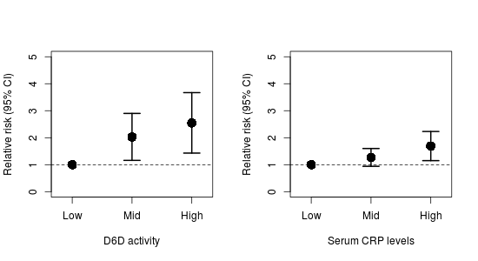

Relative risks of tertiles of D6D and CRP with CAD.

### What we want them to get at:

We want them to highlight that:

* Inflammation contributes to CAD
* Greater ARA relative to EPA+DHA is bad I’m not seeing this in the data above
* Greater D6D is bad
* That paradoxically LA is lower, while ALA is the same, in those who will develop CAD This I’m seeing
* And that paradoxically DHA+EPA is also higher, but ARA is higher I think I get what you are getting at here – that the elongation was higher independent of whether the n-3’s or n-6s are being elongated – i.e. reflecting overall higher D6D activity.

In general, Luke, I think this study will work, we will just have to focus on what we want and make certain that the data are more ‘transparent’.

## Study 2:

A community intervention was conducted to determine the effectiveness of strategies that aim to reduce dietary n-6 PUFA.

A group of alleles called the *FADS* gene (or genes) has been identified that may modulate the D6D activity. DNA was extracted from the participants to quantify the alleles.

[Include this?: Dietary intake of LA and ALA is thought to be best around a 1-to-1 ratio. The current Western diet is approximately 20-30-to-1 ratio (greater levels of LA)....]Maybe not to this detail, but the context of concerns about dietary ratios would be needed to place the intervention into context.

[For clarity right now:]

* LL = low n-6 (intervention) and <4 FADS alleles (low activity)
* LH = low n-6 (intervention) and >4 FADS alleles (high activity)
* HL = high n-6 (control) and <4 FADS alleles (low activity)
* HH = high n-6 (control) and >4 FADS alleles (high activity)

|  |  |  |
| --- | --- | --- |
|  | Intervention | Control |
| BMI | NS | NS |
| Dietary n-3 | NS | NS |
| Dietary n-6 | -150% | NS |

Significant percent changes in basic characteristics of participants from the two groups before and after the intervention. NS = not significantly different. This we could probably just tell them to cut down on figures/tables.

|  |  |  |
| --- | --- | --- |
|  | Low FADS alleles | High FADS alleles |
| Serum LA (g/100 g) | 12.2 (1.54) | 9.96 (1.10)* |
| Serum ARA (g/100 g) | 18.54 (2.08) | 20.19 (1.98)* |
| Serum ALA (g/100 g) | 0.11 (0.02) | 0.09 (0.01)* |
| Serum EPA+DHA (g/100 g) | 7.33 (1.45) | 7.78 (1.23)* |

Differences between a low number of FADS alleles and a high number of FADS alleles before the intervention.

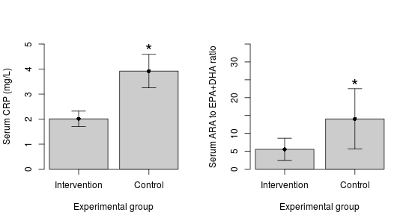

Effect of intervention on CRP and ARA to EPA+DHA ratio. Maybe leave the ‘composite’ figure out and narrow down to the one divided by genotype?

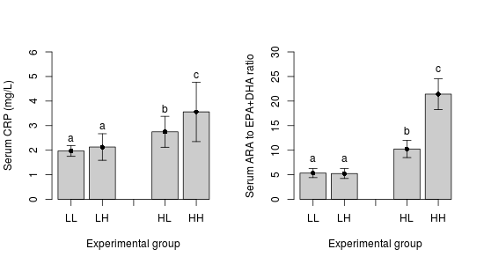

Effect of intervention on participants with either a low or a high number of FADS alleles.

### What we want them to get at:

We want them to highlight that:

* More FADS alleles greater ARA and EPA+DHA
* More FADS + greater intake of n-6 = inc CRP
* Lower intake of n-6 reduces CRP, ARA/EPA+DHA ratio, but this is independent of FADS?
* While paradoxical, the higher EPA+DHA in the FADS group is not enough to offset the higher levels of LA.
* Greater LA competes for the D6D enzyme and too much LA reduces production of EPA+DHA, favouring ARA. Yes, but this only seen in the context of high LA intake – the experimental groups showed no difference based on FADS.

## Possible questions:

Based on the data from Study 2, comment on why more individuals with African ancestry had more CAD events.

Discuss the potential mechanisms underlying Study 2 I’m not certain what you are wanting to pull on this and the question below – think it is because I’m not clear on the story yet. I’m not extracting fundamental differences in AA/EPA+DHA from the 1st study and then in the second, I’m taking home that the adverse role of FADS is only apparent when intakes of LA is high, but as you lower LA, then the genetic differences are irrelevant.

Given the role that inflammation (CRP) and elevated serum lipids (TAG) play in CAD, comment on the risk for CAD that the intervention community may have compared to the non-intervention community. What are some factors that may influence the results of Study 2, given that it is a community intervention?

Imagine you are clinician and a patient comes in who has has a mixed, but predominately East African ancestry. Given that individuals with African ancestry are more likely to have more alleles of the FADS gene cluster, given the data and your past knowledge, how could you reduce their risk for CAD disease? Defend your answer using *only* the data from both studies.

Final question (?)

Using your previous knowledge and all the data from this final: A recent clinical trial showed no effect of n-3 LC-PUFA on myocardial infarction (a common outcome of CAD), comment on 1) some reasons why improvements in dietary lipids may not translate to reductions in heart attack, 2) why a clinical trial may not always be able to pick up causal mechanisms in the general population, even though a causal effect may actually be present in a subset of the population (for example, FADS polymorphisms), and 3) why targeting only n-3 LC-PUFA may not always be effective.

# Ideas/notes for the final

Maybe instead of African + SFA intake with CVD, we look at how the role of SFA vs carbs on lipoprotein size and atherogenicity?

BUT: There is the *FADS* gene which about 80% of African Americans carry two copies of the gene (associated with increased levels of arachidonic acid) compared to about 45% in European Americans.

*FADS* gene and LDL

ALA -> d5d (FADS1) and d6d (FADS2) -> DHA LA -> d5d and d6d -> AA

Greater d5d and d6d toward AA increase risk for CAD

Combination of **both** FADS gene + dietary intake is important

rs174548 in FADS1 may influence cholesterol metabolism

Individuals with CAD had lower levels of LA than controls. So even though it has a greater inflammatory properties, it is still essential (for arterial stiffness). Combined with higher d6d + d5d activity.

Combination of higher LA intake, lower ALA intake, and greater d6d activity (eg. more risk alleles on the FADS gene cluster) is the worst case.

Even though greater d9d and elongase contribute to more ARA *and* EPA+DHA, there are vastly greater levels of both LA in the diet + more ARA. So the protective effect of EPA+DHA is offset by the higher levels of LA+ARA. (Martinelli)

Good figures/tables in Martinelli2008