### Background:

Greater systemic inflammation can disrupt metabolic processes throughout the body. Greater inflammation has also been implicated in the development of plaque buildup in blood vessels, potentially leading to cardiovascular disease (CVD). The most common type of CVD is coronary artery disease (CAD), which can increase the risk for heart attacks.

The n-3 long chain polyunsaturated fatty acids (n-3 LC-PUFA) eicosapentaenoic acid (EPA) and docosahexaenoic acid (DHA) are precursors to potent anti-inflammatory molecules. While EPA and DHA can be obtained from the diet, we can also synthesize them from the FA alpha-linolenic acid (ALA). The n-6 LC-PUFA equivalent of the n-3 LC-PUFA is arachidonic acid (ARA), which can be used in signaling pro-inflammatory processes. As with the n-3 LC-PUFA, ARA can be obtained from the diet as well as synthesized from linoleic acid (LA). However, both ALA and LA are essential FA and can *only* be obtained from the diet. ALA and LA are converted into their longer chain equivalents (EPA+DHA and ARA, respectively) by the same delta-6 desaturase (D6D) enzyme and therefore compete for its activity.

### Study 1 (Value 10/50):

To observe the role of fatty acids on the risk for CAD, a large prospective longitudinal cohort was initiated many years ago in order to record cardiovascular events. Participants were recruited from several cities in Canada. At the baseline visit, participants had their body mass index (BMI) determined and had blood samples taken. Blood samples were analyzed for C-reactive protein (CRP), which is a marker of systemic inflammation serum FA levels and D6D activity. Every year, participants were called to record any cardiovascular events that had occurred over the previous year.

After 15 years, the data collected were analyzed. Relative risks (RR) were calculated on tertiles of serum CRP levels and D6D activity with CAD events. RR indicate the percent in risk that greater CRP or D6D have on CAD events. A RR is *not* significant if the range crosses the 1.0 value (for example, a RR of 1.30 with a confidence interval of 0.90 to 1.50 is considered not significant).

|  |  |  |  |
| --- | --- | --- | --- |
|  | CAD-free (n=621) | CAD (n=457) | p-value |
| BMI | 25.5 | 26.3 | 0.11 |
| Serum LA (g/100g) | 9.77 (1.38) | 9.05 (1.40) | <0.001 |
| Serum ARA (g/100g) | 19.1 (1.45) | 23.2 (1.75) | <0.001 |
| Serum ALA (g/100g) | 0.10 (0.03) | 0.09 (0.04) | 0.24 |
| Serum EPA+DHA (g/100g) | 6.84 (1.47) | 7.03 (1.56) | 0.34 |

**Baseline** characteristics of participants who either developed CAD or did not develop CAD (CAD-free) within a 15 year timeframe.

*Values are the means and standard deviations.*

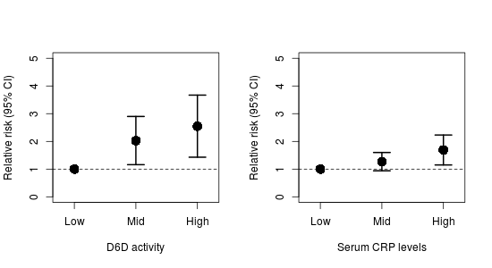

Relative risks of tertiles of D6D and CRP with CAD. Ranges above the 1.0 line (dashed horizontal line) are considered statistically significant.

### Questions:

1. Describe the results in Table 1 and Figure 1. (Value 4/50)
2. Drawing on information from the Background and the data in Table 1 and Figure 1, discuss a potential mechanism for how dietary PUFA may influence the risk for developing CAD. (Value 6/50)

### Study 2 (Value 40/50):

There is some public health concern that the ratio of dietary n-6 to n-3 FA is important for cardiovascular health, particularly in regard to Western style diets. It is generally argued that the North American diet is too high in n-6 relative to n-3 FA. Therefore, a community intervention was conducted over one year in the US to determine the effectiveness of strategies that aim to reduce dietary n-6 PUFA (indicated as the "Low" group). A nearby community with similar characteristics as the intervention community was used as the control group (indicated as the "High" group). BMI, dietary intake, and blood samples were collected from each participant. Blood samples were used to measure CRP and serum FA levels.

The field of nutrigenomics has revealed several candidate genes that may influence FA metabolism. This group of alleles, called the *FADS* gene cluster, has been associated with modulation in D6D activity. Therefore, a cheek swab was taken to extract DNA to quantify the gene cluster in the participants, who were then classified as "Low" if they had <4 *FADS* alleles present and "High" if they had >4 *FADS* alleles present.

There were no significant differences in BMI and dietary intake of n-3 FA between the two groups. However, dietary n-6 did decrease in the intervention group, suggesting good participation in the intervention.

|  |  |  |
| --- | --- | --- |
|  | Low FADS alleles | High FADS alleles |
| Serum LA (g/100 g) | 12.2 (1.54) | 9.96 (1.10)* |
| Serum ARA (g/100 g) | 18.54 (2.08) | 20.19 (1.98)* |
| Serum ALA (g/100 g) | 0.11 (0.02) | 0.09 (0.01)* |
| Serum EPA+DHA (g/100 g) | 7.33 (1.45) | 7.78 (1.23)* |

Differences between a low number of FADS alleles and a high number of FADS alleles before the intervention.

*\* indicates significantly different (p<0.05) from participants with "Low" FADS alleles.*

### Questions:

1. Describe the results of Table 2. (Value 2/50)
2. Using the Background information and the data from Table 2, discuss how the *FADS* gene cluster is influencing D6D activity. Assume that dietary intake of n-6 and n-3 FA did not differ between groups at the baseline measurements. (Value 5/50)
3. Describe the results of Figure 2. (Value 2/50)
4. Using **all** information and data up to this point, discuss how the *FADS* gene cluster may influence the risk for CAD. (Value 6/50)
5. Imagine you are clinician and a patient comes in who has a mixed, but predominately African ancestry. Considering that individuals with African ancestry are more likely to have more alleles of the *FADS* gene cluster, using the information and data in this exam and your previous knowledge, how could you reduce his/her risk for CAD disease? Defend your answer by incorporating data from both studies. (Value 7/50)
6. Given that all of these studies were conducted in Western countries with a high n-6 to n-3 ratio, discuss how the association between higher D6D activity and CAD risk may differ in countries with a lower dietary n-6 to n-3 ratio (for example, in Inuits consuming a traditional diet). Explain any neutral or positive influences the *FADS* alleles may have. Defend your answer using your own knowledge, the Background information and the two studies. (Value 8/50)
7. A recent large randomized, controlled clinical trial showed no effect of n-3 LC-PUFA supplementation on CAD. Comment on 1) why a clinical trial may not always be able to identify effects with nutrient supplementation in the general population and 2) why targeting only n-3 LC-PUFA may not always be effective. Use your previous knowledge and all the information and data from this exam. (Value 10/50)

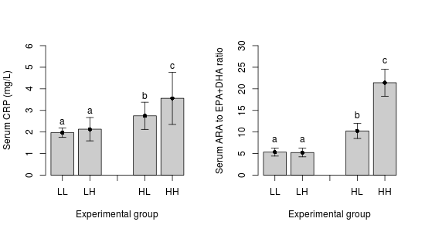

Effect of intervention on participants with either a low or a high number of FADS alleles. LL = low n-6 (intervention) and <4 FADS alleles (low); LH = low n-6 (intervention) and >4 FADS alleles (high); HL = high n-6 (control) and <4 FADS alleles (low); HH = high n-6 (control) and >4 FADS alleles (high).