**UNIVERSITY OF TORONTO**

**Department of Nutritional Sciences**

**Final Examination 2014**

**December 18, 2014**

**Advanced Nutrition**

**NFS484H1 F/1484H1 F**

**Duration — 2 hours**

**General Instructions**

1. This is an open book examination; therefore students may use any aids that have been brought into the examination room.
2. The examination is divided into 2 parts (2 studies) worth 10 marks and 40 marks respectively, for a total of 50 marks. The midterm examination will comprise 50% of your final grade.
3. Students must answer all questions in all parts of the examination. Please be certain to allocate your time appropriately to ensure that you are able to complete all parts of the examination.
4. All answers should be clearly provided in the answer booklets provided. Please provide your answer on the right-hand side of the page only. It will be assumed that the left-hand side of the page is used for note making purposes only and material appearing on this side of the page will not be read or graded.
5. PLEASE DO NOT WRITE IN PENCIL. Feel free to cross out anything that you want. Pencil smears and is often difficult to read. Thanks for your consideration in this request.

Good Luck

and

Happy Holidays

## Background:

Greater systemic inflammation can disrupt metabolic processes throughout the body. Greater inflammation has also been implicated in the development of plaque buildup in blood vessels, potentially leading to cardiovascular disease (CVD). The most common type of CVD is coronary artery disease (CAD), which can increase the risk for heart attacks --- also known as myocardial infarctions (MI)

The n-3 long chain polyunsaturated fatty acids (n-3 LC-PUFA) eicosapentaenoic acid (EPA) and docosahexaenoic acid (DHA) are precursors to potent anti-inflammatory molecules. While EPA and DHA can be obtained from the diet, we can also synthesize them from the FA alpha-linolenic acid (ALA). The n-6 LC-PUFA equivalent of the n-3 LC-PUFA is arachidonic acid (ARA), which can be used in signaling pro-inflammatory processes. As with the n-3 LC-PUFA, ARA can be obtained from the diet as well as synthesized from linoleic acid (LA). However, both ALA and LA are essential FA and can *only* be obtained from the diet. ALA and LA are converted into their longer chain equivalents (EPA+DHA and ARA, respectively) by the same delta-6 desaturase (D6D) enzyme and therefore compete for its activity.

## Study 1: (Value 10/50)

To observe the role of fatty acids on the risk for CAD, a large prospective longitudinal cohort was initiated many years ago in order to record cardiovascular events. Participants were recruited from several cities in Canada. At the baseline visit, participants had their body mass determined and had blood samples taken. Blood samples were analyzed for C-reactive protein (CRP), which is a marker of systemic inflammation, and were also analyzed for serum FA and D6D activity. Every year, participants were called to record any cardiovascular events that had occurred over the previous year.

After 15 years, the data collected were analyzed. Relative risks (RR) were calculated on tertiles of CRP and D6D activity with CAD events. RR indicate the percent in risk that greater CRP or D6D have on CAD events. A RR is *not* significant if the range crosses the 1.0 value (for example, a RR of 1.30 with a confidence interval of 0.90 to 1.50 is considered not significant).

### Questions:

1. Describe the results in Table 1 and Figure 1. (Value 4/50)
2. Drawing on information from the Background and the data in Table 1 and Figure 1, discuss a potential mechanism for how dietary PUFA may influence the risk for developing CAD. (Value 6/50)

**Table 1. Baseline** characteristics of participants who either developed CAD or did not develop CAD (CAD-free) within a 15 year timeframe.

|  |  |  |  |
| --- | --- | --- | --- |
|  | CAD-free (n=621) | CAD (n=457) | p-value |
| BMI | 25.5 | 26.3 | 0.11 |
| Serum LA (g/100g) | 9.77 (1.38) | 9.05 (1.40) | <0.001 |
| Serum ARA (g/100g) | 19.1 (1.45) | 23.2 (1.75) | <0.001 |
| Serum ALA (g/100g) | 0.10 (0.03) | 0.09 (0.04) | 0.24 |
| Serum EPA+DHA (g/100g) | 6.84 (1.47) | 7.03 (1.56) | 0.34 |

Values are the means and standard deviations.

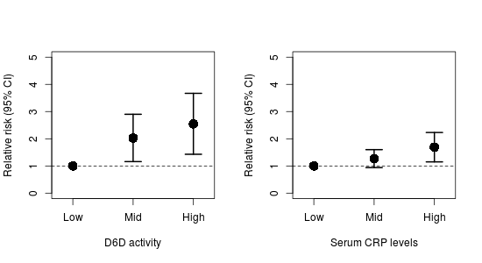

**Figure 1.** Relative risks of tertiles of D6D and CRP with CAD. Ranges above the 1.0 line (dashed horizontal line) are considered statistically significant.

## Study 2: (Value 40/50)

There is some public health concern that the ratio of dietary n-6 to n-3 FA is important for cardiovascular health, particularly in regard to Western style diets. It is generally argued that the North American diet is too high in n-6, relative to n-3, FA. Therefore, a community intervention was conducted over one year in the US to determine the effectiveness of strategies that aim to reduce dietary n-6 PUFA (indicated as the "Low" group). A nearby community with similar characteristics as the intervention community was used as the control group (indicated as the "High" group). Body mass index, dietary intake, and blood samples were collected from each participant. Blood samples were used to measure CRP and serum FA.

The field of nutrigenomics has revealed several candidate genes that may influence FA metabolism. These group of alleles, called the *FADS* gene cluster, has been associated with modulation in D6D activity. Therefore, a cheek swab was taken to extract DNA to quantify the gene cluster in the participants, who were then classified as "Low" if they had <4 *FADS* alleles present and "High" if they had >4 *FADS* alleles present.

There were no significant differences in BMI and dietary intake of n-3 FA between the two groups. However, dietary n-6 did decrease in the intervention group, suggesting good participation in the intervention.

### Questions:

1. Describe the results of Table 2. (Value 2/50)
2. Using the Background information and the data from Table 2, discuss how the *FADS* gene cluster is influencing D6D activity. Assume that dietary intake of n-6 and n-3 FA did not differ between groups at baseline. (Value 5/50)
3. Describe the results of Figure 2. (Value 2/50)
4. Using **all** information and data up to this point, discuss how the *FADS* gene cluster may influence the risk for CAD. (Value 6/50)
5. Imagine you are clinician and a patient comes in who has a mixed, but predominately African ancestry. Considering that individuals with African ancestry are more likely to have more alleles of the *FADS* gene cluster, using the information and data in this exam and your previous knowledge, how could you reduce his/her risk for CAD disease? Defend your answer by incorporating data from both studies. (Value 7/50)
6. Given that all of these studies were conducted in Western countries with a high n-6 to n-3 ratios, discuss how the association between higher D6D activity and CAD risk may differ in countries with a lower dietary n-6 to n-3 ratio (for example, in Inuits consuming a traditional diet). Explain any neutral or positive influences the *FADS* alleles may have. Defend your answer using your own knowledge, the Background information and the two studies. (Value 8/50)
7. A recent large randomized, controlled clinical trial showed no effect of n-3 LC-PUFA supplementation on myocardial infarction (a common outcome of CAD). Comment on 1) why a clinical trial may not always be able to identify effects with supplementation in the general population, and 2) why targeting only n-3 LC-PUFA may not always be effective. Use your previous knowledge and all the information and data from this exam. (Value 10/50)

***Table 2.***  *Baseline serum fatty acids in participants with a low or high number of FADS alleles*

|  |  |  |
| --- | --- | --- |
|  | Low FADS alleles | High FADS alleles |
| Serum LA (g/100 g) | 12.2 (1.54) | 9.96 (1.10)* |
| Serum ARA (g/100 g) | 18.54 (2.08) | 20.19 (1.98)* |
| Serum ALA (g/100 g) | 0.11 (0.02) | 0.09 (0.01)* |
| Serum EPA+DHA (g/100 g) | 7.33 (1.45) | 7.78 (1.23)* |

* indicates significantly different (p<0.05) from participants with "Low" FADS alleles.

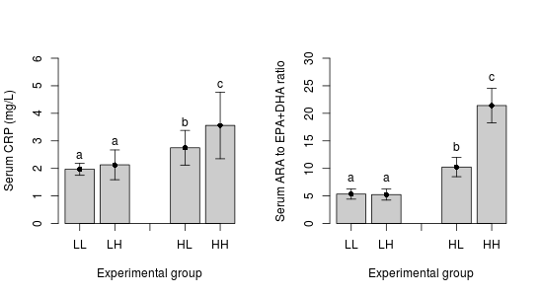

LL = low n-6 (intervention) and <4 FADS alleles (low)

LH = low n-6 (intervention) and >4 FADS alleles (high)

HL = high n-6 (control) and <4 FADS alleles (low)

HH = high n-6 (control) and >4 FADS alleles (high)

**Figure 2.** Effect of intervention on participants with either a low or a high number of FADS alleles.