# (Very) rough draft of final

## Background:

Greater systemic inflammation can disrupt multiple organs including the adipocytes, potentially leading to an increased release of stored free fatty acids (FA), as well as discruption lipid and cholesterol metabolism. Lipids and cholesterol are packaged in the liver into very-low density lipoproteins (VLDL) and low density lipoproteins (LDL) [Need this?? Maybe not..]. Higher levels of circulating LDL may eventually penetrate the blood vessels, building up plaque and leading to cardiovascular disease (CVD). The most common type of CVD is coronary artery disease (CAD), which can increase the risk for heart attacks --- also known as myocardial infarctions (MI)

The n-3 long chain polyunsaturated fatty acids (n-3 LC-PUFA) eicosapentaenoic acid (EPA) and docosahexaenoic acid (DHA) are precursors to potent anti-inflammatory molecules. While EPA and DHA can be obtained from the diet, we can also synthesize them from the FA alpha-linolenic acid (ALA). The n-6 LC-PUFA equivalent of the n-3 LC-PUFA is arachidonic acid (ARA) and is the precursor to potent pro-inflammatory molecules. As with the n-3 LC-PUFA, ARA can be obtained from the diet as well as synthesized from linoleic acid (LA). However, both ALA and LA are essential FA and can *only* be obtained from the diet. ALA and LA are converted into their longer chain equivalents (EPA+DHA and ARA, respectively) by the same delta-6 desaturase (D6D) enzyme and therefore compete for its activity.

## Study 1:

To observe the role of fatty acids on the risk for CAD, a large prospective longitudinal cohort was initiated several years ago in order to record cardiovascular events. Participants were recruited from several cities in Canada. At the baseline visit, participants had their body mass determined and had blood samples taken. Blood samples were analyzed for C-reactive protein (CRP), which is a marker of systemic inflammation, and were analyzed for serum FA and D6D activity. Every year, participants were called to record any cardiovascular events that had occurred over the last year.

After 15 years, the data collected were analyzed. Relative risks (RR) were calculated on tertiles of CRP and D6D activity with CAD events. RR indicate the percent in risk greater CRP or D6D have on CAD events. A RR is *not* significant if the range crosses the 1.0 value (for example, a RR of 1.30 with a confidence interval of 0.90 to 1.50 is considered not significant).

|  |  |  |  |
| --- | --- | --- | --- |
|  | CAD-free (n=621) | CAD (n=457) | p-value |
| BMI | 25.5 | 26.3 | 0.11 |
| Serum LA (g/100g) | 9.77 (1.38) | 9.05 (1.40) | <0.001 |
| Serum ALA (g/100g) | 0.10 (0.03) | 0.09 (0.04) | 0.24 |
| AA/LA (ratio) | 1.99 (0.36) | 2.17 (0.41) | <0.001 |
| DHA+EPA/ALA (ratio) | 7.12 (2.91) | 8.09 (3.83) | 0.009 |
| TAG (mmol/L) | 1.49 (0.70) | 1.98 (1.04) | <0.001 |

**Baseline** characteristics of participants who either developed CAD or did not develop CAD (CAD-free) within a 15 year timeframe. Values are the means and standard deviations. [Include TAG for more to work with?]

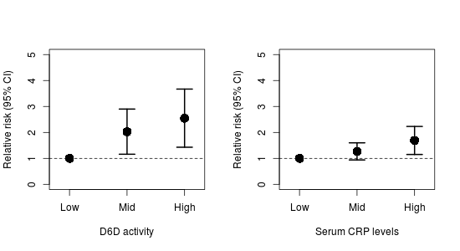

Relative risks of tertiles of D6D and CRP with CAD.

### What we want them to get at:

We want them to highlight that:

* In those that will develop CAD, there is lower LA, higher conversion of LA to AA (D6D activity; background + table 1).
* That paradoxically more DHA+EPA (in addition to ARA) is synthesized in those who eventually develop CAD (Table 1; greater ratios).
* Inflammation is influenced by eicosanoids (Background)
* Inflammation contributes to CAD (Figure 1)
* Greater D6D (FA metabolism) contributes to CAD (Figure 1)
* Greater D6D is likely increasing CRP (Background + Figure 1)
* That paradoxically LA is lower, while ALA is the same, in those who will develop CAD (Table 1)
* Something related to TAG? To get the mechanisms more involved?

## Study 2:

There is some public health concern that the ratio of dietary n-6 to n-3 FA is important for cardiovascular health, particularly in regard to Western style diets. Therefore, a community intervention was conducted over one year in the US to determine the effectiveness of strategies that aim to reduce dietary n-6 PUFA (indicated as the "Low" group). A nearby community with similar characteristics as the intervention community was used as the control group (indicated as the "High" group). A randomly sampled, representative group of participants from each community were recruited to take part in the study. Body mass, dietary intake, and blood samples were collected from each participant. Blood samples were used to measure CRP and serum FA.

The field of nutrigenomics has revealed several candidate genes that may influence FA metabolism. These group of alleles, called the *FADS* gene cluster, has been associated with modulation in D6D activity. Therefore, a cheek swab was taken to extract DNA in order to quantify the gene cluster in the participants, who were then classified depending on the number of *FADS* alleles were present (<4 alleles were classified as "Low" and >4 alleles were classified as "High").

There were no significant differences in BMI and dietary n-3 FA between the two groups. However, dietary n-6 did decrease in the intervention group, suggesting good participation in the intervention.

|  |  |  |
| --- | --- | --- |
|  | Low FADS alleles | High FADS alleles |
| Serum LA (g/100 g) | 12.2 (1.54) | 9.96 (1.10)* |
| Serum ARA (g/100 g) | 18.54 (2.08) | 20.19 (1.98)* |
| Serum ALA (g/100 g) | 0.11 (0.02) | 0.09 (0.01)* |
| Serum EPA+DHA (g/100 g) | 7.33 (1.45) | 7.78 (1.23)* |

Differences between a low number of FADS alleles and a high number of FADS alleles before the intervention. * indicates significantly different (p<0.05) from participants with "Low" FADS alleles.

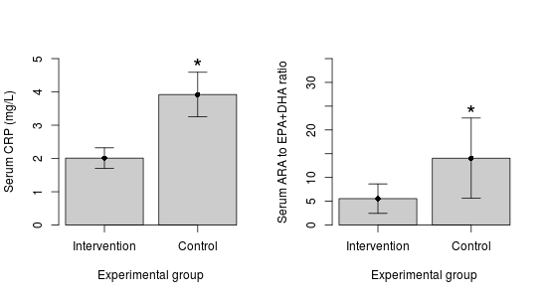

Effect of intervention on CRP and ARA to EPA+DHA ratio. Maybe remove? We can discuss

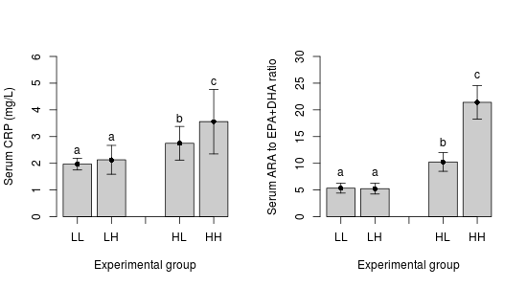

Effect of intervention on participants with either a low or a high number of FADS alleles.

* LL = low n-6 (intervention) and <4 FADS alleles (low activity)
* LH = low n-6 (intervention) and >4 FADS alleles (high activity)
* HL = high n-6 (control) and <4 FADS alleles (low activity)
* HH = high n-6 (control) and >4 FADS alleles (high activity)

### What we want them to get at:

We want them to highlight that:

* More FADS alleles greater ARA and EPA+DHA (Table 1)
* More FADS + greater intake of n-6 = inc CRP (Figure 3)
* Lower intake of n-6 reduces CRP, ARA/EPA+DHA ratio, *independent* of genotype (Figure 2, maybe?)
* That given the anti-inflammation of EPA+DHA (Background), the high FADS group has higher EPA+DHA (Table 2) but not lower CRP (Figure 3). Likely because the high FADS gene also has higher ARA to EPA+DHA ratio (more ARA; Figure 3), which likely offsets the benefit of EPA+DHA.
* Given that greater D6D increases conversion of LA and ALA to their longer chain equivalents (Background + study 1), greater FADS alleles likely increase D6D activity. The greater n-6 in the control group (Table 2 + Figure 3) are likely out competing (Background) the n-3 for the D6D action.

## Possible questions:

Discuss the potential mechanisms underlying Study 2

[Not sure of this question. If we don't keep TAG, we can remove] Given the role that inflammation (CRP) and elevated serum lipids (TAG) play in CAD, comment on the risk for CAD that the intervention community may have compared to the non-intervention community. What are some factors that may influence the results of Study 2, given that it is a community intervention?

How is the higher number of FADS alleles influencing the D6D activity? How may this translate to inflammation and risk for CAD? Why did the FADS group in the intervention group have similar CRP levels as the Use the data from Study 2.

Imagine you are clinician and a patient comes in who has has a mixed, but predominately East African ancestry. Considering that individuals with African ancestry are more likely to have more alleles of the FADS gene cluster, given the data and your past knowledge, how could you reduce their risk for CAD disease? Defend your answer using *only* the data from both studies.

Given that all of these studies were conducted in Western countries with high n-6 to n-3 ratios, discuss how the association between higher D6D activity and CAD risk may differ in countries with a lower n-6 to n-3 ratio. Explain any neutral or positive influences the FADS alleles may have. Defend your answer using your own knowledge, the Background information and the two Studies.

Final question (?)

Using your previous knowledge and all the data from this final: A recent clinical trial showed no effect of n-3 LC-PUFA on myocardial infarction (a common outcome of CAD), comment on 1) some reasons why improvements in dietary lipids may not translate to reductions in heart attack, 2) why a clinical trial may not always be able to pick up causal mechanisms in the general population, even though a causal effect may actually be present in a subset of the population (for example, FADS polymorphisms), and 3) why targeting only n-3 LC-PUFA may not always be effective.

# Ideas/notes for the final

Maybe instead of African + SFA intake with CVD, we look at how the role of SFA vs carbs on lipoprotein size and atherogenicity?

BUT: There is the *FADS* gene which about 80% of African Americans carry two copies of the gene (associated with increased levels of arachidonic acid) compared to about 45% in European Americans.

*FADS* gene and LDL

ALA -> d5d (FADS1) and d6d (FADS2) -> DHA LA -> d5d and d6d -> AA

Greater d5d and d6d toward AA increase risk for CAD

Combination of **both** FADS gene + dietary intake is important

rs174548 in FADS1 may influence cholesterol metabolism

Individuals with CAD had lower levels of LA than controls. So even though it has a greater inflammatory properties, it is still essential (for arterial stiffness). Combined with higher d6d + d5d activity.

Combination of higher LA intake, lower ALA intake, and greater d6d activity (eg. more risk alleles on the FADS gene cluster) is the worst case.

Even though greater d9d and elongase contribute to more ARA *and* EPA+DHA, there are vastly greater levels of both LA in the diet + more ARA. So the protective effect of EPA+DHA is offset by the higher levels of LA+ARA. (Martinelli)

Good figures/tables in Martinelli2008