**UNIVERSITY OF TORONTO**

**Department of Nutritional Sciences**

**Mid-Term Examination 2013**

**November 7, 2013**

**Advanced Nutrition**

**NFS 484H1 F/ 1484H1 F**

**Duration – 2 hours**

**General Instructions:**

1. This is an open book examination; therefore students may use any aids that have been brought into the examination room. However, electronic devices may only be used to scroll through class notes. Texting and internet access is not permitted.

2. The examination is divided into 2 parts (2 studies) worth 18 marks and 32 marks respectively, for a total of 50 marks. The midterm examination will comprise 25% of your final grade.

3. Students must answer all questions in all parts of the examination. Please be certain to allocate your time appropriately to ensure that you are able to complete all parts of the examination.

4. All answers should be clearly provided in the answer booklets provided. Please provide your answer on the right-hand side of the page only. It will be assumed that the left-hand side of the page is used for note making purposes only and material appearing on this side of the page will not be read or graded.

## Background

Dietary fatty acid (FA) intake impact risk for diabetes, with saturated fatty acid (SFA) intake associated with increased and omega-3 fatty acids associated with decreased risk. Transition into diabetes occurs when the pancreatic, insulin secreting beta-cells fail to adequately respond to elevated blood glucose. Saturated fatty acids may mediate their influence on diabetes risk through impairing beta-cell function (possibly via increased fat deposition in the cells), while polyunsaturated fatty acids likely are protective against impairment via their anti-inflammatory properties – not seeing how this is fitting in and how students would use. Likely candidates for SFA and PUFA are palmitic acid (PA) and eicosapentaenoic acid (EPA), respectively.

There are a number of pathways that could be influenced by dietary FA. Glucose-stimulated insulin secretion (GSIS) occurs when glucose enters the pancreatic beta-cell, goes through the glycolytic pathway, and enters the Kreb Cycle to produce ATP. The accumulation of intracellular ATP closes beta-cell K+ channels and depolarizing the cell membrane. Depolarization opens Ca++ ion channels and increases intracellular Ca++, causing storage vesicles containing insulin to merge with the cell membrane and release insulin into circulation. (Not sure if or how much we need of this. Good for now to have a good understanding of what is going on in the pancreas). We need to give them the info on how to use the UCP data – so this needs to be written in.

## Study 1

To determine the effect of the long chain polyunsaturated fatty acids (EPA and docosahexaenoic acid (DHA)) on diabetes management, a randomized controlled trial was conducted to determine the influence of EPA and DHA on glucose control. Forty participants with diabetes were put into a control and an experimental group. Both groups were instructed to replace their breakfast meal with a prescribed liquid diet (set per kg of weight for each participant) while maintaining their typical daily diets for 3 months. The control and experimental liquid meals were isocaloric and had the same macronutrient composition, except the experimental meal contained EPA and DHA, while the control meal was devoid of these two fatty acids . Fasting glucose (FPG), hemoglobin A1c (HbA1c; a measure of long term blood glucose), and C-peptide (C-pep; a protein co-released with insulin and used as a measure of total insulin secretion) were measured in a fasted state in the morning at baseline and after the three month treatment (Table 1). Subjects were then given a XXXg (what is usually used here?) glucose load and blood, collected over a 2 hour period, was monitored for glucose and insulin. These data were used to determine the insulin sensitivity index (ISI; a measure of peripheral (muscle) insulin sensitivity, with higher values indicating better insulin sensitivity), and glucose and insulin area-under-the-curve (gAUC and iAUC, respectively) (Table 2). There were no significant changes in body weight between groups.

**Questions:**

1. Describe the results from Table 1.
2. Based on the data in Table 1, taken under fasting conditions, discuss a potential mechanism whereby n-3 fatty acids may decrease the risk of T2DM. if we are asking the question this way, then should we make the subjects obese and at risk for diabetes, but not already diabetic?
3. Describe the results in Table 2.
4. What was the value of adding a glucose load/challenge to this experiment and what additional information does it provide as it relates to the impact of the long chain omega-3 fatty acids on diabetes risk?

I’M ELIMINATING THIS TABLE AS THE STUDENTS REALLY DON’T NEED THIS INFO TO ANSWER THE QUESTIONS AND WE KEEP DATA TO THE ABSOLUTE MINIMUM TO BE ‘FAIR’. ALSO WE TELL THEM THAT THEY MUST USE DATA FROM ALL TABLES AND FIGURES IN THEIR ANSWERS AND I DON’T THINK THERE IS ANYTHING HERE THAT THEY NEED TO INCORPORATE.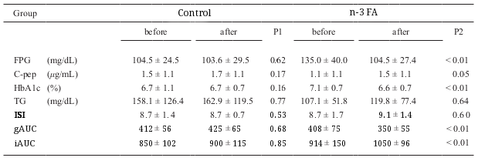

Randomized controlled trial of n-3 FA and control liquid meals. Columns represent values at baseline and after intervention. FPG = fasting plasma glucose, HbA1c = hemoglobin A1c , C-pep = C-peptide .WHAT ARE THE Pvalues INDICATING – NEED TO DESCRIBE WHAT P1 AND P2 ARE. It does not make sense having the EPA/DHA group starting with higher fasting glucose levels and then decreasing to values equivalent to those in the control group. You would be better to also increase the control values to the 135 range ‘before’ and then have no change with the intervention.

Separate this out into a separate table ISI = Muscle insulin sensitivity index (a higher number is better), gAUC and iAUC = glucose and insulin area-under-the-curve. I’m trying to help with a train of thought for the students so that they are not overwhelmed with the data from the beginning. I think this should help them work through the data in a sequential manner.

## Study 2

SFA have been proposed to have a lipotoxic effect on pancreatic islets, however, it is unkown how this occurs. An experimental study using rats was conducted to determine the effect of PA or EPA on the pancreas and mechanisms underlying GSIS. Rats were fed either control, PA, EPA, or EPA-PA diets for 3 weeks, after which they were sacrificed to obtain the pancreas. Pancreatic islets were then measured for level of insulin production, triglyceride (TG) content, SREBP-1c (transcription factor which initiates lipogenesis), and UCP-2 (uncoupling protein-2, which decreases the oxidative phosphorylation potential of glucose – this needs to link with the background).

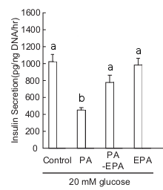

Insulin secretion in control, PA, EPA, and PA-EPA feeding groups. Groups that share a superscript are not significantly different from each other at p<0.05.

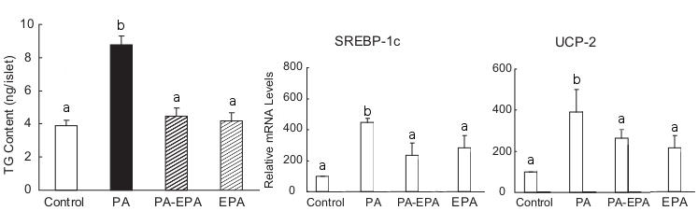

Pancreatic islet triglyceride (TG) content and mRNA levels of SREBP-1 (lipogenic enzyme transcription factor) and UCP-2 (uncoupling protein) in control, PA, EPA, and PA-EPA feeding groups. Groups that share a superscript are not significantly different from each other at p<0.05.

**Questions:**

1. Describe the results presented in Figure 1.
2. Describe the results shown in Figure 2.
3. Drawing on your own knowledge of biology and from the background information, how might TG within the cell influence insulin secretion? (need this question?) maybe not
4. Using information from the background and Study 2, propose mechanism(s) on how PA and EPA may contribute to the mitochrondrial and cytolic regulation of insulin secretion.
5. Given the data in Study 2, what could the investigators have measured in study 1 to get a better understanding of the role of n-3 fatty acids in diabetes risk.
6. Think back to the previous assignment regarding the Sandy Lake population, where some individuals had a SNP in the HNF1A gene which caused a decrease in pancreatic insulin production. Given the increasing consumption of Western style foods that are high in SFA in Sandy Lake, discuss the potential influence on the risk for diabetes that an increased consumption of fatty fish (which are high in EPA) may have on an individual in the Sandy Lake community with the *HNF1A* gene SNP. What influence would a decrease intake of fatty acid have on an individual with *HNF1A*? Not certain what you are trying to ask with this last sentence.