**UNIVERSITY OF TORONTO**

**Department of Nutritional Sciences**

**Mid-Term Examination 2013**

**November 7, 2013**

**Advanced Nutrition**

**NFS 484H1 F/ 1484H1 F**

**Duration – 2 hours**

**General Instructions**

1. This is an open book examination; therefore students may use any aids that have been brought into the examination room.
2. The examination is divided into 2 parts (2 studies) worth 15 marks and 25 marks respectively, for a total of 40 marks. The midterm examination will comprise 30% of your final grade.
3. Students must answer all questions in all parts of the examination. Please be certain to allocate your time appropriately to ensure that you are able to complete all parts of the examination.
4. All answers should be clearly provided in the answer booklets provided. Please provide your answer on the right-hand side of the page only. It will be assumed that the left-hand side of the page is used for note making purposes only and material appearing on this side of the page will not be read or graded.
5. PLEASE DO NOT WRITE IN PENCIL. Feel free to cross out anything that you want. Pencil smears and is often difficult to read. Thanks for your consideration in this request.

**Background**

Dietary fatty acid (FA) intake influences risk for type 2 diabetes (T2DM), with saturated fatty acid (SFA) and n-3 FA intake associated with an increased and decreased risk, respectively. SFA may mediate their influence on T2DM risk through impairing beta-cell function (possibly via increased cytosolic fat deposition in the beta-cells, leading to impaired cytosolic activity and functioning). A variety of different mechanisms have been explored to uncover protective effects of the n-3 FA., with several still under investigation. Likely candidates for the effects of SFA and n-3 FA are palmitic acid (PA) and eicosapentaenoic acid (EPA), respectively.

There are a number of pathways that could be influenced by dietary FA. Glucose-stimulated insulin secretion (GSIS) occurs when glucose enters the pancreatic beta-cell, goes through the glycolytic pathway, and enters the Kreb Cycle to produce ATP. The accumulation of intracellular ATP results in depolarization of the cell membrane and ultimately release of insulin into the circulation.

**Study 1 (Value 15/40 marks)**

A randomized controlled trial was conducted to determine the influence of EPA on glucose control. Forty participants at-risk for T2DM were put into a control and an experimental group. Both groups were instructed to replace the dietary fats they typically use with either butter (45% SFA, does not contain EPA) or butter supplemented with EPA, both of which were provided by the researchers, while maintaining their usual diet for 3 months. Fasting plasma glucose (FPG), hemoglobin A1c (HbA1c; a measure of long term blood glucose), and C-peptide (C-pep; a protein co-released with insulin and used as a measure of total insulin secretion) were measured in a fasted state in the morning at baseline and after the three month treatment (Table 1). Subjects were given a glucose load and blood was drawn over a 2 hour period to monitor glucose and insulin levels. These data were used to determine the insulin sensitivity index (ISI; a measure of peripheral (muscle) insulin sensitivity, with higher values indicating better insulin sensitivity), and glucose and insulin area-under-the-curve (gAUC and iAUC, respectively) (Table 2). There were no significant changes in body weight between groups.

**Questions:**

1. Describe the results from Table 1. (2/40 marks)
2. Based on the data in Table 1, taken under fasting conditions, discuss a potential mechanism whereby EPA may decrease the risk of T2DM. (4/40 marks)
3. Describe the results in Table 2. (2/40 marks)
4. What was the value of adding a glucose load, compared to just using fasting measures, to this experiment? What additional information does the glucose/insulin response to the glucose load provide, in terms of mechanisms, as it relates to the impact of EPA on T2DM risk? (7/40 marks)

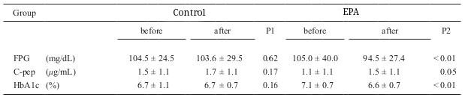

**Table 1:** Randomized controlled trial of EPA and control groups. Columns represent values at baseline (before) and after intervention. FPG = fasting plasma glucose, HbA1c = hemoglobin A1c, C-pep = C-peptide. P1 reflects comparisons within the control group and P2 reflects comparisons within the EPA group. Significance is denoted at P<0.05. Could you change the HbA1c data in the EPA group so that they are starting closer to one another (e.g. 6.9) and then maintain your spread (e.g. 6.4) I don’t want students to think that the groups were different at baseline. Thanks.

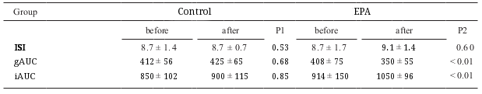

**Table 2:** Randomized controlled trial of EPA and control liquid meals. Columns represent values at baseline (before) and after intervention. ISI = Muscle insulin sensitivity index, gAUC and iAUC = glucose and insulin area-under-the-curve. P1 reflects comparisons within the control group and P2 reflects comparisons within the EPA group. Significance is denoted at P<0.05.

**Study 2 (Value 25/40 marks)**

SFA are proposed to have a lipotoxic effect (which includes impairment to cytosolic metabolism caused by an accumulation of intracellular FA) on pancreatic islets, however, it is unknown how this occurs. An experimental study using rats was conducted to determine the effect of PA or EPA on the pancreas and mechanisms underlying glucose-stimulate insulin secretion (GSIS). Rats were fed standard chow (control; contains no PA or EPA), or chow supplemented with PA, EPA, or PA and EPA (denoted as PA-EPA in figures) diets for 3 weeks, after which they were sacrificed to obtain the pancreas. Pancreatic islets were then measured for level of glucose stimulated insulin secretion (Figure 3), triglyceride (TG), SREBP-1c (transcription factor which initiates lipogenesis), and UCP-2 (uncoupling protein-2; disrupts ATP production in the mitochondria) content (Figure 4).

**Questions:**

1. Describe the results presented in Figure 3. (2/40 marks)
2. Describe the results shown in Figure 4. (3/40 marks)
3. Using information from the background and Study 2, propose mechanism(s) on how PA and EPA may contribute to the regulation of insulin secretion within the mitochondria and the cytosol. (6/40 marks)
4. Given the data in Study 2, give 3 examples of additional factors/measures the investigators could have considered in Study 1 to get a better understanding of the role of n-3 FA in T2DM risk. Provide a one or two sentence justification for each of these factors/measures. (6/40 marks)
5. Think back to the course assignment regarding the Sandy Lake population, where some individuals had a single nucleotide polymorphism (SNP) at amino acid 319 (G→S) in the *HNF1A* gene which caused a decrease in pancreatic insulin production. Given the increasing consumption of Western style foods that are high in SFA in Sandy Lake, discuss 1) how the increase in SFA intake could contribute to T2DM risk and 2) whether the return to a traditional diet, including increased consumption of fatty fish (which are high in EPA), would impact the risk for T2DM. Be certain to compare and contrast the impact of dietary fat in both the GG (wild type) and SS (homozygote for the SNP) groups [you do not need to consider the GS heterzygote group in your answer]. Defend your answer by drawing on data provided in this exam. (8/40 marks)

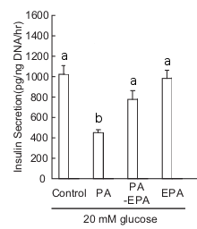

**Figure 3:** Pancreatic islet insulin secretion in control, PA, EPA, and PA and EPA (PA-EPA) feeding groups. Groups that share a superscript are not significantly different from each other at p<0.05.

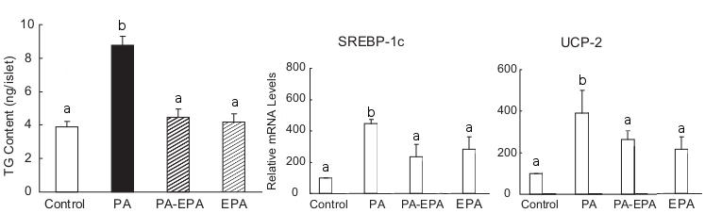

**Figure 4:** Pancreatic islet triglyceride (TG) content and mRNA levels of SREBP-1 (lipogenic enzyme transcription factor) and UCP-2 (uncoupling protein) in control, PA, EPA, and PA and EPA (PA-EPA) feeding groups. Groups that share a superscript are not significantly different from each other at p<0.05.