Tutorial #5

Female Sprague-Dawley rats were treated with a colon-specific carciongen, DMH, or saline as a control group. DMH has a stimulating effect on cell proliferation that lasts for a number of weeks. Rats were subsequently fed either a high sucrose diet (46g/kg) or a high corn starch diet (46g/kg) for 30 days or 105 days. At the end of the 30 or 105 days of feeding, a series of indices of cecal function were evaluated, as summarized in Table 1. As well, the cecal and fecal content of total and individual SCFAs were evaluated (Figure 1,2, and Table 2). In these same rats, the proliferative activity of cells in the rectal mucosa was assessed by measuring the number of 3H-thymidine-labelled cells (Figure 3). Proliferative activity in the colon was expressed as the number of labeled cells (LC)/crypt. Using Pearson correlation analysis, rectal proliferation data was then compared to variations in cecal SCFAs at 105 days after feeding diets (Table 3).

Questions
1. Describe the effects of sucrose and starch-rich diets on cecal function (Table 1), cecal and fecal concentrations of SCFAs (Figures 1 & 2, and Table 2). (5)

2. Discuss a mechanism to explain why the cecal and fecal content of total and individual SCFAs may differ in rats fed sucrose and starch-rich diets for 105 days? (10)

3 a) Describe the effects of sucrose and starch-rich diets on proliferative activity in the rectal mucosa of control and DMH-treated rats fed the diets for 30 and 105 days (Figure 3) (5)
3 b) Describe the correlations between colonic proliferative activity in rats and SCFA concentrations in rats fed sucrose and starch-rich diets for 105d (Table 3). (5)

4. Based on all of the data presented, discuss a mechanism for the effect of dietary carbohydrates on colonic proliferative activity? (10).

5. Discuss the purpose of 2 experimental periods in the study (i.e. 30d & 105d
Table 1 - Cecal variables from rats fed different diets for 30d or 105d¹
 |  |  |  | 30d |  |  |  | 105d
 |  |  | Sucrose |  | Starch |  | Sucrose |  | Starch
Wet cecal sac weight (g) |  |  | 0.68+/-0.04 |  | 0.58+/-0.02 |  | 0.82+/-0.06 |  | 0.71+/-0.04
Wet cecal content weight (g) |  |  | 1.31+/-0.09 |  | 1.17+/-0.08 |  | 1.61+/-0.14 |  | 1.47+/-0.11
Cecal pH |  |  | 7.28+/-0.08 |  | 7.19+/-0.07 |  | 7.37+/-0.04 |  | 7.16+/-0.03ª
¹ Values are means +/-SEM for 12 (30d) or 15 (105d) rats
ª p<0.01 compared with the sucrose diet

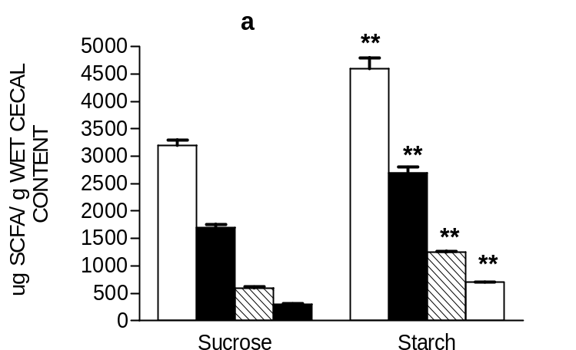
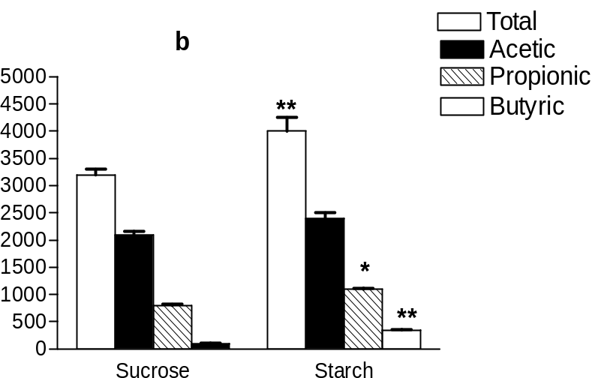
Figure 1- Concentration of SCFA (ug/g) in the wet cecal content of rats fed difference diets for 30d (panel a, n=12) and 105 d (panel b, n=15). Values are means ± SEM.
*P<0.05 as compared with the sucrose diet.
**P<0.01 as compared with the sucrose diet.

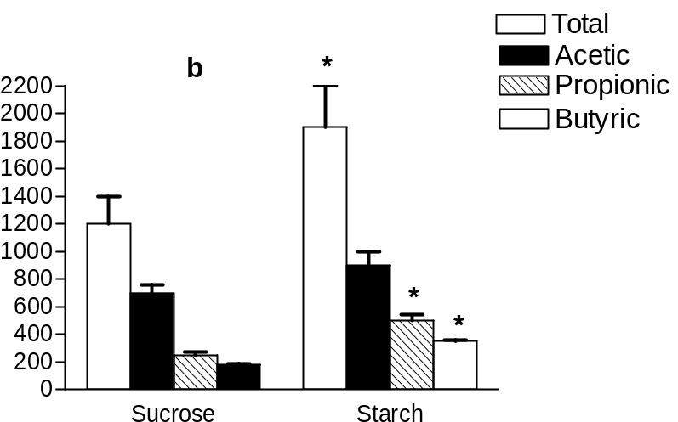
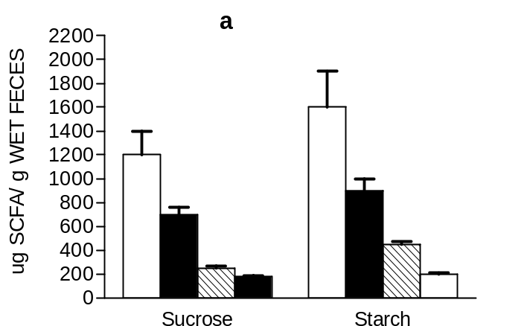

Figure 2- Concentration of SCFA (ug/g) in the wet feces of rats fed difference diets for 30d (panel a, n=12) and 105 d (panel b, n=15). Values are means ± SEM.
*P<0.05 as compared with the sucrose diet.
.

Table 2 - Percentage of individual SCFAs in the cecal content of rats fed different diets for 30 or 105 d¹
 |  |  |  | 30d |  |  |  | 105d
 |  |  | Sucrose |  | Starch | % | Sucrose |  | Starch
Acetic |  |  | 58.1+/-1.1 |  | 58.3+/-1.3 |  | 62.3+/-1.0 |  | 58.4+/-0.8ª
Propionic |  |  | 22.3+/-1.1 |  | 23.3+/-0.9 |  | 25.2+/-0.4 |  | 24.7+/-0.5
Butyric |  |  | 12.3+/-0.9 |  | 13.3+/-0.9 |  | 5.1+/-0.8 |  | 9.0+/-0.4ª
Acetic/Butyric |  |  | 5.0+/-0.4 |  | 4.1+/-0.4 |  | 14.7+/-1.7 |  | 8.3+/-0.4ª
¹ Values are means +/-SEM for 12 (30d) or 15 (105d) rats
ª p<0.01 compared with the sucrose diet

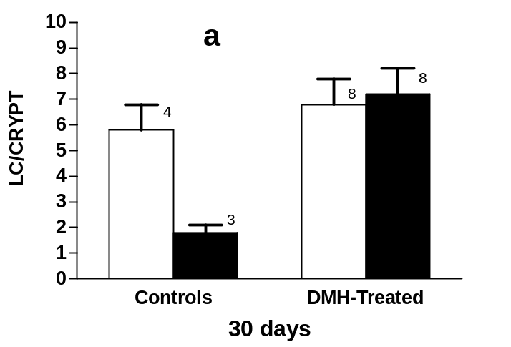
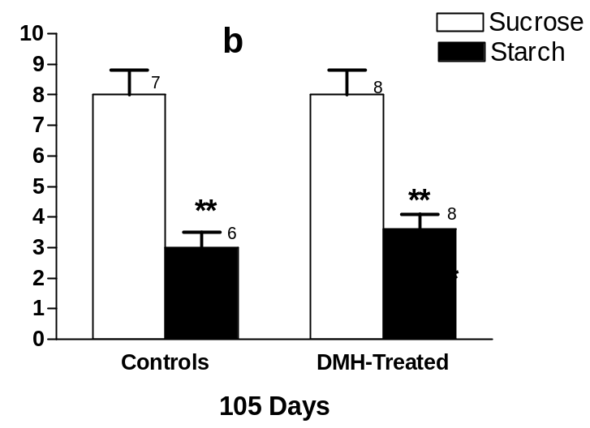
Figure 3- Proliferative Activity [labelled cells (LC)/crypt] in rectal mucosa of rats fed different diets for 30d (panel a) and 105 d (panel b). Numbers above bars represent # of animals in each treatment group.
**P<0.01 as compared with the sucrose diet.
.

Table 3 - Parameters of Linear Correlation between Proliferative Activity (LC/crypt) in the rectum and
variations in Cecal SCFAs 105d after feeding starch or sucrose diets¹
 |  |  |  | Labelled cells/crypt
 |  |  |  | r |  | P
Total SCFA concentraton |  |  |  | -0.14 |  | 0.47
Acetate Concentration |  |  |  | -0.08 |  | 0.69
Butyrate Concentration |  |  |  | -0.65 |  | 0.00011
Acetate/total SCFA, % |  |  |  | 0.64 |  | 0.00018
Butyrate/total SCFA, % |  |  |  | -0.71 |  | 0.00001
Acetate/Butyrate |  |  |  | 0.63 |  | 0.00024
Cecal pH |  |  |  | 0.46 |  | 0.011
1 Correlation Coefficient was calculated by Pearson Correlation
r = correlation coefficient and P = probability values

Tutorial #4: Tutor Notes

Objectives of Tutorial:
- To further practice statistical interpretation of figures and tables
- To introduce the concept of linear regression analysis and give them a basic understanding of looking at both the r values and p values in assessing the relationship between 2 variable
- Note: emphasize that they should look at the r value to determine the direction of the association→(is it a positive or negative correlation?) and look at the p value to determine whether the correlation is significant. Also, remind them that correlation does not mean causation.

Key Points for Discussion:

Question 2: Discuss a mechanism to explain why the cecal and fecal content of total and individual SCFAs may differ in rats fed sucrose and starch-rich diets for 105 days?

- Digestion/Absorption differences:
Sucrose is a simple sugar and would have very efficient digestion & absorption. Starch is a complex polysaccharide, has a slower digestion process and would reach the colon allowing for greater bacterial fermentation and greater production of SCFA. (Fig 1: ↑ total production of SCFAs at 30 & 105d, Table 1: ↓ pH on starch at 105 d )

- Differences in Colonic bacterial populations:
Starch feeding results in significant differences in proportion of individual SCFAs produced in cecum at 105 days suggesting the stimulation of specific bacterial populations at this time. (Table 2)
By 105 days, bacteria are very efficient at producing SCFA (see sig. ↓ pH at this time) and the absorptive capacitiy of the cecum has been exceeded, resulting in significant excretion of SCFAs in feces (Fig 2).

Question 4: Based on all of the data presented, discuss a mechanism for the effect of dietary carbohydrates on colonic proliferative activity.

- High starch diet vs high sucrose diet→ ↑ SCFA production in the gut (Fig. 1)
- SCFA’s lower the pH of the gut (Table 1) and this may in turn affect the microfloral balance and cause an increase in beneficial, protective bacteria. (Table 2 shows different proportions of SCFA) This is supported in table 3 showing a significant positive correlation between cecal pH and proliferative activity.
- High starch diet results in different proportions of individual SCFAs in the cecum (fig. 1, table 2). Specifically, butyrate concentration & proportion increase and proportion of acetate and acetate:butyrate ratio decreases. (Table 2)
- Butyrate concentration and percentage are both significantly negatively correlated with proliferative activity in the rectum (Table 3).
- Butyrate is a preferred energy source for the colon; it helps repair cells and improves colonocyte maintenance. (Note: this information wasn’t given to them so we would not necessarily expect them to bring in outside information about the known positive effects of butyrate on colonic cells)
- SCFA’s (especially butyrate) may inhibit colon cancer by inhibiting cell proliferation (Figure 3) (We can’t say this conclusively since there was no difference in rectal proliferation between saline and DMH-treated groups)

Question 5: Discuss the purpose of 2 experimental periods in the study (ie 30d & 105 d).
- Adaptation (how long does it take to see changes in bacterial populations?)
- Acute vs chronic effects
A number of answers may be given as long as they are logical and can be substantiated with data.

