Tutorial # 6

Study #1
The objective of this study was to determine the effect of refeeding food-deprived rats on hepatic glucose-6-phosphatase (G6Pase) activity. Rats were food-deprived for 48hrs and then given free access to food for 0, 90, 180 or 360 minutes. At each time point, plasma was obtained for glucose and insulin measurements and liver samples removed for enzyme determination. In addition to G6Pase, paprnitrophenyl-phosphatase (PNPase) activity was monitored as a control for the G6Pase measurement.
To determine whether changes in glucose or insulin were mediating the effects of refeeding on hepatic G6Pase activity, a euglycemic, hyperinsulinemic clamp experiment was performed. Food-deprived rats were fitted with catheters in the carotid artery and jugular vein for blood sampling (artery) and glucose and insulin infusions (vein). Rats were perfused with predetermined doses of insulin and then variable doses of glucose were administered in order to maintain normal blood glucose levels. Fifty minutes after commencement of the infusion, liver samples were removed for G6Pase determination.

1a) Describe the differences in blood glucose and insulin associated with refeeding the food-deprived rats (Table 1) (2).
1b) Describe the effects of refeeding on G6Pase activity (Figure 1) (1).

2. Using the data provided, discuss the relative contributions of hepatic and dietary carbohydrate to plasma glucose levels observed over the time course monitored (7).

3. Describe the major outcomes of the euglycemic clamp study (Table 2) (2).

4. Discuss whether G6Pase activity is predominantly regulated by dietary carbohydrate or hormonal factors (8).

Table 1. Changes in plasma glucose and insulin
levels in previously unfed rats in the course of refeeding
Refeeding time |  | Plasma glucose |  | Plasma insulin
min |  | mmol/L |  | pmol/L
0 |  | 6.3+/-0.6 |  | 83+/-14
90 |  | 11.1+/-0.7* |  | 366+/-54
180 |  | 10.1+/-1.1* |  | 331+/-56*
360 |  | 9.2+/-0.8* |  | 345+/-41*
Values are means +/- SEM. *p<0.05 vs time 0.

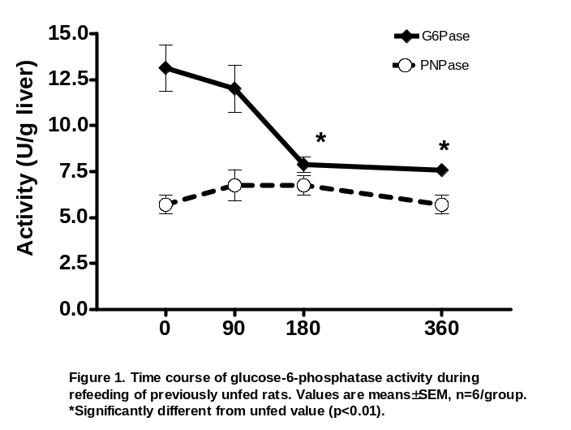

Table 2: Effect of insulin infusion on glucose-6-phosphatase activity in unfed rats with euglycemic clamps:

Insulin Perfused | Glucose Perfused | Basal glucose | Final glucose | Final insulin | Final G6Pase
pmol/hr | umol/min | mmol/L plasma | mmol/L plasma | pmol/L plasma | units/g liver
Saline | -------- | 6.4 ± 0.2 | 6.8 ± 0.2 | 97 ± 7 | 12.0 ± 0.8
240 | 11 ± 1 | 6.4 ± 0.1 | 7.1 ± 0.2 | 221 ± 8 | 10 ± 0.4
480 | 18 ± 2 | 6.7 ± 0.5 | 6.8 ± 0.2 | 324 ± 29 | 11.3 ± 0.7
960 | 35 ± 1 | 6.0 ± 0.4 | 6.9 ± 0.5 | 704 ± 94 | 12.1 ± 1.2
2,880 | 50 ± 2 | 5.9 ± 0.2 | 6.0 ± 0.2 | >1400 | 14.6 ± 0.8
28,800 | 49 ± 2 | 5.9 ± 0.4 | 6.5 ± 0.8 | >1400 | 13.6 ± 0.3

Values are means ± SEM (n=3-8 rats/group) Basal glucose was determined just prior to the infusion and final glucose and insulin was measured at the end of the perfusion period. For the G6Pase activity, ANOVA did not reveal any significant differencds (p>0.15)

Tutorial #6

Study 2
The purpose of this experiment was to determine the effects of dietary restriction and subsequent weight loss on phosphofructokinase-I (PFK-I) activity in selected skeletal and heart muscles. Fifty-five female rats were separated into 3 groups for 10 weeks of dietary restriction. 1) AL = ad libitum fed (no restriction), 2) MR = moderate restriction (weight reduced to 81% of AL) and 3) SR = severe restriction (weight reduced to 63% of AL). During the last week of the study, a measurement of the animal’s resting oxygen uptake was taken in order to estimate total oxygen consumption associated with energy metabolism. The rats were then killed and the PFK-1 activity in the heart and various skeletal muscles was determined using standardized techniques.

1. Describe changes in body weight, and resting oxygen uptake (both in absolute and relative terms) for the AL, MR, and SR groups (Table 1, Figure 1)(3).
1b). Describe changes in the activity of PFK-1 in heart and skeletal muscles caused by dietary restriction (Table 2)(2).

2. Discuss a mechanism to explain the effects of dietary restriction on substrate utilization in skeletal muscle (10).

3. What other enzyme/metabolites would you want to measure to verify the PFK-I enzyme effect, and why? (5)
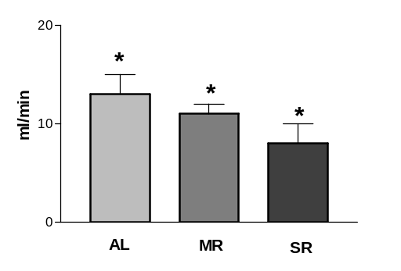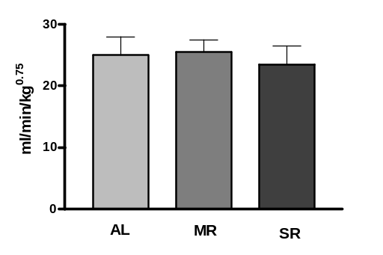
Figure 1. Resting oxygen uptake for 55 female Sprague-Dawley rats expressed
in absolute (ml/min) and relative (ml/min/kg^{0.75}) terms. *All groups are
statistically different from each other, p<0.05.

Table 1 Mean body weight of animals |  |  |  |  | Table 2. Effect of dietary restriction on PFK-1
prior to and after the dietary restriction. |  |  |  |  | (umol/g/min) activity in skeletal and heart muscle.
 |  | Body Weight (g) |  |  |  | AL | MR | SR
 | AL | MR | SR |  | #per group | 16 | 20 | 19
pre- | 350+/-30 | 350+/-30 | 350+/-30 |  | Skeletal
restriction |  |  |  |  | Gastrocnemius | 105+/-7ª | 86+/-6^{b} | 62+/-6^{c}
post- | 395+/-60ª | 331+/-50^{b} | 253+/-38^{c} |  | Plantaris | 92+/-6ª | 86+/-5ª | 66+/-4^{b}
restriction |  |  |  |  | Soleus | 25+/-2ª | 22+/-1ª | 16+/-1^{b}
Mean +/- SEM. Means in the same row with |  |  |  |  | Heart | 64+/-3 | 68+/-3 | 66+/-3
different superscripts are significantly |  |  |  |  | Means +/- SEM. Means in the same row with
different (p<0.05). |  |  |  |  | different superscripts are significantly different, p<0.05

Tutorial #6: Tutor Notes

Objectives of Tutorial:
- To introduce the hyperinsulinemic-euglycemic clamp technique (study 1)
- To understand differences in interpreting data when it’s expressed in relative and absolute terms. (study 2)

Key Points for Discussion (Study 1):
Question 2: Using the data provided, discuss the relative contributions of hepatic and dietary carbohydrate to plasma glucose levels observed over the time course monitored.

- G-6-Pase activity decreases significantly by 180 & 360 minutes, while blood glucose & insulin levels continue to rise during this time. We would expect this since a supply of glucose from the food reduces the amount that the body needs to supply endogenously from the liver
- Illustrates the shift from the metabolic state seen in the post-absorptive or fasted state, to the metabolic state of a fed animal
- PNPase is just a housekeeping enzyme.

Question3: (Table 2) Give Overview of Clamp Technique:
Step 1: infuse a set amount of insulin into the animal’s vein
Step 2: infuse glucose into the same vein & adjust the amount of glucose infused to keep blood glucose at normal levels (∼5mM) (so that animal does not pass out & die)
Step 3: measure how much glucose had to be infused to keep blood glucose normal
∴ BY DESIGN, blood glucose doesn’t change in the animal, but blood insulin levels are very high.

- Clamp is often used in studies examining insulin resistance and/or type 2 diabetes→in an insulin resistant state, less glucose is needed to maintain normal blood levels since the individual is resistant to the action of insulin and has less effective cellular uptake of glucose. As a result, glucose remains in the blood

Question 4: Discuss whether G6Pase activity is predominantly regulated by dietary carbohydrate or hormonal factors.
- Discuss why the clamp was done: to determine whether the change in G6Pase is caused by insulin or glucose
- Table 1: feeding increased glucose & insulin
- Figure 1: After the increase in glucose and insulin, G6Pase activity drops
- This drop in G6Pase is likely due to changes in glucose since changes in insulin have no effects on G6Pase activity
Study 2:

Question 2: Discuss a mechanism to explain the effects of dietary restriction on substrate utilization in skeletal muscle.
- Table 1: Caloric restriction causes a drop in body weight
- Figure 1: Calorically restricted rats have decreased metabolism (measured from resting O₂ uptake) but this effect is totally accounted for by the loss in body weight (there is no significant difference between groups when data is normalized for body weight→expressed in relative terms)
- Table 2: Skeletal muscle PFK-1 activity drops with caloric restriction (but not heart PFK-1)
- Total oxidative activity hasn’t changed (fig. 1) but glycolysis is decreased (↓ PFK-1)
- Decreased energy intake leads to decreased PFK-1 activity and therefore decreased glucose use
- The animals are most likely mobilizing fat from adipose tissue for fuel and some protein

Question3: What other enzyme/metabolites would you want to measure to verify the PFK-1 enzyme effect, and why?
- Any enzymes/metabolites in glycolytic pathway
- Any enzymes/metabolites in beta-oxidation to confirm increased use of fat for fuel

