Tutorial #3

Study 1
Six week old rats were fed standard chow for 7 days and then, following an overnight fast, were force fed either a low starch, long chain triglyceride diet (LCT) (70% fat as corn oil), a low starch, medium chain triglyceride diet (MCT) (70% fat as medium chain triglycerides), or a high carbohydrate diet (HC) (70% carbohydrate) for 12 hours. For the rats on the HC diet, carbohydrate was provided either as sucrose or α-methylglucoside, a non-metabolizable sugar. Following sacrifice, jejunal lactase mRNA levels were measured, and lactase activity.

Study 2
Six week old rats were fed either the LCT diet, the MCT diet, or a high starch diet (HS) (70% of energy as starch) for 7 days. In order to estimate the absolute rate of synthesis of lactase, the rats were given an i.v. infusion of [³H]-phenylalanine 30 minutes prior to sacrifice. The jejunum was then removed and the incorporation of the [³H]-phenylalanine was measured by standard methods. Lactase activity and mRNA levels were also measured.

Q1a. Describe the effects of the diets in study 1 on lactase mRNA levels and lactase activity (2/20).

Q1b. Describe the effects of the diets in study 2 on lactase rate of synthesis, activity, and mRNA levels (3/20).

Q2. Discuss a comprehensive mechanism, supported by the data provided, which would explain the effects of the differing diets on lactase regulation (15/20).

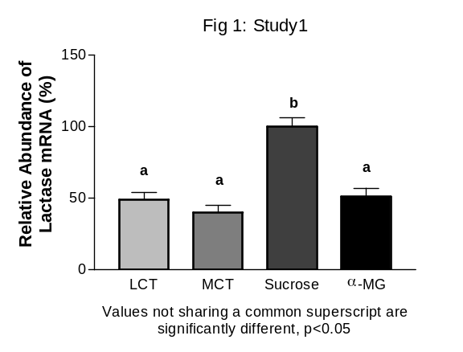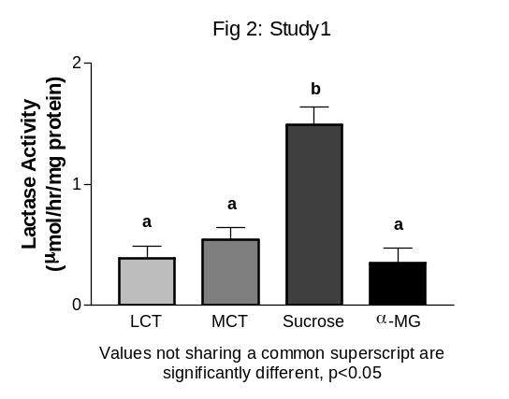

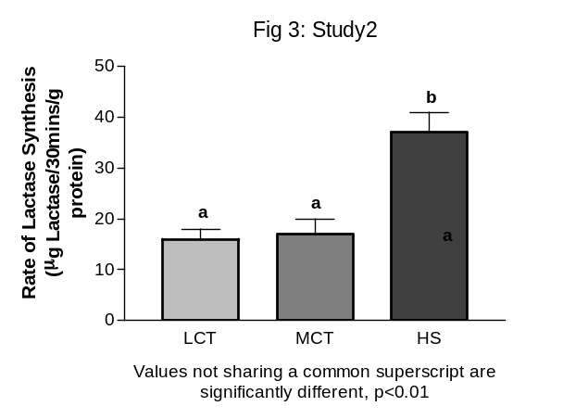

Table 1: Study 2

 | LCT | MCT | HS
Lactase Activity  (μmol/hr/mg protein) | 0.45 ± 0.04ª | 0.64 ± 0.05 ^{b} | 1.49 ± 0.08 ^{c}
Relative abundance of lactase mRNA (%) | 54 ± 3ª | 55 ± 2ª | 100^{b}
Values not sharing a common superscript are significantly different, p<0.01.

Tutorial #2 – notes for Tutors

Objectives of Tutorial:

- To practice statistical interpretation of figures and tables.
- To practice interpretation of experimental design.
- To introduce concepts: chronic versus acute effects of diet
: gene regulation by diet
: importance of metabolism for biological activity
: consideration of hormonal environment

Key Points for discussion:
Q2. Discuss a comprehensive mechanism, supported by the data provided, which would explain the effects of the differing diets on lactase regulation (15/20).

Lactase is subject to regulation both transcriptionally, and post-transcriptionally. Effects of diet on lactase regulation differ depending on chronic versus acute exposure.
• In the presence of a metabolizable sugar (sucrose), lactase mRNA synthesis is increased (Fig1). Since the non-metabolizable sugar (α-MG) does not affect lactase transcription, we can assume that one or more of the components of sucrose can induce lactase gene transcription.
• Sucrose is composed of glucose and fructose.
• Glucose is a component of lactose, and it also stimulates insulin secretion. Either glucose or insulin are likely candidates for the increase in lactase mRNA seen with the HC-sucrose diet.
• After acute (12 hour) administration of diets, only sucrose increases lactase activity. Neither the non-metabolizeable sugar, the LCT diet, nor the MCT diet increase lactase activity (Fig 2). Therefore lactase gene expression is acutely regulated only by sucrose.
• Lactase enzyme protein expression is chronically regulated also only by a metabolizable carbohydrate (Fig3).
• Since starch breaks down only into glucose subunits, this further suggests that glucose, or insulin, but not fructose, are stimulators of lactase enzyme expression (Fig3).
• According to table 1, increased lactase enzyme expression with the HS diet (Fig3) is likely mediated by increased lactase gene transcription.
• Interestingly, chronic administration of the MCT diet will increase lactase activity (although not as much as the HS diet). This indicates that the lactase gene is chronically regulated by MCTs (Table 1) as well as HS diet.

Summary: Lactase mRNA expression and enzyme activity are regulated acutely by a metabolizable sugar (sucrose) that yields glucose and fructose. Chronically, lactase mRNA expression, enzyme protein expression, and enzyme activity are regulated by a metabolizable carbohydrate (starch) that yields only glucose. This suggests that glucose, and possibly insulin, mediate the effects of carbohydrates on lactase. Chronic exposure to diets differing in macronutrient content results in differing regulation of lactase activity. Diets rich in MCTs stimulate lactase activity when fed chronically, but not acutely. This occurs despite no evidence of changes in enzyme synthesis, or mRNA levels, indicating that chronic effects of MCTs on lactase activity are mediated post-translationally.

