# Title page

Title: Fatty acids involved in de novo lipogenesis within the serum triacylglycerol fraction strongly predict lower insulin sensitivity.

Author: Luke W. Johnston (1), MSc; Stewart B. Harris (2), MD; Ravi Retnakaran (3,4), MD; Adria Giacca (5), PhD; Zhen Liu (1), PhD; Richard P. Bazinet (1), PhD; and Anthony J. Hanley (1,3, 6), PhD

{{Bernie?}}

Affiliation:

1. Department of Nutritional Sciences, University of Toronto, Toronto, Ontario, Canada.
2. Centre for Studies in Family Medicine, University of Western Ontario, London, Ontario, Canada.
3. Leadership Sinai Centre for Diabetes, Division of Endocrinology, University of Toronto, Toronto, ON, Canada.
4. Lunenfeld Tanenbaum Research Institute, Mount Sinai Hospital, Toronto, Ontario, Canada.
5. Department of Physiology, University of Toronto, Toronto, Ontario, Canada.
6. Dalla Lana School of Public Health, University of Toronto, Toronto, Ontario, Canada.

Corresponding author:

* Name: Anthony J. Hanley
* Current address:  
  Department of Nutritional Sciences  
  Faculty of Medicine  
  University of Toronto  
  FitzGerald Building, 150 College Street, Room 341  
  Toronto, ON, Canada, M5S 3E2
* Phone number: 416.978.3616
* Fax number:
* Email: [anthony.hanley@utoronto.ca](mailto:anthony.hanley@utoronto.ca)

Disclaimers:

Funding support:

Word count: ~4200

# Abstract

# Background

Hypertriglyceridemia is an extensively studied and well-known factor involved in the dysregulation of metabolic function and subsequent negative health outcomes. It is a component of the metabolic syndrome (1), a strong risk factor for cardiovascular disease (2), and has been shown to contribute to the pathogenesis of diabetes. Measuring triacylglcerides (TAG) within the blood is commonly done during routine clinical visits as part of health assessment. However, clinically measured TAG is limited as it represents all the types of fatty acids within the TAG fraction as a single measure. Given the increasing appreciation for the role of the specific fatty acid composition on health outcomes, for instance with differences in associations of fatty acids within the PL lipid fraction (3,4) including an analysis from the PROMISE cohort (5), there are relatively few studies that have explored this area of research in the TAG fraction.

The interaction between TAG and insulin sensitivity is complex and has components of a feedback system. Greater resistance to insulin in both the liver and muscle may result in greater production of TAG and secretion of lipoproteins that transport TAG (6). Likewise, greater TAGFA may contribute to metabolic dysfunction and lipotoxicity in various tissues, such as the beta-cells, and thus continuing the cycle. Given the complexity and temporal nature of the relationship, long term studies with multiple data collections are paramount to better understanding the underlying biology and subsequent risk.

While several prospective studies have documented a prospective association of hypertriglyceridemia with incident type 2 diabetes (2,7,8), there are limited longitudinal studies that have examined the relationship between TAG and it's composition on the pathophysiological factors underlying diabetes, particularly in regard to beta-cell function. Our objective was to examine the longitudinal role of the specific composition of the serum TAG fraction on OGTT-derived measures of insulin sensitivity and beta-cell function in a Canadian population at risk for diabetes.

# Subjects and Methods

Recruitment for the baseline visit of the Prospective Metabolism and Islet Cell Evaluation (PROMISE) cohort took place between 2004-2006 in London and Toronto, Canada. Individuals were selected to participant if they met the eligibility criteria of having one or more risk factors for type 2 diabetes mellitus, including obesity, hypertension, family history of diabetes, and/or a history of gestational diabetes or birth of a macrosomic infant. A total of 736 individuals attended the baseline visit. Subsequent examinations occurred every three years, with three examination visits completed to date (2004-2006, 2007-2009, and 2010-2013). Participants are contacted annually by telephone. The current study used data on participants who did not have diabetes at baseline, who returned for one or more of the follow-up examinations, and who had samples available for fatty acid measurements (n=477; see the CONSORT diagram in Figure 1; a total of 423 attended all three visits). Metabolic characterization, anthropometric measurements, and questionnaires on lifestyle and sociodemographics are administered at each examination visit. Research ethics approval was obtained from Mount Sinai Hospital and the University of Western Ontario, and all participants provided written informed consent. Data collection methods were standardized across the 2 centres and research nurses were centrally trained.

## Metabolic characterization

After 8-12 hours of fasting, participants completed an 75g oral glucose tolerance test (OGTT) at each examination visit, with blood samples taken at fasting, 30 min, and 2 hr post-glucose load. Samples were subsequently processed and frozen at -70°C. Alanine aminotransferase (ALT) was measured using standard laboratory procedures. Cholesterol, HDL, and clinically-measured triacylglycerides (TAG) were measured using Roche Modular's enzymatic colorimetric tests (Mississauga, ON). Both insulin and glucose were measured from OGTT blood samples at fasting, 30 minute, and 2 hour time points. Specific insulin was measured with the Elecsys 1010 (Roche Diagnostics, Basel, Switzerland) immunoassay analyzer and electrochemiluminescence immunoassay, which shows 0.05% cross-reactivity to intact human pro-insulin and the Des 31,32 circulating split form (Linco Res. Inc) and has a coefficient of variation (CV) of 9.3%. Glucose was determined using an enzymatic hexokinase (Roche Modular, Roche Diagnostics) with a detection range of 0.11 to 41.6 mmol/L and an inter-assay %CV of <1.1% and an intra-assay %CV of < 1.9%. All assays were performed at the Banting and Best Diabetes Centre Core Lab at Mt Sinai Hospital. Impaired fasting glucose (IFG), impaired glucose tolerance (IGT), and diabetes were categorized using the 2006 WHO criteria (9).

TAGFA composition was quantified using stored fasting serum samples from the baseline visit, which had been frozen at -70°C for 4-6 years and had not been exposed to any freeze-thaw cycles. Serum fatty acids have been documented to be stable at these temperatures for up to 10 years (10). A known amount of {{confirm with Richard the correct name}} heptadecanoic acid (17:0) was added as an internal standard prior to extracting total lipids according to the method of Folch (11). Each serum lipid fraction (non-esterified fatty acids (NEFA), cholesteryl ester, phospholipid, and TAGFA) was isolated using thin layer chromatography. Fatty acid methyl esters were separated and quantified using a Varian-430 gas chromatograph (Varian, Lake Forest, CA, USA) equipped with a Varian Factor Four capillary column and a flame ionization detector. Fatty acid concentrations (nmol/ml) were calculated by proportional comparison of gas chromatography peak areas to that of the internal standards (12). There were 22 fatty acids measured in the TAGFA fraction. Given that each lipid fraction differs in biology and given the complexity of the analyses, findings for other lipid fractions in this cohort are reported separately (see ref (5) for the analysis of the phospholipid and cholesteryl ester fractions).

## Anthropometrics and sociodemographics

Height, weight, and waist circumference (WC) were measured at all clinic examinations using standard procedures. WC was measured at the natural waist, defined as the narrowest part of the torso between the umbilicus and the xiphoid process. BMI was calculated by dividing weight (kg) by height (m) squared. Questionnaires administered at each examination determined sociodemographics. A version of the Modifiable Activity Questionnaire (MAQ) (13) determined estimated physical activity. The MAQ collects information on leisure and occupational activity, including intensity, frequency, and duration, over the past year. Each reported activity from the MAQ was weighted by its metabolic intensity allowing for the estimation of MET-hours per week.

## Variable calculation and statistical analysis

Insulin sensitivity and beta-cell function indices were computed using the OGTT glucose and insulin data. Insulin sensitivity was assessed using HOMA2-%S (14) using the HOMA2 Calculator and the Insulin Sensitivity Index (ISI) (15). HOMA largely reflects hepatic insulin resistance, while ISI reflects whole-body insulin sensitivity (16). Beta-cell function was assessed using the Insulinogenic Index (17) over HOMA-IR (18) (IGI/IR) and the Insulin Secretion-Sensitivity Index-2 (ISSI-2) (19). IGI/IR is a measure of the first phase of insulin secretion while ISSI-2 is analogous to the disposition index (but using OGTT values). Each index has been validated against gold standard measures (15,18–20). Specific formulas for each OGTT-derived measure can be found in the {{ Supplementary Material }}.

The primary outcome variables for this analysis were HOMA2-%S, ISI, IGI/IR, and ISSI-2, which were log-transformed for the statistical modeling. The primary predictor variables for this analysis were 22 individual TAGFA, modeled as mole percent (mol%) of the total fraction and as concentration (nmol/mL). Clinically-measured TAG was also included as a primary predictor to serve as a comparison against the TAGFA composition. A limitation with the clinically-measured TAG is that it was only quantified on a portion of the participants at the 6-year visit (n = 126). Pearson correlation coefficients were computed to assess the relationships of individual TAGFA with other continuous variables. Correlations were also computed for TAGFA against each other, followed by using hierarchical clustering analysis to identify clusters within the correlation matrix of the TAGFA composition.

Generalized estimating equation (GEE) models (21) were used in the primary analysis to determine the longitudinal associations between the outcome variables and the predictor variables. Given the longitudinal design, an auto-regressive of order 1 (AR1) working correlation matrix was chosen for the GEE models as it had the best model fit when assessed using quasi-likelihood information criteria (QIC), though other matrices (eg. exchangeable) had similar fit (data not shown). GEE is well suited to longitudinal cohort studies given its capacity to handle missed visits. The predictor variables and continuous covariates were scaled (mean-centered and standardized). The TAGFA, total NEFA, sex, ethnicity, and baseline age were classified as *time-independent* (held constant) as they were measured only at the baseline visit or do not change throughout the study, while the outcome variables and remaining covariates were set as *time-dependent*. No imputation was conducted on missing values. Given how the samples for TAGFA measurement were determined and how the outcome variables are calculated, cases of diabetes at baseline and follow-up were not included in the GEE modeling.

Covariates were selected based on the previous literature, from directed acyclic graph (22) recommendations (using the DAGitty software (23), <http://dagitty.net/>; see Figure 2 and Figure 3), and from QIC. Table 1 shows the covariates compared using QIC. While the final GEE model selected as best fitting differed between insulin sensitivity and beta-cell function measures, the differences in QIC values were less than 10 between many of the models, suggesting similar fit. As such, we selected the model that had the fewest covariates and that had similar fit between the outcome measures. The final GEE model was adjusted for time, waist circumference, baseline age, ethnicity, sex, ALT, MET, and total NEFA. After scaling, log-transforming, and exponentiating, the GEE estimates are interpreted as an expected percent difference in the outcome variable for every standard deviation (SD) increase in the predictor variable given the covariates are held constant (including time). Lastly for the GEE models, we tested for an interaction with sex, ethnicity, or time by the predictor term for each outcome variable.

While GEE accounts for the longitudinal design of the data, this approach is limited in that it cannot analyze the inherent multivariate nature of the composition of the TAGFA fraction. To confirm the GEE results in a multivariate environment (i.e. all TAGFA analyzed collectively), partial least squares regression (PLS) was used to identify the patterns of TAGFA composition against insulin sensitivity and beta-cell function. No prevalent diabetes cases were included in the PLS analysis. For more detailed explanation of GEE and PLS, please see the {{supplemental}} Methods.

All analyses were performed using R 3.3.1 (24), along with the R packages geepack 1.2.1 for GEE (25) and pls 2.6.0 for PLS. The R code and extra analyses for this manuscript is available at {{code doi}}. Results were considered statistically significance at p<0.05, after adjusting for multiple testing using the Benjamini-Hochberg False Discovery Rate (26). STROBE was used as a guideline for reporting (27).

# Results

## Basic characteristics of the PROMISE cohort

Table 2 shows basic characteristics of the PROMISE cohort. The mean follow-up time was 5.6 (1.0) years, where 88.7% of participants attended all three visits. There were 349 (73.2%) females and 336 (70.4%) who had European-ancestry, with a mean age in years of 50.1 (9.8) and a mean BMI of 31.1 (6.4) kg/m^2. As expected from the study’s eligibility criteria, the majority of participants (308 (64.8%)) had a family history of diabetes. Between the baseline visit and the 6-year visit in this sample, insulin sensitivity and beta-cell function measures had a significant median decline between 14% to 27% (p<0.001 from GEE; n=367-470). There were 42 (9%) and 96 (20%) incident cases of diabetes and pre-diabetes (IFG and IGT), respectively.

Figure 4 shows the composition of each FA in the TAG fraction (see Table 3 for a tabular presentation of the values). Three TAGFA contributed 82.4% to the total TAG concentration: 18:1n-9 (37.8%); 16:0 (26.6%); and, 18:2n-6 (18.0%). Figure 5 shows a heatmap of the correlation of individual TAGFA with the outcome variables and several basic characteristics. As expected, nearly all TAGFA had very strong positive correlations (r= 0.33 to 0.92) with clinically-measured TAG and moderate positive correlations with WC (r=0.31 to 0.36). There was also moderate negative correlations with HDL (r=-0.53 to -0.32). For the outcome variables, the correlations for the insulin sensitivity measures were generally higher (HOMA2-%S: r=-0.48 to -0.32, ISI: r=-0.48 to -0.33) than for the beta-cell function measures (all r<0.30).

## Generalized estimating equation models

There were 141 FDR-corrected significant associations in the unadjusted GEE model (see Figure 7) and 88 FDR-corrected significant associations in the adjusted GEE model as shown in Figure 8. The majority of associations with beta-cell function measures were attenuated after full model adjustment, while nearly all associations with insulin sensitivity remained significant.

In analyses modeling TAGFA as concentrations, nearly all TAGFA had a strong negative association on HOMA2-%S and ISI (estimates ranging from -13.7 to -3.6 and -14.7 to -4.4, respectively), and a few had strong negative associations with IGI/IR and ISSI-2 (estimates ranging from -7.4 to -7.3 and -4.1 to -3.4, respectively). In analyses modeling TAGFA as mol%, four TAGFA (14:0, 16:0, 14:1n-7, and 16:1n-7) had negative associations with HOMA2-%S and ISI (between -11.6 to -5.7 and -12.3 to -5.8%, respectively, lower insulin sensitivity for every SD increase in the TAGFA), while several more TAGFA had positive associations with HOMA2-%S and ISI (20:0, 18:1n-9, 20:1n-9, 22:1n-9, 18:2n-6, 20:2n-6, 20:4n-6, and 22:5n-3) predicting between 4.3 to 14.2 and 5.8 to 15.2%, respectively, higher insulin sensitivity for every SD increase in the TAGFA. One TAGFA, 20:2n-6, had a very strong positive association with the insulin sensitivity measures, with a 14.2 to 15.2% higher insulin sensitivity for every SD increase in 20:2n-6.

Both clinically-measured TAG and total TAGFA concentration had very strong negative associations with all outcome variables. There were no significant interactions by time, sex, or ethnicity for any of the TAGFA (data not shown). A tabular presentation of the GEE results is shown in Table 4 for unadjusted models and Table 5 for adjusted models.

## Clustering of TAGFA by metabolic measures

To determine which components to use, internal CV showed that the first two components gave the highest amount of explained variance (data not shown). Confirming the findings from the GEE models, PLS analysis on the beta-cell function measures revealed that there was a low correlation (though significant at p<0.001) between the predicted values and the actual values (r= 0.25 to 0.24), suggesting poor predictability. While the clustering of TAGFA from the PLS results of the beta-cell function measures were similar to the insulin sensitivity measures, only the insulin sensitivity measures are presented given the higher predictive ability.

The PLS results for the insulin sensitivity (Figure 9) revealed a clustering of the fatty acids 14:0, 14:1n-7, 16:0, and 16:1n-7. These TAGFA loaded strongly (meaning the fatty acids fell between the dashed and solid circles) and negatively on HOMA2-%S and ISI, suggesting this cluster of TAGFA tracks together with lower insulin sensitivity. The TAGFA 20:2n-6, 20:5n-3, 22:5n-3, and 22:6n-3 loaded positively on both insulin sensitivity measures. No other TAGFA loaded strongly, the results of which remained after running the PLS model on the cross-validated testing set. The PLS model for insulin sensitivity had good predictive ability, determined by correlating the predicted outcome values with the actual values (HOMA2-%S: r=0.46, p<0.001; ISI: r=0.39, p<0.001).

# Discussion

## Overall conclusion

We found that in an at-risk for diabetes Canadian population who were mainly female and of European ancestry, the specific TAGFA composition was strongly associated with insulin sensitivity and moderately associated with beta-cell function. In particular, TAGFA myristic acid (14:0), 7-tetradecenoic acid {{ confirm name }} (14:1n-7), palmitic acid (16:0), and palmitoleic acid (16:1n-7) all strongly and negatively predicted lower insulin sensitivity. While most TAGFA were not associated with beta-cell function, two fatty acids, 16:0 and 18:1n-7, were associated negatively and positively, respectively, with both measures of beta-cell function. We also found that four TAGFA (14:0, 14:1n-7, 16:0, 16:1n-7) clustered together, and that this cluster strongly predicted lower insulin sensitivity. These four fatty acids are also involved in the DNL of refined and simple carbohydrates. Our results, which are in agreement with the current literature, suggest that higher activity of DNL (potentially through higher intakes of simple carbohydrates) may increase the risk for diabetes, likely through worsening insulin sensitivity.

## Interpretation and previous literature

To our knowledge, no longitudinal study to date has examined the role of the composition of the TAGFA fraction on detailed OGTT-derived metabolic measures using advanced {{another word? appropriate?}} statistical techniques designed to maximally utilize the data. Two large prospective studies have been published that had similar research objectives as the present analysis. One was a nested case-control analysis (n=189 cases and n=189 controls) within the Framingham offspring cohort (28), which found that TAGFA composition with a lower carbon chain and less double bonds (e.g. 14:0, 16:0) had a higher risk for diabetes after 12-years, while higher carbon chain and more double bond TAGFA had a lower risk for diabetes. This pattern of TAGFA with diabetes risk remained the same when they examined HOMA-IR cross-sectionally at the baseline visit. The other study was a prospective cohort of males in Finland (29), for which TAGFA data were available for 831 participants after 6-years of follow-up. This cohort has similar outcomes as PROMISE, however, OGTT data was only available at the 6-year visit. A beta-cell function measure was computed, but only included calculations up to 30 minutes of the OGTT. As with our results, they found a larger effect size for insulin sensitivity compared to the beta-cell function. The specific TAGFA that associated with the metabolic measures were similar between studies, particularly with the four DNL fatty acids. A limitation of the study was the simpler statistical techniques used to analyze the data, which are not able to adequately use the longitudinal and high-dimensional dataset. {{ Their article and methods were ... questionable... }} In another study of a much smaller (n=16) mostly female group (30), the authors report a positive correlation between total esterified (of which TAG make up the majority) 16:0, 16:1n-7, and 18:1n-9 with HOMA-IR, similar as our results except for the 18:1n-9 finding.

Previous research has shown that carbohydrate intake increases DNL (31–35). In particular, DNL from refined or simple carbohydrate sources increases the 14 to 16 chain fatty acids as well as the 18 chain TAGFA. Several studies have shown a link between higher estimated DNL and an increased risk for metabolic dysfunction (4,29,36,37). Our study extends these findings by showing that TAGFA with 14 to 16 carbons all strongly predicted lower insulin sensitivity. While these fatty acids also had a significant association with beta-cell function, the results were not as strong as with the insulin sensitivity.

The link between higher DNL and increases in specific fatty acids has been examined in several studies. Previous studies that have examined DNL have used markers of estimated DNL, such as the ratio between 18:2n-6 to 16:0 or 16:1n-7 to 16:0 (29,31,37). However, there are major limitations to using these ratios as the fatty acids used in their calculation can also be obtained from the diet in addition to being created through DNL (31). A short, small feeding trial (n=24) was conducted to identify fatty acids that most accurately reflected DNL, as potential biomarkers (38). The study found that palmitoleic acid (16:1n-7), directly measured DNL using isotopes, and liver fat were all highly correlated with each other (r>0.50), suggesting that 16:1n-7 may be a good biomarker for hepatic DNL. In another small (n=14) feeding trial, meal type (high fat vs low fat) was tested to determine its effect on DNL and TAGFA composition (39). The authors reported that 14:0, 16:0, 16:1, and 18:2 were higher in the low fat (high carbohydrate) group. These fatty acids are similar to the fatty acids we found that clustered together using the PLS analysis, implicating these fatty acids as indicative of a higher carbohydrate diet. A higher carbohydrate diet, particularly one characterized by a predominance of simple carbohydrates, may lead to greater DNL in an attempt to control blood glucose, increasing hepatic fat stores, and increasing the amount of TAGFA in circulation. The higher concentration of circulating 14 and 16 carbon fatty acids may then expose tissues to greater lipotoxicity, for instance from palmitic acid (16:0), which is well-known to have harmful effects on tissues (40,41).

We found no interaction by time for any of the TAGFA on the metabolic outcomes. Analyzing these biological processes longitudinally is challenging due to the potential feedback mechanisms involved. For instance, while greater DNL may promote muscle insulin resistance, the reverse may also be true (42). Higher insulin resistance may encourage greater DNL to handle the higher blood glucose. To illustrate this, in a weight loss intervention trial (n=19 with TAGFA data), participants who lost weight over 33 weeks showed higher insulin sensitivity and lower TAGFA composition indicative of lower DNL (less 14:0, 14:1, 16:0, 16:1, etc) (43). Given the complex biological mechanisms and feedback loops involved, disentangling whether insulin sensitivity influences TAGFA more strongly than TAGFA influencing insulin sensitivity will require more complicated research designs and analyses. Our own null results on this question may tentatively point to an equally influential feedback mechanism between TAGFA and insulin sensitivity.

Serum TAG are packaged into lipoproteins, particularly VLDL, by the liver. The sources of fatty acids for TAG production during fasting are stored fatty acids within the liver, circulating NEFA, and through DNL (44). Therefore, the TAGFA composition reflects not just dietary intake but also stored fatty acids from the adipose tissue and the DNL capacity of the individual. During fasting, a large portion of fatty acids bound together as TAG are obtained from circulating NEFA. A study examining this found that NEFA contributed 60-80% of newly synthesized VLDL-TAG during fasting and ~40% during the fed state while dietary fatty acids contributed ~25% to newly synthesized VLDL-TAG (44). In an analysis of the serum NEFA fraction in the PROMISE cohort with the OGTT-derived outcomes (currently unpublished), we found that higher total NEFA but not the specific composition associated with lower beta-cell function and not with insulin resistance. While NEFA may contribute substantially to the TAG fraction, there may be something unique about the specific composition of the TAGFA fraction that may allow it to enter insulin sensitive tissues more easily than NEFA. It may be that VLDL receptors allow fatty acids to enter these tissues more easily than NEFA bound to albumin, or it may be due to the other influences on TAGFA composition such as dietary intake.

{{ Not sure about this... Include this? }} As with our previous analysis of the PL fatty acid fraction {{cite}}, we found that cis-vaccenic acid strongly predicted higher insulin sensitivity and beta-cell function. Likewise, in the TAGFA fraction we found a similar association with cis-vaccenic acid. {{we can discuss to include more}}

## Limitations

There are a few important limitations to our study. In addition to the observational nature of the cohort, the biology underlying the interaction between TAGFA, insulin secretion, and insulin sensitivity is complex and multifaceted and as such there may be some residual confounding we were unaware of or had not been able to adjust for. However, we have taken extensive, empirically based precautions in identifying potential confounders and mediators through the use of the DAG modeling, relying on previous literature, and through QIC model fit comparison methods.

TAGFA were only quantified at the baseline visit and as such we cannot investigate whether there are concomitant changes in TAGFA and the metabolic measures over time. In relation to this limitation, while GEE is well suited to longitudinal datasets, the complex biology and temporal nature of the associations may restrict the ability of GEE to appropriately analyze and interpret the data. However, to maximize the potential of GEE, we used the model to infer that a given value of TAGFA could predict values of insulin sensitivity or beta-cell function over a 6 year period. This in our view is a strength of our analysis, as it reduces the chance of reverse causality given the tight integration of the glucose and fatty acid metabolism pathways, as well as maximizes the specific usage of the GEE modeling.

PLS is a well-established technique for constructing predictive models of high dimensionality data structures (i.e. fatty acid composition), however a limitation is that the initial models analyzed through PLS and the final computed scores are not able to control for potential confounders and other effect modifiers. Likewise, PLS is not able to handle longitudinal data so only the baseline visit was used in the PLS analysis. In light of these limitations, we still observe concordant results between the PLS and GEE analyses.

Even with these limitations, our study has several notable strengths, including the longitudinal design and the rigorous statistical techniques and methods applied in analyzing the data. These statistical techniques take advantage of the longitudinal data to allow appropriate investigation of temporal relationships and are able to handle the multivariate nature of the data. Lastly, our cohort contains highly detailed and comprehensive variable measurements at each collection visit, as well as having both concentration and mol% data for the fatty acids.

## Final conclusion

In conclusion, we found that a TAGFA composition indicative of higher DNL (containing higher 14:0, 14:1n-7, 16:0, and 16:1n-7) associated strongly with lower insulin sensitivity and moderately with lower beta-cell function. The fatty acids that clustered together represent fatty acids created from DNL, which is characteristic of higher simple carbohydrate (e.g. added sugar) intake. Our results, which are congruent with current evidence, suggest that higher DNL, likely due to greater intake of simple or refined carbohydrates ,may increase the risk of diabetes through worsening of insulin sensitivity.

# Acknowledgements

The authors thank Jan Neuman, Paula Van Nostrand, Stella Kink, Nicole Rubio and Annette Barnie of the Leadership Sinai Centre for Diabetes, Mount Sinai Hospital, Toronto, Canada and Sheila Porter and Mauricio Marin of the Centre for Studies in Family Medicine, University of Western Ontario, London, Canada for their expert technical assistance and dedication in their work for PROMISE.

## Funding

This study was supported by grants from the Canadian Diabetes Association (CDA), the Canadian Institutes for Health Research, and the University of Toronto Banting and Best Diabetes Centre; LWJ is supported by a CDA Doctoral Student Research Award; RR is supported by a Heart and Stroke Foundation of Ontario Mid-Career Investigator Award {{confirm}}; SBH holds the CDA Chair in National Diabetes Management and the Ian McWhinney Chair of Family Medicine Studies at the University of Western Ontario {{confirm}}; RBP holds a Tier II Canada Research Chair in Brain Lipid Metabolism; AJH holds a Tier II Canada Research Chair in Diabetes Epidemiology.

## Conflicts of interest

The authors report no potential conflicts of interest relevant to this study.

## Contribution statement

The authors had the following responsibility: LWJ conducted research, analyzed data, and wrote the paper; RR, ZL, and SBH designed research, conducted research, and provided essential materials (infrastructure and clinical resources); RR, SBH, RPB, and AG provided intellectual feedback on the paper; RPB conducted research, provided essential reagents and materials; AJH designed research, assisted with interpretation, and provided intellectual feedback on all versions of the paper; LWJ and AJH had primary responsibility for final content. All authors read and approved the final manuscript.

{{Bernie?}}

# Tables

Table 2: Basic characteristics of PROMISE participants at each of the 3 clinic visits.

|  |  |  |  |
| --- | --- | --- | --- |
| Measure | Baseline | 3-yr | 6-yr |
| HOMA2-%S | 88.8 (54.2-136.7) | 76.8 (49.1-121.8) | 73.7 (49.5-110.1) |
| ISI | 13.6 (8.7-21.8) | 11.6 (6.9-19.1) | 11.6 (7.5-17.5) |
| IGI/IR | 7.1 (4.2-10.6) | 5.6 (3.6-9.8) | 5.6 (3.5-9.0) |
| ISSI-2 | 727.5 (570.0-922.5) | 613.4 (493.9-836.7) | 622.5 (472.5-810.3) |
| ALT (U/L) | 29.6 (16.0) | 28.4 (19.5) | 25.9 (16.9) |
| TAG (mmol/L) | 1.5 (0.8) | 1.4 (0.8) | 1.4 (0.7) |
| Chol (mmol/L) | 5.2 (0.9) | 5.1 (1.0) | 5.1 (0.9) |
| HDL (mmol/L) | 1.4 (0.4) | 1.3 (0.4) | 1.4 (0.4) |
| TAGFA (nmol/mL) | 3137.5 (1686.6) |  |  |
| NEFA (nmol/mL) | 383.1 (116.3) |  |  |
| MET | 45.2 (59.7) | 48.5 (60.5) | 44.1 (57.1) |
| Age (yrs) | 50.1 (9.8) | 53.2 (9.7) | 56.5 (9.6) |
| BMI (kg/m2) | 31.1 (6.4) | 31.4 (6.5) | 31.1 (6.6) |
| WC (cm) | 98.5 (15.5) | 99.3 (15.7) | 100.4 (15.7) |
| Ethnicity |  |  |  |
| - European | 336 (70%) |  |  |
| - Latino/a | 58 (12%) |  |  |
| - Other | 51 (11%) |  |  |
| - South Asian | 32 (7%) |  |  |
| Sex |  |  |  |
| - Female | 349 (73%) |  |  |
| - Male | 128 (27%) |  |  |

Table 3: Concentration (nmol/mL) and relative percent (mol%) values of triacylglycerol fatty acids in PROMISE participants at the baseline visit (2004-2006).

|  |  |  |
| --- | --- | --- |
| TAGFA | Concentrations (nmol/mL) | Proportion (mol%) |
| 18:3n-3 | 45.2 (31.1) | 1.5 (0.6) |
| 20:5n-3 | 9.9 (8.1) | 0.4 (0.4) |
| 22:5n-3 | 8.3 (5.7) | 0.3 (0.2) |
| 22:6n-3 | 16.7 (14.5) | 0.6 (0.6) |
| 18:2n-6 | 548.6 (298.7) | 18.0 (4.2) |
| 18:3n-6 | 15.1 (9.9) | 0.5 (0.2) |
| 20:2n-6 | 10.2 (4.7) | 0.4 (0.1) |
| 20:3n-6 | 10.2 (6.0) | 0.3 (0.1) |
| 20:4n-6 | 38.2 (19.1) | 1.3 (0.5) |
| 22:4n-6 | 4.6 (2.9) | 0.1 (0.1) |
| 14:1n-7 | 5.1 (6.1) | 0.1 (0.1) |
| 16:1n-7 | 126.1 (98.8) | 3.8 (1.3) |
| 18:1n-7 | 71.6 (34.8) | 2.4 (0.4) |
| 18:1n-9 | 1168.5 (592.2) | 37.8 (3.7) |
| 20:1n-9 | 8.5 (5.2) | 0.3 (0.2) |
| 22:1n-9 | 1.0 (0.6) | 0.0 (0.0) |
| 24:1n-9 | 2.2 (4.0) | 0.1 (0.1) |
| 14:0 | 62.4 (59.0) | 1.8 (1.0) |
| 16:0 | 868.0 (556.2) | 26.6 (4.4) |
| 18:0 | 113.6 (63.4) | 3.7 (0.8) |
| 20:0 | 1.9 (1.3) | 0.1 (0.0) |
| 22:0 | 1.5 (1.2) | 0.1 (0.0) |
| Total | 3137.5 (1686.6) |  |

Table 4: Raw estimates and confidence interval values for *time*-adjusted GEE models of the association of the triacylglycerol fatty acids (mol% and nmol/mL) and total clinically-measured TAG with insulin sensitivity and beta-cell function outcomes using the 6 year longitudinal data from the PROMISE cohort. Estimates represent a percent difference in the outcome per SD increase in the fatty acid. P-values were adjusted for the BH false discovery rate, with an asterisk (*) denoting a significant (p<0.05) association.

|  |  |  |  |  |
| --- | --- | --- | --- | --- |
| Fatty acid | log(HOMA2-%S) | log(ISI) | log(IGI/IR) | log(ISSI-2) |
| **Totals** |  |  |  |  |
| Clinical TAG | -25.0 (-29.1, -20.8)* | -24.6 (-28.4, -20.7)* | -18.5 (-24.2, -12.3)* | -11.1 (-14.4, -7.6)* |
| Total | -22.4 (-27.8, -16.7)* | -23.1 (-28.5, -17.2)* | -15.8 (-22.2, -8.8)* | -9.2 (-13.2, -5.1)* |
| **nmol/mL** |  |  |  |  |
| 14:0 | -19.1 (-23.7, -14.2)* | -19.6 (-24.2, -14.8)* | -10.8 (-16.5, -4.7)* | -6.7 (-10.0, -3.2)* |
| 16:0 | -23.2 (-28.5, -17.5)* | -23.9 (-29.2, -18.2)* | -16.4 (-22.9, -9.4)* | -9.6 (-13.5, -5.4)* |
| 18:0 | -21.1 (-26.6, -15.2)* | -21.6 (-27.3, -15.5)* | -15.3 (-21.8, -8.2)* | -9.0 (-12.9, -4.9)* |
| 20:0 | -13.1 (-17.1, -8.9)* | -13.0 (-17.6, -8.2)* | -8.4 (-13.7, -2.7)* | -5.7 (-8.6, -2.8)* |
| 22:0 | -12.6 (-17.1, -7.9)* | -13.1 (-17.8, -8.2)* | -2.2 (-7.9, 3.9) | -1.9 (-4.7, 1.0) |
| 18:1n-9 | -21.6 (-26.2, -16.8)* | -22.1 (-26.8, -17.1)* | -15.9 (-21.8, -9.5)* | -9.1 (-12.6, -5.4)* |
| 20:1n-9 | -15.0 (-19.2, -10.7)* | -14.9 (-19.0, -10.6)* | -12.7 (-18.8, -6.2)* | -7.0 (-10.2, -3.6)* |
| 22:1n-9 | -13.8 (-19.3, -7.8)* | -11.9 (-18.1, -5.3)* | -11.1 (-15.7, -6.4)* | -5.5 (-8.1, -2.9)* |
| 24:1n-9 | -4.5 (-8.6, -0.2) | -6.4 (-10.7, -1.8)* | 4.0 (-1.6, 9.8) | 2.0 (-0.7, 4.7) |
| 14:1n-7 | -14.8 (-19.3, -10.1)* | -15.2 (-19.7, -10.4)* | -9.0 (-14.4, -3.2)* | -5.4 (-8.4, -2.3)* |
| 16:1n-7 | -19.3 (-24.4, -13.8)* | -19.8 (-25.0, -14.4)* | -14.2 (-20.7, -7.1)* | -8.1 (-12.0, -4.1)* |
| 18:1n-7 | -22.3 (-26.2, -18.3)* | -22.9 (-26.9, -18.7)* | -16.0 (-21.3, -10.4)* | -9.0 (-12.0, -5.9)* |
| 18:2n-6 | -19.0 (-23.7, -14.0)* | -19.5 (-24.3, -14.4)* | -12.0 (-17.7, -5.8)* | -7.2 (-10.7, -3.6)* |
| 18:3n-6 | -13.3 (-18.2, -8.1)* | -13.2 (-18.4, -7.8)* | -9.1 (-15.0, -2.8)* | -5.3 (-8.8, -1.7)* |
| 20:2n-6 | -15.8 (-20.9, -10.4)* | -16.3 (-21.5, -10.9)* | -12.8 (-19.3, -5.9)* | -6.8 (-10.7, -2.8)* |
| 20:3n-6 | -17.7 (-22.8, -12.2)* | -18.5 (-23.7, -13.0)* | -12.5 (-18.6, -5.9)* | -7.3 (-10.9, -3.4)* |
| 20:4n-6 | -17.2 (-24.6, -9.1)* | -18.3 (-25.9, -9.9)* | -13.3 (-21.6, -4.1)* | -7.5 (-12.7, -1.9)* |
| 22:4n-6 | -18.1 (-25.8, -9.6)* | -18.7 (-26.4, -10.2)* | -10.1 (-17.6, -1.9)* | -5.8 (-10.4, -0.9)* |
| 18:3n-3 | -15.8 (-19.7, -11.7)* | -16.8 (-20.7, -12.6)* | -9.5 (-14.3, -4.5)* | -6.0 (-8.6, -3.3)* |
| 20:5n-3 | -5.5 (-9.3, -1.5)* | -8.4 (-12.2, -4.5)* | -3.7 (-8.5, 1.3) | -3.2 (-5.8, -0.5)* |
| 22:5n-3 | -7.7 (-11.8, -3.3)* | -8.0 (-12.3, -3.5)* | -11.0 (-15.7, -5.9)* | -6.7 (-9.1, -4.2)* |
| 22:6n-3 | -7.3 (-11.1, -3.3)* | -10.1 (-14.0, -6.0)* | -4.2 (-8.6, 0.4) | -3.4 (-5.9, -0.9)* |
| **mol%** |  |  |  |  |
| 14:0 | -14.0 (-17.8, -10.0)* | -13.8 (-17.8, -9.6)* | -4.8 (-10.5, 1.4) | -3.6 (-6.6, -0.6)* |
| 16:0 | -20.0 (-23.6, -16.2)* | -20.4 (-24.2, -16.5)* | -13.5 (-18.9, -7.7)* | -8.0 (-10.9, -5.0)* |
| 18:0 | 3.7 (-0.9, 8.6) | 3.4 (-1.4, 8.3) | 1.4 (-5.2, 8.5) | 0.5 (-2.7, 3.8) |
| 20:0 | 9.5 (2.5, 16.9)* | 9.6 (2.3, 17.4)* | 7.6 (0.8, 15.0)* | 3.0 (-0.6, 6.7) |
| 22:0 | 4.2 (-0.7, 9.3) | 4.2 (-0.4, 8.9) | 11.0 (5.1, 17.2)* | 5.2 (2.6, 7.9)* |
| 18:1n-9 | 14.6 (9.1, 20.4)* | 15.5 (9.5, 22.0)* | 5.6 (-0.5, 12.0) | 4.4 (1.4, 7.5)* |
| 20:1n-9 | 7.3 (1.9, 13.1)* | 8.2 (2.3, 14.4)* | 2.1 (-4.8, 9.6) | 1.8 (-2.0, 5.7) |
| 22:1n-9 | 10.3 (4.8, 16.1)* | 12.7 (7.1, 18.6)* | 6.6 (-0.3, 14.0) | 4.3 (0.8, 7.8)* |
| 24:1n-9 | 3.2 (-1.5, 8.0) | 1.4 (-3.2, 6.3) | 10.5 (4.3, 17.0)* | 4.7 (1.8, 7.8)* |
| 14:1n-7 | -10.0 (-14.2, -5.6)* | -9.6 (-14.0, -5.0)* | -4.1 (-9.7, 2.0) | -2.8 (-5.7, 0.3) |
| 16:1n-7 | -10.9 (-15.2, -6.4)* | -10.7 (-15.2, -6.0)* | -8.5 (-14.2, -2.3)* | -5.0 (-7.9, -1.9)* |
| 18:1n-7 | 7.2 (1.7, 12.9)* | 7.9 (2.4, 13.8)* | 5.3 (-1.0, 12.0) | 3.8 (0.7, 7.0)* |
| 18:2n-6 | 12.6 (6.7, 18.8)* | 13.1 (7.1, 19.6)* | 10.0 (3.4, 17.1)* | 5.1 (1.9, 8.5)* |
| 18:3n-6 | 8.4 (3.7, 13.2)* | 10.3 (5.5, 15.3)* | 7.3 (1.2, 13.8)* | 3.9 (1.0, 6.9)* |
| 20:2n-6 | 21.4 (16.2, 26.9)* | 21.9 (16.3, 27.7)* | 9.3 (2.9, 16.2)* | 6.6 (3.5, 9.8)* |
| 20:3n-6 | 4.3 (-0.1, 9.0) | 3.6 (-1.0, 8.4) | 1.6 (-3.2, 6.8) | 0.7 (-1.7, 3.2) |
| 20:4n-6 | 10.1 (5.0, 15.4)* | 8.9 (3.1, 15.0)* | 3.5 (-2.4, 9.8) | 2.4 (-0.5, 5.4) |
| 22:4n-6 | 1.6 (-3.1, 6.4) | 1.6 (-3.0, 6.3) | 6.1 (-0.5, 13.1) | 3.3 (0.4, 6.4)* |
| 18:3n-3 | 5.7 (0.6, 11.1)* | 5.3 (-0.2, 11.2) | 5.9 (-1.0, 13.3) | 2.3 (-1.0, 5.7) |
| 20:5n-3 | 8.2 (1.7, 15.0)* | 4.7 (-1.9, 11.6) | 7.1 (1.6, 12.9)* | 2.6 (-0.1, 5.4) |
| 22:5n-3 | 12.9 (7.4, 18.6)* | 12.1 (6.0, 18.5)* | 3.2 (-2.8, 9.5) | 1.6 (-1.4, 4.6) |
| 22:6n-3 | 5.4 (0.2, 10.8) | 2.2 (-3.0, 7.7) | 5.6 (0.6, 10.9)* | 2.0 (-0.6, 4.7) |

Table 5: Raw estimates and confidence interval values for *fully*-adjusted GEE models of the association of the triacylglycerol fatty acids (mol% and nmol/mL) and total clinically-measured TAG with insulin sensitivity and beta-cell function outcomes using the 6 year longitudinal data from the PROMISE cohort. Variables controlled for were follow-up time, waist circumference, baseline age, ethnicity, sex, ALT, physical activity, and total NEFA. Estimates represent a percent difference in the outcome per SD increase in the fatty acid. P-values were adjusted for the BH false discovery rate, with an asterisk (*) denoting a significant (p<0.05) association.

|  |  |  |  |  |
| --- | --- | --- | --- | --- |
| Fatty acid | log(HOMA2-%S) | log(ISI) | log(IGI/IR) | log(ISSI-2) |
| **Totals** |  |  |  |  |
| Clinical TAG | -16.7 (-20.6, -12.5)* | -16.8 (-20.5, -12.9)* | -9.5 (-15.1, -3.5)* | -5.9 (-8.8, -2.8)* |
| Total | -13.3 (-17.5, -9.0)* | -14.3 (-18.7, -9.7)* | -6.8 (-12.3, -1.0)* | -3.7 (-6.7, -0.6)* |
| **nmol/mL** |  |  |  |  |
| 14:0 | -11.0 (-14.5, -7.3)* | -12.1 (-15.8, -8.2)* | -4.1 (-9.0, 1.0) | -2.5 (-5.0, 0.1) |
| 16:0 | -13.7 (-17.8, -9.4)* | -14.7 (-19.0, -10.2)* | -7.3 (-12.8, -1.5)* | -3.9 (-6.9, -0.8)* |
| 18:0 | -12.5 (-16.6, -8.1)* | -13.2 (-17.7, -8.5)* | -7.4 (-13.0, -1.4)* | -4.1 (-7.2, -1.0)* |
| 20:0 | -7.2 (-10.5, -3.8)* | -7.7 (-11.6, -3.6)* | -4.5 (-9.6, 1.0) | -3.4 (-5.9, -0.7)* |
| 22:0 | -8.6 (-12.4, -4.7)* | -8.5 (-12.7, -4.2)* | -1.5 (-7.0, 4.2) | -1.5 (-4.0, 1.0) |
| 18:1n-9 | -12.7 (-16.5, -8.8)* | -13.6 (-17.8, -9.3)* | -6.5 (-11.9, -0.7) | -3.4 (-6.3, -0.4) |
| 20:1n-9 | -7.7 (-10.7, -4.5)* | -7.9 (-11.3, -4.3)* | -5.3 (-10.7, 0.4) | -2.4 (-5.1, 0.3) |
| 22:1n-9 | -6.2 (-10.1, -2.2)* | -4.8 (-9.3, 0.0) | -4.2 (-9.1, 0.9) | -1.2 (-3.6, 1.2) |
| 24:1n-9 | -3.6 (-6.5, -0.5)* | -4.4 (-7.8, -1.0)* | 1.6 (-3.3, 6.7) | 0.8 (-1.5, 3.1) |
| 14:1n-7 | -7.8 (-11.1, -4.4)* | -8.8 (-12.3, -5.2)* | -3.2 (-8.0, 1.8) | -1.8 (-4.1, 0.6) |
| 16:1n-7 | -10.1 (-13.8, -6.2)* | -10.9 (-14.8, -6.8)* | -5.1 (-10.6, 0.7) | -2.5 (-5.2, 0.4) |
| 18:1n-7 | -12.3 (-16.1, -8.3)* | -12.9 (-17.2, -8.5)* | -5.2 (-10.7, 0.8) | -2.3 (-5.1, 0.6) |
| 18:2n-6 | -12.1 (-15.9, -8.1)* | -12.7 (-16.7, -8.5)* | -5.7 (-10.8, -0.2) | -3.4 (-6.3, -0.5)* |
| 18:3n-6 | -8.3 (-12.1, -4.3)* | -8.7 (-13.0, -4.2)* | -5.5 (-10.5, -0.2) | -3.0 (-5.7, -0.2) |
| 20:2n-6 | -8.2 (-11.9, -4.2)* | -8.8 (-12.9, -4.5)* | -5.0 (-10.1, 0.2) | -2.1 (-4.8, 0.7) |
| 20:3n-6 | -9.5 (-13.0, -5.8)* | -10.5 (-14.3, -6.5)* | -4.7 (-9.4, 0.3) | -2.5 (-5.1, 0.1) |
| 20:4n-6 | -9.3 (-14.0, -4.3)* | -10.5 (-15.6, -5.0)* | -6.3 (-12.2, -0.1) | -3.2 (-6.5, 0.3) |
| 22:4n-6 | -9.9 (-14.8, -4.7)* | -10.5 (-15.4, -5.2)* | -4.2 (-9.5, 1.4) | -2.1 (-5.0, 1.0) |
| 18:3n-3 | -10.2 (-13.4, -7.0)* | -11.2 (-14.6, -7.8)* | -5.3 (-10.1, -0.3) | -3.5 (-5.8, -1.1)* |
| 20:5n-3 | -3.3 (-6.5, 0.0) | -6.0 (-9.4, -2.4)* | -1.0 (-5.2, 3.5) | -1.7 (-3.8, 0.5) |
| 22:5n-3 | -2.8 (-6.3, 0.9) | -3.9 (-7.9, 0.3) | -2.8 (-7.7, 2.3) | -2.2 (-4.5, 0.1) |
| 22:6n-3 | -4.9 (-8.5, -1.2)* | -7.2 (-11.0, -3.3)* | -0.2 (-4.2, 3.9) | -1.4 (-3.4, 0.7) |
| **mol%** |  |  |  |  |
| 14:0 | -9.0 (-12.0, -5.9)* | -9.7 (-13.1, -6.2)* | -2.1 (-7.1, 3.1) | -1.9 (-4.3, 0.6) |
| 16:0 | -11.6 (-14.7, -8.3)* | -12.3 (-15.8, -8.7)* | -6.3 (-11.4, -1.0)* | -3.4 (-5.9, -0.8)* |
| 18:0 | 2.2 (-1.3, 5.9) | 1.9 (-1.9, 5.9) | -1.6 (-7.4, 4.6) | -1.3 (-4.0, 1.4) |
| 20:0 | 5.9 (1.6, 10.5)* | 5.9 (1.1, 10.9)* | 2.5 (-3.2, 8.5) | 0.3 (-2.7, 3.3) |
| 22:0 | 1.0 (-2.3, 4.4) | 1.6 (-1.8, 5.1) | 3.7 (-2.5, 10.4) | 1.1 (-1.5, 3.8) |
| 18:1n-9 | 8.7 (4.4, 13.1)* | 9.0 (4.1, 14.1)* | 4.4 (-1.1, 10.3) | 3.5 (0.7, 6.3)* |
| 20:1n-9 | 5.4 (1.1, 9.8)* | 6.2 (1.1, 11.5)* | 1.9 (-4.4, 8.7) | 1.6 (-2.0, 5.3) |
| 22:1n-9 | 7.3 (3.4, 11.3)* | 8.9 (4.7, 13.3)* | 4.1 (-1.8, 10.4) | 2.8 (0.0, 5.7) |
| 24:1n-9 | 0.6 (-3.0, 4.3) | 0.3 (-3.6, 4.4) | 4.2 (-1.6, 10.3) | 1.2 (-1.3, 3.9) |
| 14:1n-7 | -6.0 (-9.2, -2.7)* | -6.6 (-10.1, -2.9)* | -1.3 (-6.2, 3.9) | -0.9 (-3.3, 1.5) |
| 16:1n-7 | -5.7 (-9.1, -2.2)* | -5.8 (-9.5, -1.8)* | -1.9 (-7.6, 4.3) | -0.9 (-3.6, 2.0) |
| 18:1n-7 | 7.8 (3.7, 12.2)* | 8.8 (4.3, 13.5)* | 8.3 (2.4, 14.5)* | 5.4 (2.7, 8.2)* |
| 18:2n-6 | 5.4 (1.2, 9.9)* | 6.8 (2.1, 11.8)* | 2.1 (-3.3, 7.7) | 0.6 (-2.0, 3.3) |
| 18:3n-6 | 2.9 (-1.1, 7.1) | 4.3 (-0.2, 9.0) | 0.3 (-5.2, 6.0) | 0.1 (-2.5, 2.8) |
| 20:2n-6 | 14.2 (10.2, 18.3)* | 15.2 (10.8, 19.9)* | 4.5 (-1.1, 10.5) | 3.8 (1.1, 6.6)* |
| 20:3n-6 | 4.3 (0.7, 8.0)* | 4.1 (0.1, 8.2) | 1.2 (-3.1, 5.7) | 0.6 (-1.5, 2.8) |
| 20:4n-6 | 6.5 (2.5, 10.7)* | 5.8 (1.0, 10.9)* | -0.4 (-5.4, 4.9) | 0.3 (-2.1, 2.8) |
| 22:4n-6 | 1.9 (-1.5, 5.5) | 2.4 (-1.3, 6.2) | 2.0 (-4.0, 8.3) | 1.3 (-1.3, 3.9) |
| 18:3n-3 | 1.1 (-2.5, 4.8) | 1.3 (-2.7, 5.5) | 0.4 (-5.2, 6.3) | -0.9 (-3.5, 1.8) |
| 20:5n-3 | 4.1 (-0.1, 8.5) | 1.3 (-3.4, 6.2) | 3.4 (-0.8, 7.8) | 0.6 (-1.5, 2.7) |
| 22:5n-3 | 8.6 (4.6, 12.7)* | 7.6 (2.9, 12.5)* | 3.0 (-1.8, 8.0) | 1.2 (-1.2, 3.6) |
| 22:6n-3 | 2.3 (-1.2, 5.9) | -0.1 (-3.9, 4.0) | 3.4 (-0.5, 7.5) | 0.7 (-1.4, 2.7) |

Table 1: Comparison of GEE model fitness for variable selection using quasi-likelihood information criteria.

|  |  |  |
| --- | --- | --- |
| Model | QIC | Delta |
| **log(ISI)** | NA | NA |
| M4 | -1663.8 | 0.0 |
| M5 | -1661.4 | 2.4 |
| M3 | -1657.3 | 6.5 |
| Full | -1656.3 | 7.4 |
| M8 | -1655.1 | 8.7 |
| M9 | -1654.7 | 9.0 |
| M2 | -1653.3 | 10.5 |
| M10 | -1652.6 | 11.2 |
| M7 | -1651.1 | 12.6 |
| M6 | -1647.9 | 15.9 |
| M1 | -1627.6 | 36.1 |
| Int | -1261.7 | 402.1 |
| M0 | -1258.3 | 405.4 |
| **log(ISSI-2)** | NA | NA |
| M10 | -2598.4 | 0.0 |
| Full | -2597.0 | 1.4 |
| M9 | -2594.4 | 4.0 |
| M7 | -2586.6 | 11.9 |
| M6 | -2586.1 | 12.3 |
| M5 | -2584.9 | 13.6 |
| M8 | -2584.2 | 14.3 |
| M2 | -2583.2 | 15.3 |
| M4 | -2581.2 | 17.3 |
| M3 | -2580.8 | 17.6 |
| M1 | -2572.9 | 25.5 |
| Int | -2301.4 | 297.0 |
| M0 | -2300.3 | 298.2 |

# Figures

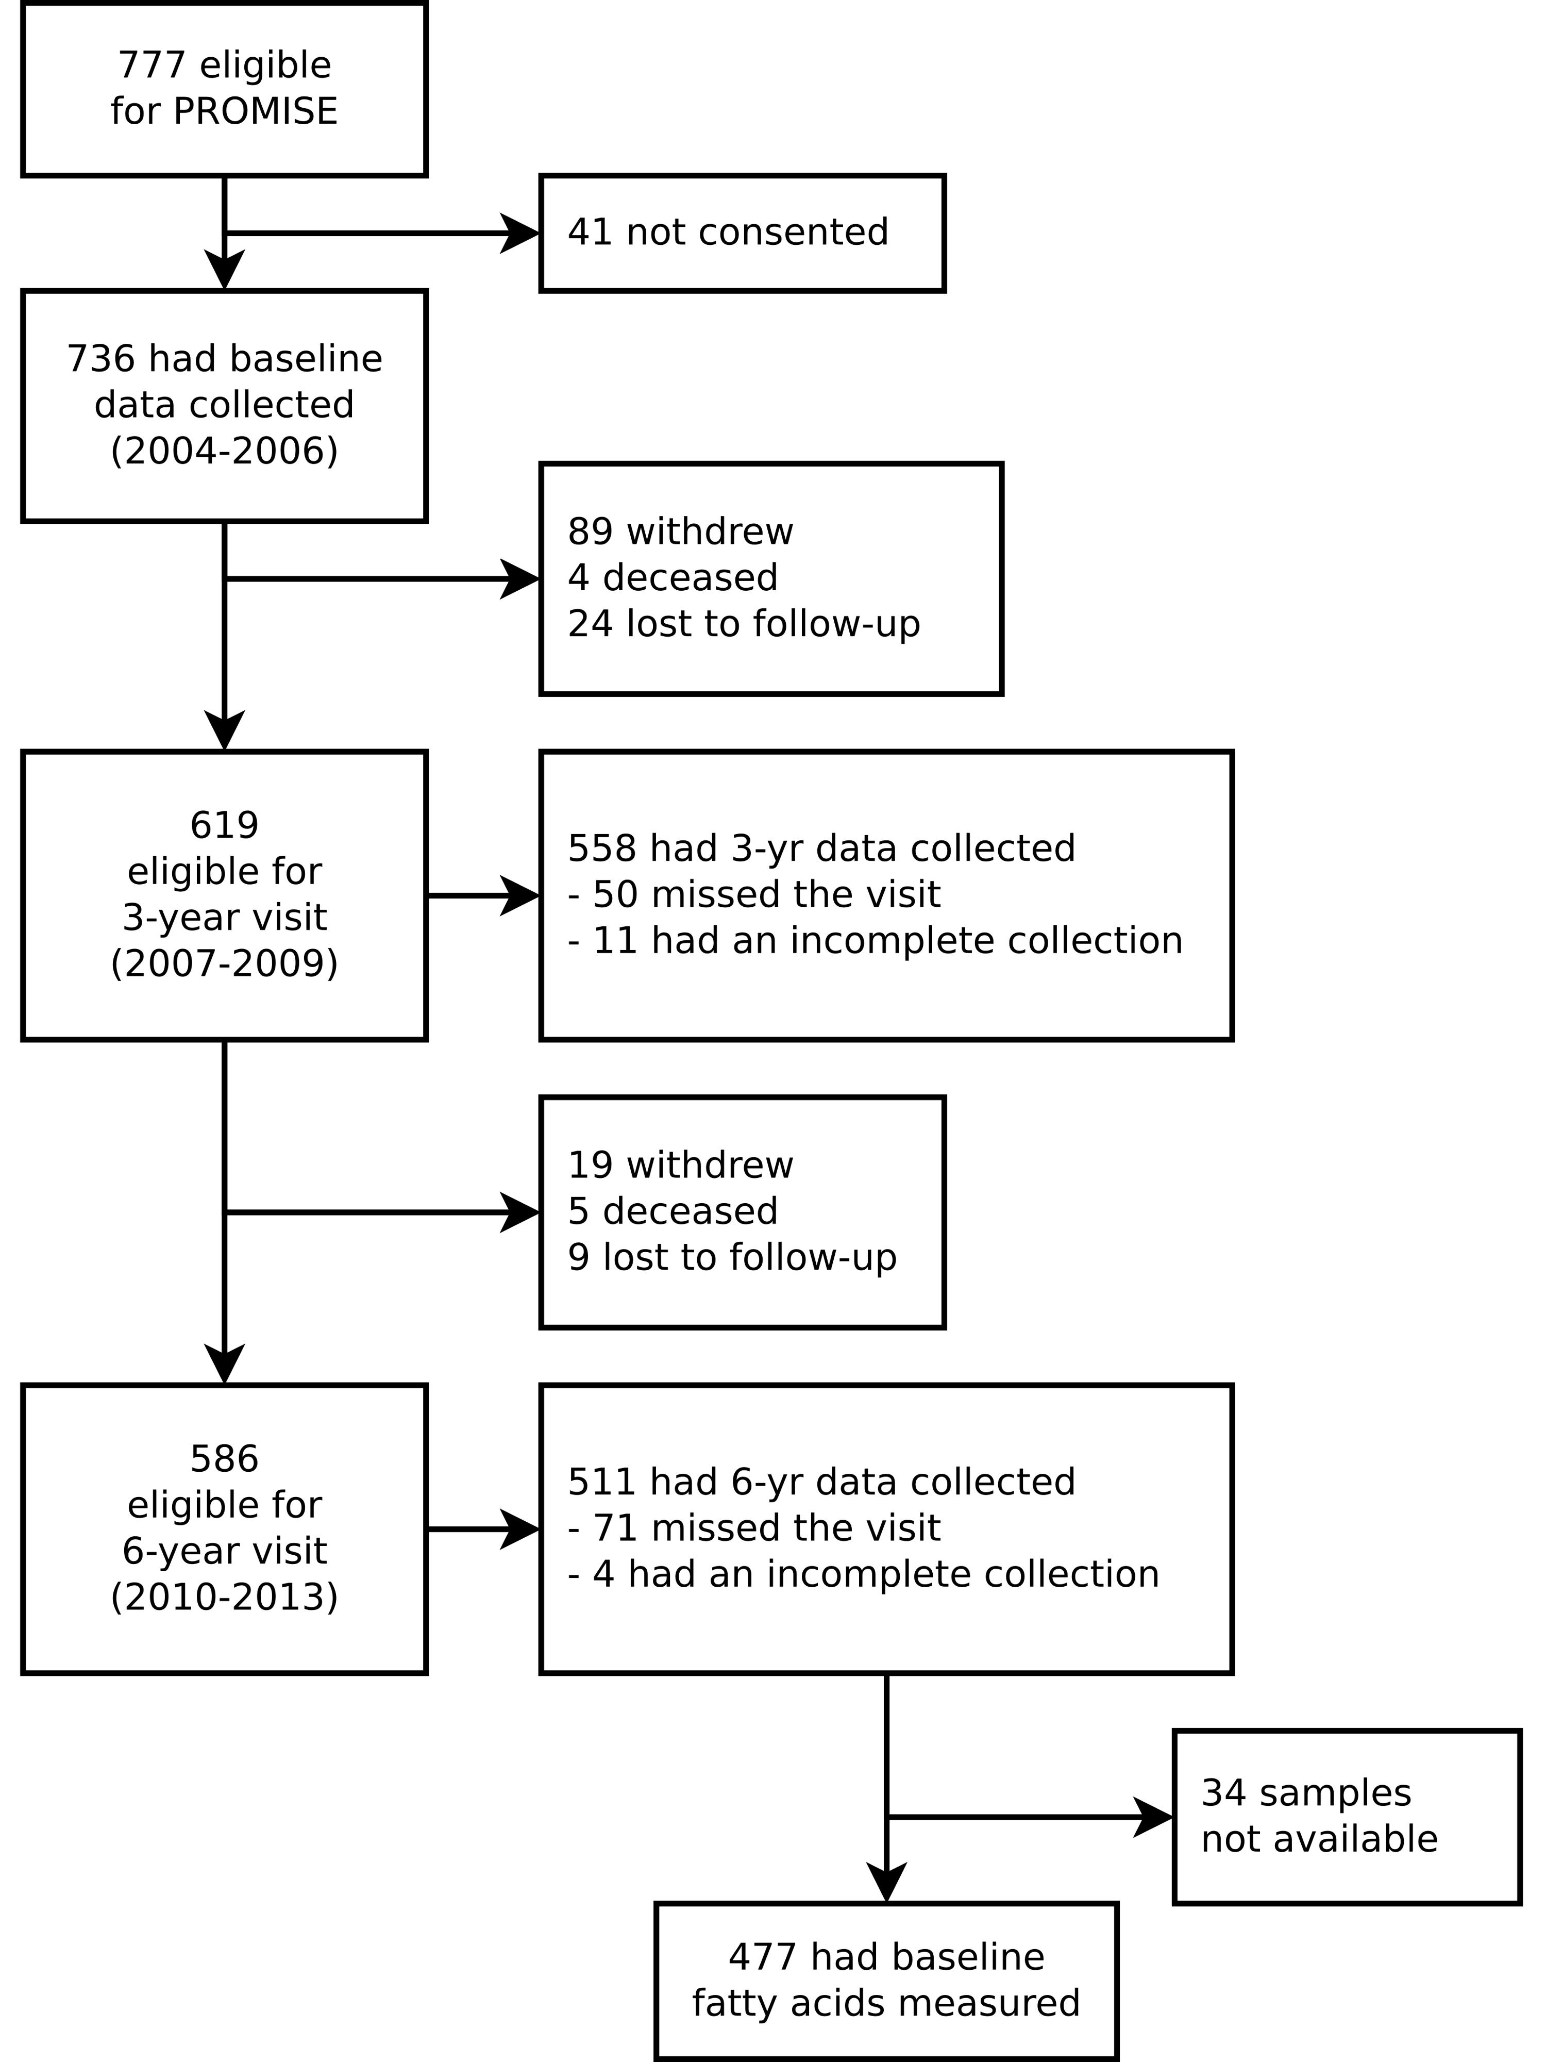

Figure 1: CONSORT diagram of PROMISE participants over the 3 visits.

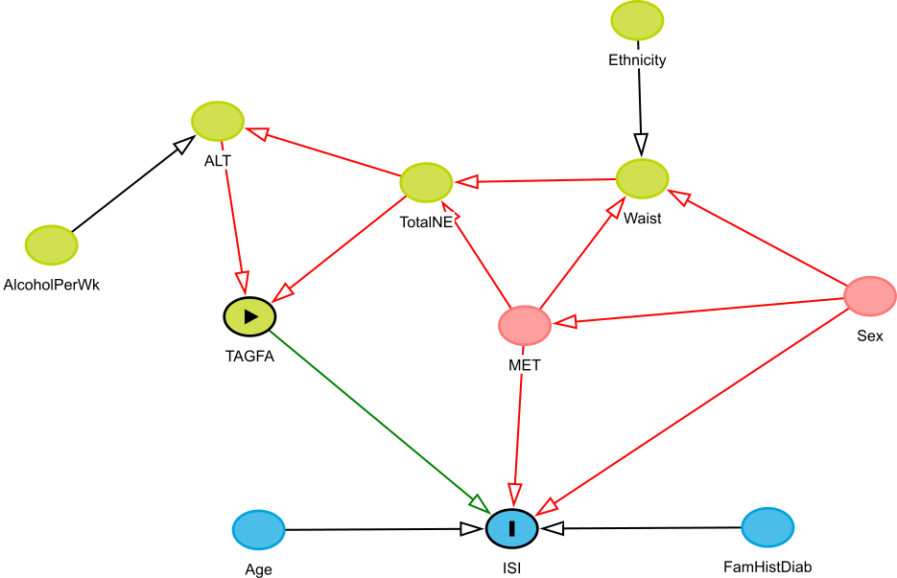

Figure 2: Directed acyclic graphic output from the DAGitty online software for insulin sensitivity.

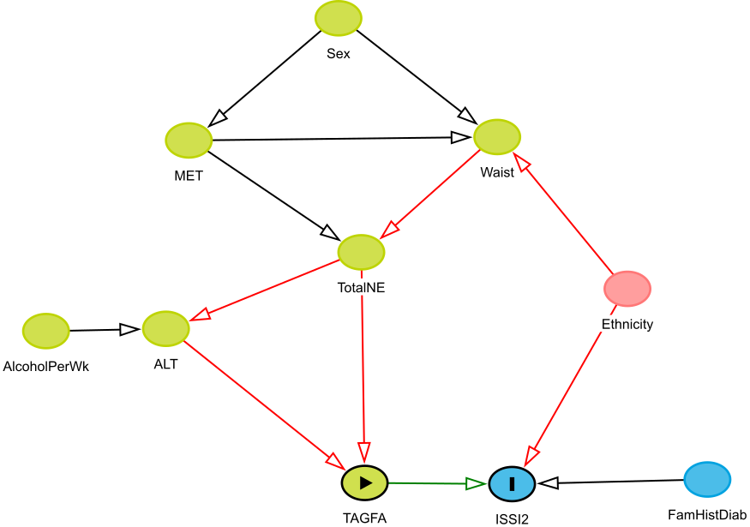

Figure 3: Directed acyclic graphic output from the DAGitty online software for beta-cell function.

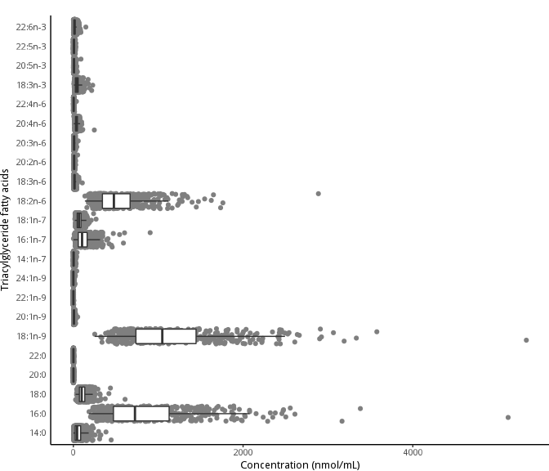

Figure 4: Distribution of the composition of triacylglycerol fatty acids in the baseline visit of PROMISE participants (2004-2006). Boxplots represent the median and interquartile range of the fatty acid values.

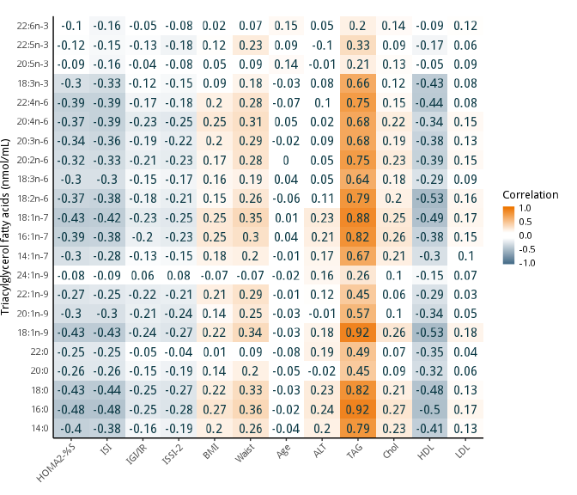

Figure 5: Pearson correlation heatmap of triacylglycerol fatty acids (nmol/mL) with continuous basic and metabolic characteristics of PROMISE participants from the baseline visit (2004-2006). Darker orange represents a positive correlation; darker blue represents a negative correlation.

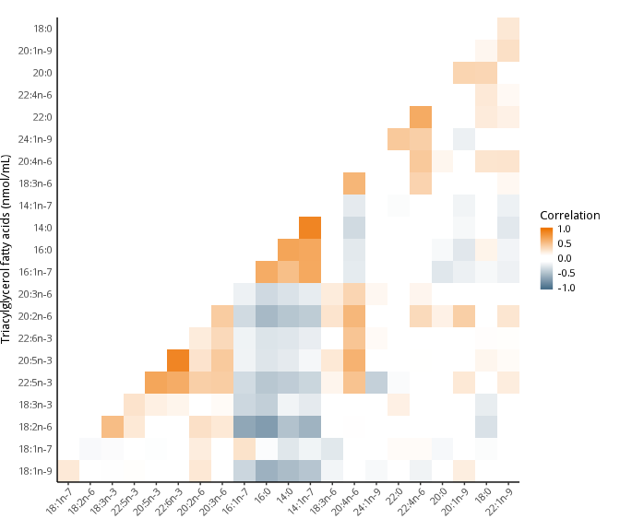

Figure 6: Pearson correlation heatmap of the triacylglycerol fatty acids in the PROMISE participants from the baseline visit (2004-2006). The correlations of fatty acids grouped using heirarchical cluster analysis; fatty acids along the x and y axis are ordered according to this analysis. Darker orange represents a positive correlation; darker blue represents a negative correlation.

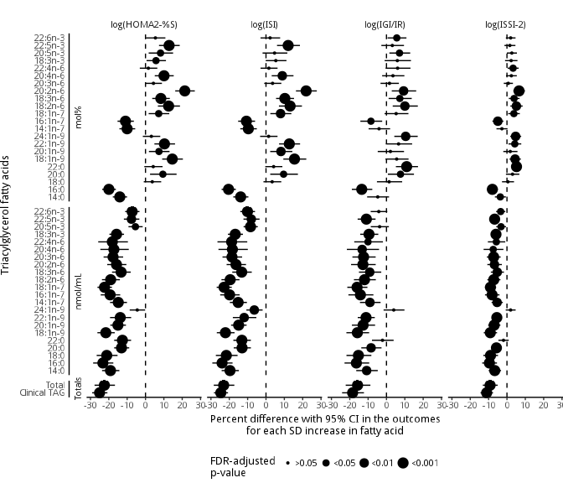

Figure 7: Time-adjusted GEE models of the association of the triacylglycerol fatty acids (mol% and nmol/mL) and total clinically-measured TAG with insulin sensitivity and beta-cell function outcomes using the 6 year longitudinal data from the PROMISE cohort. X-axis values represent a percent difference in the outcome per SD increase in the fatty acid. P-values were adjusted for the BH false discovery rate, with the largest dot representing a significant (p<0.05) association.

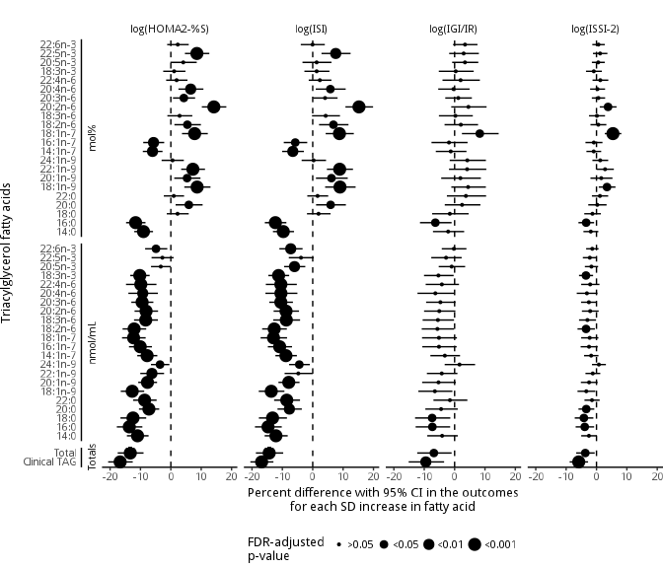

Figure 8: Fully-adjusted GEE models of the association of the triacylglycerol fatty acids (mol% and nmol/mL) and total clinically-measured TAG with insulin sensitivity and beta-cell function outcomes using the 6 year longitudinal data from the PROMISE cohort. Variables controlled for were follow-up time, waist circumference, baseline age, ethnicity, sex, ALT, physical activity, and total NEFA. X-axis values represent a percent difference in the outcome per SD increase in the fatty acid. P-values were adjusted for the BH false discovery rate, with the largest dot representing a significant (p<0.05) association.

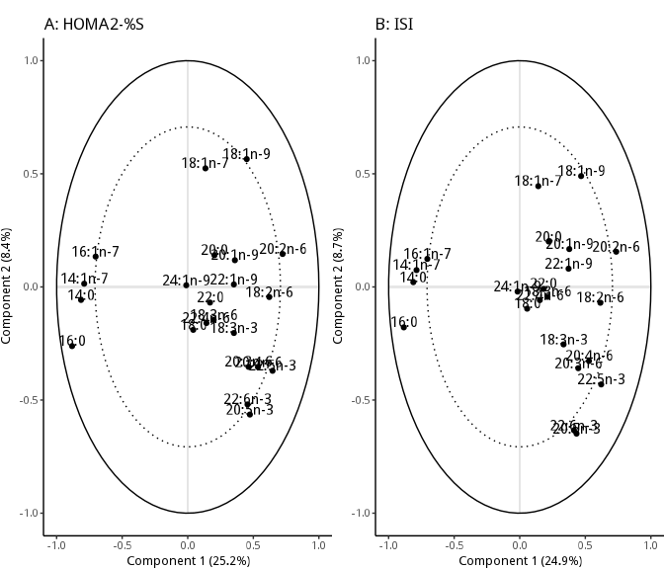

Figure 9: Partial least squares (PLS) models showing the clustering of triacylglycerol fatty acids on insulin sensitivity and beta-cell function measures. The R value shown above the graph is the correlation between predicted and actual values, using cross-validation; a higher value suggests the fatty acids strongly predict the metabolic outcome. The percent explained variance of each component is shown in brackets on each axis. The solid line represents an explained variance of 100% while the dashed line represents an explained variance of 50%. Fatty acids between these lines represent variables that strongly explain the underlying structure of the data. See the Supplemental Methods for a description of PLS analysis and an explanation of interpreting this plot.

# Supplemental Methods

# References

1. Alberti K, Eckel RH, Grundy SM, Zimmet PZ, Cleeman JI, Donato KA, et al. Harmonizing the Metabolic Syndrome: A Joint Interim Statement of the International Diabetes Federation Task Force on Epidemiology and Prevention; National Heart, Lung, and Blood Institute; American Heart Association; World Heart Federation; International Atherosclerosis Society; and International Association for the Study of Obesity. Circulation. 2009;120(16):1640–5.

2. D’Agostino RB, Hamman RF, Karter AJ, Mykkanen L, Wagenknecht LE, Haffner SM. Cardiovascular Disease Risk Factors Predict the Development of Type 2 Diabetes: The Insulin Resistance Atherosclerosis Study. Diabetes Care. 2004 Aug;27(9):2234–40.

3. Forouhi NG, Koulman A, Sharp SJ, Imamura F, Kröger J, Schulze MB, et al. Differences in the prospective association between individual plasma phospholipid saturated fatty acids and incident type 2 diabetes: The EPIC-InterAct case-cohort study. Lancet Diabetes Endocrinol. 2014 Oct;2(10):810–8.

4. Ma W, Wu JHY, Wang Q, Lemaitre RN, Mukamal KJ, Djoussé L, et al. Prospective association of fatty acids in the de novo lipogenesis pathway with risk of type 2 diabetes: The Cardiovascular Health Study. Am J Clin Nutr. 2015 Jan;101(1):153–63.

5. Johnston LW, Harris SB, Retnakaran R, Zinman B, Giacca A, Liu Z, et al. Longitudinal associations of phospholipid and cholesteryl ester fatty acids with disorders underlying diabetes. J Clin Endocrinol Metab. 2016 May;jc20154267.

6. Yu SS, Castillo DC, Courville AB, Sumner AE. The triglyceride paradox in people of African descent. Metab Syndr Relat Disord. 2012;10(2):77–82.

7. Chien K, Cai T, Hsu H, Su T, Chang W, Chen M, et al. A prediction model for type 2 diabetes risk among Chinese people. Diabetologia. 2008 Dec;52(3):443–50.

8. Schulze MB, Weikert C, Pischon T, Bergmann MM, Al-Hasani H, Schleicher E, et al. Use of Multiple Metabolic and Genetic Markers to Improve the Prediction of Type 2 Diabetes: The EPIC-Potsdam Study. Diabetes Care. 2009 Aug;32(11):2116–9.

9. WHO, IDF. Definition and diagnosis of diabetes mellitus and intermediate hyperglycaemia: Report of a WHO/IDF consultation. 2006.

10. Matthan NR, Ip B, Resteghini N, Ausman LM, Lichtenstein AH. Long-term fatty acid stability in human serum cholesteryl ester, triglyceride, and phospholipid fractions. J Lipid Res. 2010 Sep;51(9):2826–32.

11. Folch J, Lees M, Sloane Stanley GH. A simple method for the isolation and purification of total lipides from animal tissues. J Biol Chem. 1957;226(1):497–509.

12. Nishi S, Kendall CWC, Gascoyne A-M, Bazinet RP, Bashyam B, Lapsley KG, et al. Effect of almond consumption on the serum fatty acid profile: A dose-response study. Br J Nutr. 2014 Oct;112(7):1137–46.

13. Kriska A, Knowler W, LaPorte R, Drash A, Wing R, Blair S, et al. Development of questionnaire to examine relationship of physical activity and diabetes in Pima Indians. Diabetes Care. 1990;13(4):401–11.

14. Levy JC, Matthews DR, Hermans MP. Correct Homeostasis Model Assessment (HOMA) Evaluation Uses the Computer Program. Diabetes Care. 1998 Dec;21(12):2191–2.

15. Matsuda M, DeFronzo R. Insulin sensitivity indices obtained from oral glucose tolerance testing: Comparison with the euglycemic insulin clamp. Diabetes Care. 1999;22(9):1462–70.

16. Abdul-Ghani M, Matsuda M, Balas B, DeFronzo R. Muscle and liver insulin resistance indexes derived from the oral glucose tolerance test. Diabetes Care. 2007;30(1):89–94.

17. Wareham N, Phillips D, Byrne C, Hales C. The 30 minute insulin incremental response in an oral glucose tolerance test as a measure of insulin secretion. Diabet Med. 1995;12(10):931.

18. Matthews D, Hosker J, Rudenski A. Homeostasis model assessment: Insulin resistance and beta-cell function from fasting plasma glucose and insulin concentrations in man. Diabetologia. 1985;28(7):412–9.

19. Retnakaran R, Qi Y, Goran M, Hamilton J. Evaluation of proposed oral disposition index measures in relation to the actual disposition index. Diabet Med. 2009;26(12):1198–203.

20. Hermans MP, Levy JC, Morris RJ, Turner RC. Comparison of insulin sensitivity tests across a range of glucose tolerance from normal to diabetes. Diabetologia. 1999 May;42(6):678–87.

21. Zeger SL, Liang KY. Longitudinal data analysis for discrete and continuous outcomes. Biometrics. 1986 Mar;42(1):121–30.

22. Greenland S, Pearl J, Robins JM. Causal diagrams for epidemiologic research. Epidemiology. 1999;10(1):37–48.

23. Textor J, Hardt J, Knüppel S. DAGitty: A graphical tool for analyzing causal diagrams. Epidemiology. 2011 Sep;22(5):745.

24. R Core Team. R: A Language and Environment for Statistical Computing [Internet]. Vienna, Austria: R Foundation for Statistical Computing; 2015. Available from: <http://www.R-project.org/>

25. Højsgaard S, Halekoh U, Yan J. The R Package geepack for Generalized Estimating Equations. Journal of Statistical Software. 2006;15/2:1–11.

26. Benjamini Y, Hochberg Y. Controlling the False Discovery Rate: A Practical and Powerful Approach to Multiple Testing. J R Stat Soc Series B Stat Methodol [Internet]. 1995;57(1):289–300. Available from: <http://www.jstor.org/stable/2346101>

27. Vandenbroucke JP, von Elm E, Altman DG, Gøtzsche PC, Mulrow CD, Pocock SJ, et al. Strengthening the Reporting of Observational Studies in Epidemiology (STROBE): Explanation and elaboration. PLoS Med. 2007 Oct;4(10):e297.

28. Rhee EP, Cheng S, Larson MG, Walford GA, Lewis GD, McCabe E, et al. Lipid profiling identifies a triacylglycerol signature of insulin resistance and improves diabetes prediction in humans. J Clin Invest. 2011;121(4):1402–11.

29. Lankinen MA, Stančáková A, Uusitupa M, Ågren J, Pihlajamäki J, Kuusisto J, et al. Plasma fatty acids as predictors of glycaemia and type 2 diabetes. Diabetologia. 2015;[Epub ahead of print].

30. Kotronen A, Velagapudi VR, Yetukuri L, Westerbacka J, Bergholm R, Ekroos K, et al. Serum saturated fatty acids containing triacylglycerols are better markers of insulin resistance than total serum triacylglycerol concentrations. Diabetologia. 2009;52(4):684–90.

31. Hodson L, Skeaff CM, Fielding BA. Fatty acid composition of adipose tissue and blood in humans and its use as a biomarker of dietary intake. Prog Lipid Res. 2008;47(5):348–80.

32. Kawano Y, Cohen DE. Mechanisms of hepatic triglyceride accumulation in non-alcoholic fatty liver disease. J Gastroenterol. 2013;48(4):434–41.

33. Harding SV, Bateman KP, Kennedy BP, Rideout TC, Jones PJH. Desaturation index versus isotopically measured de novo lipogenesis as an indicator of acute systemic lipogenesis. 2015;8:49.

34. Hudgins LC. Effect of high-carbohydrate feeding on triglyceride and saturated fatty acid synthesis. Proc Soc Exp Biol Med. 2000;225(3):178–83.

35. Parks EJ, Krauss RM, Christiansen MP, Neese RA, Hellerstein MK. Effects of a low-fat, high-carbohydrate diet on VLDL-triglyceride assembly, production, and clearance. J Clin Invest. 1999;104(8):1087–96.

36. Zong G, Zhu J, Sun L, Ye X, Lu L, Jin Q, et al. Associations of erythrocyte fatty acids in the de novo lipogenesis pathway with risk of metabolic syndrome in a cohort study of middle-aged and older Chinese. Am J Clin Nutr. 2013;98(2):319–26.

37. Kröger J, Zietemann V, Enzenbach C, Weikert C, Jansen EH, Döring F, et al. Erythrocyte membrane phospholipid fatty acids, desaturase activity, and dietary fatty acids in relation to risk of type 2 diabetes in the European Prospective Investigation into Cancer and Nutrition (EPIC)-Potsdam Study. Am J Clin Nutr. 2011;93(1):127–42.

38. Lee JJ, Lambert JE, Hovhannisyan Y, Ramos-Roman MA, Trombold JR, Wagner DA, et al. Palmitoleic acid is elevated in fatty liver disease and reflects hepatic lipogenesis. Am J Clin Nutr. 2015 Jan;101(1):34–43.

39. Wilke MS, French MA, Goh YK, Ryan EA, Jones PJ, Clandinin MT. Synthesis of specific fatty acids contributes to VLDL-triacylglycerol composition in humans with and without type 2 diabetes. Diabetologia. 2009;52(8):1628–37.

40. Risérus U. Fatty acids and insulin sensitivity. Curr Opin Clin Nutr Metab Care. 2008;11(2):100–5.

41. Iggman D, Arnlöv J, Vessby B, Cederholm T, Sjögren P, Risérus U. Adipose tissue fatty acids and insulin sensitivity in elderly men. Diabetologia. 2010;53(5):850–7.

42. Flannery C, Dufour S, Rabøl R, Shulman GI, Petersen KF. Skeletal muscle insulin resistance promotes increased hepatic de novo lipogenesis, hyperlipidemia, and hepatic steatosis in the elderly. Diabetes. 2012;61(11):2711–7.

43. Schwab U, Seppänen-Laakso T, Yetukuri L, Agren J, Kolehmainen M, Laaksonen DE, et al. Triacylglycerol fatty acid composition in diet-induced weight loss in subjects with abnormal glucose metabolism–the GENOBIN study. PLoS ONE. 2008;3(7):e2630.

44. Barrows BR, Parks EJ. Contributions of different fatty acid sources to very low-density lipoprotein-triacylglycerol in the fasted and fed states. J Clin Endocrinol Metab. 2006;91(4):1446–52.