Paper 1: Kidney Dysfunction

Windy Wang

# PAPER 1: KIDNEY DYSFUNCTION RESULTS

### Subject Characteristics

## Stratified by udbpTertile  
## 1   
## n 18   
## Age (mean (sd)) 53.78 (7.87)   
## Sex = Male (%) 8 (44.4)   
## Ethnicity (%)   
## European 13 (72.2)   
## Latino/a 3 (16.7)   
## Other 1 (5.6)   
## South Asian 1 (5.6)   
## BMI (mean (sd)) 31.67 (5.27)   
## Waist (mean (sd)) 103.65 (15.98)   
## eGFR (mean (sd)) 94.28 (12.98)   
## ACR (median [IQR]) 0.66 [0.36, 0.94]   
## UrineCreatinine (mean (sd)) 9.36 (5.51)   
## UrineMicroalbumin (median [IQR]) 3.20 [2.09, 12.55]   
## UrinaryCalcium (mean (sd)) 2.49 (2.28)   
## UDBP (median [IQR]) 11.46 [1.01, 16.06]  
## udbpCr (mean (sd)) 1.85 (1.73)   
## Systolic (mean (sd)) 126.44 (12.60)   
## Diastolic (mean (sd)) 78.33 (6.81)   
## MeanArtPressure (mean (sd)) 94.37 (7.71)   
## dmStatus (%)   
## NGT 15 (83.3)   
## PreDM 0 (0.0)   
## DM 3 (16.7)   
## Stratified by udbpTertile  
## 2   
## n 13   
## Age (mean (sd)) 53.46 (11.02)   
## Sex = Male (%) 4 (30.8)   
## Ethnicity (%)   
## European 8 (61.5)   
## Latino/a 2 (15.4)   
## Other 2 (15.4)   
## South Asian 1 (7.7)   
## BMI (mean (sd)) 30.23 (4.96)   
## Waist (mean (sd)) 101.71 (14.42)   
## eGFR (mean (sd)) 91.05 (15.16)   
## ACR (median [IQR]) 0.50 [0.36, 0.63]   
## UrineCreatinine (mean (sd)) 8.83 (4.07)   
## UrineMicroalbumin (median [IQR]) 3.70 [1.99, 6.70]   
## UrinaryCalcium (mean (sd)) 1.97 (1.26)   
## UDBP (median [IQR]) 37.62 [28.64, 66.20]  
## udbpCr (mean (sd)) 5.78 (2.54)   
## Systolic (mean (sd)) 128.31 (12.17)   
## Diastolic (mean (sd)) 78.31 (8.31)   
## MeanArtPressure (mean (sd)) 94.97 (8.90)   
## dmStatus (%)   
## NGT 11 (84.6)   
## PreDM 0 (0.0)   
## DM 2 (15.4)   
## Stratified by udbpTertile  
## 3 p test   
## n 21   
## Age (mean (sd)) 58.10 (7.97) 0.210   
## Sex = Male (%) 11 (52.4) 0.467   
## Ethnicity (%) 0.762   
## European 15 (71.4)   
## Latino/a 2 (9.5)   
## Other 4 (19.0)   
## South Asian 0 (0.0)   
## BMI (mean (sd)) 32.66 (5.74) 0.449   
## Waist (mean (sd)) 105.59 (13.93) 0.756   
## eGFR (mean (sd)) 86.20 (13.73) 0.196   
## ACR (median [IQR]) 0.76 [0.47, 1.20] 0.286 nonnorm  
## UrineCreatinine (mean (sd)) 15.61 (6.02) <0.001   
## UrineMicroalbumin (median [IQR]) 11.00 [6.90, 16.00] 0.003 nonnorm  
## UrinaryCalcium (mean (sd)) 3.44 (2.02) 0.124   
## UDBP (median [IQR]) 116.15 [85.75, 175.10] <0.001 nonnorm  
## udbpCr (mean (sd)) 9.82 (5.08) <0.001   
## Systolic (mean (sd)) 130.48 (20.29) 0.738   
## Diastolic (mean (sd)) 80.62 (15.02) 0.769   
## MeanArtPressure (mean (sd)) 97.24 (15.93) 0.737   
## dmStatus (%) 0.229   
## NGT 13 (61.9)   
## PreDM 3 (14.3)   
## DM 5 (23.8)

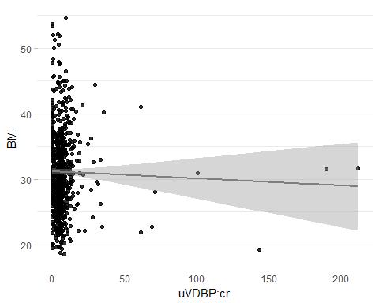

TABLE 2: Subject characteristics across UDBP:cR tertiles

## Stratified by udbpCrTertile  
## 1 2   
## n 219 282   
## Age (mean (sd)) 49.07 (10.21) 49.55 (9.75)   
## Sex = Male (%) 83 (37.9) 107 (37.9)   
## Ethnicity (%)   
## European 130 (59.4) 188 (66.7)   
## Latino/a 47 (21.5) 32 (11.3)   
## Other 27 (12.3) 34 (12.1)   
## South Asian 15 (6.8) 28 (9.9)   
## BMI (mean (sd)) 31.18 (6.51) 30.57 (5.87)   
## Waist (mean (sd)) 99.81 (15.24) 99.01 (15.62)   
## eGFR (mean (sd)) 94.98 (14.81) 93.63 (14.61)   
## ACR (median [IQR]) 0.48 [0.26, 0.71] 0.47 [0.32, 0.67]   
## UrineCreatinine (mean (sd)) 12.67 (5.99) 11.79 (7.06)   
## UrineMicroalbumin (median [IQR]) 5.00 [2.45, 9.05] 4.00 [2.00, 8.95]   
## UrinaryCalcium (mean (sd)) 2.77 (1.89) 2.18 (1.70)   
## UDBP (median [IQR]) 6.10 [1.15, 16.66] 51.73 [30.65, 79.65]  
## udbpCr (mean (sd)) 1.06 (1.08) 5.09 (0.99)   
## Systolic (mean (sd)) 123.75 (14.70) 126.37 (16.33)   
## Diastolic (mean (sd)) 78.50 (9.16) 79.98 (10.20)   
## MeanArtPressure (mean (sd)) 93.58 (10.28) 95.44 (11.42)   
## dmStatus (%)   
## NGT 187 (85.4) 234 (83.0)   
## PreDM 9 (4.1) 14 (5.0)   
## DM 23 (10.5) 34 (12.1)   
## Stratified by udbpCrTertile  
## 3 p test   
## n 226   
## Age (mean (sd)) 50.77 (10.20) 0.177   
## Sex = Male (%) 42 (18.6) <0.001   
## Ethnicity (%) 0.034   
## European 155 (68.6)   
## Latino/a 29 (12.8)   
## Other 28 (12.4)   
## South Asian 14 (6.2)   
## BMI (mean (sd)) 31.79 (6.16) 0.088   
## Waist (mean (sd)) 98.65 (14.84) 0.714   
## eGFR (mean (sd)) 96.71 (14.70) 0.064   
## ACR (median [IQR]) 0.84 [0.53, 1.51] <0.001 nonnorm  
## UrineCreatinine (mean (sd)) 11.07 (6.05) 0.033   
## UrineMicroalbumin (median [IQR]) 8.00 [4.00, 19.00] <0.001 nonnorm  
## UrinaryCalcium (mean (sd)) 2.06 (1.55) <0.001   
## UDBP (median [IQR]) 109.33 [70.91, 169.89] <0.001 nonnorm  
## udbpCr (mean (sd)) 15.18 (22.45) <0.001   
## Systolic (mean (sd)) 128.31 (16.48) 0.011   
## Diastolic (mean (sd)) 81.90 (11.28) 0.002   
## MeanArtPressure (mean (sd)) 97.37 (12.12) 0.002   
## dmStatus (%) 0.466   
## NGT 178 (78.8)   
## PreDM 15 (6.6)   
## DM 33 (14.6)

TABLE 3: Subject characteristics across time

## Stratified by fVN  
## Baseline   
## n 729   
## Age (mean (sd)) 49.78 (10.03)   
## Sex = Male (%) 232 (31.8)   
## Ethnicity (%)   
## European 475 (65.2)   
## Latino/a 108 (14.8)   
## Other 89 (12.2)   
## South Asian 57 (7.8)   
## BMI (mean (sd)) 31.11 (6.18)   
## Waist (mean (sd)) 99.06 (15.30)   
## eGFR (mean (sd)) 94.99 (14.73)   
## ACR (median [IQR]) 0.54 [0.35, 0.95]   
## UrineCreatinine (mean (sd)) 11.83 (6.47)   
## UrineMicroalbumin (median [IQR]) 5.60 [2.55, 11.40]   
## UDBP (median [IQR]) 47.56 [15.30, 93.10]  
## udbpCr (median [IQR]) 5.17 [2.51, 7.74]   
## Systolic (mean (sd)) 126.19 (16.00)   
## Diastolic (mean (sd)) 80.13 (10.32)   
## MeanArtPressure (mean (sd)) 95.48 (11.40)   
## dmStatus (%)   
## NGT 601 (82.4)   
## PreDM 38 (5.2)   
## DM 90 (12.3)   
## Stratified by fVN  
## 3Year   
## n 636   
## Age (mean (sd)) 54.64 (9.97)   
## Sex = Male (%) 190 (29.9)   
## Ethnicity (%)   
## European 455 (71.5)   
## Latino/a 65 (10.2)   
## Other 65 (10.2)   
## South Asian 51 (8.0)   
## BMI (mean (sd)) 31.30 (6.35)   
## Waist (mean (sd)) 100.28 (15.21)   
## eGFR (mean (sd)) 89.33 (17.11)   
## ACR (median [IQR]) 0.63 [0.43, 1.06]   
## UrineCreatinine (mean (sd)) 11.91 (9.05)   
## UrineMicroalbumin (median [IQR]) 5.99 [4.00, 9.00]   
## UDBP (median [IQR]) 39.96 [8.55, 89.91]  
## udbpCr (median [IQR]) 4.91 [0.95, 7.85]   
## Systolic (mean (sd)) 127.29 (14.98)   
## Diastolic (mean (sd)) 80.04 (10.05)   
## MeanArtPressure (mean (sd)) 95.79 (10.65)   
## dmStatus (%)   
## NGT 380 (59.7)   
## PreDM 136 (21.4)   
## DM 120 (18.9)   
## Stratified by fVN  
## 6Year p test   
## n 487   
## Age (mean (sd)) 57.24 (9.66) <0.001   
## Sex = Male (%) 140 (28.7) 0.494   
## Ethnicity (%) 0.033   
## European 355 (72.9)   
## Latino/a 48 (9.9)   
## Other 47 (9.7)   
## South Asian 37 (7.6)   
## BMI (mean (sd)) 31.04 (6.37) 0.764   
## Waist (mean (sd)) 100.68 (15.36) 0.149   
## eGFR (mean (sd)) 90.57 (14.95) <0.001   
## ACR (median [IQR]) 0.66 [0.46, 1.04] <0.001 nonnorm  
## UrineCreatinine (mean (sd)) 11.42 (6.65) 0.517   
## UrineMicroalbumin (median [IQR]) 5.99 [5.00, 10.00] <0.001 nonnorm  
## UDBP (median [IQR]) 48.91 [12.04, 89.70] 0.135 nonnorm  
## udbpCr (median [IQR]) 5.08 [1.56, 8.34] 0.447 nonnorm  
## Systolic (mean (sd)) 125.95 (15.03) 0.277   
## Diastolic (mean (sd)) 79.52 (9.37) 0.560   
## MeanArtPressure (mean (sd)) 95.00 (10.35) 0.483   
## dmStatus (%) <0.001   
## NGT 306 (62.8)   
## PreDM 90 (18.5)   
## DM 91 (18.7)

TABLE 4: Subject characteristics across time (complete data)

## Stratified by fVN  
## Baseline   
## n 413   
## Age (mean (sd)) 51.25 (9.60)   
## Sex = Male (%) 126 (30.5)   
## Ethnicity (%)   
## European 299 (72.4)   
## Latino/a 41 (9.9)   
## Other 39 (9.4)   
## South Asian 34 (8.2)   
## BMI (mean (sd)) 30.81 (6.01)   
## Waist (mean (sd)) 98.27 (14.73)   
## eGFR (mean (sd)) 93.00 (14.40)   
## ACR (median [IQR]) 0.53 [0.35, 0.91]   
## UrineCreatinine (mean (sd)) 11.87 (6.61)   
## UrineMicroalbumin (median [IQR]) 5.45 [2.99, 11.00]   
## UDBP (median [IQR]) 48.23 [17.26, 93.10]  
## udbpCr (median [IQR]) 5.36 [3.04, 7.84]   
## Systolic (mean (sd)) 127.25 (16.32)   
## Diastolic (mean (sd)) 80.11 (9.95)   
## MeanArtPressure (mean (sd)) 95.82 (11.17)   
## dmStatus (%)   
## NGT 342 (82.8)   
## PreDM 19 (4.6)   
## DM 52 (12.6)   
## Stratified by fVN  
## 3Year   
## n 413   
## Age (mean (sd)) 54.38 (9.56)   
## Sex = Male (%) 126 (30.5)   
## Ethnicity (%)   
## European 299 (72.4)   
## Latino/a 41 (9.9)   
## Other 39 (9.4)   
## South Asian 34 (8.2)   
## BMI (mean (sd)) 31.04 (6.12)   
## Waist (mean (sd)) 98.95 (14.65)   
## eGFR (mean (sd)) 88.77 (16.02)   
## ACR (median [IQR]) 0.61 [0.42, 0.96]   
## UrineCreatinine (mean (sd)) 11.98 (7.83)   
## UrineMicroalbumin (median [IQR]) 5.99 [4.00, 9.00]   
## UDBP (median [IQR]) 45.79 [13.14, 94.35]  
## udbpCr (median [IQR]) 5.32 [1.51, 7.99]   
## Systolic (mean (sd)) 126.84 (15.53)   
## Diastolic (mean (sd)) 80.33 (10.13)   
## MeanArtPressure (mean (sd)) 95.84 (11.10)   
## dmStatus (%)   
## NGT 276 (66.8)   
## PreDM 77 (18.6)   
## DM 60 (14.5)   
## Stratified by fVN  
## 6Year p test   
## n 413   
## Age (mean (sd)) 57.16 (9.59) <0.001   
## Sex = Male (%) 126 (30.5) 1.000   
## Ethnicity (%) 1.000   
## European 299 (72.4)   
## Latino/a 41 (9.9)   
## Other 39 (9.4)   
## South Asian 34 (8.2)   
## BMI (mean (sd)) 30.88 (6.31) 0.862   
## Waist (mean (sd)) 100.37 (15.02) 0.117   
## eGFR (mean (sd)) 90.59 (14.45) <0.001   
## ACR (median [IQR]) 0.66 [0.46, 1.02] <0.001 nonnorm  
## UrineCreatinine (mean (sd)) 11.27 (5.95) 0.278   
## UrineMicroalbumin (median [IQR]) 5.99 [5.00, 10.00] 0.002 nonnorm  
## UDBP (median [IQR]) 48.91 [13.29, 88.50] 0.769 nonnorm  
## udbpCr (median [IQR]) 5.20 [1.64, 8.43] 0.868 nonnorm  
## Systolic (mean (sd)) 126.01 (15.09) 0.510   
## Diastolic (mean (sd)) 79.75 (9.40) 0.687   
## MeanArtPressure (mean (sd)) 95.17 (10.40) 0.603   
## dmStatus (%) <0.001   
## NGT 264 (63.9)   
## PreDM 78 (18.9)   
## DM 71 (17.2)

### Cross-sectional

#### ACR

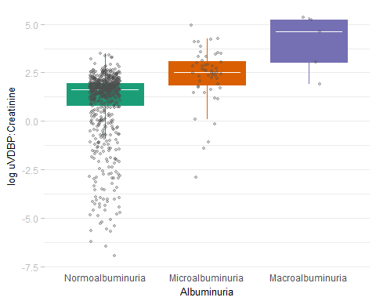

## # A tibble: 3 x 2  
## acrStatus n  
## <ord> <int>  
## 1 Normoalbuminuria 671  
## 2 Microalbuminuria 51  
## 3 Macroalbuminuria 5  
## Df Sum Sq Mean Sq F value Pr(>F)   
## acrStatus 2 137.4 68.72 21.76 6.64e-10 ***  
## Residuals 724 2286.2 3.16   
## ---  
## Signif. codes: 0 '***' 0.001 '**' 0.01 '*' 0.05 '.' 0.1 ' ' 1  
## Tukey multiple comparisons of means  
## 95% family-wise confidence level  
##   
## Fit: aov(formula = log(udbpCr) ~ acrStatus, data = acr)  
##   
## $acrStatus  
## diff lwr upr p adj  
## Microalbuminuria-Normoalbuminuria 1.402365 0.7961787 2.008551 0.0000002  
## Macroalbuminuria-Normoalbuminuria 3.083235 1.2099205 4.956550 0.0003553  
## Macroalbuminuria-Microalbuminuria 1.680871 -0.2748537 3.636595 0.1084839

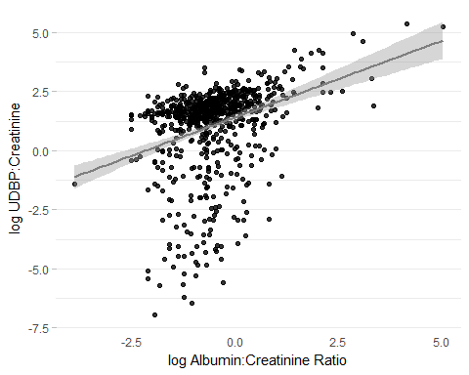

##   
## Spearman's rank correlation rho  
##   
## data: ACR and udbpCr  
## S = 40152000, p-value < 2.2e-16  
## alternative hypothesis: true rho is not equal to 0  
## sample estimates:  
## rho   
## 0.373019

|  |  |  |  |  |
| --- | --- | --- | --- | --- |
| Yterms | Xterms | term | estCI | p |
| ACR | udbpCr | <-Xterm | 0.35 (0.33, 0.37) | <0.001 |
| ACR | udbpCr | <-Xterm | 0.36 (0.33, 0.38) | <0.001 |
| ACR | udbpCr | Age | 0.02 (-0.01, 0.05) | 0.22 |
| ACR | udbpCr | SexMale | 1.23 (0.55, 1.9) | <0.001 |
| ACR | udbpCr | EthnicityEuropean | 0 (-0.67, 0.67) | 1 |
| ACR | udbpCr | dmStatusPreDM | -1.03 (-2.44, 0.38) | 0.15 |
| ACR | udbpCr | dmStatusDM | -0.19 (-1.16, 0.78) | 0.7 |

#### eGFR

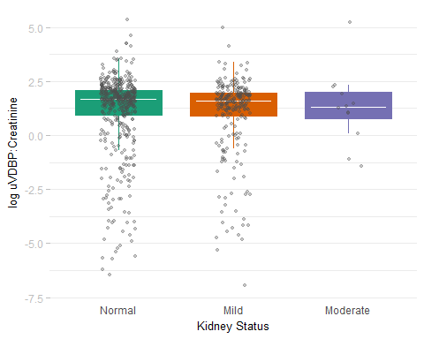

## # A tibble: 3 x 2  
## eGFRStatus n  
## <ord> <int>  
## 1 Normal 471  
## 2 Mild 244  
## 3 Moderate 12  
## Df Sum Sq Mean Sq F value Pr(>F)  
## eGFRStatus 2 2.7 1.365 0.408 0.665  
## Residuals 724 2420.9 3.344  
## Tukey multiple comparisons of means  
## 95% family-wise confidence level  
##   
## Fit: aov(formula = log(udbpCr) ~ eGFRStatus, data = eGFR)  
##   
## $eGFRStatus  
## diff lwr upr p adj  
## Mild-Normal -0.1163688 -0.4551061 0.2223686 0.6989226  
## Moderate-Normal 0.1768658 -1.0785510 1.4322825 0.9414475  
## Moderate-Mild 0.2932345 -0.9766080 1.5630771 0.8504238

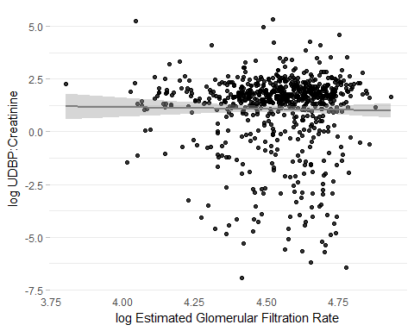

##   
## Spearman's rank correlation rho  
##   
## data: eGFR and udbpCr  
## S = 60785000, p-value = 0.171  
## alternative hypothesis: true rho is not equal to 0  
## sample estimates:  
## rho   
## 0.05082987  
## # A tibble: 7 x 5  
## Yterms Xterms term estCI p  
## <chr> <chr> <chr> <chr> <chr>  
## 1 eGFR udbpCr <-Xterm -0.02 (-0.1, 0.05) 0.53  
## 2 eGFR udbpCr <-Xterm -0.02 (-0.09, 0.04) 0.44  
## 3 eGFR udbpCr Age -0.85 (-0.94, -0.76) <0.001  
## 4 eGFR udbpCr SexMale 0 (-1.85, 1.86) 1  
## 5 eGFR udbpCr EthnicityEuropean -4.25 (-6.09, -2.4) <0.001  
## 6 eGFR udbpCr dmStatusPreDM 1.81 (-2.04, 5.67) 0.36  
## 7 eGFR udbpCr dmStatusDM 5.13 (2.47, 7.79) <0.001

## # A tibble: 4 x 10  
## Yterms Xterms term estimate std.error statistic p.value  
## <chr> <chr> <chr> <dbl> <dbl> <dbl> <dbl>  
## 1 eGFR udbpCr (Intercept) 91.69174961 0.41488529 221.005065 0.000000  
## 2 eGFR udbpCr <-Xterm 0.02860309 0.02697961 1.060174 0.289204  
## 3 eGFR udbpCr (Intercept) 91.69174961 0.41488529 221.005065 0.000000  
## 4 eGFR udbpCr <-Xterm 0.02860309 0.02697961 1.060174 0.289204  
## # ... with 3 more variables: conf.low <dbl>, conf.high <dbl>,  
## # sample.size <int>

### Medication

* There are 705 values across all time points with blood pressure medication data
* This is approximately half of all observations (1852 vs 705)
* CHECK IF MISSINGNESS == NOT TAKING OR REALLY MISSING!!

### Progression

### Generalized Estimating Equations

GEE where predictor is baseline UDBP

|  |  |  |  |  |
| --- | --- | --- | --- | --- |
| Yterms | Xterms | term | estCI | p |
| ACR (mg/mmol) | udbpBase | Baseline uVDBP (ug/mmol) | 18.16 (11.8, 24.88) | <0.001 |
| ACR (mg/mmol) | udbpBase | Follow-up Duration (months) | 10.55 (6.66, 14.57) | <0.001 |
| ACR (mg/mmol) | udbpBase | Baseline Age (years) | 4.43 (-0.89, 10.03) | 0.1 |
| ACR (mg/mmol) | udbpBase | SexMale | -27.74 (-35.12, -19.52) | <0.001 |
| ACR (mg/mmol) | udbpBase | EthnicityEuropean | -5.71 (-15.38, 5.05) | 0.29 |
| ACR (mg/mmol) | udbpBase | dmStatusPreDiabetes | 3 (-6.92, 13.98) | 0.57 |
| ACR (mg/mmol) | udbpBase | dmStatusDiabetes | 11.47 (-8.56, 35.89) | 0.28 |
| eGFR (ml/min/1.73m^2) | udbpBase | Baseline uVDBP (ug/mmol) | 0.05 (-0.97, 1.09) | 0.92 |
| eGFR (ml/min/1.73m^2) | udbpBase | Follow-up Duration (months) | -1.48 (-2.03, -0.93) | <0.001 |
| eGFR (ml/min/1.73m^2) | udbpBase | Baseline Age (years) | -8.04 (-8.87, -7.21) | <0.001 |
| eGFR (ml/min/1.73m^2) | udbpBase | SexMale | -0.45 (-2.51, 1.66) | 0.67 |
| eGFR (ml/min/1.73m^2) | udbpBase | EthnicityEuropean | -4.09 (-6, -2.15) | <0.001 |
| eGFR (ml/min/1.73m^2) | udbpBase | dmStatusPreDiabetes | -0.45 (-2.39, 1.53) | 0.65 |
| eGFR (ml/min/1.73m^2) | udbpBase | dmStatusDiabetes | 1.37 (-3.17, 6.13) | 0.56 |

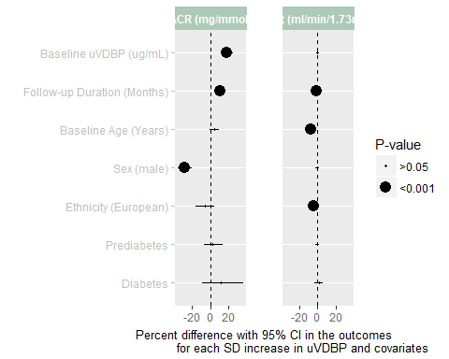

GEE where predictor is UDBP over time

|  |  |  |  |  |
| --- | --- | --- | --- | --- |
| Yterms | Xterms | term | estCI | p |
| ACR (mg/mmol) | Urinary VDBP (ng/mL) | Baseline uVDBP (ug/mmol) | 16.55 (5.93, 28.23) | <0.001 |
| ACR (mg/mmol) | Urinary VDBP (ng/mL) | Follow-up Duration (months) | 10.33 (6.61, 14.17) | <0.001 |
| ACR (mg/mmol) | Urinary VDBP (ng/mL) | Baseline Age (years) | 3.86 (-1.44, 9.45) | 0.16 |
| ACR (mg/mmol) | Urinary VDBP (ng/mL) | SexMale | -28 (-35.48, -19.64) | <0.001 |
| ACR (mg/mmol) | Urinary VDBP (ng/mL) | EthnicityEuropean | -4.5 (-14.4, 6.54) | 0.41 |
| ACR (mg/mmol) | Urinary VDBP (ng/mL) | dmStatusPreDiabetes | 4.79 (-5.44, 16.14) | 0.37 |
| ACR (mg/mmol) | Urinary VDBP (ng/mL) | dmStatusDiabetes | 10.54 (-8.86, 34.05) | 0.31 |
| eGFR (ml/min/1.73m^2) | Urinary VDBP (ng/mL) | Baseline uVDBP (ug/mmol) | -0.59 (-1.04, -0.14) | 0.01 |
| eGFR (ml/min/1.73m^2) | Urinary VDBP (ng/mL) | Follow-up Duration (months) | -1.48 (-2.03, -0.93) | <0.001 |
| eGFR (ml/min/1.73m^2) | Urinary VDBP (ng/mL) | Baseline Age (years) | -8.03 (-8.85, -7.19) | <0.001 |
| eGFR (ml/min/1.73m^2) | Urinary VDBP (ng/mL) | SexMale | -0.45 (-2.52, 1.66) | 0.67 |
| eGFR (ml/min/1.73m^2) | Urinary VDBP (ng/mL) | EthnicityEuropean | -4.09 (-6, -2.14) | <0.001 |
| eGFR (ml/min/1.73m^2) | Urinary VDBP (ng/mL) | dmStatusPreDiabetes | -0.47 (-2.41, 1.5) | 0.64 |
| eGFR (ml/min/1.73m^2) | Urinary VDBP (ng/mL) | dmStatusDiabetes | 1.43 (-3.14, 6.22) | 0.55 |

