**Methods**

**Dynamic simulation of the clonal expansion of deletions within mtDNA populations**

*Between-division model*

We developed an exact, discrete stochastic model of the expansion of mtDNA mutations during mtDNA replication between cell divisions. The model is general enough to simulate the dynamics of random genetic drift ([Elson et al. (2001)](https://doi.org/10.1086/318801)) or the effects of a putative replicative advantage for smaller mtDNA molecules ([Wallace (1992)](https://doi.org/10.1126/science.1533953)).

The model describes a population of *W* wild-type mtDNA molecules and *M* mtDNA mutations within a single cell. The proportion of wild-type mtDNA is defined as $F_{w} =\frac{ W}{W+M}$ and the proportion of mutant mtDNA (or the mutation load) is defined as $F_{m} =\frac{ M}{W+M}$. The initial state of the population is *W0*, *M0* and the population evolves between time *t = 0* and a specified stopping time, *t = tstop*, or until $F_{m}≥L$, where *L* is the lethal mutation load. The system evolves according to the following network of reactions and we simulate it using the Gillespie algorithm ([Gillespie (1976)](https://doi.org/10.1016%2F0021-9991%2876%2990041-3)):

$W\underset{→}{{\left(d_{w}-r_{w}\right)F_{w}T+r}_{w}W\left(1-m\right)}2W$ Replication of wild-type mtDNA molecule without mutation $W\underset{→}{\left(d_{w}-r_{w}\right)F_{w}T+r_{w}Wm}W+M$ Replication of wild-type mtDNA molecule with mutation $M\underset{→}{{\left(d_{m}-r_{m}\right)F_{m}T r}_{m}M}2M$ Replication of mutant mtDNA molecule $W\underset{→}{d_{w}}∅$ Degradation of wild-type mtDNA molecule $M\underset{→}{d_{m}}∅$ Degradation of mutant mtDNA molecule

*rw* is the rate constant describing replication of wild-type molecules according to first order mass-action kinetics and *dw* is the equivalent degradation rate. *T* is a target, stead-state total mtDNA population size and, in the absence of any other known mechanism, copy number homeostasis is modelled here with a linear controller which increases replication when total mtDNA number is lower than *T* and decreases replication when it is greater than *T*. *m* is the probability that a replication event gives rise to a mutant mtDNA molecule. *rm* is the rate constant describing replication of mutant molecules (set equal to *rw* to simulate no selective advantage for deletions).

To simulate mtDNA population dynamics in a post-mitotic skeletal muscle, we set the model parameters *rw*, *dw, rm,* *dm, m,* *T* and *L*, chose appropriate initial conditions *W0* & *M0* and simulated each replication, mutation and degradation event from *t = 0* until *t ≥ tstop* (where *tstop* is chosen to suit the biological system under examination) using the Gillespie algorithm ([Gillespie (1976)](https://doi.org/10.1016%2F0021-9991%2876%2990041-3)). To capture the range of possible dynamics from this stochastic model we simulate 1,200 times and examine distributions of e.g. mutation loads before comparing with experimental results.

*Stem cell niche model*

We also developed an exact, individual-based stochastic model of the dynamics of the stem cell niche at the base of epithelial crypts. We define *N*, the number of stem cells in the niche and *Ntarg* the target, steady-state number of stem cells. The initial condition: *N0 = Ntarg*. Each cell is defined by the time it was born (*tb*), its mtDNA population at birth (*Mb* & *Wb*) andthe time to next division (*tdiv*). *tdiv* is sampled from the Gaussian distribution with mean *µ* and standard deviation *σ*. We simulate cell divisions by selecting the cell in the niche with the smallest value of *tdiv* and then use the between-division model to simulate mtDNA population from *tb* to *tdiv* or until $F_{m}≥L$. To simulate mtDNA replication during cell division, we note that mtDNA copy number increases before cell division ([Smith et al. (1968)](https://doi.org/10.1073/pnas.60.3.936)) and so, if $F_{m}<L$, we double the mtDNA population before randomly sampling approximately half of the doubled population for each of the two resulting daughter cells. In the absence of mechanistic information about how the niche maintains *N*, we simulate control by assuming that division is always symmetric, giving rise to two stem cells if *N < Ntarg – δ* and always symmetric giving rise to two non-stem cells if *N > Ntarg + δ*. Otherwise, the type of the two daughter cells is defined by the parameter *P*, the probability of asymmetric division.

*Simulating from models*

The output from stochastic models such as these typically requires thousands of independent, typically parallel, simulations to capture the distribution of possible outcomes resulting from the random nature of modelled processes. Carrying out this number of simulations requires a lot of CPU time. Models were coded in Julia ([Bezanson et al. (2017)](http://dx.doi.org/10.1137/141000671)), a scientific programming language, to allow fast simulation and easy deployment across multiple CPUs.

Code for carrying out simulations, together with experimental data from this work can be found in a GitHub repository: <https://github.com/CnrLwlss/Su_2019>

**Results**

**Extra mtDNA replication due to cell division in mitotic cells can explain difference between the mutation load dynamics observed in skeletal muscle fibres and epithelial crypts**

Assuming that the mutation load dynamics observed in dissected epithelial crypts is a good proxy for the mutation load dynamics within crypt stem cell niche, we simulated both post-mitotic skeletal muscle fibres (between-division model alone) and mitotic epithelial stem cell niche (stem cell niche model) with the same set of parameters, where appropriate. We did not carry out formal parameter inference, but the simulated output was fit to the data by eye. The parameters common to both models were:

*rw = 0.001875 d-1*

*dw = 0.0075 d-1*

*rm = 0.001875 d-1*

*dm = 0.0075 d-1*

*m = 0.00003* [Vermulst et al. (2007)](https://www.nature.com/articles/ng1988)

*T = 200* [Lee et al. (2015)](https://www.ncbi.nlm.nih.gov/pubmed/25719248)

*L = 0.875*

*W0* & *M0* were estimated from mutation loads experimentally observed at 10 d, assuming initial total copy number was equal to *T*.

Post-mitotic skeletal muscle fibres were simulated with *tstop = 730 d*, whereas for the epithelial stem cell niche the *tstop* varied for each stem cell division. Parameters specific to the stem cell niche simulation were:

*Ntarg = 7* [Kozar et al. (2013)](https://doi.org/10.1016/j.stem.2013.08.001)

*µ = 3 d* [Kozar et al. (2013)](https://doi.org/10.1016/j.stem.2013.08.001)

*σ = 0.1 d*

*δ = 2*

*P = 0.75* [Stamp et al. (2018)](https://doi.org/10.1016/j.ebiom.2018.04.017)

Examining experimental results (Figure X) we can see that there is negligible change in the mutation load distribution in skeletal muscle fibres with age and that the mutation load distribution in epithelial crypts in young mice is very similar to that from skeletal muscle fibres in old mice (p-values?). However, we observed a considerably broader range of mutation loads in the epithelial crypts in older mice. Simulated results match the pattern in the experimental data distributions. In skeletal muscle, the distributions of experimentally observed mutation loads in both young and old mice are tightly distributed with means of 69% (SD = 0.07%) and 68% (SD = 0.08%). The equivalent simulated results are similar, with means of 74% (SD = 0.06%) and 73% (SD = 0.08%) (Figure XA). However, in epithelial crypts, experimentally observed mutation loads in young mice have mean 68% (SD = 0.1%) and in old mice have mean 61% (SD = 0.19%). The equivalent simulated results are similar with means of 71% (SD = 0.07%) and 60% (SD = 0.15%).

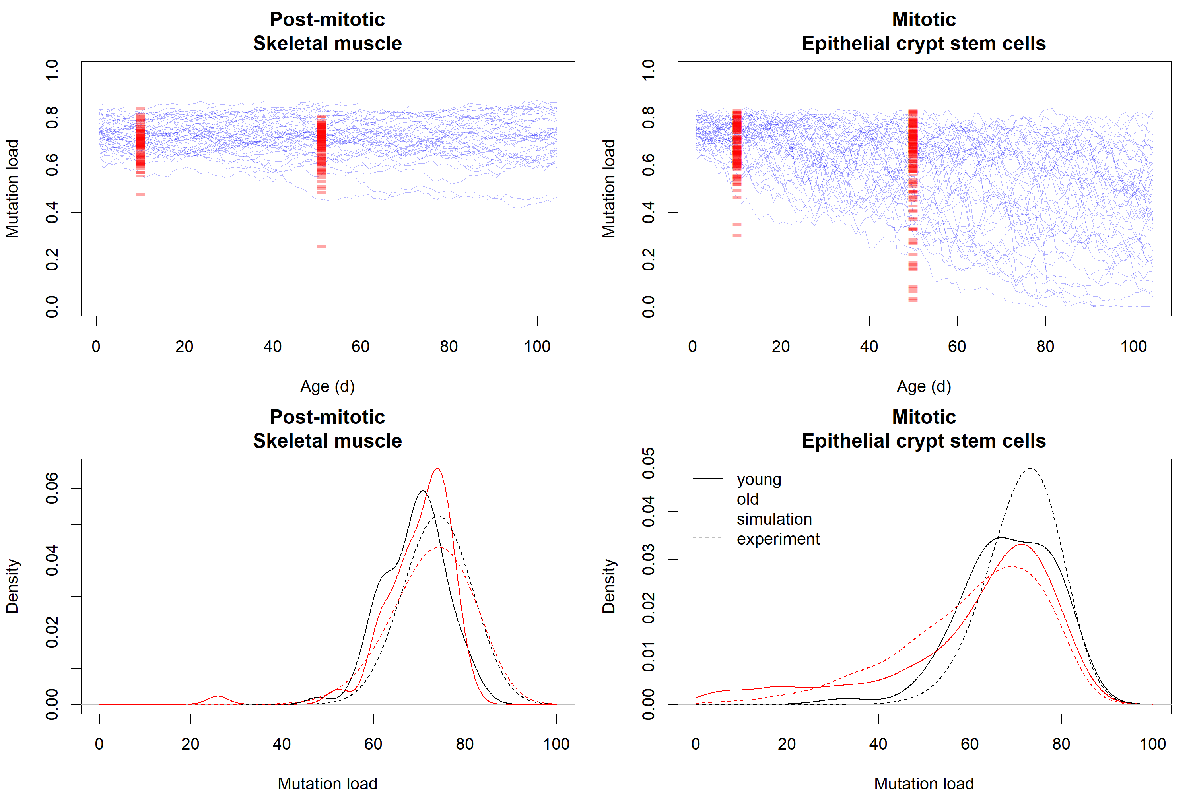

***Figure X*** *Comparing experimental observations of mtDNA population dynamics with model predictions* A) 88 experimental observations of mutation load in skeletal muscle from young mice and 100 observations in old mice (red) together with 50 simulations of mutation load dynamics drawn randomly from 1,200 simulations (blue) B) 125 experimental observations of mutation load in epithelial crypts from young mice and 141 observations in old mice (red) together with 50 simulations of mutation load dynamics drawn randomly from 1,200 simulations (blue) C) Density plots comparing the experimental and observed distributions for young and old mice. Simulation distributions constructed based on all 1,200 simulations.

**Discussion**

We observed two very distinct ageing phenotypes in mutation load from different tissues from the same mice. We developed two simple models of mtDNA population dynamics and stem cell niche dynamics and showed that, simulating from these models, using the same model parameters, where applicable, we can capture these two distinct phenotypes. The main difference between these two strongly related models is the extra replication undergone by mtDNA molecules in cells which are undergoing division. We conclude that this extra replication could be sufficient to describe the differences in how mutation load develops with age in these two tissues. One major assumption we made when building the model of post-mitotic skeletal muscle fibres was that the total copy number was the same as that in stem cells: 200. Clearly there are several thousand mtDNA inside an individual muscle fibre, since these cells are much bigger than epithelial crypt stem cells. However, we assume that there is an effective population size within fibres, outside of which mtDNA molecules do not typically move. We plan to carry out further investigation to investigate this effective population size in muscle fibres.