Java基础练习3

1. 建立一个实体类Student类，属性：姓名，年龄，成绩，班级

建立一个list1，包含 “张三，18岁，80分，1班”，“李四，19岁，100分，1班”，“王五，17岁，59分，1班”。

建立一个list2，包含 “赵六，18岁，85分，2班”，“刘七，19岁，93分，2班”，“孙八，17岁，55分，2班”。

1. 整合两个list学生信息成一个新的list
2. 按照分数给出学生信息排名
3. 输出不及格的学生信息
4. 查找张三的信息
5. 从list剔除年龄大于18岁的学生信息

代码：

/\*\*

\* Student类

\* LiangWeiMing

\* 2020/3/4-17:00

\*/

public class Student {

/\*

姓名

\*/

private String name;

/\*

年龄

\*/

private int age;

/\*

成绩

\*/

private int record;

/\*

班级

\*/

private String grade;

public String getName() {

return name;

}

public void setName(String name) {

this.name = name;

}

public int getAge() {

return age;

}

public void setAge(int age) {

this.age = age;

}

public double getRecord() {

return record;

}

public void setRecord(int record) {

this.record = record;

}

public String getGrade() {

return grade;

}

public void setGrade(String grade) {

this.grade = grade;

}

}

/\*\*

\* StudentTest类

\* LiangWeiMing

\* 2020/3/4-17:10

\*/

import java.util.ArrayList;

import java.util.List;

public class StudentTest {

public static void main(String[] args) {

/\*

创建list1及往里添加对象

\*/

List<Student> list1 = new ArrayList<>();

Student stu1 = new Student();

stu1.setName("张三");

stu1.setAge(18);

stu1.setRecord(80);

stu1.setGrade("1班");

Student stu2 = new Student();

stu2.setName("李四");

stu2.setAge(19);

stu2.setRecord(100);

stu2.setGrade("1班");

Student stu3 = new Student();

stu3.setName("王五");

stu3.setAge(17);

stu3.setRecord(59);

stu3.setGrade("1班");

list1.add(stu1);

list1.add(stu2);

list1.add(stu3);

/\*

创建list2及往里添加对象

\*/

List<Student> list2 = new ArrayList<>();

Student stu4 = new Student();

stu4.setName("赵六");

stu4.setAge(18);

stu4.setRecord(85);

stu4.setGrade("2班");

Student stu5 = new Student();

stu5.setName("刘七");

stu5.setAge(19);

stu5.setRecord(93);

stu5.setGrade("2班");

Student stu6 = new Student();

stu6.setName("孙八");

stu6.setAge(17);

stu6.setRecord(55);

stu6.setGrade("2班");

list1.add(stu4);

list1.add(stu5);

list1.add(stu6);

StudentTest test1 = new StudentTest();

List<Student> list = new ArrayList<>();

list = test1.integration(list1,list2);

test1.sort(list);

test1.fail(list);

test1.find(list);

test1.eliminate(list);

}

/\*

（1）整合两个list学生信息成一个新的list

\*/

public List<Student> integration(List<Student> list1,List<Student> list2){

List<Student> list3 = new ArrayList<>();

list3.addAll(list1); //将list1添加到list3

list3.addAll(list2); //将list2添加到list3

System.out.println("------------1整合-------------");

for(int i = 0;i < list3.size();i++){

System.out.print("name:"+list3.get(i).getName()+" ");

System.out.println("age:"+list3.get(i).getAge());

System.out.print("record:"+list3.get(i).getRecord()+" ");

System.out.println("grade:"+list3.get(i).getGrade());

}

return list3;

}

/\*

（2）按照分数给出学生信息排名

\*/

public void sort(List<Student> list3){

Student temp = new Student();

for(int i = 0;i < list3.size()-1;i++){ //冒泡排序

for(int k = 0;k < list3.size()-i-1;k++){

if(list3.get(k).getRecord() < list3.get(k+1).getRecord()){

temp = list3.get(k);

list3.set(k,list3.get(k+1));

list3.set(k+1,temp);

}

}

}

System.out.println("------------2排名-------------");

for(int j = 0;j < list3.size();j++){

System.out.print("name:"+list3.get(j).getName()+" ");

System.out.println("age:"+list3.get(j).getAge());

System.out.print("record:"+list3.get(j).getRecord()+" ");

System.out.println("grade:"+list3.get(j).getGrade());

}

}

/\*

（3）输出不及格的学生信息

\*/

public void fail(List<Student> list3){

List<Student> faillist = new ArrayList<>();

System.out.println("------------3.不及格-------------");

for(int i = 0;i < list3.size();i++){

if(list3.get(i).getRecord() < 60){ //筛选成绩小于60的人

faillist.add(list3.get(i));

System.out.print("name:"+list3.get(i).getName()+" ");

System.out.println("age:"+list3.get(i).getAge());

System.out.print("record:"+list3.get(i).getRecord()+" ");

System.out.println("grade:"+list3.get(i).getGrade());

}

}

}

/\*

（4）查找张三的信息

\*/

public void find(List<Student> list3){

System.out.println("------------4查找张三信息-------------");

for(int i = 0;i < list3.size();i++){

if(list3.get(i).getName().equals("张三")){ //比较list3中的信息是否有张三

System.out.print("name:"+list3.get(i).getName()+" ");

System.out.println("age:"+list3.get(i).getAge());

System.out.print("record:"+list3.get(i).getRecord()+" ");

System.out.println("grade:"+list3.get(i).getGrade());

}

}

}

/\*

（5）从list剔除年龄大于18岁的学生信息

\*/

public void eliminate(List<Student> list3){

for(int i = 0;i < list3.size();i++){

if(list3.get(i).getAge() > 18){ //筛选年龄大于18的

list3.remove(list3.get(i));

}

}

System.out.println("------------剔除年龄大于18的-------------");

for(int k = 0;k < list3.size();k++){

System.out.print("name:"+list3.get(k).getName()+" ");

System.out.println("age:"+list3.get(k).getAge());

System.out.print("record:"+list3.get(k).getRecord()+" ");

System.out.println("grade:"+list3.get(k).getGrade());

}

}

}

运行结果：

1.1

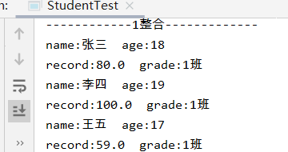

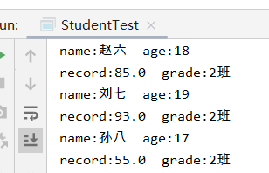

1.2

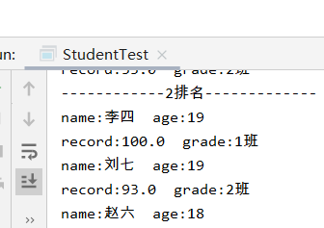

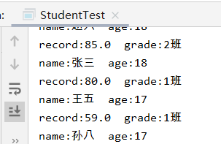

1.3

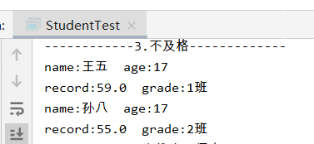

1.4

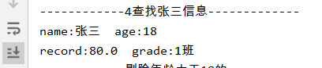

1.5

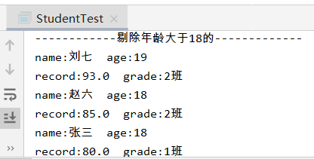

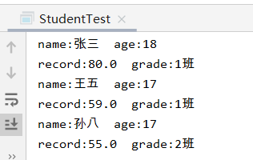

1. 使用Map 完成练习1的习题。

代码：

/\*\*

\* Map类

\* LiangWeiMing

\* 2020/3/4-18:00

\*/

import java.util.HashMap;

public class Map {

public static void main(String[] args){

java.util.Map<String,String> map = new HashMap<>();

map.put("1","a");

map.put("2","b");

map.put("3","c");

for(java.util.Map.Entry<String,String> entry:map.entrySet()){

String mapKey = entry.getKey();

String mapValue = entry.getValue();

System.out.println(mapKey+":"+mapValue);

}

for(String key : map.keySet()){

System.out.print(key+" ");

}

System.out.println();

for(String value : map.values()){

System.out.print(value+" ");

}

}

}

运行结果：

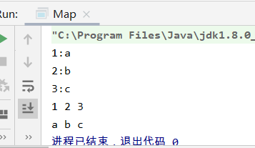

1. 仿照手机淘宝，设计订单和商品的实体类。

3.1订单类

/\*\*

\* Order类

\* LiangWeiMing

\* 2020/3/4-19:00

\*/

public class Order {

/\*商品信息\*/

private String goodInformation;

/\*商品编码\*/

private String goodsCode;

/\*商品总价\*/

private double totalMoney;

/\*买家备注\*/

private String remark;

/\*订单编号\*/

private String orderCode;

/\*买家账户ID\*/

private String buyerAccount;

/\*卖家账户ID\*/

private String sellerAccount;

/\*订单创建时间\*/

private String creatTime;

/\*订单付款时间\*/

private String paymentTime;

/\*发货时间\*/

private String deliveryTime;

/\*签收时间\*/

private String signTime;

/\*收货地址\*/

private String receivingAddress;

/\*联系电话\*/

private String telephoneNum;

/\*签收人\*/

private String Consignee;

public String getGoodInformation() {

return goodInformation;

}

public void setGoodInformation(String goodInformation) {

this.goodInformation = goodInformation;

}

public String getGoodsCode() {

return goodsCode;

}

public void setGoodsCode(String goodsCode) {

this.goodsCode = goodsCode;

}

public double getTotalMoney() {

return totalMoney;

}

public void setTotalMoney(double totalMoney) {

this.totalMoney = totalMoney;

}

public String getRemark() {

return remark;

}

public void setRemark(String remark) {

this.remark = remark;

}

public String getOrderCode() {

return orderCode;

}

public void setOrderCode(String orderCode) {

this.orderCode = orderCode;

}

public String getBuyerAccount() {

return buyerAccount;

}

public void setBuyerAccount(String buyerAccount) {

this.buyerAccount = buyerAccount;

}

public String getSellerAccount() {

return sellerAccount;

}

public void setSellerAccount(String sellerAccount) {

this.sellerAccount = sellerAccount;

}

public String getCreatTime() {

return creatTime;

}

public void setCreatTime(String creatTime) {

this.creatTime = creatTime;

}

public String getPaymentTime() {

return paymentTime;

}

public void setPaymentTime(String paymentTime) {

this.paymentTime = paymentTime;

}

public String getDeliveryTime() {

return deliveryTime;

}

public void setDeliveryTime(String deliveryTime) {

this.deliveryTime = deliveryTime;

}

public String getSignTime() {

return signTime;

}

public void setSignTime(String signTime) {

this.signTime = signTime;

}

public String getReceivingAddress() {

return receivingAddress;

}

public void setReceivingAddress(String receivingAddress) {

this.receivingAddress = receivingAddress;

}

public String getTelephoneNum() {

return telephoneNum;

}

public void setTelephoneNum(String telephoneNum) {

this.telephoneNum = telephoneNum;

}

public String getConsignee() {

return Consignee;

}

public void setConsignee(String consignee) {

Consignee = consignee;

}

}

3．2商品类

/\*\*

\* Goods类

\* LiangWeiMing

\* 2020/3/4-20:00

\*/

public class Goods {

/\*商品信息\*/

private String goodInformation;

/\*商品规格\*/

private String productSpecification;

/\*商品单价\*/

private double money;

/\*商品总价\*/

private double totalMoney;

/\*商品编码\*/

private String goodsCode;

/\*卖家ID\*/

private String sellerID;

/\*评价-用户ID\*/

private String evaluatUserID;

/\*评价-内容\*/

private String evaluation;

public String getGoodInformation() {

return goodInformation;

}

public void setGoodInformation(String goodInformation) {

this.goodInformation = goodInformation;

}

public String getProductSpecification() {

return productSpecification;

}

public void setProductSpecification(String productSpecification) {

this.productSpecification = productSpecification;

}

public double getMoney() {

return money;

}

public void setMoney(double money) {

this.money = money;

}

public double getTotalMoney() {

return totalMoney;

}

public void setTotalMoney(double totalMoney) {

this.totalMoney = totalMoney;

}

public String getGoodsCode() {

return goodsCode;

}

public void setGoodsCode(String goodsCode) {

this.goodsCode = goodsCode;

}

public String getSellerID() {

return sellerID;

}

public void setSellerID(String sellerID) {

this.sellerID = sellerID;

}

public String getEvaluatUserID() {

return evaluatUserID;

}

public void setEvaluatUserID(String evaluatUserID) {

this.evaluatUserID = evaluatUserID;

}

public String getEvaluation() {

return evaluation;

}

public void setEvaluation(String evaluation) {

this.evaluation = evaluation;

}

}