Project GR001 IP AHB_SRAMC
Hardware Design Document

Provided by Neo Wang Provided Date

Approved by Approved Date

Revision History
Version | Release Date | Owner | Description
V0.1 | 2023/9/26 | Neo Wang | Initial Version

Attention: The blue italics are template comments, please remove all of them before releasing the document！

注意： 蓝色斜体字部分是模版注释内容，请在正式发布的版本中将他们全部移除！

Contents
Revision History 2
Contents 3
Table List 5
Figure List 6
1 Introduction 7
2 Feature List 8
3 Functional Description 9
3.1 Architecture 9
3.2 Design Description 9
3.3 High Level Timing Diagram 9
3.4 Clock and Reset 10
3.4.1 Clock 10
3.4.2 Reset 10
3.5 I/O Interfaces 11
3.6 Address Mapping 12
4 Block Description 13
4.1 AHB_SRAMC 13
5 Use cases 14
5.1 Scenario 1 14
5.2 Scenario 2 14
6 Configuration 16
6.1 Parameter 16
6.2 Macro 16
6.3 Memory 16
7 PPA Information 17
7.1 Power 17
7.2 Performance 17
7.3 Area 17
8 Implementation Constraints 19
9 P & R Guidelines 20
10 Verification 21
11 Appendix 22

Table List

Table 3-1 Clock Requirements 10
Table 3-2 Reset Requirements 10
Table 3-3 I/O Interfaces (see 6 Configuration for configurable width) 12
Table 3-4 Address Mapping 12
Table 6-1 Parameter List 16
Table 6-2 Macro List 16
Table 6-3 Memory Requirements Table 16
Table 7-1 Power State Table 17
Table 7-2 Power Consumption Table 17
Table 7-3 Area Information 17
Table 7-4 VT Cell Number 18

Figure List

Figure 3-1 AHB_SRAMC architecture Diagram 9
Figure 3-2 High Level Timing Diagram 10
Figure 5-1 Data Path of Normal Write 14
Figure 5-2 Data Path of Narrow Write 14

Introduction
Please provide brief and high-level description here for the IP or SYS. For example, design background and basic IP functions.
AHB_SRAMC is a SRAM memory controller based on the standard AHB bus. It provides an AHB3 lite slave interface that can be connected to AHB3 master or interconnect devices in the AHB3 Lite systems and a user-defined master interface of memory wrapper.

Feature List
Please list all main features of IP or Sub System here.

FL-001: 32-bit address bus of AMBA3 AHB_Lite slave interface
FL-002: supports 32/64/128/256-bit data bus (the data width corresponds to the SRAM data width)
FL-003: supports bursts of 4, 8, and 16-beats, undefined length bursts, and single transfers
FL-004: supports RMW operation for ECC
FL-005: only support single-port SRAM
FL-006: supports SRAM capacity: 1KB~8M
FL-007: only support same read/write latency for SRAM
FL-008: supports up to 16 GB/s write or read bandwidth @500MHz

Functional Description
Please provide detailed function description and architecture diagram in this chapter.

Architecture
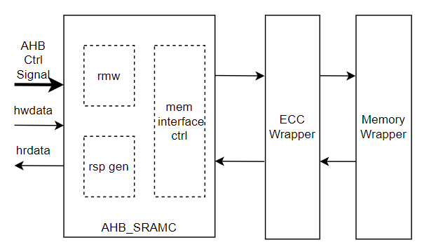
Figure 3-1 AHB_SRAMC architecture Diagram

Design Description
AHB_SRAMC is responsible for converting AHB access transactions into SRAM access transactions. The upstream AHB master initiates a read or write request to SRAM. AHB transaction is converted into a mem request through block mem interface ctrl. And then, it is sent to the downstream Memory Wrapper. In order to complete data error correction and improve robustness, an ECC module is used to encode written data and decode read data. Because data granularity of the ECC module encoding and decoding is the bus bit width, for AHB narrow write transaction, AHB_SRAMC needs to initiate a read operation to obtain complete write data before continuing the write operation.

High Level Timing Diagram
Please provide the high level I/O timing diagram for the whole IP or SYS.
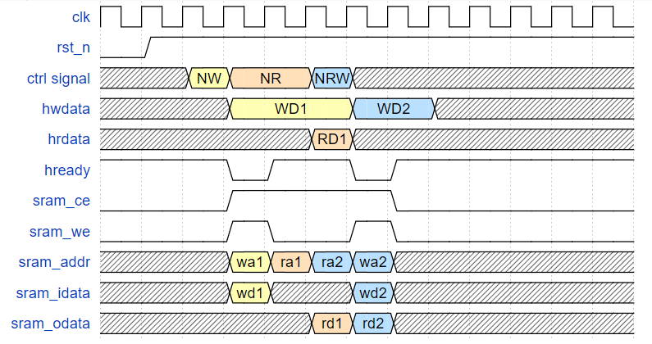
Figure 3-2 High Level Timing Diagram
As shown in Figure 3-2, there are three AHB write operations, the first is a normal write transaction (NW) with “hsize==data width”, the second is a normal read transaction (NR) with “hsize==data width”, the third is a narrow write transacton (NRW) with “hsize!=data width”. Assuming that the latency of SRAM is 1 cycle.

Clock and Reset
Please provide required clock and reset information in this chapter.

Clock
Clock Group | Clock Name | Frequency | Duty Cycle | Accuracy
group 1 | clk | 500MHz | 45%~55% |  | ±100 ppm
Table 3-1 Clock Requirements

Reset
Reset Name | Related Clock | Comments
rstn | clk
Table 3-2 Reset Requirements

I/O Interfaces
Please give the fully I/O interfaces in the interface table, the interfaces can be divided into different groups such as:
- Clock
- Reset
- Bus interfaces
- Interrupts
- DFT
- Etcs.

Category | Interface Name | Width | I/O | Description
clock | clk | 1 | I | AHB_SRAMC main clock
reset | rstn | 1 | I | Reset signal, active low
AHB interfaces | s_hsel | 1 | I | AHB slave select
 | s_haddr | 32 | I | AHB access address
 | s_hwrite | 1 | I | AHB transfer direction
 | s_htrans | 2 | I | AHB transfer type
 | s_hsize | 3 | I | AHB transfer size
 | s_hburst | 3 | I | AHB transfer burst type
 | s_hport | 4 | I | AHB protection control signal
 | s_hmastlock | 1 | I | AHB lock sequence
 | s_hreadyin | 1 | I | AHB previous transfer complete
 | s_hwdata | configurable | I | Write data
 | s_hrdata | configurable | O | Read data
 | s_hreadyout | 1 | O | Transfer finish signal
 | s_hresp | 1 | O | AHB transfer response
Memory interfaces | m_mi_ce | 1 | O | Memory access valid
 | m_mi_we | 1 | O | 0: read; 1: write
 | m_mi_addr | 32 | O | Memory access address
 | m_mi_data | configurable | O | Memory write data
 | m_mo_data | configurable | I | Memory read data
Register | ahb_sramc_idle | 1 | O | AHB_SRAMC module is idle
Table 3-3 I/O Interfaces (see 6 Configuration for configurable width)

Address Mapping
Field Name | Address Range
SRAM | 0x0~0x80_0000
Table 3-4 Address Mapping

Block Description
The IP or SYS could be divided into several sub modules, please provide detailed design information for each sub block in this chapter.

AHB_SRAMC
As shown in Figure 3-1 AHB_SRAMC architecture Diagram, this module supports all transfer type and burst type specified in the AHB3 Lite protocol, and the transfer size set by HSIZE must be less than or equal to the width of the data bus. First AHB transfer is converted into a mem request. For write operation, the memory write request can be initiated only after write data has been collected in AHB data phase. For read operations, when the memory returns the read data, the module converts it to the AHB read data and passes it upstream master. It is worth noting that the sram access address is aligned with the bit width of the SRAM data bus.
Considering the narrow write (transfer size less than width of data bus), the write request will be specially handled with RMW (Read Modify Write) operation. RMW operation will first initiate a read operation to read back the data of the complete bus bit width corresponding to the write address, then merge it with the actual data to be written, and finally write the combined data into memory. Since AHB protocol reads and writes are strictly sequence-preserving, SRAMC gains additional operation time by pulling down the ready signal to the upstream master.

Use cases
Please draw all necessary data path flow for typical scenarios, and the necessary description was required.

Scenario 1
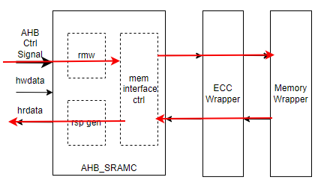
Figure 5-1 Data Path of Normal Write
The upstream AHB master initiates a normal read request to SRAM. AHB transaction is converted into a memory request block mem interface ctrl. And then, it is sent to the downstream memory wrapper. When mem completes the read operation, it will return the relevant rdata to AHB_SRAMC to generate B channel response.

Scenario 2
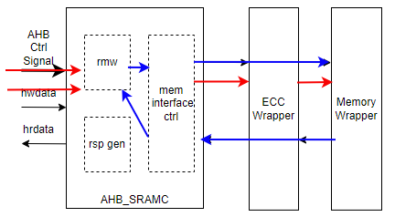
Figure 5-2 Data Path of Narrow Write
The upstream AHB master initiates a narrowwrite request to SRAM. First, block rmw ctrl will initiate a read request of the corresponding address to memory, and after reading back the data, it will splice the read data with the original AHB narrow write data. And finally write the spliced data into memory. For example, AHB original write data is 64’h1111_2222_3333_4444, address is ‘h1234 and hsize is “Word”; Assume that the data stored at address ‘h1230 in memory is 64’h5555_6666_7777_8888 at this time. Then the data finally written to this address ‘h1230 is 1111_2222_7777_8888.

Configuration

Parameter
Parameter | Default Value | Description
AHB_DATA_WIDTH | 64 | Bus data width, support 32/64/128/256
SRAM_R_LATENCY | 1 | Memory read data delay
HAS_NARROW_TR | 1 | Whether narrow transfers are supported
Table 6-1 Parameter List

Macro
Macro | Default Value | Description
Table 6-2 Macro List

Memory
Mem Name | Depth | Width | Frequency | Type | Comments
Table 6-3 Memory Requirements Table

PPA Information

Power
Please give the description regarding the whole low power design methodology in this chapter, and list all of power domain related information in below sheets.

Power State | Power Domain 1 | Power Domain 2 | Power Domain 3
Table 7-1 Power State Table

IP Name | Leakage Power | Internal Power | Switching Power | Total Power
Table 7-2 Power Consumption Table

Performance
Please give the peak performance information in this section.
For example:
- Max Frequency
- Max Bandwidth
- Max Outstanding Number

Please list the performance requirement to achieve the basic function.
- Latency
- Bandwidth

Area
Logic和mem区分开，加个表，包括各个VT cell比例
Please list the area and vt cell information in below tables, the synthesis configurations should be announced.
Logic Area | Memory Area | Total Area
Table 7-3 Area Information

SVT Cell Num | LVT Cell Num | ULVT Cell Num | Total Cell Num
Table 7-4 VT Cell Number

Implementation Constraints
Please list all design constraints if have:
For example:
- Multicycle
- False path
- Logical exclusive
- Etcs.

P & R Guidelines
Please provide guidelines for P & R stage.

Verification
Please list special requirements for verification.

Appendix

