World Cup Data Analysis Project
DATA 3010 – Python Project
Student Name: Canyon White__________________________
Course: Data 3010____________________________________
Instructor: Nicole Carder______________________________
Semester: Summer 2026______________________________
Date Submitted: 07/29/2026__________________________

Introduction
Purpose of the Analysis
The purpose of this project is to explore the match statistics of professional Soccer players during the 2026 World Cup and how these affected the outcomes for their nations. The descriptive statistics, data visuals, and analysis have been performed utilizing the SAS programming language.
Description of the Dataset
This dataset was gathered from Kaggle and contains various match statistics for each player in the 2026 World Cup. This dataset is useful for identifying potential contributing factors in teams either winning or losing each of their World Cup matches and can give us insights into how teams might perform at future World Cup appearances.

Variables being Analyzed
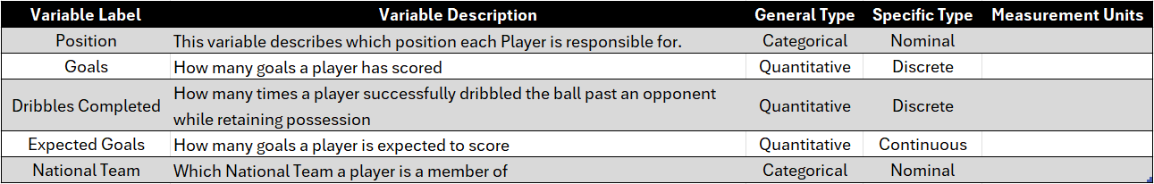

Section 1:

