Matthew Fagan – 15700612

Luke Woollett – 47870172

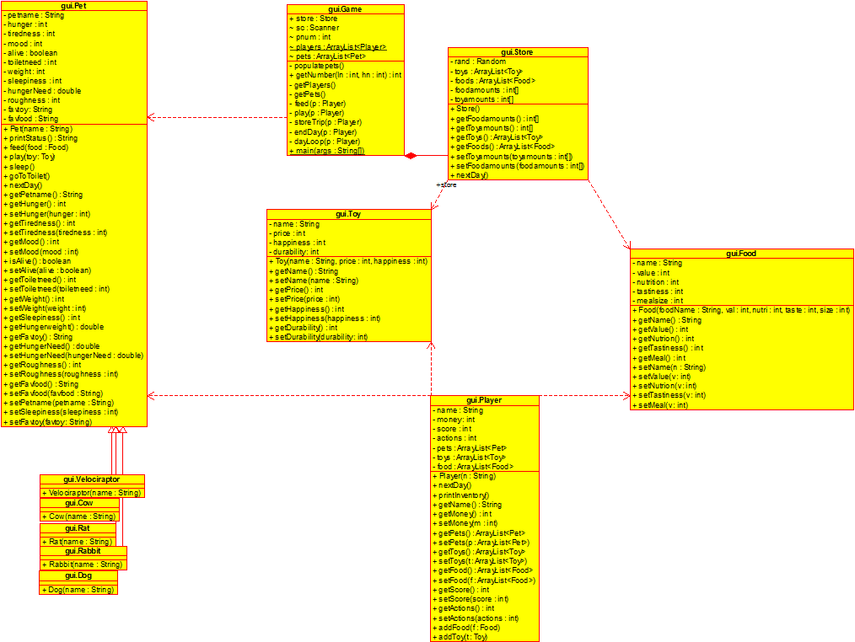 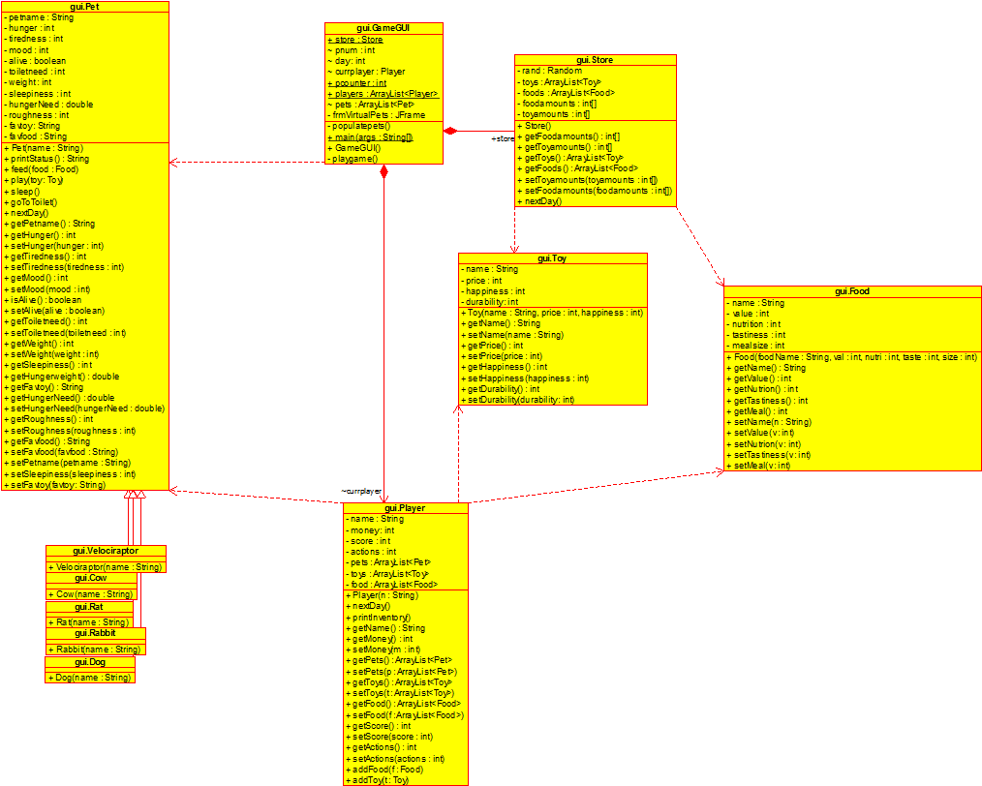

The main class for each of the game variants (Command Line and GUI) is the Game class. This class is what runs the game, creating the displays and calling on each of the other classes when they are needed. The game class starts off by creating a given number of Player classes, dictated by the user. It uses a scanner to collect the names of the players and assigns them. After the Players are created and stored in an array the Pets are created and stored in arrays for each of the Players.

After collecting the Players and all the Pets for the Player the game iterates over each day for each Player. The Players are given 2 actions to use on each day and use those on their Pets or to buy Food or Toys. If the player chooses to buy Food or Toys the Game class calls upon the Store class to return the Toys/Food it has and the number of stock it has of each item, it then reduces the number of the bought item by 1 when bought. The Game class then puts the Toy/Food into the player’s inventory.

Once the number of actions the player has left reaches 0 the Game class then iterates onto the next player. Once all players have used their actions for the day the Game uses the nextDay method. This method iterates over all the Pets using their nextDay method which reduces their stats accordingly with their subclass attributes, uses the nextDay method for the Store, which increases the stock in the Store by a random amount each night.