Summary

1. Context and objective of the PROJECT 3
2. Application Architecture Diagram 4
3. Functional architecture 5
3.1. Utilisateurs (rôles et fonctionnalités) 5
3.2. Fonctions principales 5
3.3. Volumétrie de la base de données 5
4. Sécurité 6
4.1. Introduction to keycloak 6
4.2. Authentication using keycloak 6
4.3. Logs using keycloak 6
5. Quality Monitoring (QM) 7
5.1. Real-time error checking and handling(Sentry) 7
5.2. Web Analysis (matomo) : 7
6. Quality Insurance (QA) 8
6.1. Testing strategy 8
6.2. QA tools: 8
7. Front-end application 9
8. Back-end application 10
9. Tools and libraries 11

- Contexte et objectif du PROJET

Contexte :

Objectif :
- Context and objective of the PROJECT
The architecture diagram illustrates the workflow of an indoor navigation app, highlighting two primary entities: the Front-End and the Admin Panel. Here's a detailed explanation of the components and their interactions:
- Front-End: User-facing interface for navigation and interaction and Authenticates with keycloak to ensure secure access.
- Admin Panel: Used by administrators to manage maps through SharePoint, routes, and user activity and Also authenticates with keycloak for restricted access.
- Keycloak: Handles user authentication and authorization as a layer of security
- Back-End: Contains app logic and processes requests from both the front-end and admin panel and Interacts with the Filesystem (for maps) and Database (for storing data).
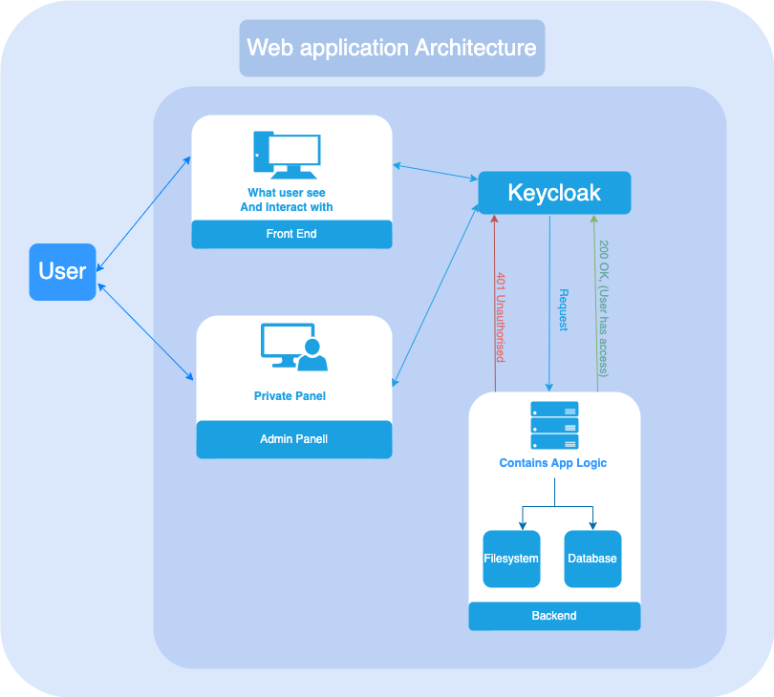
- Functional architecture

  - Users (users and functionalities)

Each role has specific functionalities based on their specific needs, ensuring the app provides a customized and secure experience for all types of users including :
- Guest User: which has access to basic navigation and explore the building , able to search for specific rooms or locations and access public information (e.g.,Bathroom, emergency exits, cafeteria).
- Supplier User: can access restricted areas related to delivery zones, View specific routes for supply delivery and log delivery times or confirm completed tasks.

- Maintenance Staff: can access Access utility routes (e.g., electrical rooms, staff rooms…), Report or mark areas requiring repairs, Track maintenance schedules and update task statuses.
- VIP Visitor: can Access premium services or restricted zones (e.g., VIP lounges), Receive personalized navigation and assistance

User Types and Communication Flows
There is 3 types of users each user communicates with the back-end through a certain flow
- User: Can only access the indoor navigation app maps and navigate the building and he can send requests to the backend for retrieving map data (e.g., room locations, routes), The backend processes the request and returns map details.
- Admin: Can access both of Admin Panel and indoor navigation app , he is able edit rooms, buildings, and assets within the system, he can send requests to the backend to update or manage specific data (e.g., adding or renaming a room). the Backend verifies the admin role, processes the changes, and updates the database.
- SuperAdmin: Has all the permissions of an Admin and Additionally he can modify user permissions and roles plus all the admin capabilities
  - Volumétrie de la base de données

Env. | Nom de l’instance | Volume (GB) | Description fonctionnelle
DEV | DB_NAME | 10->50 | Serveur de Test
PROD | DB_NAME | 10->50 | Serveur de production

- Security

4.1 Introduction to Keycloak

Keycloak is an open-source identity and access management solution that provides features like user authentication, authorization, and user management. It simplifies the process of securing applications by integrating Single Sign-On (SSO), social logins, and role-based access control (RBAC). Keycloak ensures secure and seamless access to applications while offloading complex authentication tasks from developers.
- Single Sign-On (SSO): Enables users to log in once and access multiple applications without needing to authenticate repeatedly.
- Role-Based Access Control (RBAC): Allows administrators to define and manage user roles and permissions across applications.
- Social Login Integration: Simplifies authentication by allowing users to log in via social providers like Google, Facebook, or LinkedIn.
4.2 Authentication using Keycloak

Keycloak simplifies the authentication process by handling user identity verification and session management. It integrates smoothly with applications, providing a secure and standard way for users to authenticate.
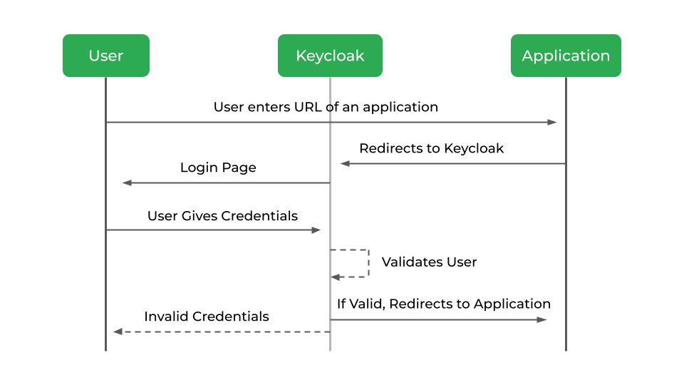

4.3 Logs using Keycloak
Keycloak supports real-time logging through its event system, which captures events like user logins, role changes, and failed authentication attempts. These events can be streamed or accessed in real-time, allowing administrators to monitor activities as they happen. Keycloak can be configured to send these logs to external systems like Sentry for real-time analysis and alerting, enabling quick responses to security or system issues.
- Quality Monitoring (QM)
5.1 Real-time error checking and handling (Sentry):
Sentry is an open-source error tracking and monitoring tool that helps developers identify, diagnose, and fix errors in real time. It captures and aggregates errors, exceptions, and performance issues across various applications, providing detailed reports to improve troubleshooting efficiency. Sentry supports a wide range of programming languages and frameworks, offering deep integration with modern tech stacks.
- Error Detection: Sentry captures unhandled errors and exceptions from applications in real time.
- Event Aggregation: It groups similar errors to provide clear insights into recurring issues.
- Contextual Information: Each error report includes rich context, like stack traces, user data, and environment details, helping developers understand the root cause.
- Alerting: Sentry can notify developers via email, Slack, or other channels when new issues arise or existing issues resurface
5.2 Web Analysis (Matomo):
Matomo is an open-source web analytics platform that helps track and monitor user interactions on websites and applications. It provides detailed insights into website traffic, user behavior, and conversion tracking. While Matomo is primarily focused on analytics, it can also be used for monitoring real-time data and performance metrics, allowing businesses to understand and respond to user behavior in real time.
- Performance monitoring: Get insights into how users interact with different parts of your site and identify areas needing optimization.
- Real-time user behavior analysis: Monitor website visitors' actions as they happen and adjust content or functionality based on their needs.
- Conversion tracking: Track specific goals, such as form submissions or product purchases, and assess campaign effectiveness.

- Quality Insurance (QA)
The QA process ensures the platform meets the highest standards by identifying defects early and improving the overall quality of the project. This includes comprehensive testing across various aspects of the system.
6.1 Testing Strategy
- Unit Testing: Ensures individual components (e.g., navigation, API calls) function as expected and meets quality standards.
- Test Driven Design: writing test cases before writing the actual code or feature
- Integration Testing: Verifies that SharePoint integration and API interactions work smoothly, ensuring the system's parts function well together.
- UI/UX Testing: Ensures user interactions are intuitive and responsive across different devices, providing a seamless experience.
- Stress Testing: Measures the platform’s performance under heavy loads to confirm its scalability and robustness.
- Security Testing: Identifies vulnerabilities and ensures that the platform follows OWASP security standards.
6.2 Qa Tools
- Selenium (UI Automation): Automates browser actions by simulating user interactions to ensure the platform’s user interface works as expected.
- Postman (API Testing): Used to validate the functionality and performance of APIs, ensuring that data exchanges occur as intended.
- JMeter (Performance Testing): Performs stress and load testing to measure the system's performance under different conditions, ensuring the platform can handle high traffic loads.

- technical aspects for the front-end application

- Navigation Module: Handles position updates and path visualization to guide users through the building.
- Network Layer: Communicates with the backend to fetch building data such as graph data and floor plans.
- 3D Map and Interactive Features: Utilizes Three.js for an interactive 3D map of the building, allowing users to explore floor layouts.
- Multi-Criteria Route Calculation: Provides users with the option to select the best route based on criteria like shortest distance, accessibility, or safety.
- User Interface (UI) Components:
  - Thematic Menu: Displays a categorized menu for easy access to building features (e.g., rooms, amenities).
  - Search: Allows users to search and quickly find locations or points of interest within the building.
- QR Code & Link Access: Enables users to access the system via shared links or QR codes linked to specific building floors or entry points.
- Tutorial / Guide: Offers a tutorial to guide users on how to use the navigation system, including QR code scanning and 2D/3D navigation.
- Feedback System: Allows users to report issues or provide suggestions for improving the navigation system.

- technical aspects for the back-end application
API Controller:
- Provides endpoints for handling data requests such as building structure, floor plans, and other essential resources needed by the front-end. These endpoints are designed to respond to specific user queries efficiently.
Database:
- Stores crucial data including maps content for each floor and user-related data (e.g., preferences, navigation history). The database serves as the central storage for all the building data that is used for rendering maps, managing user information, and calculating routes.
Route Calculation:
- Utilizes Dijkstra's Algorithm to calculate the optimal route between two points (e.g., rooms, floors) based on the graph data. This part of the backend processes the user's start and destination requests and provides the most efficient path considering factors like shortest distance or accessibility.

- required tools and libraries
QR Code Detection:
- react-qr-reader or react-qrcode-scanner for detecting and scanning QR codes, allowing quick access to specific building floors or locations.
Mapping:
- react-leaflet for rendering interactive 2D maps of the building and surrounding areas.
- three.js for creating interactive 3D visuals of the building, including floor layouts and navigation paths.
Navigation Algorithms:
- dijkstrajs or a custom Dijkstra implementation in TypeScript for calculating the optimal route between two points based on the building's graph data.
Search Functionality:
- A custom search bar component that enables users to quickly find points of interest (POIs), such as rooms, amenities, or floors within the building.
Responsive Design:
- Utilize React Responsive to ensure the application is mobile-friendly and adapts smoothly to different screen sizes, providing an optimal experience on both desktop and mobile devices.

