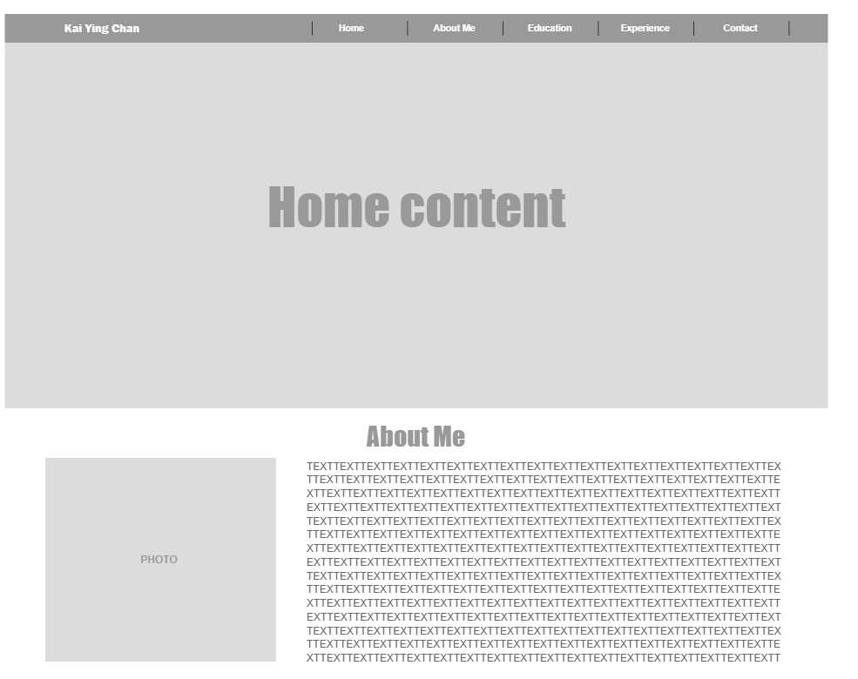This is the first part of the assignment because the page is too big. The second part is on second page.

My website page name will be Lite’s profile.

For the home content I am thinking about putting images about myself. Probably a gallery or even just a simple image following some quotes or just a small introduction to the website. For the header I will put navigations to each title in the page. Each section would have a topic and I haven’t decided if I want a background image for each section or simply a background color. If I were to use a background color I think I will use rgb(146,172,209) or Morandi colors. I will try with different colors for the background color and the titles of course. For the education and Club experience part I will add information about the recent colleges I went and some important courses worth pointing out. I will also include the experiences I had in the club since I was captain for the softball team in college. For the contact me form, I will include forms with First and Last Name, email and phone number. I will also add a text column if they want to send me some messages. It will be a simple form for them to contact me if they are interested in me. For the footer part, I will also include a bootstrap image for Instagram.