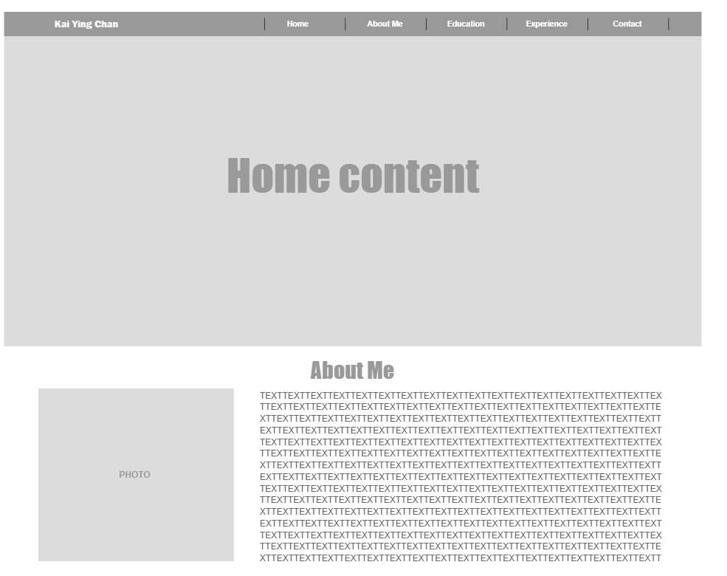This is the first part of the assignment because the page is too big. The second part is on second page.

For the background color I think I will use rgb(146,172,209) or Morandi colors. I will try with different colors for the background color and the titles of course. For the education and Club experience part I will add information about the recent colleges I went and some important courses worth pointing out. I will also include the experiences I had in the club since I was captain for the softball team in college. For the contact me form, I will include forms with First and Last Name, email and phone number. It will be a simple form for them to contact me if they are interested in me. For the footer part, I will also include a bootstrap image for Instagram.