MCMC Lab #2

Methodology
For this lab I used regular Gibb-Metropolis. For most of my node types I used a normal distribution for my candidate distribution. For Beta nodes, I actually used a Beta(1, 1) distribution as my candidate distribution.

Results

Faculty Data
As can be seen in the illustrations below, I was able to get similar results to what were shown in class. Here I used a burn of 50, and took 10,000 samples. You could expect to get even better results with larger sample sizes.
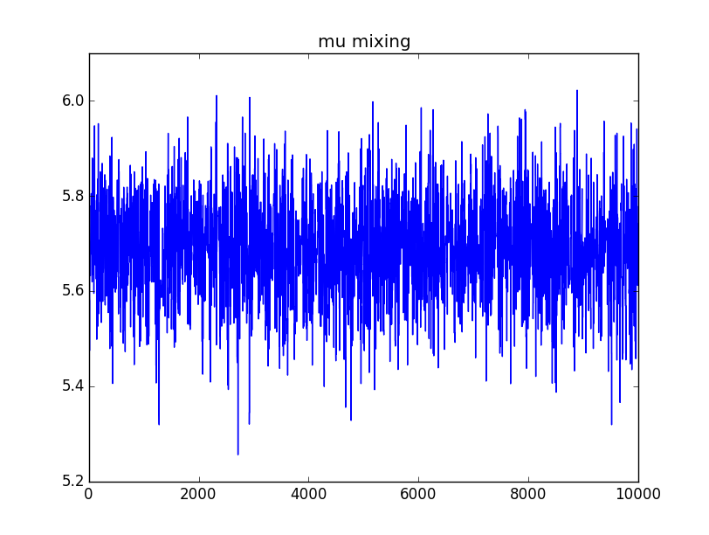Illustration 1: Mixing Plot for mean.
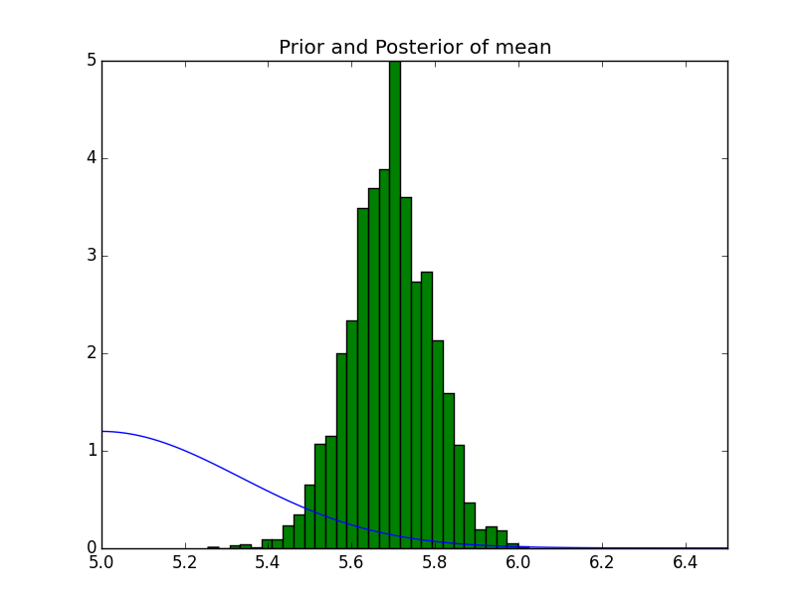Illustration 2: Prior and Posterior for mean.
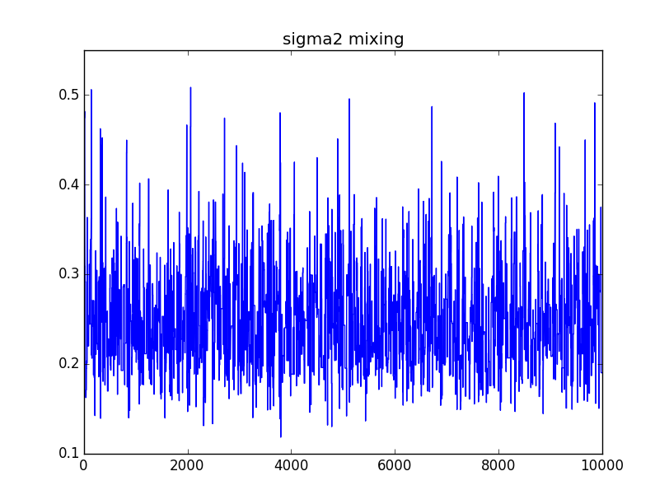Illustration 3: Mixing Plot for varience.
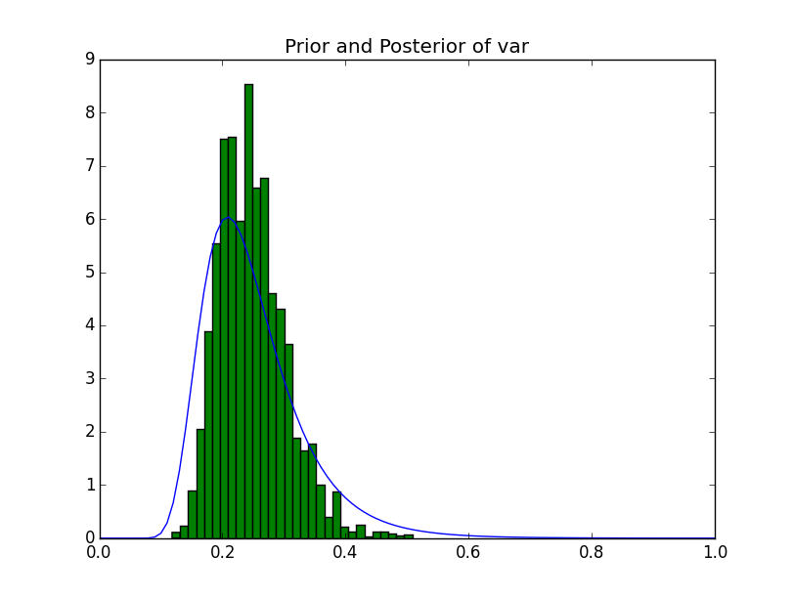Illustration 4: Prior and Posterior for varience.

Golfer Data
For the Golfer Data, I used a burn of 1,000 and took 100,000 samples. Here I will only show the top and bottom few of the results, but the entire set will be contained inside my project.
1: VijaySingh -3.906447; 90% interval: (-4.504126, -3.326780)
2: TigerWoods -3.769976; 90% interval: (-4.582426, -3.000115)
3: PhilMickelson -3.399245; 90% interval: (-4.086515, -2.741334)
4: ErnieEls -3.370781; 90% interval: (-4.284688, -2.519823)
5: StewartCink -3.063484; 90% interval: (-3.704623, -2.459434)
6: JayHaas -2.953525; 90% interval: (-3.641581, -2.277345)
7: SergioGarcia -2.923204; 90% interval: (-3.693806, -2.158839)
8: ScottVerplank -2.848907; 90% interval: (-3.510737, -2.204605)
9: RetiefGoosen -2.767124; 90% interval: (-3.630764, -1.950194)
10: PadraigHarrington -2.761819; 90% interval: (-3.774030, -1.783685)
11: StephenAmes -2.742376; 90% interval: (-3.350723, -2.146788)
12: ChrisDiMarco -2.703103; 90% interval: (-3.311964, -2.095429)
13: AdamScott -2.504414; 90% interval: (-3.350539, -1.652776)
14: RobertAllenby -2.503431; 90% interval: (-3.118186, -1.879881)
...
597: JohnAber 4.687440; 90% interval: (2.623945, 6.746701)
598: KevinSavage 4.740842; 90% interval: (2.563744, 7.017054)
599: AndyBarrett 4.838207; 90% interval: (2.755317, 6.959118)
600: TommyAaron 4.938912; 90% interval: (2.830908, 7.196950)
601: DerekSanders 5.239521; 90% interval: (3.229904, 7.260694)
602: BobLohr 6.050143; 90% interval: (3.892943, 8.232351)
603: ArnoldPalmer 6.138403; 90% interval: (4.485955, 7.845696)
604: TimTims 7.910875; 90% interval: (5.718268, 10.155110)

Wacky Network
I tried toying around with the parameters and was able to get pretty good results for most nodes, but a couple of the nodes were still having problems even given extremely large sample sizes.

Default
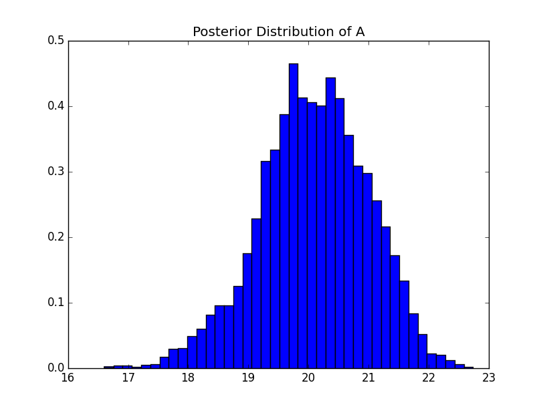Illustration 5: Posterior for node A.
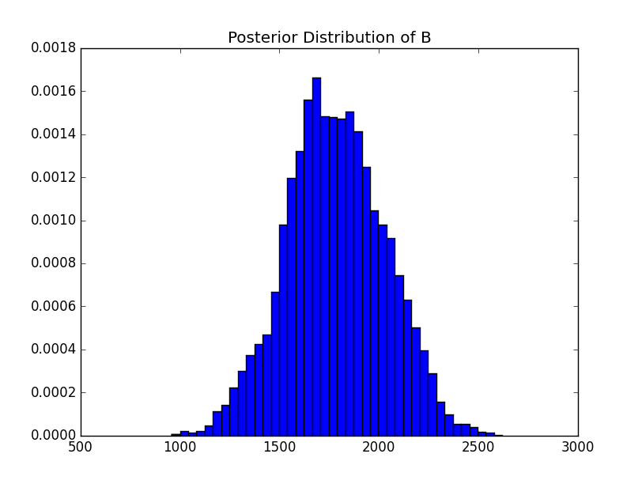Illustration 6: Posterior for node B.

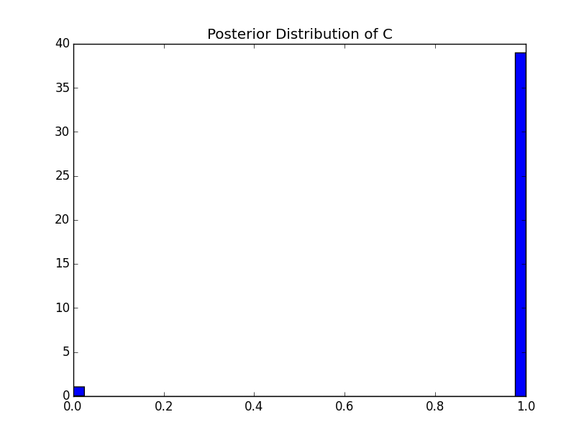Illustration 7: Posterior for node C.
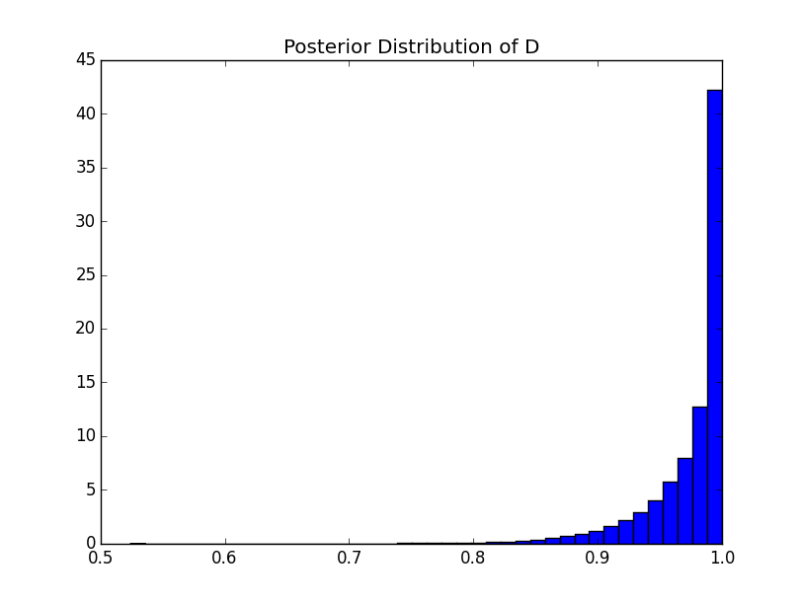Illustration 8: Posterior for node D.
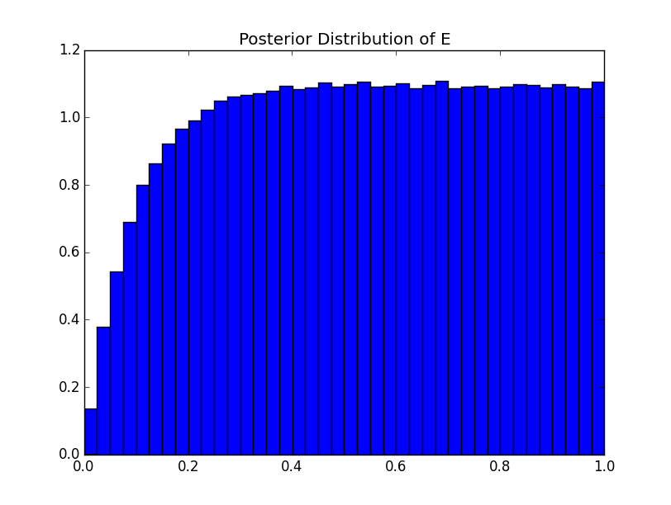Illustration 9: Posterior for node E.
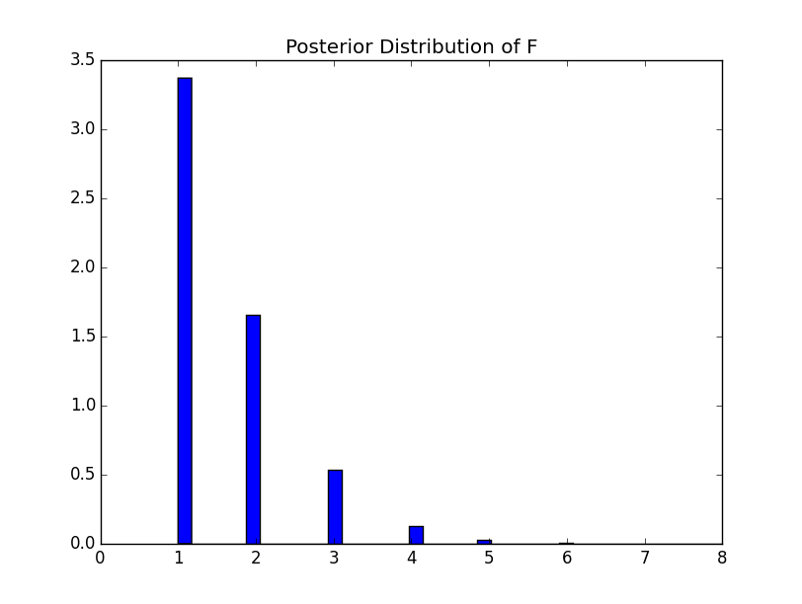Illustration 10: Posterior for node F.
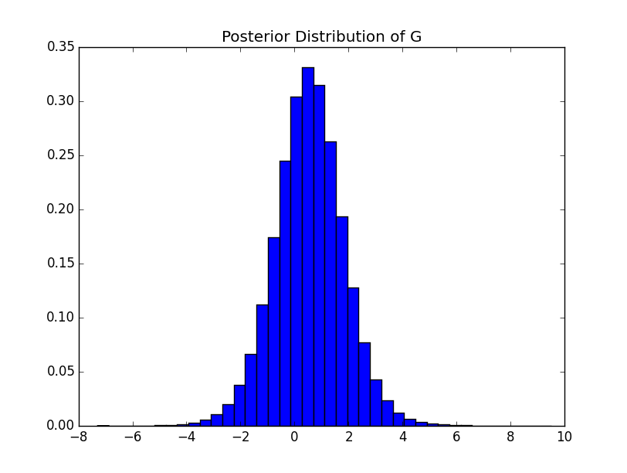Illustration 11: Posterior for node G.

With G = 5
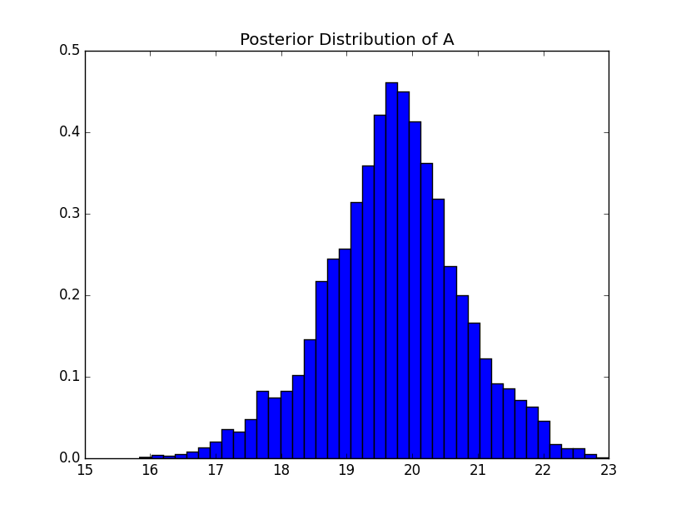Illustration 12: Posterior for node A given G=5.
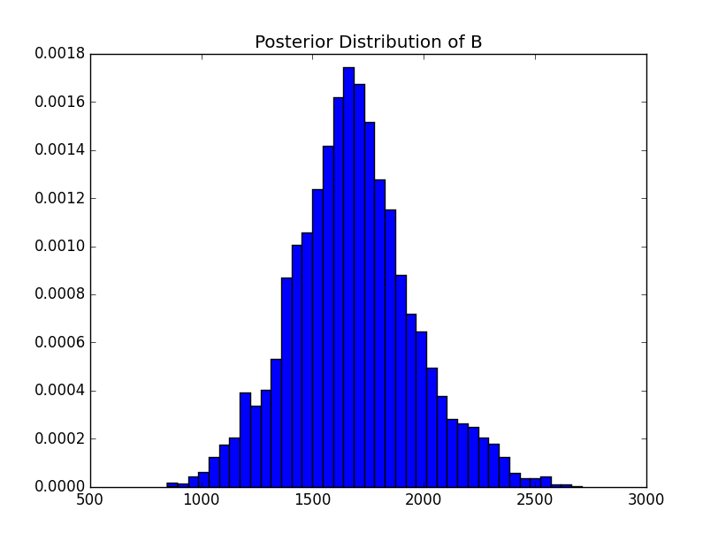Illustration 13: Posterior for node B given G=5.
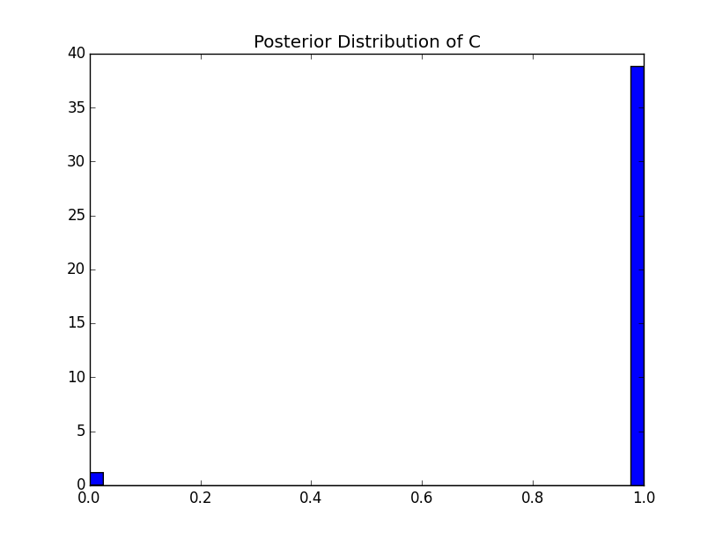Illustration 14: Posterior for node C given G=5.
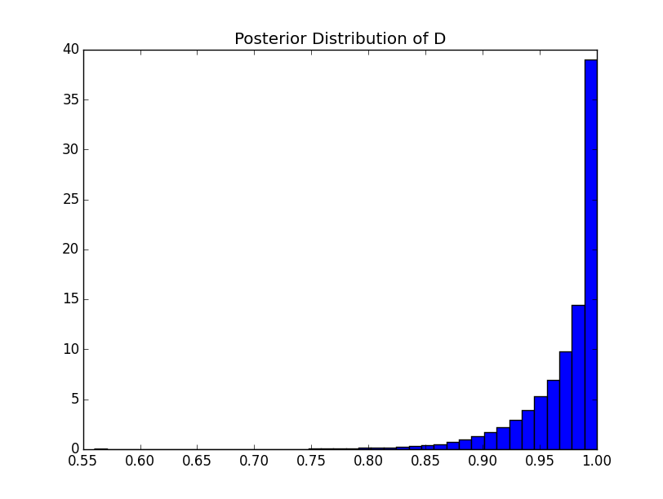Illustration 15: Posterior for node D given G=5.
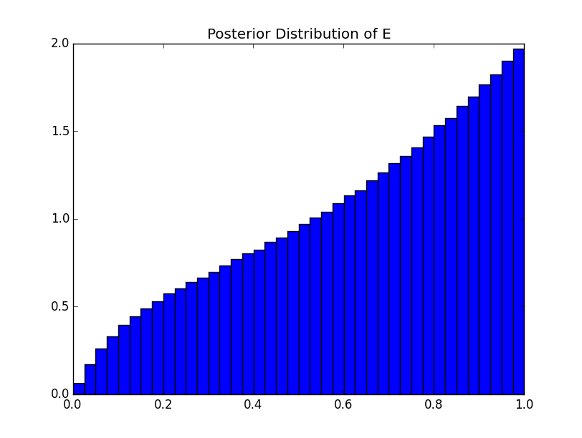Illustration 16: Posterior for node E given G=5.
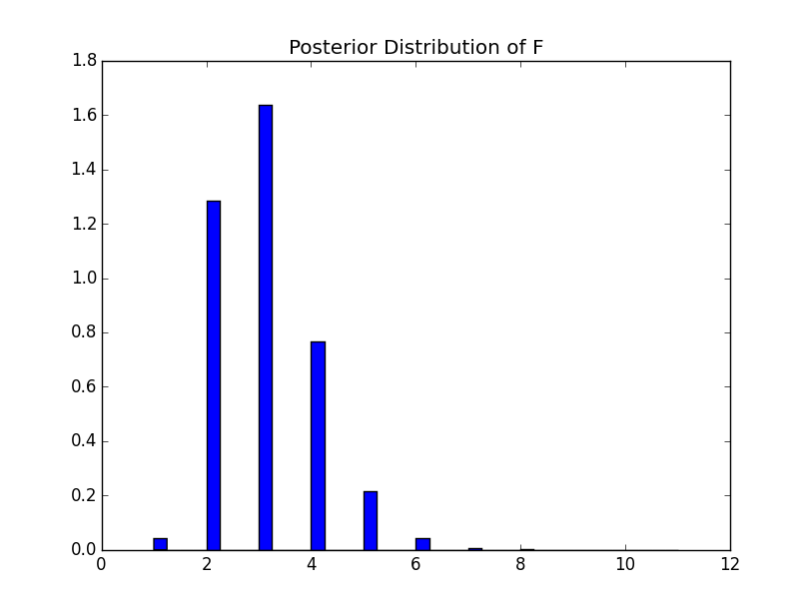Illustration 17: Posterior for node F given G=5.

Personal Experiments

Sanity Checks
These are the sanity checks I posted on LearningSuite. For each of these I used a known conjugate pair relationship and computed by hand the expected posterior. This way I could check to veryify that my various node types worked using Gibbs-Metropolis.
In the following plots I show the distribution samples from Gibbs-Metropolis, as well as the expected posterior distribution curve:
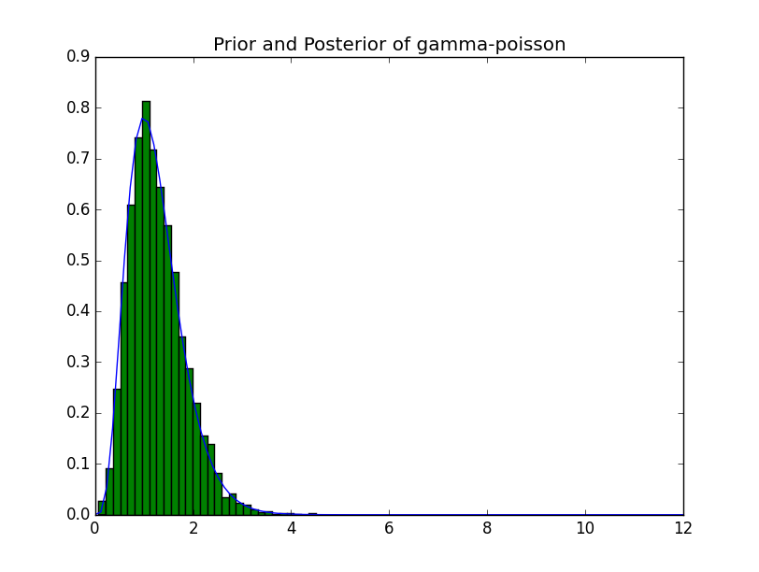Illustration 18: λ~Gamma(2,3) -> Y~Poisson(λ) with observation of Y=5.
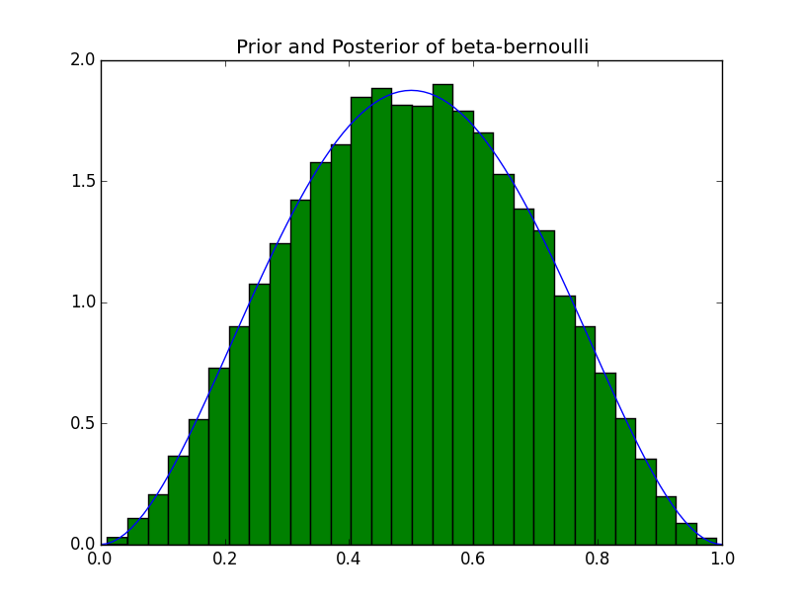Illustration 19: A~Beta(2,3) -> B~Bernoulli(p=A) with observation B = True.
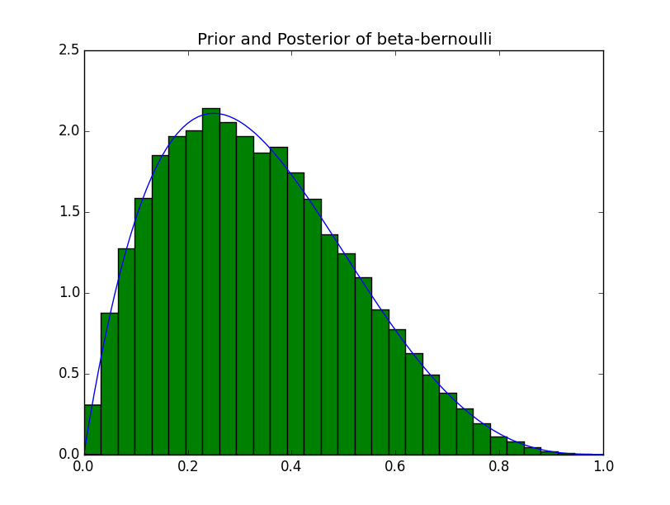Illustration 20: A~Beta(2,3) -> B~Bernoulli(p=A) with observation B=False.
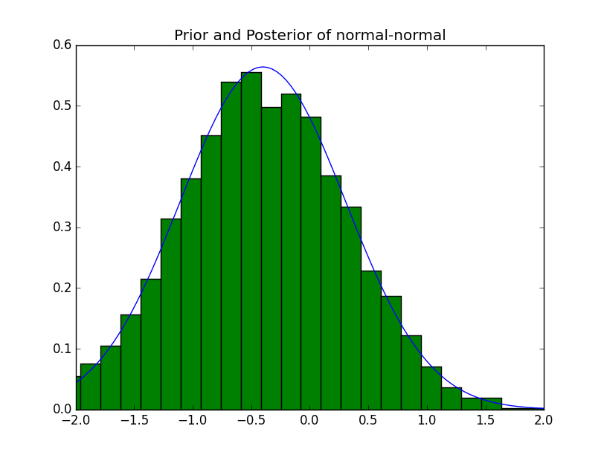Illustration 21: A~N(0,1) -> B~(A+2, 1) with observation B = 1.2

Gamma-Pareto-Poisson
This is the example model I posted:
A~Gamma(9,2) -> λ~Pareto(alpha=A, x0=22) -> C~Poisson(λ)
What are the medians for each node?
How often is the median for λ greater than the median for C?
From running this model I got the following medians:
A median = 4.40089526102
λ median = 25.1968944022
C median = 26.0
In general, you shouldn't ever expect (or at least highly unlikely) to see the median for λ to be greater than the median for C, simply based off of the nature of pareto and poisson distribtions. This becomes more apparent as you graph the distributions:
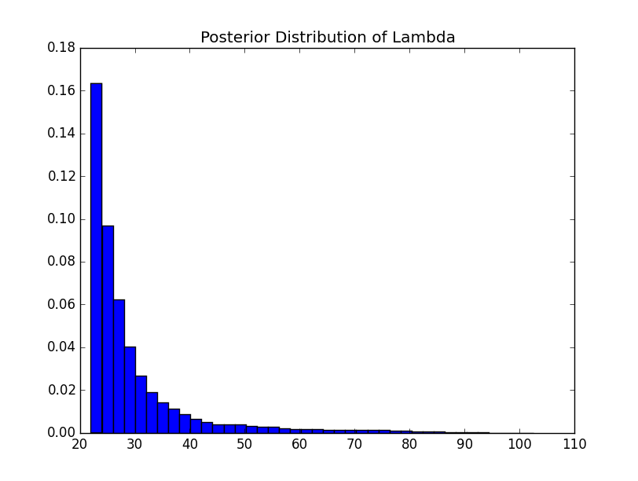Illustration 22: Posterior distribution of λ.
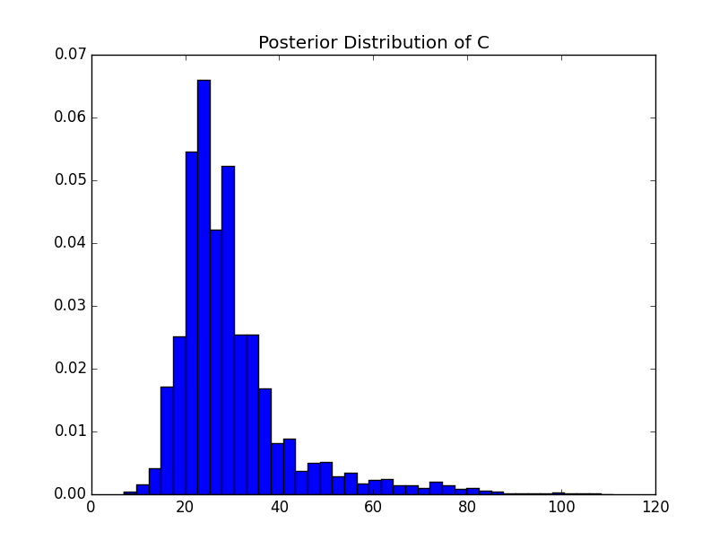Illustration 23: Posterior distribution of C.

You could expect to see as you take larger sample sizes that the heavy tail of the Poisson will outweigh the light tail of the Pareto.

Encounters (Nozomu's Network)
I also ran Nozomu's posted network:
Let Progress be distributed as Beta(alpha=2, beta=15) and Encounters be distributed as Poisson(rate=1/Progress).
What is the median value for the values sampled from Encounters?
Plotting the results of the posterior distribution for 'Encounters':
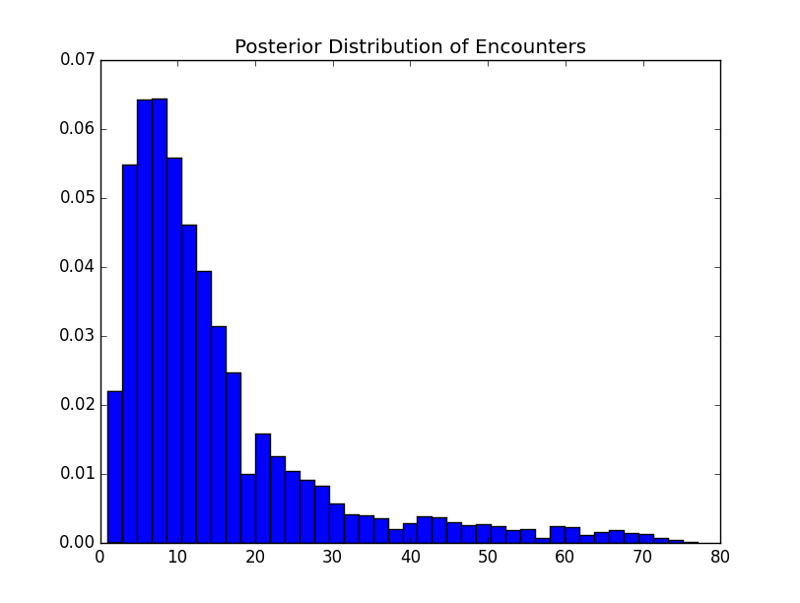Illustration 24: Posterior distribution for 'Encounters' in Nozomu's D&D network. Here it is easy to see that the median is 11.

From running experiments on this I got a median of 11.

