实 验 报 告 三
课 程 | 桌面应用程序开发 | 实验项目 | C#的构造函数与析构函数的使用 | 成 绩
专业班级 | 软件工程一大班 | 实验日期 | 2019.10.28 | 批阅日期
姓 名 | 李毅 | 学 号 | 201731062133 | 指导教师 | 王世元
姓 名 | 李文毅 | 学 号 | 201731062208
姓 名 | 江镇岐 | 学 号 | 201731062210

一【实验目的】
掌握C#中继承的特点。掌握C#中接口的使用。
通过编程掌握继承的定义方式，掌握继承过程中构造函数的调用次序，掌握虚方法和覆写方法；掌握抽象类，密封类，静态类各自的定义方式以及特点。通过编程掌握如何声明接口，如何实现接口，以及as运算符的使用。
二【实验内容】
实验1：强制记单词应用程序
软件概述：改软件在电脑开机后，自动启动，用户只能选对单词意思后，方可进入系统。达到加深英语的记忆和学习。
要求1：电脑开机后自动全屏启动
要求2：建议屏幕显示3行5列，共15个单词
要求3：每个单元格具体显示单词的哪些内容自己定（可以参考，百词斩，等英语词汇类APP寻找灵感），包括可以放该英文单词的音频MP3，显示该对应的单词的图片，播放包含这个单词的视频等多种形式加深记忆。
要求4：通过的用黄色表示，没有记忆过的用灰色加锁的图标表示，所有都通过才能进入系统。
要求5（选做）：为避免用户利用ALT + F4方式关闭软件，可以百度相关方法，屏蔽上述按键。
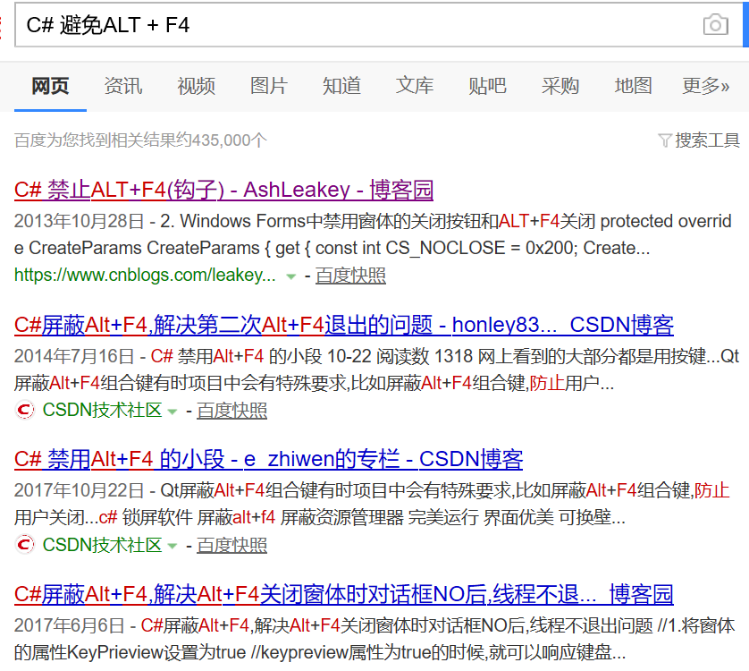

要求6：基本界面设计思路如下。尽量参考其他软件的布局，配色，将界面做美观。

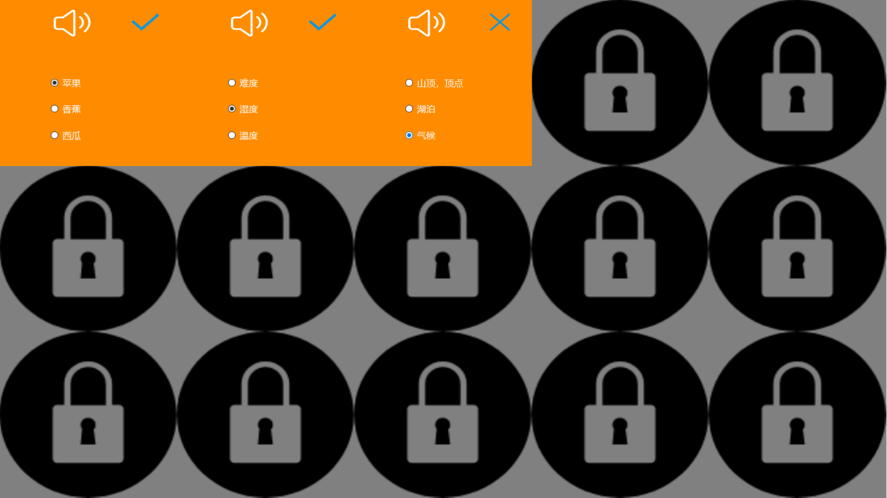
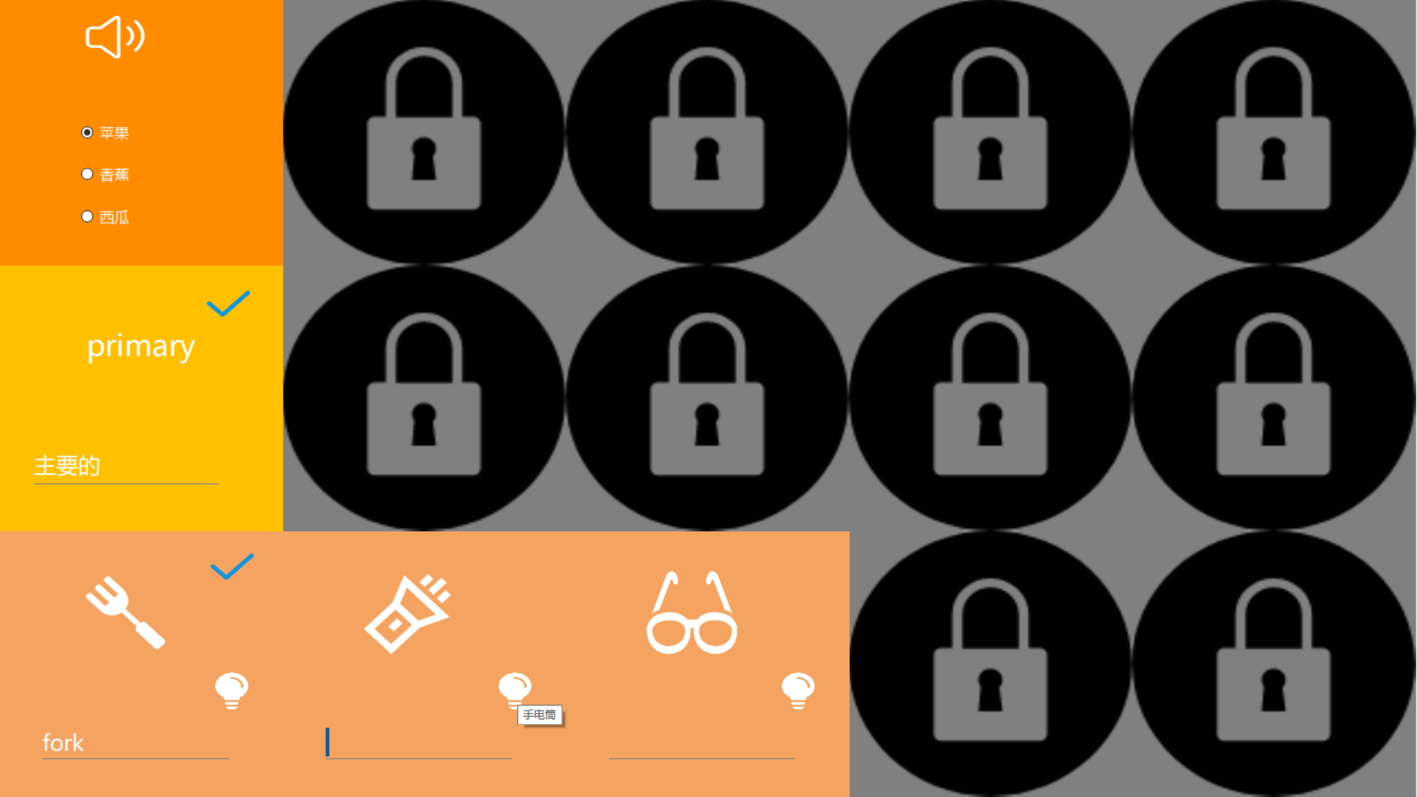
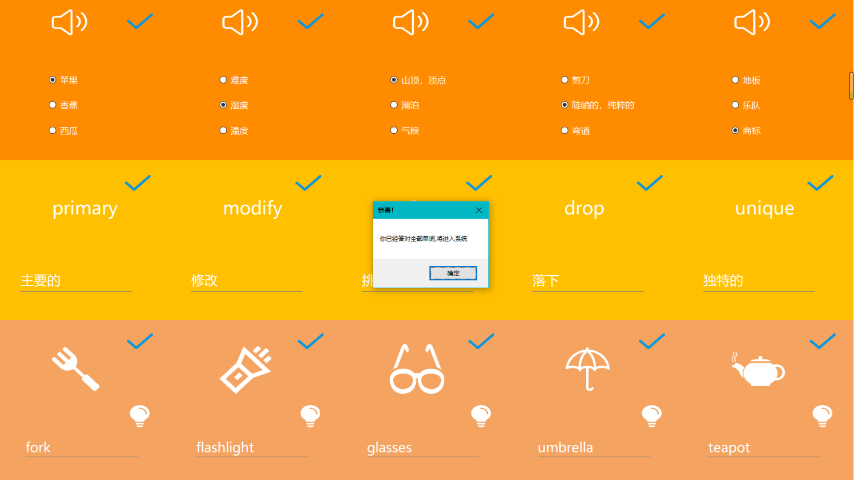
主窗体代码：
using IWshRuntimeLibrary;
using Microsoft.Win32;
using System;
using System.Collections;
using System.Collections.Generic;
using System.Diagnostics;
using System.Drawing;
using System.IO;
using System.Linq;
using System.Runtime.InteropServices;
using System.Text;
using System.Windows.Forms;
namespace ForceLearnEng
{
public partial class Form1 : Form
{
public Form1()
{
InitializeComponent();
}
//钩子屏蔽ALT+F4
private const int SC_CLOSE = 0xF060;
private const int MF_ENABLED = 0x00000000; private const int MF_GRAYED = 0x00000001; private const int MF_DISABLED = 0x00000002;
[DllImport("user32.dll", EntryPoint = "GetSystemMenu")]
private static extern IntPtr GetSystemMenu(IntPtr hWnd, int bRevert);[DllImport("User32.dll")]
public static extern bool EnableMenuItem(IntPtr hMenu, int uIDEnableItem, int uEnable);
protected override CreateParams CreateParams
{
get
{
const int CS_NOCLOSE = 0x200; CreateParams cp = base.CreateParams; cp.ClassStyle = cp.ClassStyle | CS_NOCLOSE; return cp;
}
}
//开机自启动
private static RegistryKey HKCU = Registry.CurrentUser;
private static string name = "DBAnalyzer";
private static string path = Application.ExecutablePath;
/// 快捷方式名称-任意自定义
private const string QuickName = "TCNVMClient";
/// 自动获取系统自动启动目录
private string systemStartPath { get { return Environment.GetFolderPath(Environment.SpecialFolder.Startup); } }
/// 自动获取程序完整路径
private string appAllPath { get { return Process.GetCurrentProcess().MainModule.FileName; } }
/// 自动获取桌面目录
private string desktopPath { get { return Environment.GetFolderPath(Environment.SpecialFolder.DesktopDirectory); } }
/// 设置开机自动启动-只需要调用改方法就可以了参数里面的bool变量是控制开机启动的开关的，默认为开启自启启动
/// <param name="onOff">自启开关</param>
public void SetMeAutoStart(bool onOff = true)
{
if (onOff)//开机启动
{
//获取启动路径应用程序快捷方式的路径集合
List<string> shortcutPaths = GetQuickFromFolder(systemStartPath, appAllPath);
//存在2个以快捷方式则保留一个快捷方式-避免重复多于
if (shortcutPaths.Count >= 2)
{
for (int i = 1; i < shortcutPaths.Count; i++)
{
DeleteFile(shortcutPaths[i]);
}
}
else if (shortcutPaths.Count < 1)//不存在则创建快捷方式
{
CreateShortcut(systemStartPath, QuickName, appAllPath, "中吉售货机");
}
}
else//开机不启动
{
//获取启动路径应用程序快捷方式的路径集合
List<string> shortcutPaths = GetQuickFromFolder(systemStartPath, appAllPath);
//存在快捷方式则遍历全部删除
if (shortcutPaths.Count > 0)
{
for (int i = 0; i < shortcutPaths.Count; i++)
{
DeleteFile(shortcutPaths[i]);
}
}
}
//创建桌面快捷方式-如果需要可以取消注释
//CreateDesktopQuick(desktopPath, QuickName, appAllPath);
}
/// 向目标路径创建指定文件的快捷方式
/// <param name="directory">目标目录</param>
/// <param name="shortcutName">快捷方式名字</param>
/// <param name="targetPath">文件完全路径</param>
/// <param name="description">描述</param>
/// <param name="iconLocation">图标地址</param>
/// <returns>成功或失败</returns>
private bool CreateShortcut(string directory, string shortcutName, string targetPath, string description = null, string iconLocation = null)
{
try
{
if (!Directory.Exists(directory)) Directory.CreateDirectory(directory); //目录不存在则创建
//添加引用 Com 中搜索 Windows Script Host Object Model
string shortcutPath = Path.Combine(directory, string.Format("{0}.lnk", shortcutName)); //合成路径
WshShell shell = new IWshRuntimeLibrary.WshShell();
IWshShortcut shortcut = (IWshRuntimeLibrary.IWshShortcut)shell.CreateShortcut(shortcutPath); //创建快捷方式对象
shortcut.TargetPath = targetPath; //指定目标路径
shortcut.WorkingDirectory = Path.GetDirectoryName(targetPath); //设置起始位置
shortcut.WindowStyle = 1; //设置运行方式，默认为常规窗口
shortcut.Description = description; //设置备注
shortcut.IconLocation = string.IsNullOrWhiteSpace(iconLocation) ? targetPath : iconLocation; //设置图标路径
shortcut.Save(); //保存快捷方式
return true;
}
catch (Exception ex)
{
string temp = ex.Message;
temp = "";
}
return false;
}

/// <summary>
/// 获取指定文件夹下指定应用程序的快捷方式路径集合
/// </summary>
/// <param name="directory">文件夹</param>
/// <param name="targetPath">目标应用程序路径</param>
/// <returns>目标应用程序的快捷方式</returns>
private List<string> GetQuickFromFolder(string directory, string targetPath)
{
List<string> tempStrs = new List<string>();
tempStrs.Clear();
string tempStr = null;
string[] files = Directory.GetFiles(directory, "*.lnk");
if (files == null || files.Length < 1)
{
return tempStrs;
}
for (int i = 0; i < files.Length; i++)
{
//files[i] = string.Format("{0}\\{1}", directory, files[i]);
tempStr = GetAppPathFromQuick(files[i]);
if (tempStr == targetPath)
{
tempStrs.Add(files[i]);
}
}
return tempStrs;
}

/// <summary>
/// 获取快捷方式的目标文件路径-用于判断是否已经开启了自动启动
/// </summary>
/// <param name="shortcutPath"></param>
/// <returns></returns>
private string GetAppPathFromQuick(string shortcutPath)
{
//快捷方式文件的路径 = @"d:\Test.lnk";
if (System.IO.File.Exists(shortcutPath))
{
WshShell shell = new WshShell();
IWshShortcut shortct = (IWshShortcut)shell.CreateShortcut(shortcutPath);
//快捷方式文件指向的路径.Text = 当前快捷方式文件IWshShortcut类.TargetPath;
//快捷方式文件指向的目标目录.Text = 当前快捷方式文件IWshShortcut类.WorkingDirectory;
return shortct.TargetPath;
}
else
{
return "";
}
}

/// <summary>
/// 根据路径删除文件-用于取消自启时从计算机自启目录删除程序的快捷方式
/// </summary>
/// <param name="path">路径</param>
private void DeleteFile(string path)
{
FileAttributes attr = System.IO.File.GetAttributes(path);
if (attr == FileAttributes.Directory)
{
Directory.Delete(path, true);
}
else
{
System.IO.File.Delete(path);
}
}

/// <summary>
/// 在桌面上创建快捷方式-如果需要可以调用
/// </summary>
/// <param name="desktopPath">桌面地址</param>
/// <param name="appPath">应用路径</param>
public void CreateDesktopQuick(string desktopPath = "", string quickName = "", string appPath = "")
{
List<string> shortcutPaths = GetQuickFromFolder(desktopPath, appPath);
//如果没有则创建
if (shortcutPaths.Count < 1)
{
CreateShortcut(desktopPath, quickName, appPath, "软件描述");
}
}
//创建控件1：听声音选择答案
public myMP3Player.UserControl1 creatControl1(string a,string b,string c,string d,string e,Point p)
{
myMP3Player.UserControl1 us1 = new myMP3Player.UserControl1(a,b,c,d,e);
us1.Location = p;
return us1;
}
//创建控件2：看英语单词填中文
public myMP3Player.UserControl2 creatControl2(string a, string b, Point p)
{
myMP3Player.UserControl2 us2 = new myMP3Player.UserControl2(a,b);
us2.Location = p;
return us2;
}
//创建控件3：看图识单词
public myMP3Player.UserControl3 creatControl3(string a,string b,string c,Point p)
{
myMP3Player.UserControl3 us3 = new myMP3Player.UserControl3(a,b,c);
us3.Location = p;
return us3;
}
List<myMP3Player.UserControl1> myControl1 = new List<myMP3Player.UserControl1>();
List<myMP3Player.UserControl2> myControl2 = new List<myMP3Player.UserControl2>();
List<myMP3Player.UserControl3> myControl3 = new List<myMP3Player.UserControl3>();

private void Form1_Load(object sender, EventArgs e)
{
SetMeAutoStart(true);//调用函数实现开机自启动
//使用钩子，屏蔽ALT+F4
IntPtr hMenu = GetSystemMenu(this.Handle, 0);
EnableMenuItem(hMenu, SC_CLOSE, MF_DISABLED | MF_GRAYED);
int myWidth = this.Width / 5;
int myHeight= this.Height / 3;
FileStream fs = new FileStream(@"..\..\..\单词信息.txt", FileMode.Open);//读取文件获得单词信息
Encoding encode = Encoding.GetEncoding("GB2312");
StreamReader sr = new StreamReader(fs,encode);
ArrayList al = new ArrayList();
string[] words;
string s;
int j = -1;
while((s=sr.ReadLine())!=null)
{
j++;
words = s.Split(' ');
if (j<5)//添加第一种控件
{
myMP3Player.UserControl1 us = creatControl1(words[0], words[1], words[2], words[3],words[4],
new Point(myWidth * j, 0));
myControl1.Add(us);
this.Controls.Add(us);
}
if(j>4&&j<10)//添加第二种控件
{
myMP3Player.UserControl2 us = creatControl2(words[0],words[1],
new Point(myWidth * (j-5), myHeight));
myControl2.Add(us);
this.Controls.Add(us);
}
if(j>9&&j<15)//添加第三种控件
{
myMP3Player.UserControl3 us = creatControl3(words[0],words[2],words[1],
new Point(myWidth * (j - 10), myHeight*2));
myControl3.Add(us);
this.Controls.Add(us);
}
}
}
public bool isAllRight1;
public bool isAllRight2;
public bool isAllRight3;
private void Timer1_Tick(object sender, EventArgs e)
{
isAllRight1 = myControl1.All(p=>p.IsRight==true);//第一种控件的所有实例的IsRight属性是否为True
isAllRight2 = myControl2.All(p => p.IsRight == true);//第二种
isAllRight3 = myControl3.All(p => p.IsRight == true);//第三种
if (isAllRight1 == true&& isAllRight2==true&& isAllRight3==true)
{
timer1.Enabled = false;
MessageBox.Show("你已经答对全部单词,将进入系统", "恭喜！");
this.Close();
}
}
private void Form1_KeyDown(object sender, KeyEventArgs e)
{
if ((e.KeyCode == Keys.F4) && (e.Alt == true)) //屏蔽ALT+F4，先把Form1的KeyPreview属性置为True（弃用）
{
// e.Handled = true;
}
}
}
}
“听语音选答案”控件代码：
using System;
using System.Collections.Generic;
using System.ComponentModel;
using System.Drawing;
using System.Media;
using System.Windows.Forms;
namespace myMP3Player
{
public partial class UserControl1: UserControl
{
private string a;//第一个选项
private string b;//第二个
private string c;//第三个
private string answer;//答案
private string myfilename;//音频文件地址
List<RadioButton> rb = new List<RadioButton>();
private bool isRight;
[CategoryAttribute("其他"), DescriptionAttribute("答案是否正确")]
public bool IsRight
{
get
{
return isRight;
}
set
{
isRight = value;
}
}
private void UserControl1_Load(object sender, EventArgs e)
{
this.IsRight = false;
this.radioButton1.Text = a;
this.radioButton2.Text = b;
this.radioButton3.Text = c;
rb.Add(radioButton1);
rb.Add(radioButton2);
rb.Add(radioButton3);
Rectangle ScreenArea = System.Windows.Forms.Screen.GetBounds(this);//获取屏幕大小
this.Width = ScreenArea.Width / 5;
this.Height = ScreenArea.Height / 3;
this.BackgroundImage = Properties.Resources.锁;
}
public UserControl1(string a, string b, string c,string d,string e)
{
this.a = a;
this.b = b;
this.c = c;
this.myfilename = d;
answer = e;
InitializeComponent();
}
private void PictureBox1_Click(object sender, EventArgs e)
{
SoundPlayer s = new SoundPlayer(myfilename);
s.Play();
}
private void UserControl1_Click(object sender, EventArgs e)
{
this.pictureBox1.Visible = true;
this.panel1.Visible = true;
this.BackColor = Color.FromArgb(255, 140, 0);
this.BackgroundImage = null;
this.button1.Focus();
}
private void RadioButton1_Click(object sender, EventArgs e)
{
this.button1.Focus();
}
private void Button1_Click(object sender, EventArgs e)
{
foreach (RadioButton r in rb)
{
if (r.Checked == true && r.Text == answer)
{
pictureBox2.BackgroundImage = Properties.Resources.勾;
pictureBox2.Visible = true;
IsRight = true;
}
if (r.Checked == true && r.Text != answer)
{
pictureBox2.BackgroundImage = Properties.Resources.叉;
pictureBox2.Visible = true;
IsRight = false ;
}
}
}
}
}
“看单词写中文”控件二：
using System;
using System.ComponentModel;
using System.Drawing;
using System.Windows.Forms;
namespace myMP3Player
{
public partial class UserControl2 : UserControl
{
private string eng;//显示的单词
private string answer;//答案
public UserControl2(string a,string b)
{
eng = a;
answer = b;
InitializeComponent();
}
private bool isRight;//用户是否答对
[CategoryAttribute("其他"), DescriptionAttribute("答案是否正确")]
public bool IsRight
{
get
{
return isRight;
}
set
{
isRight = value;
}
}
private void UserControl2_Load(object sender, EventArgs e)
{
this.IsRight = false;
this.label1.Text = eng;
Rectangle ScreenArea = System.Windows.Forms.Screen.GetBounds(this);
this.Width = ScreenArea.Width / 5;
this.Height = ScreenArea.Height / 3;
}
private void UserControl2_Click(object sender, EventArgs e)
{
label1.Visible = true;
panel1.Visible = true;
textBox1.Visible = true;
this.BackColor = Color.FromArgb(255, 192, 0);
this.BackgroundImage = null;
this.textBox1.Focus();
}
private void TextBox1_KeyPress(object sender, KeyPressEventArgs e)
{
if (textBox1.Text == answer && e.KeyChar == (char)13)
{
pictureBox2.BackgroundImage = Properties.Resources.勾;
pictureBox2.Visible = true;
IsRight = true;
}
if (textBox1.Text != answer && e.KeyChar == (char)13&&textBox1.Text != "")
{
pictureBox2.BackgroundImage = Properties.Resources.叉;
pictureBox2.Visible = true;
IsRight = false;
}
}
private void Timer1_Tick(object sender, EventArgs e)
{
if(textBox1.Text=="")
{
pictureBox2.Visible = false;
}
}
}
}
“看图写单词”控件代码：
using System;
using System.ComponentModel;
using System.Drawing;
using System.Windows.Forms;
namespace myMP3Player
{
public partial class UserControl3 : UserControl
{
public string img;//图片地址
private string answer;//答案
private string tip;//提示
public UserControl3(string i,string b,string c)
{
img = i;
answer = b;
tip = c;
InitializeComponent();
}
private bool isRight;
[CategoryAttribute("其他"), DescriptionAttribute("答案是否正确")]
public bool IsRight
{
get
{
return isRight;
}
set
{
isRight = value;
}
}
private void UserControl3_Load(object sender, EventArgs e)
{
this.IsRight = false;
pictureBox1.BackgroundImage =Image.FromFile(img);
Rectangle ScreenArea = System.Windows.Forms.Screen.GetBounds(this);
this.Width = ScreenArea.Width / 5;
this.Height = ScreenArea.Height / 3;
toolTip1.SetToolTip(pictureBox3,tip);
}
private void UserControl3_Click(object sender, EventArgs e)
{
pictureBox3.Visible = true;
panel1.Visible = true;
textBox1.Visible = true;
pictureBox1.Visible = true;
this.BackColor = Color.FromArgb(244, 164, 96);
this.BackgroundImage = null;
this.textBox1.Focus();
}
private void TextBox1_KeyPress(object sender, KeyPressEventArgs e)
{
if (textBox1.Text == answer && e.KeyChar == (char)13)
{
pictureBox2.BackgroundImage = Properties.Resources.勾;
pictureBox2.Visible = true;
IsRight = true;
}
if (textBox1.Text != answer && e.KeyChar == (char)13 && textBox1.Text != "")
{
pictureBox2.BackgroundImage = Properties.Resources.叉;
pictureBox2.Visible = true;
IsRight = false;
}
}
private void Timer1_Tick(object sender, EventArgs e)
{
if (textBox1.Text == "")
{
pictureBox2.Visible = false;
}
}
}
}

