实验五 广播应用

|  |  |  |  |  |  |
| --- | --- | --- | --- | --- | --- |
| **课 程** | 移动应用软件开发技术 | **实验项目** | 广播应用 | **成 绩** |  |
| **专业班级** | 软件工程2017 | **班内序号** |  | **指导教师** | 杨云 |
| **姓 名** | **李文毅** | **学 号** | **201731062208** | **实验日期** | 2019.12.18 |

**实验目的及要求：**

1. 掌握：广播的创建
2. 理解：自定义广播发送与接收
3. 掌握：本地广播的发送与接收
4. 实验报告上传：<http://study.swpu.edu.cn/portal>

**实验内容：**

# 1.自定义广播：

(1) 发送一个自定义广播，在intent中附加数据(putExtra方法)，key为”extraKey”，value为”CustomValue”

(2) 新创建一个项目，创建BroadcastReceiver子类，接收2中发出的自定义广播，并将附加的数据用log.d打印出来

## 运行截图：

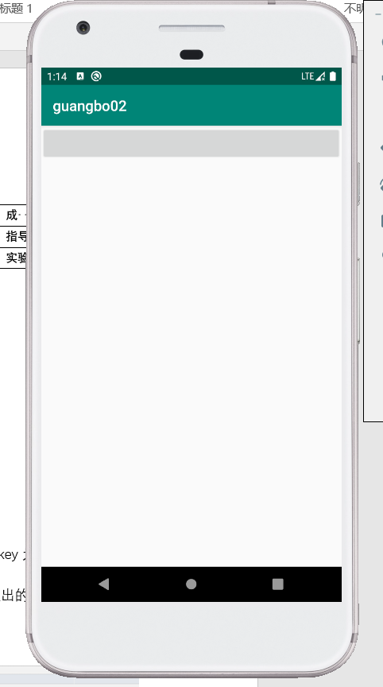

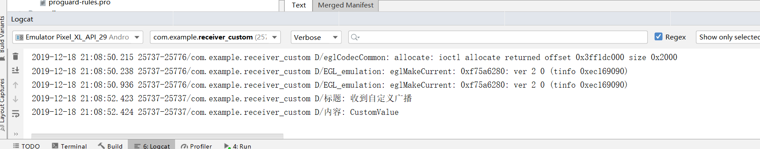

## 代码：

### 第一个应用主活动代码：

**package** com.example.guangbo02;  
  
**import** androidx.appcompat.app.AppCompatActivity;  
  
**import** android.content.ComponentName;  
**import** android.content.Intent;  
**import** android.os.Bundle;  
**import** android.view.View;  
**import** android.widget.Button;  
  
**public class** MainActivity **extends** AppCompatActivity {  
  
 @Override  
 **protected void** onCreate(Bundle savedInstanceState) {  
 **super**.onCreate(savedInstanceState);  
 setContentView(R.layout.***activity_main***);  
 Button button=(Button) findViewById(R.id.***button***);  
 button.setOnClickListener(**new** View.OnClickListener() {  
 @Override  
 **public void** onClick(View v) {  
 Intent intent=**new** Intent();  
 intent.setAction(**"com.example.guangbo02.customReceiver"**);*//自定义广播的类型* intent.putExtra(**"extraKey"**, **"CustomValue"**);*//发送带参数的广播；* intent.setComponent(**new** ComponentName(getPackageName(),**"com.example.guangbo02.customReceiver"**));  
 sendBroadcast(intent);*//直接发送广播* }  
 });  
 }  
}

### 第二个应用主活动代码：

**package** com.example.receiver_custom;  
  
**import** androidx.appcompat.app.AppCompatActivity;  
  
**import** android.content.BroadcastReceiver;  
**import** android.content.Context;  
**import** android.content.Intent;  
**import** android.content.IntentFilter;  
**import** android.os.Bundle;  
**import** android.util.Log;  
  
**public class** MainActivity **extends** AppCompatActivity {  
 **private** customreceiver **customreceiver**;  
  
 @Override  
 **protected void** onCreate(Bundle savedInstanceState) {  
 **super**.onCreate(savedInstanceState);  
 setContentView(R.layout.***activity_main***);  
 IntentFilter intentFilter=**new** IntentFilter();  
 intentFilter.addAction(**"com.example.receiver_custom.customreceiver"**);  
 **customreceiver** = **new** customreceiver();  
 registerReceiver(**customreceiver**, intentFilter);  
 }  
}

### 第二个应用广播接收器代码：

**package** com.example.receiver_custom;  
  
**import** android.content.BroadcastReceiver;  
**import** android.content.Context;  
**import** android.content.Intent;  
**import** android.util.Log;  
**import** android.widget.Toast;  
  
**public class** customreceiver **extends** BroadcastReceiver {  
  
 @Override  
 **public void** onReceive(Context context, Intent intent) {  
 *//* ***TODO: This method is called when the BroadcastReceiver is receiving*** *// an Intent broadcast.  
 //throw new UnsupportedOperationException("Not yet implemented");* Log.*d*(**"标题"**,**"收到自定义广播"**);  
 String info = intent.getStringExtra(**"extraKey"**);*//接受广播带的参数* Log.*d*(**"内容"**, info);  
  
 }  
}

# 2.本地广播：

1. 发送一个本地广播，在intent中附加数据(putExtra方法)，key为” extraKey”，value为”LocalValue”
2. 创建一个BroadcastReceiver子类，接收广播并以Toast显示接收到的值

## 运行截图：

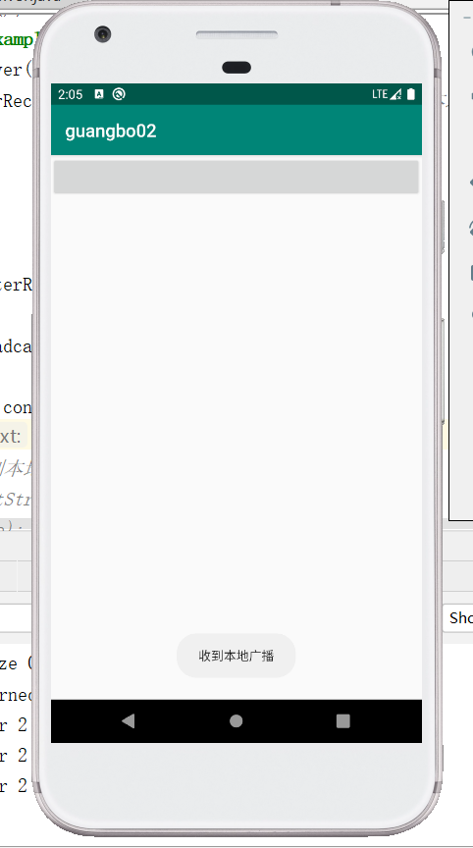

## 代码：

**package** com.example.guangbo02;  
  
**import** androidx.appcompat.app.AppCompatActivity;  
**import** androidx.localbroadcastmanager.content.LocalBroadcastManager;  
  
**import** android.content.BroadcastReceiver;  
**import** android.content.ComponentName;  
**import** android.content.Context;  
**import** android.content.Intent;  
**import** android.content.IntentFilter;  
**import** android.os.Bundle;  
**import** android.util.Log;  
**import** android.view.View;  
**import** android.widget.Button;  
**import** android.widget.Toast;  
**public class** MainActivity **extends** AppCompatActivity {  
 **private** IntentFilter **intentFilter**;  
 **private** LocalReceiver **localReceiver**;  
 **private** LocalBroadcastManager **localBroadcastManager**;  
 @Override  
 **protected void** onCreate(Bundle savedInstanceState) {  
 **super**.onCreate(savedInstanceState);  
 setContentView(R.layout.***activity_main***);  
 **localBroadcastManager**=LocalBroadcastManager.*getInstance*(**this**);*//获取实例* Button button=(Button)findViewById(R.id.***button***);  
 button.setOnClickListener(**new** View.OnClickListener() {  
 @Override  
 **public void** onClick(View v) {  
 Intent intent=**new** Intent(**"com.example.guangbo02.localreceiver"**);  
 intent.putExtra(**"extrakey"**,**"LocalValue"**);**localBroadcastManager**.sendBroadcast(intent);  
 }  
 });  
 **intentFilter**=**new** IntentFilter();  
 **intentFilter**.addAction(**"com.example.guangbo02.localreceiver"**);  
 **localReceiver**=**new** LocalReceiver();  
 **localBroadcastManager**.registerReceiver(**localReceiver**,**intentFilter**);*//注册本地广播监听器*/* }  
 @Override  
 **protected void** onDestroy() {  
 **super**.onDestroy();  
 **localBroadcastManager**.unregisterReceiver(**localReceiver**);  
 }  
 **class** LocalReceiver **extends** BroadcastReceiver{  
 @Override  
 **public void** onReceive(Context context, Intent intent) {  
 Toast.*makeText*(context,**"收到本地广播"**,Toast.***LENGTH_LONG***).show();}  
 }  
}