**实 验 报 告 七**

|  |  |  |  |  |  |
| --- | --- | --- | --- | --- | --- |
| **课 程** | 桌面应用程序开发 | **实验项目** | C#程序设计综合设计 | **成 绩** |  |
| **专业班级** | **软件工程一大班** | **实验日期** | **2019.11.11** | **批阅日期** |  |
| **姓 名** | **李毅** | **学 号** | **201731062133** | **指导教师** | 王世元 |
| **姓 名** | **李文毅** | **学 号** | **201731062208** |  |  |
| **姓 名** | **江镇岐** | **学 号** | **201731062210** |  |  |

**一【实验目的】**

1. 学会使用C#语言解决实际问题。

**二【实验内容】**

**【实验1】**

1. **利用本门课程学到的知识，结合自己的兴趣点，小组一起实现一个桌面应用程序，并将项目代码以及运行结果截图附录如下。**

**一、运行截图：**

**1、文本或链接转换为二维码**

**1.1、文本生成二维码**

**1.1.1、文本框内输入文字以生成二维码**

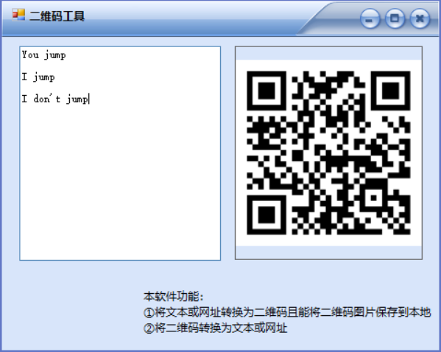

**1.1.2、手机扫描二维码截图**

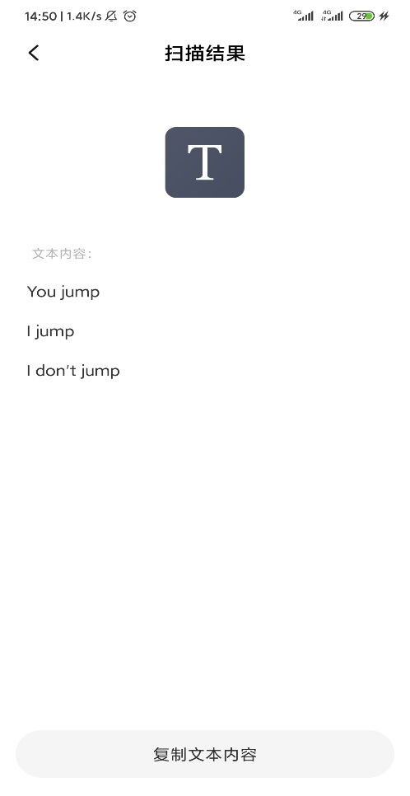

**1.2、链接生成二维码**

**1.2.1、文本框内输入链接以生成二维码**

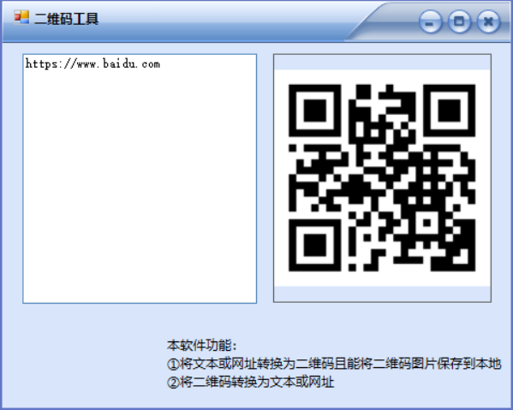

**1.2.2、保存二维码图片到本地**

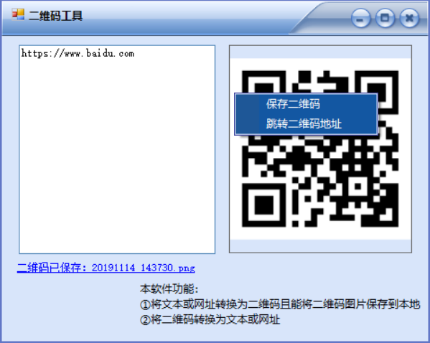

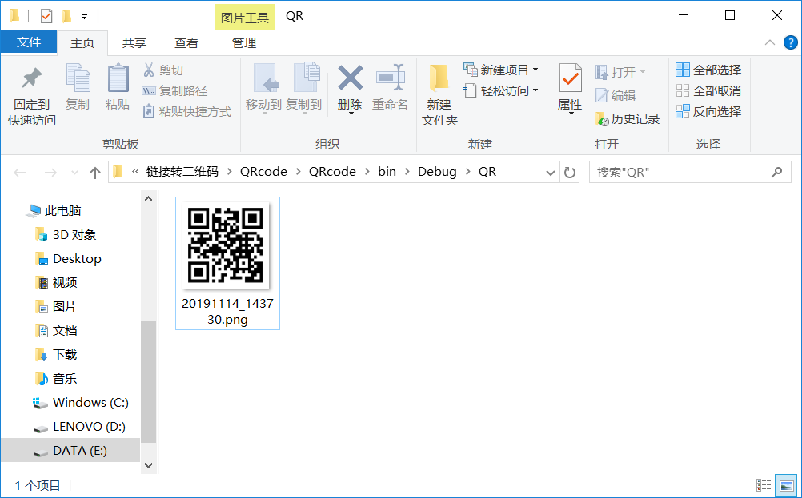

**1.2.3、跳转二维码地址**

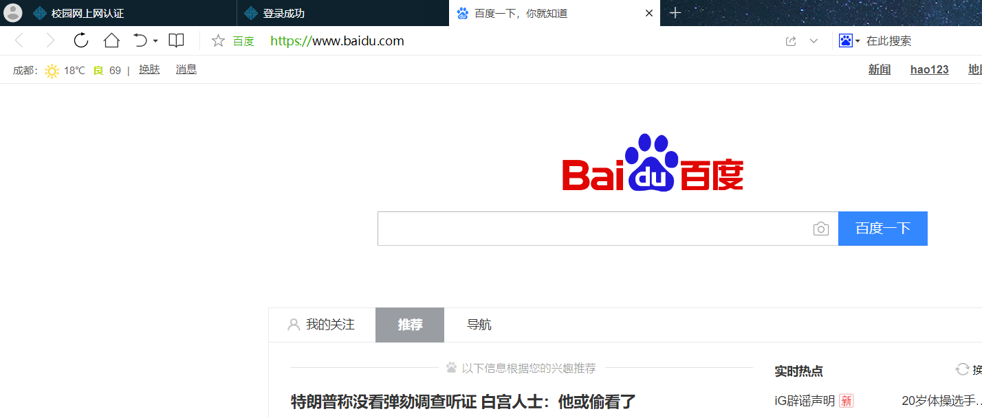

**2、将二维码转为文本或链接**

**2.1、将二维码拖入软件图片框中**

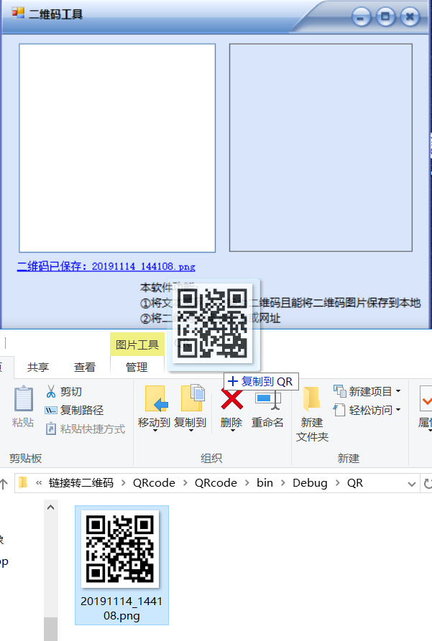

**2.2、成功拖入二维码后**

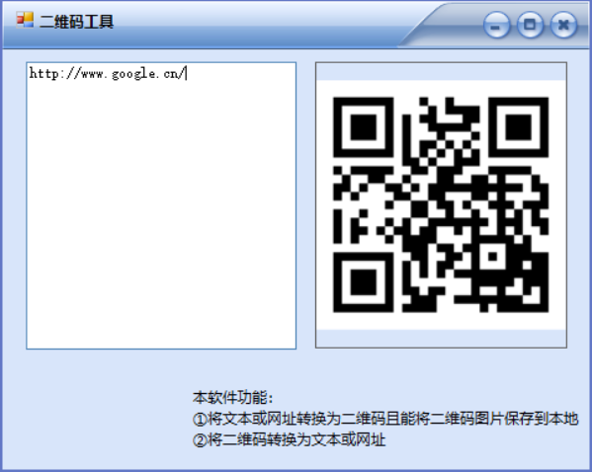

**二、代码：**

**1、主窗体代码(QRTool.cs)：**

using Gma.QrCodeNet.Encoding;

using Gma.QrCodeNet.Encoding.Windows.Render;

using System;

using System.Collections.Generic;

using System.ComponentModel;

using System.Data;

using System.Drawing;

using System.Drawing.Imaging;

using System.IO;

using System.Linq;

using System.Text;

using System.Threading.Tasks;

using System.Windows.Forms;

using Yc.QrCodeLib;

using Yc.QrCodeLib.Data;

namespace QRcode

{

public partial class frmQR : Form

{

public static string QRname = "";//二维码名称

public frmQR()

{

InitializeComponent();

}

private void frmQR_Load(object sender, EventArgs e)

{

this.skinEngine1.SkinFile = "Skins/mp10.ssk";

}

bool isUpdated = true;//url地址变是否动，变动则更新二维码显示

private void txtURL_TextChanged(object sender, EventArgs e)

{

label2.Visible = false;

if (isUpdated)

{

string url = txtURL.Text;

if (!url.Equals(""))

{

Bitmap bmp = TxtToQR(url);

picQR.Image = bmp;

}

if(url.Equals(""))

{

picQR.Image = null;

}

}

}

private void pnlDragQR_DragEnter(object sender, DragEventArgs e)//拖入文件

{

if (e.Data.GetDataPresent(DataFormats.FileDrop))//判断拖来的是否是文件

{

e.Effect = DragDropEffects.Link;//是则将拖动源中的数据连接到控件

}

else

{

e.Effect = DragDropEffects.None;

}

}

private void pnlDragQR_DragDrop(object sender, DragEventArgs e)//成功拖入文件

{

Array files = (System.Array)e.Data.GetData(DataFormats.FileDrop);//将拖来的数据转化为数组存储

foreach (object file in files)

{

try

{

string str = file.ToString();

Image bmp = Bitmap.FromFile(str);

picQR.Image = bmp;

// 解析二维码图像

isUpdated = false;

String code = QRToTxt(new Bitmap(bmp));

txtURL.Text = code;

isUpdated = true;

break;

}

catch (Exception ex) { }

}

}

public static Bitmap TxtToQR(string url)//将链接地址转化为二维码图像

{

QrEncoder qrEncoder = new QrEncoder(ErrorCorrectionLevel.M);

QrCode qrCode = qrEncoder.Encode(url);

GraphicsRenderer render = new GraphicsRenderer(new FixedModuleSize(5, QuietZoneModules.Two), Brushes.Black, Brushes.White);

DrawingSize size = render.SizeCalculator.GetSize(qrCode.Matrix.Width);

Bitmap bmp = new Bitmap(size.CodeWidth, size.CodeWidth);

Graphics g = Graphics.FromImage(bmp);

render.Draw(g, qrCode.Matrix);

return bmp;

}

public static string QRToTxt(Bitmap bmp)//将二维码图像转化为编码串

{

QRCodeDecoder decoder = new QRCodeDecoder();

String decodedString = decoder.decode(new QRCodeBitmapImage(bmp));

return decodedString;

}

private void linkLabel1_LinkClicked(object sender, LinkLabelLinkClickedEventArgs e)//在文件浏览器中显示已保存的二维码图像文件

{

String dir = curDir() + "QR\\";

String name = linkLabel1.Text.Substring("二维码已保存：".Length);

ShowFileInExplorer(dir + name);

linkLabel1.Visible = false;

}

private void ShowFileInExplorer(string file)//在文件浏览器中显示指定的文件

{

if (File.Exists(file))

{

System.Diagnostics.Process.Start("explorer.exe", "/e,/select, " + file);

}

else

{

System.Diagnostics.Process.Start("explorer.exe", "/e, " + file);

}

}

public static String Save(Bitmap bmp)//图像返回文件名

{

String path = curDir() + "QR\\";

checkDir(path);

String name = DateTime.Now.ToString("yyyyMMdd_HHmmss") + ".png";

if (!QRname.Equals(""))

{

name = QRname;

}

SaveImage(bmp, path + name);

return name;

}

public static void SaveImage(Bitmap bmp, String filePath)//保存图片

{

if (File.Exists(filePath))

{

File.Delete(filePath);

}

bmp.Save(filePath, ImageFormat.Png);

}

private static string curDir()//获取当前运行路径

{

return AppDomain.CurrentDomain.BaseDirectory;

}

public static void checkDir(string path)//检测目录是否存在，若不存在则创建

{

if (!Directory.Exists(path))

{

Directory.CreateDirectory(path);

}

}

private void 保存ToolStripMenuItem_Click(object sender, EventArgs e)

{

linkLabel1.Visible = true;

if (picQR.Image != null)

{

Bitmap bmp= new Bitmap(picQR.Image);

String filepath = Save(bmp);

linkLabel1.Text = "二维码已保存：" + filepath;

}

else linkLabel1.Text = "";

}

private void 跳转二维码地址ToolStripMenuItem_Click_1(object sender, EventArgs e)

{

if (!txtURL.Text.Equals(""))

{

try

{

System.Diagnostics.Process.Start(txtURL.Text);

}

catch(System.ComponentModel.Win32Exception)

{

label2.Visible = true;

label2.Text= "链接地址错误，请输入正确的网址！";

}

}

}

}

}

**2、资源类代码(DependentFiles.cs)：**

using System;

using System.Reflection;

namespace QRcode

{

class DependentFiles

{

public static void LoadResourceDll()

{

AppDomain.CurrentDomain.AssemblyResolve += new ResolveEventHandler(CurrentDomain_AssemblyResolve);

}

private static System.Reflection.Assembly CurrentDomain_AssemblyResolve(object sender, ResolveEventArgs args)

{

string dllName = args.Name.Contains(",") ? args.Name.Substring(0, args.Name.IndexOf(',')) : args.Name.Replace(".dll", "");

dllName = dllName.Replace(".", "_");

if (dllName.EndsWith("_resources")) return null;

string Namespace = Assembly.GetEntryAssembly().GetTypes()[0].Namespace;

System.Resources.ResourceManager rm = new System.Resources.ResourceManager(Namespace + ".Properties.Resources", System.Reflection.Assembly.GetExecutingAssembly());

byte[] bytes = (byte[])rm.GetObject(dllName);

return System.Reflection.Assembly.Load(bytes);

}

}

}

**3、二维码函数类代码（QR.cs）：**

using System;

using System.Collections.Generic;

using System.Drawing;

using System.Windows.Forms;

namespace QRcode

{

static class QR

{

[STAThread]

static void Main(String[] args)

{

args = PreAnalyseParams(args);//参数预解析

Application.EnableVisualStyles();

Application.SetCompatibleTextRenderingDefault(false);

//Application.Run(new QR());

DependentFiles.LoadResourceDll();//载入资源dll文件

if (args != null && args.Length > 0)//生成参数对应二维码

{

foreach (String arg in args)

{

Bitmap pic = frmQR.TxtToQR(arg);//生成二维码

frmQR.Save(pic);//保存图像

}

}

else Application.Run(new frmQR());

}

private static string[] PreAnalyseParams(string[] args)

{

List<string> lst = new List<string>();

if (args != null && args.Length > 0)//生成参数对应二维码

{

foreach (String arg0 in args)

{

String arg = arg0.Trim();

if (arg.StartsWith("QRname=")) frmQR.QRname = arg.Substring("QRname=".Length);

else lst.Add(arg);

}

}

return lst.ToArray();

}

}

}