|  |  |  |  |  |  |
| --- | --- | --- | --- | --- | --- |
| **课 程** | 软件质量保证与测试 | **实验项目** | LoadRunner网页性能测试 |  |  |
| **专业班级** | **软件工程1702** | **实验日期** | **2019.11.17** |  |  |
| **姓 名** | **李文毅** | **学 号** | 201731062208 | **指导教师** | 张剑 |

## 生成脚本：

**Action**()  
{  
  
    web_add_cookie("QQ_Sogou_Openid=**0460EA971DC5A7603D2B0DEAA76E6193**,1573960257; DOMAIN=**get.sogou.com**");  
  
    web_custom_request("q",   
        "URL=**http://get.sogou.com/q**",   
        "Method=**POST**",   
        "Resource=**1**",   
        "RecContentType=**image/gif**",   
        "Referer=",   
        "Snapshot=**t1.inf**",   
        "Body=k=**r2lU5Bxmq16IRUq9LqLQBvjIAU3rQjLJZ2N8XUnXbHfQ35ScQVj6t4t+o3nkhnPQC0FitYNkKVji1j8NXZWb8JGyeRRyBZj/rYDn7d4M4Wrez4SFJ6wJPZsvX8Z8T52d0wLryaPYnBo1JYFMPLibqhT0UC23GMEt3K6aeZX5nAU**=&v=**EAwrjHm2PJ8QD0MSirc1H2LhYEhEIFXYUe3fBeA1bTGjGnwOzXm7dHtcmWmKRol5zVMI3UA0jV+ozrYlAMVBQb4Z5vRz4U2ccdErBKWZTO5rxuuRO63G2q/SG7sFlSRXL7cH/GokWD88XnuhrZ4sPHphvlgNYt+gk3Rff85DSWA**=&u=kJRXyoZZuTQtSl9q06p9ivG9ClMAcg2Xh254V6Zi5b3NbpqyUePANwJ8duVWSGWL&p=**n8KmtsPeddLf2KqrlCY+CAB6C4FwKVJb9aIz/wV/**"  
        "Vrqv4s5nNyt7cItfs0hQtqQeSJqhnPHW0GAXFysNWh1vUsCBwbDUxeQrWVpnvzN9u49GOjb4mtJCDZsQTbhjZHZXWxqPghjzdiyOjYqvpBRoX1ufQUOXIBw2pGxQ2bP207QbwyF/UYwg67R9hOtEU+ZN",   
        **LAST**);  
  
    return 0;  
}

## 设计器设计

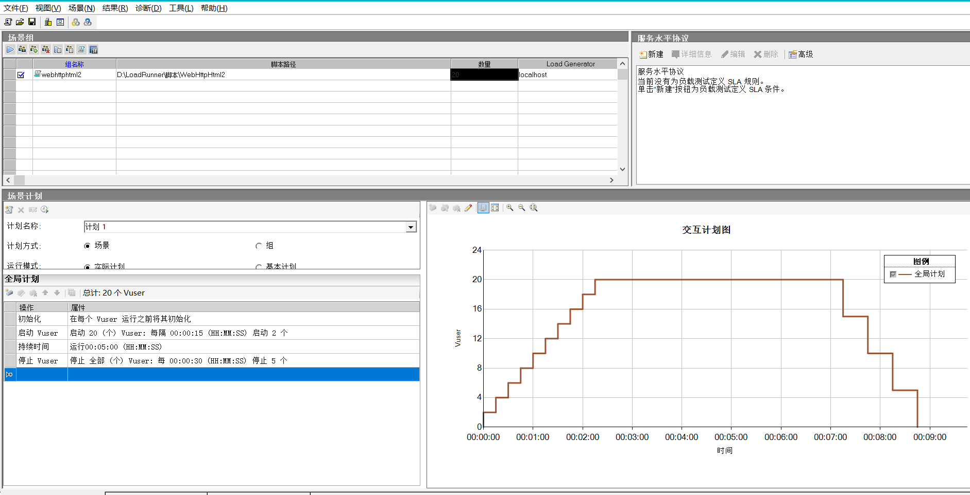

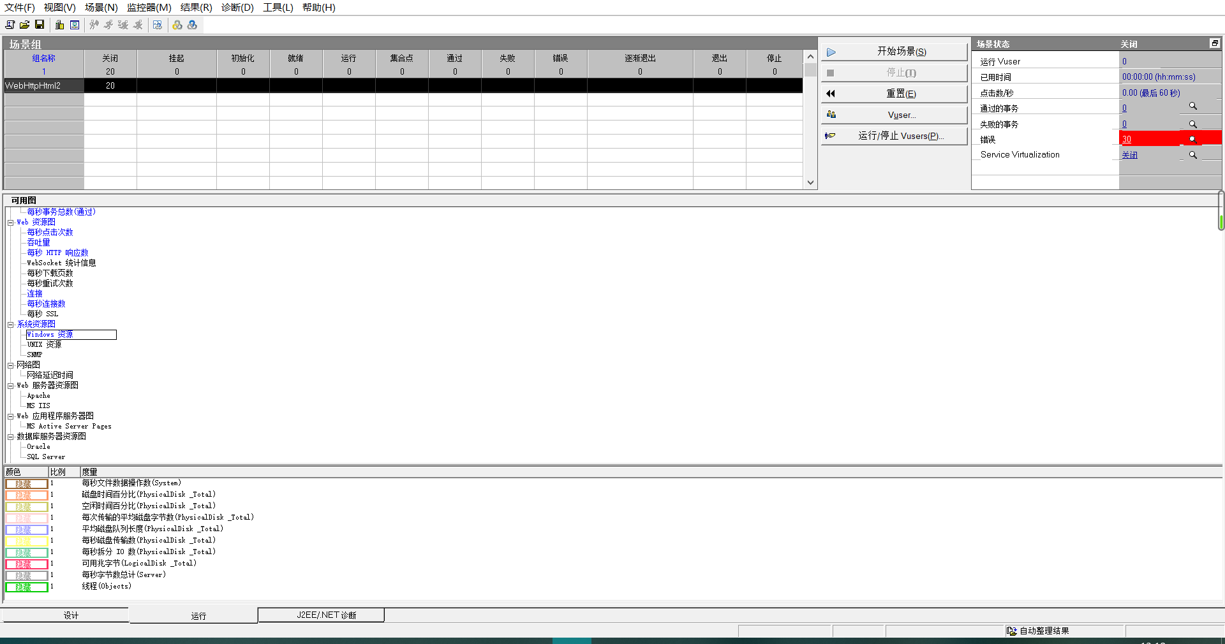

## 分析数据:

